This Word module should be used for all taxonomic proposals.
Please complete Part 1 and:
either Part 3 for proposals to create new taxa or change existing taxa
or Part 2 for proposals of a general nature.
Submit the completed Word module, together with the accompanying Excel module named in Part 3, to the appropriate ICTV Subcommittee Chair.
For guidance, see the notes written in blue, below, and the help notes in file Taxonomic_Proposals_Help_2018.

Part 1: TITLE, AUTHORS, etc

Code assigned: | 2018.004M |  | (to be completed by ICTV officers)
Short title: One new species in the genus Ledantevirus, family Rhabdoviridae
Author(s):
Davide Lelli, Alice Prosperi, Ana Moreno, Chiara Chiapponi, Enrica Sozzi, Antonio Lavazza
Corresponding author with e-mail address:
Davide Lelli
Istituto Zooprofilattico Sperimentale della Lombardia e dell’Emilia Romagna (IZSLER), Via Bianchi 9 - 25124 Brescia, Italy.
E-mail: davide.lelli@izsler.it
List the ICTV study group(s) that have seen this proposal:
 |  | ICTV Rhabdoviridae Study Group
ICTV Study Group comments (if any) and response of the proposer:
The majority of Study Group members support the proposal (8 supporters and 4 non-responders)
Date first submitted to ICTV: |  |  | June 6, 2018
Date of this revision (if different to above):

ICTV-EC comments and response of the proposer:

Part 3: PROPOSED TAXONOMY

Name of accompanying Excel module: 2018.004M.N.v1.Ledantevirus_sp

Supporting material:
The Rhabdoviridae is one of the most ecologically diverse families of RNA viruses which can infect a wide range of vertebrates and invertebrates. Bats, among mammals, are pointed to harbor a significantly higher proportion of unknown or emerging viruses with zoonotic potential. We recently reported the isolation of a novel rhabdovirus, detected from an insectivorous bat (Pipistrellus kuhlii) in Northern Italy, which was tentatively named Vaprio virus (VAPV) (Figure 1) [1]. The complete genomic sequence of VAPV demonstrated that this new virus is genetically related to the Le Dantec virus (LDV), isolated from a human in Senegal in 1965. However, VAPV showed large nucleotide and amino acid divergence from LDV and other viruses belonging to the genus Ledantevirus, of which LDV is the assigned to the type species Ledantec ledantevirus.

Genome Characterization
The complete viral genome was obtained by next generation sequencing (NGS) from a contig of 11,774 nucleotides, assembly results are shown in Table 1. The full genome sequence of the viral strain was determined and compared with those of rhabdoviruses available on GenBank. Therefore, the preliminary morphological identification obtained by EM was eventually confirmed.
The whole genome is comprised of 5 genes encoding the canonical rhabdovirus structural proteins (N, P, M, G and L), with an additional transcriptional unit (U1) encoding a hypothetical small protein of 157 amino acids located between the G and L genes (Figure 2).
The results of BLAST analysis showed the highest amino acid sequence identity for each protein of VAPV was to LDV (human, 1965, Senegal) and Keuraliba virus (KEUV) (gerbil, 1968, Senegal). The amino acid identity range was from 37% (for the phosphoprotein) to 70% (for the L protein, which is the most highly conserved) (Table 2). If we consider the complete viral genome sequence, BLAST analysis revealed the highest nucleotide identity (65%) to LDV. The complete genome sequence for VAPV was submitted to GenBank under accession number MG02144.
Phylogenetic analysis performed with 14 known viruses belonging to the genus Ledantevirus (Figure 3) suggested that VAPV is a new member of phylogroup B of this recently established genus. Moreover, VAPV satisfies the species demarcation criteria of the International Committee on the Taxonomy of Viruses (ICTV), Rhabdoviridae Study Group for classification to a separate species in the genus Ledantevirus [2].

Species demarcation criteria.
VAPV widely fulfills four of the five species demarcation criteria of the ICTV Rhabdoviridae Study Group for Viruses classification [2]. Therefore, it should be assigned to a new species within the genus Ledantevirus based on:
- minimum amino acid sequence divergence of 7% in L proteins (VAPV vs KEUV = 30%) (Table 1);
- minimum amino acid sequence divergence of 15% in G proteins (VAPV vs LDV = 46%) (Table 1);
- same genome organization as other members of ledantevirus phylogroup B, which includes LDV, KEUV and Kern Canyon virus, and features an additional gene between the G gene and L gene encoding a small protein (U1) of unknown function (Figure 2); the VAPV U1 proteins do not display significant identity with those of other phylogroup B ledanteviruses.
- occupancy in a different ecological niche than other ledanteviruses, as evidenced by detection in a new host (Pipistrellus kuhlii) and area (Italy).
- Only the last criterion, i.e., possibility to differentiate by serological tests was not evaluated due to the lack of availability of the other species of genus Ledantevirus. However, the high divergence of the VAPV G protein sequence, the only surface protein, strongly suggests that VAPV should also be serologically distinct.

VAPV therefore satisfies criteria A, B, C and D, and is also likely to satisfy E (not tested).

Origin of the new species name.
The new virus was tentatively named Vaprio virus (VAPV) based on the sampling place of the infected bat, the village of Vaprio d’Adda, Bergamo province in northern Italy. The name of the new viral species we propose to include in the genus Ledantevirus is Vaprio ledantevirus.

Table 1. Assembly report of NGS sequencing by NextGen DNASTAR Lasergene Package software (v12.0).
Contig length | Contig length without gaps | Total seq. length | Number Seq. | Average Coverage
12,120 | 11,774 | 26,894,188 | 177,679 | 2,218.99

Table 2. Highest amino acid sequence identities for each protein of the novel VAPV.
Protein | % identity (query cover %) | Ledantevirus | GenBank Acession No.
N | 64 (100) | LDV | YP_009361868
 | 63 (100) | KEUV | YP_009362195
P | 37 (99) | KEUV | YP_009362196
 | 34 (99) | LDV | YP_009361869
M | 56 (98) | LDV | YP_009361870
 | 53 (98) | KEUV | YP_009362197
G | 64 (86) | LDV | YP_009361871
 | 61 (91) | KEUV | YP_009362198
U1 | No significant alignment |  | NA
L | 70 (99) | KEUV | AJR_28566
 | 69 (99) | LDV | AJR_28452
Note: N = nucleoprotein; P = phosphoprotein; M = matrix protein; G = glycoprotein; U1 = additional transcriptional unit; L = large protein (RNA-dependent RNA polymerase) and NA = Not applicable.

Figure 1. Fig. 1 (a) Cytopathic effect with rounded cells fluctuating in the culture medium of Vero cells infected with the pool of bat’s organs (heart and lungs) at 3 days after inoculation (original magnification × 100) (b) Mock cells (original magnification × 100). (c) and (d) Negative-staining electron microscopy showing the presence of virions morphologically related to rhabdoviruses in Vero cell culture. The scale bar in panel C indicates 200 nm, which is 400 nm in panel D.
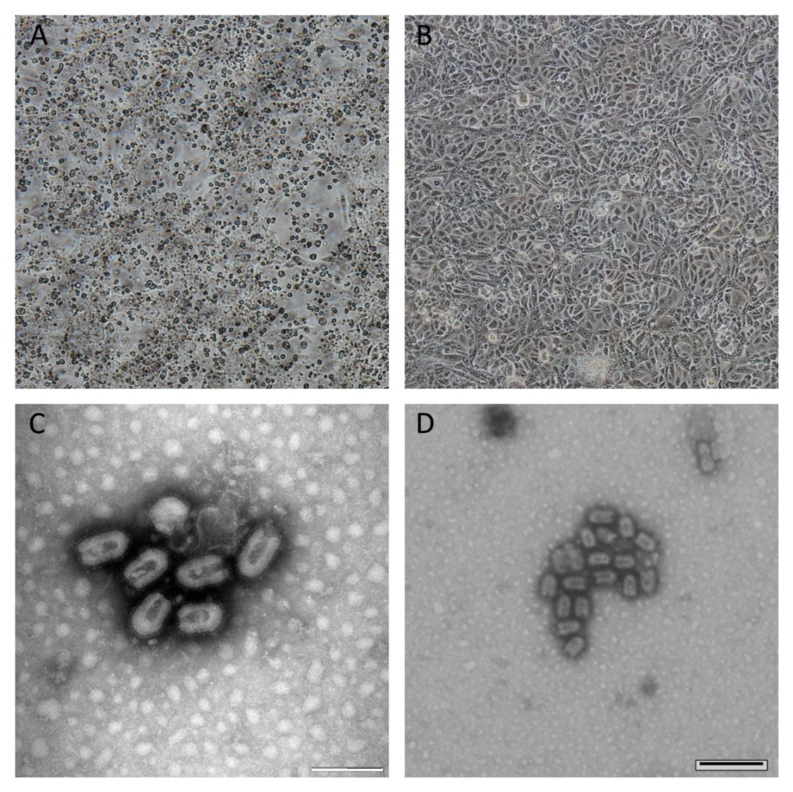

Figure 2. Genome organization of VAPV. Letters indicate the canonical rhabdovirus nucleoprotein (N), phosphoprotein (P), matrix protein (M), glycoprotein (G) and polymerase (L) ORFs and the ORF ecoded in the additional transcriptional unit (U1).
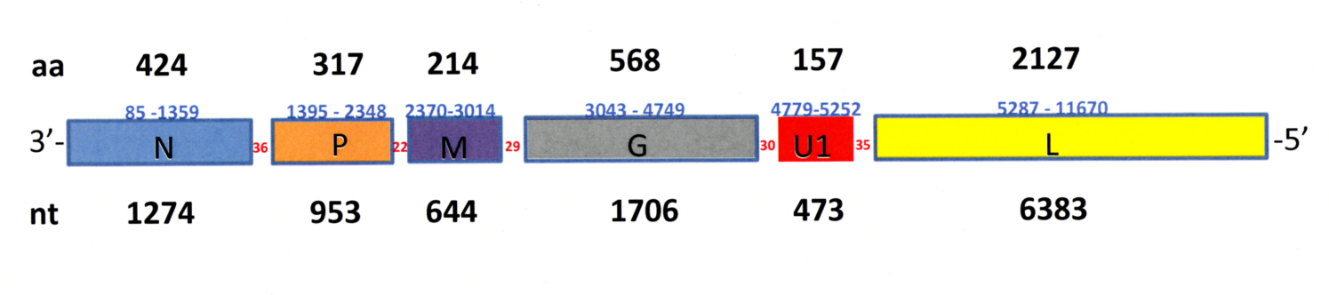

Figure 3. Phylogenetic tree based on the complete VAPV genome (11,774 nt) performed with all the 14 known viral species belonging to the genus Ledantevirus (family Rhaboviridae).
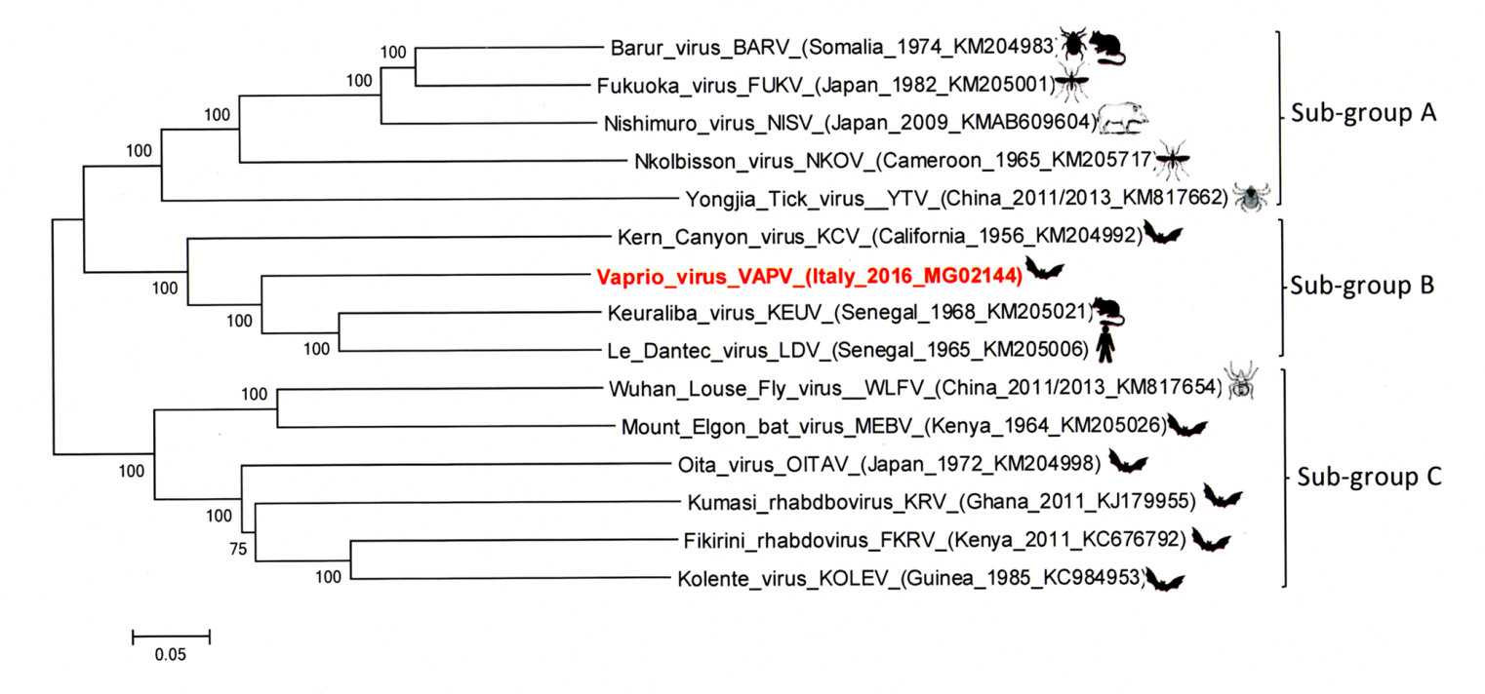
Legend figure 3: The tree was performed using the maximum likelihood method, which is namely the GTR-G model within the IQ-tree software with a bootstrap of 1000 replicates. The VAPV strain is reported in red. Scale bar indicate nucleotide substitutions per site.

References:
- Lelli D, Prosperi A, Moreno A, Chiapponi C, Gibellini AM, De Benedictis P, Leopardi S, Sozzi E, Lavazza A. 2018. Isolation of a novel rhabdovirus from an insectivorous bat (Pipistrellus kuhlii) in Italy. Virol J, 15(1):37.
- Walker PJ, Blasdell KR, Vasilakis N, Tesh RB, Calisher CH et al. One new genus (Ledantevirus) including 14 new species in the family Rhabdoviridae. International Committee on Taxonomy of Viruses (ICTV) TaxoProp 2016.006a-dM. Available online: https://talk.ictvonline.org/ICTV/proposals/2016.006a-dM.A.v2.Ledantevirus.pdf. [accessed on 25 September 2017].
- Blasdell KR, Guzman H, Widen SG, Firth C, Wood TG, Holmes EC, Tesh RB, Vasilakis N, Walker PJ. 2015. Ledantevirus: a proposed new genus in the Rhabdoviridae has a strong ecological association with bats. Am J Trop Med Hyg, 92:405-410.
- Amarasinghe GK, Aréchiga Ceballos NG, Banyard AC, Basler CF, Bavari S, Bennett AJ, Blasdell KR, Briese T, Bukreyev A, Caì Y, Calisher CH, Campos Lawson C, Chandran K, Chapman CA, Chiu CY, Choi KS, Collins PL, Dietzgen RG, Dolja VV, Dolnik O, Domier LL, Dürrwald R, Dye JM, Easton AJ, Ebihara H, Echevarría JE, Fooks AR, Formenty PBH, Fouchier RAM, Freuling CM, Ghedin E, Goldberg TL, Hewson R, Horie M, Hyndman TH, Jiāng D, Kityo R, Kobinger GP, Kondō H, Koonin EV, Krupovic M, Kurath G, Lamb RA, Lee B, Leroy EM, Maes P, Maisner A, Marston DA, Mor SK, Müller T, Mühlberger E, Ramírez VMN, Netesov SV, Ng TFF, Nowotny N, Palacios G, Patterson JL, Pawęska JT, Payne SL, Prieto K, Rima BK, Rota P, Rubbenstroth D, Schwemmle M, Siddell S, Smither SJ, Song Q, Song T, Stenglein MD, Stone DM, Takada A, Tesh RB, Thomazelli LM, Tomonaga K, Tordo N, Towner JS, Vasilakis N, Vázquez-Morón S, Verdugo C, Volchkov VE, Wahl V, Walker PJ, Wang D, Wang LF, Wellehan JFX, Wiley MR, Whitfield AE, Wolf YI, Yè G, Zhāng YZ, Kuhn JH. 2018. Taxonomy of the order Mononegavirales: update 2018. Arch Virol, 2018 Apr 11. doi: 10.1007/s00705-018-3814-x. [Epub ahead of print].

