This Word module should be used for all taxonomic proposals.
Please complete Part 1 and:
either Part 3 for proposals to create new taxa or change existing taxa
or Part 2 for proposals of a general nature.
Submit the completed Word module, together with the accompanying Excel module named in Part 3, to the appropriate ICTV Subcommittee Chair.
For guidance, see the notes written in blue, below, and the help notes in file Taxonomic_Proposals_Help_2018.

Part 1: TITLE, AUTHORS, etc

Code assigned: | 2018.013S |  | (to be completed by ICTV officers)
Short title: (e.g. “6 new species in the genus Zetavirus”)
Create a new family Matonaviridae to include the genus Rubivirus, removed from the family Togaviridae
Author(s):
Rubing Chen, Suchetana Mukhopadhyay, Andres Merits, Bethany Bolling, Farooq Nasar, Lark L. Coffey, Ann Powers, Scott C. Weaver, Donald Smith, Peter Simmonds and Stuart Siddell
Corresponding author with e-mail address:
Rubing Chen, rubing.chen@gmail.com
List the ICTV study group(s) that have seen this proposal:
A list of study groups and contacts is provided at http://www.ictvonline.org/subcommittees.asp . If in doubt, contact the appropriate subcommittee chair (there are six virus subcommittees: animal DNA and retroviruses, animal ssRNA-, animal ssRNA+, fungal and protist, plant, bacterial and archaeal) |  | Togaviridae SG
ICTV Study Group comments (if any) and response of the proposer:
Date first submitted to ICTV: |  |  | June 2018
Date of this revision (if different to above):

ICTV-EC comments and response of the proposer:
Members of the Matonaviridae have an RNA genome and use cognate RNA-dependent RNA polymerases (RdRps) for replication. Thus, they should be assigned to the realm Riboviria.

Part 2: NON-STANDARD
Template for any proposal regarding ICTV procedures, rules or policy, not involving the creation of new taxonomy.
Text of proposal:

Part 3: PROPOSED TAXONOMY

Name of accompanying Excel module: 2018.013S.N.v1.Matonaviridae
The taxonomic changes you are proposing should be presented on an accompanying Excel module, 2017_TP_Template_Excel_module. Please enter the file name of the completed module in this box.

Supporting material:
additional material in support of this proposal
Please explain the reasons for the taxonomic changes you are proposing and provide evidence to support them. The following information should be provided, where relevant:
- Species demarcation criteria: Explain how new species differ from others in the genus and demonstrate that these differences meet the criteria previously established for demarcating between species. If no criteria have previously been established, and if there will now be more than one species in the genus, please state the demarcation criteria you are proposing.
- Higher taxa:
  - There is no formal requirement to state demarcation criteria when proposing new genera or other higher taxa. However, a similar concept should apply in pursuit of a rational and consistent virus taxonomy.
  - Please indicate the origin of names assigned to new taxa at genus level and above.
  - For each new genus a type species must be designated to represent it. Please explain your choice.
- Supporting evidence: The use of Figures and Tables is strongly recommended (note that copying from publications will require permission from the copyright holder). For phylogenetic analysis, try to provide a tree where branch length is related to genetic distance.

The family Togaviridae currently includes two genera; Alphavirus and Rubivirus, the latter including the single species Rubella virus. The assignment of rubella virus to Togaviridae was made in 1975 (Fenner et al., 1974) when inclusion to the family was based on the following definition that corresponded to knowledge at that time:

‘Virions contain single-stranded RNA, 3 x 10⁶ to 4 x 10⁶ daltons, have isometric, probably icosahedral, nucleocapsids surrounded by a lipoprotein envelope containing host cell lipid and virus-specified polypeptides including one or more glycopeptides. Virions yield infectious RNA’.

However, in many other respects members of the two genera are quite distinct:

- Alphaviruses are typically transmitted between vertebrate hosts by arthropods (although viruses of sea mammals and fish have no known vector), or only infect arthropods. In contrast, rubella virus is confined to humans and is transmitted by inhalation of respiratory aerosols.

- Alphaviruses are spherical, about 70 nm in diameter. Particles contain a distinct icosahedral core and icosahedral glycoprotein layer (Li et al., 2010). In contrast, rubella virus particles are pleomorphic, often tube-like, and do not have icosahedral symmetry (and in retrospect do not follow the original criterion for inclusion in the Togaviridae from Fenner et al., 1974). Rubella virus capsid proteins form homodimers in a grid-like pattern and the glycoproteins are arranged in rows on the virion surface (Mangala Prasad et al., 2017).

- Rubella virus amino acid sequences are most closely related to those of viruses outwith the family Togaviridae. For example, rubella virus is most closely related to beet necrotic yellow vein virus (Benyviridae) and hepatitis E virus (Hepeviridae) on the basis of amino acid homology in the helicase and replicase regions of the nonstructural proteins (Koonin, & Dolja. 1993, Weaver et al., 1993). A tBLASTx search of Genbank using the rubella genome sequence gives the closest matches as unclassified viruses in the families Hepeviridae and Astroviridae.

- Phylogenetic analysis of the RNA-dependent RNA polymerase of alphaviruses, rubella virus and other positive-sense RNA viruses shows the two genera within the Togaviridae are not monophyletic (Figure 1) (Shi et al., 2018). In particular, rubella virus groups more closely with members of the families Benyviridae, Hepeviridae and Alphatetraviridae, along with several unclassified viruses, than it does with members of the family Togaviridae belonging to the genus Alphavirus.

- An alignment-independent method of ascertaining relationships amongst complete genome sequences of viruses (GRAViTy) supports the conclusion that the family Togaviridae is not monophyletic (Figure 2; Aiewsakun & Simmonds 2018).

- Analysis of the subgenomic promoter region of rubella virus revealed that it did not conform to the consensus sequence for alphaviruses for this region, while there were parallels with the presumed subgenomic promoter region of hepatitis E virus (Tzeng & Frey 2002).

- The only specific similarity between alphaviruses and rubella virus is the previously described 122 aa region in nsP3 where sequences show 30% overall identity (Dominguez et al., 1990). Other alpha-like viruses lack this region of similarity. However, the order of the helicase and nsP3 domains is reversed between alphaviruses and rubella virus, thus more likely represent one or more episodes of recombination between progenitors of alphaviruses, rubella virus and potentially other alpha-like viruses. As discussed by the authors, this area of homology may represent an example of chimaerism rather than being directly indicative of a shared evolutionary origin of the two togavirus genera.

For these reasons, we propose that the genus Rubivirus be moved from the Togaviridae to a new family, Matonaviridae, named after George de Maton who in 1814 first distinguished rubella from measles and scarlet fever.

Figure legends

Figure 1. Phylogenetic analysis of RNA dependent RNA polymerase amino acid sequences from alpha-like viruses, including members of the family Togaviridae. The phylogenetic tree was produced by maximum likelihood using the optimal model (LG + gamma + invariant sites) using MEGA7 (Figure courtesy of Peter Simmonds). Robustness of branching was estimated by bootstrap re-sampling of sequences (100 replicates); values of ≥ 70% shown.

Figure 2. GRAViTy analysis of alpha-like viruses. The dendrogram was constructed from composite generalised Jaccard distances based on similarities to protein motifs in viral coding sequences (Aiewsakun & Simmonds 2018). Robustness of branching was estimated by bootstrap re-sampling of protein profile data (100 replicates) using a modified resampling method (Lemoine et al., 2018); values of ≥ 70% shown.

FIGURE 1

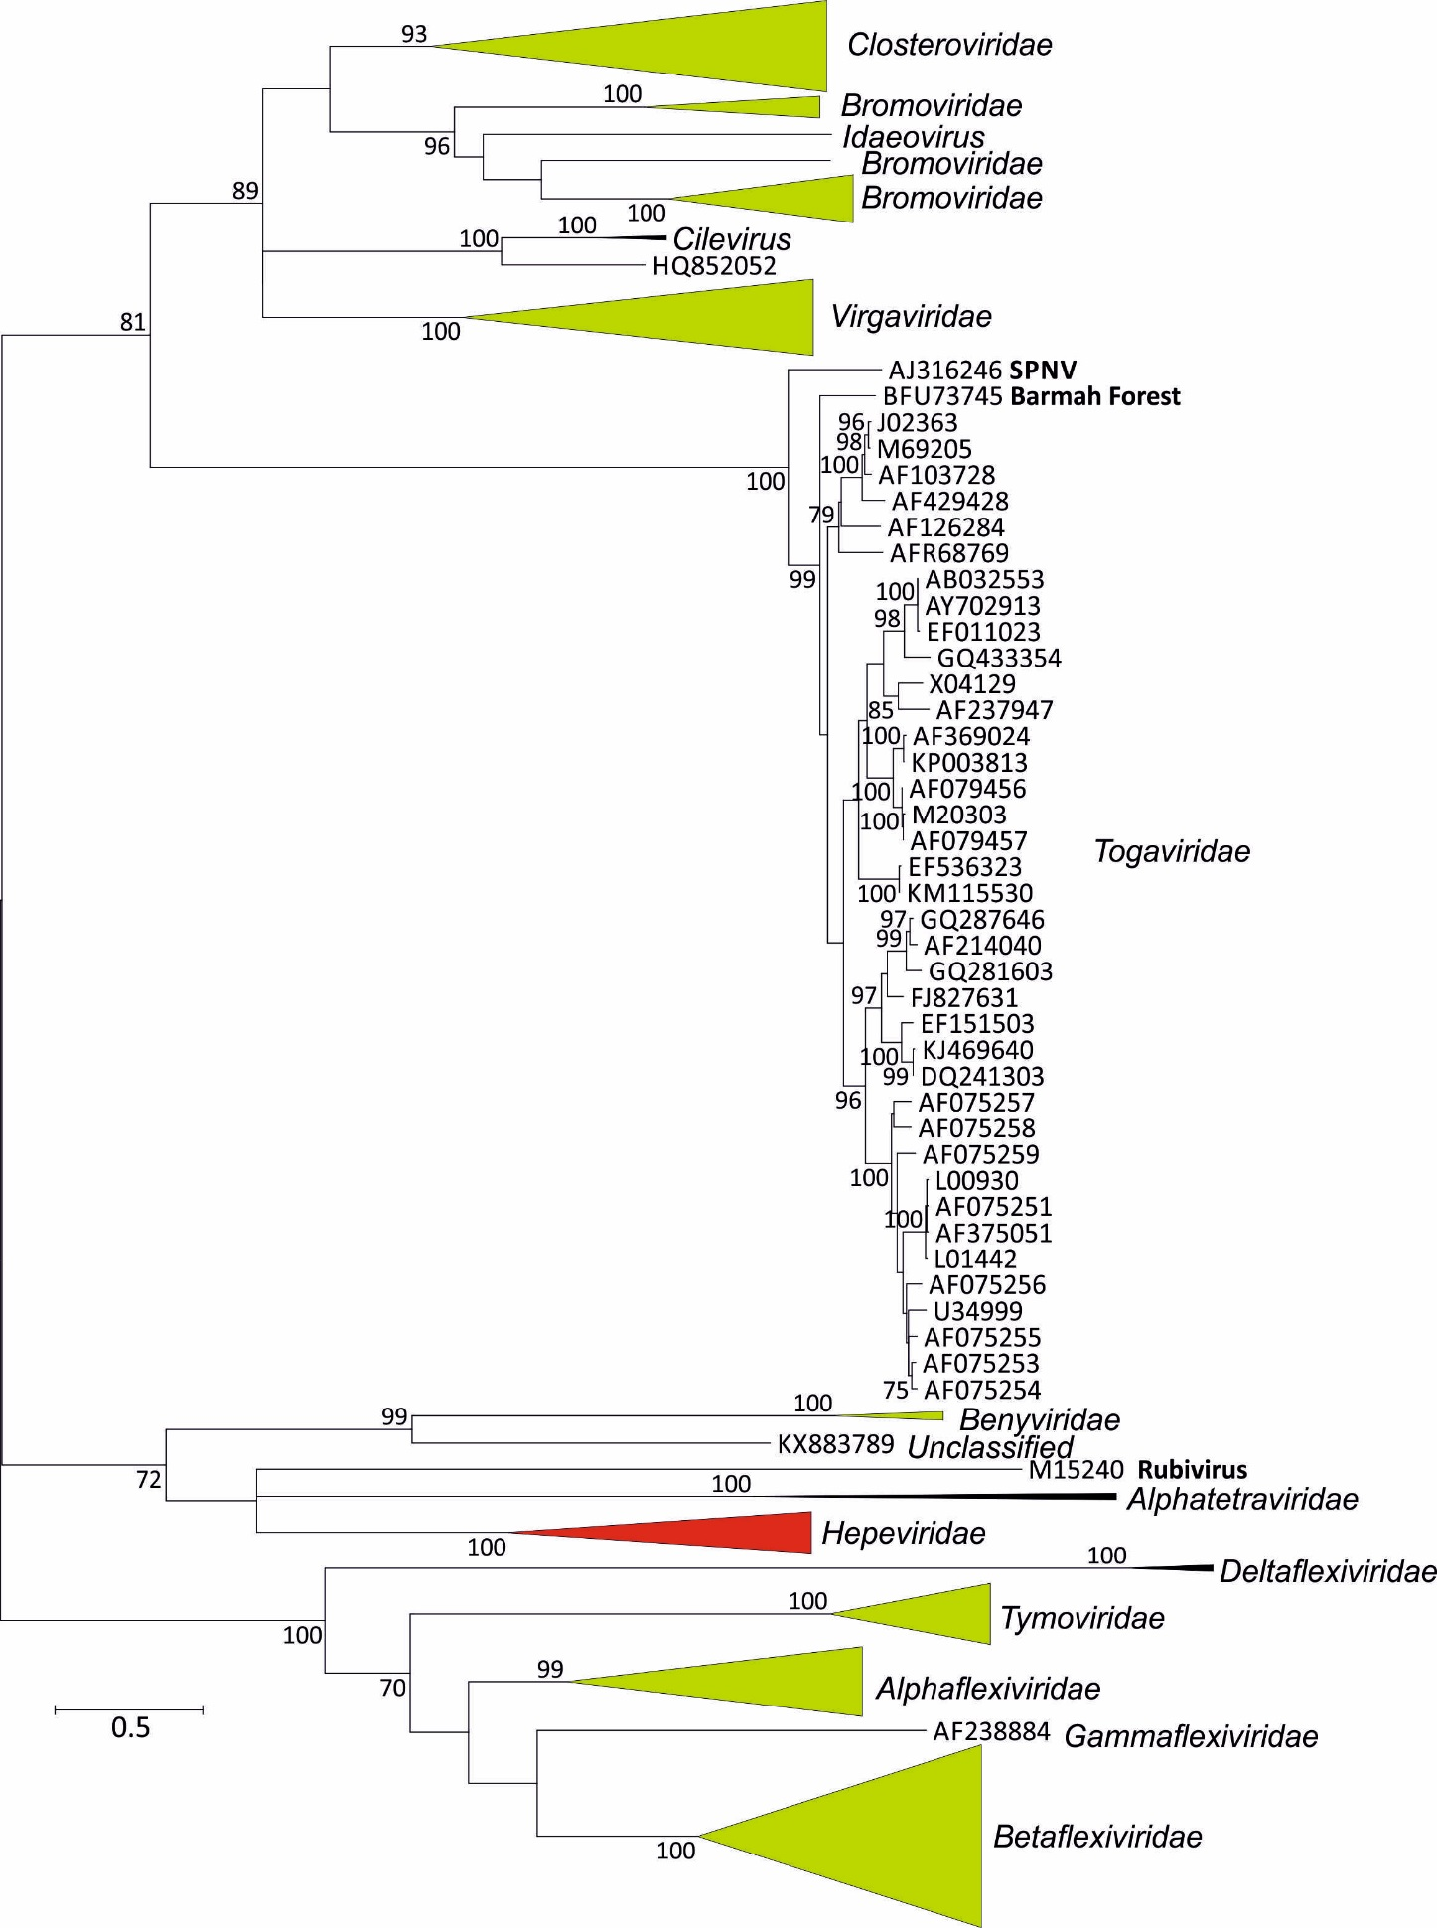

FIGURE 2

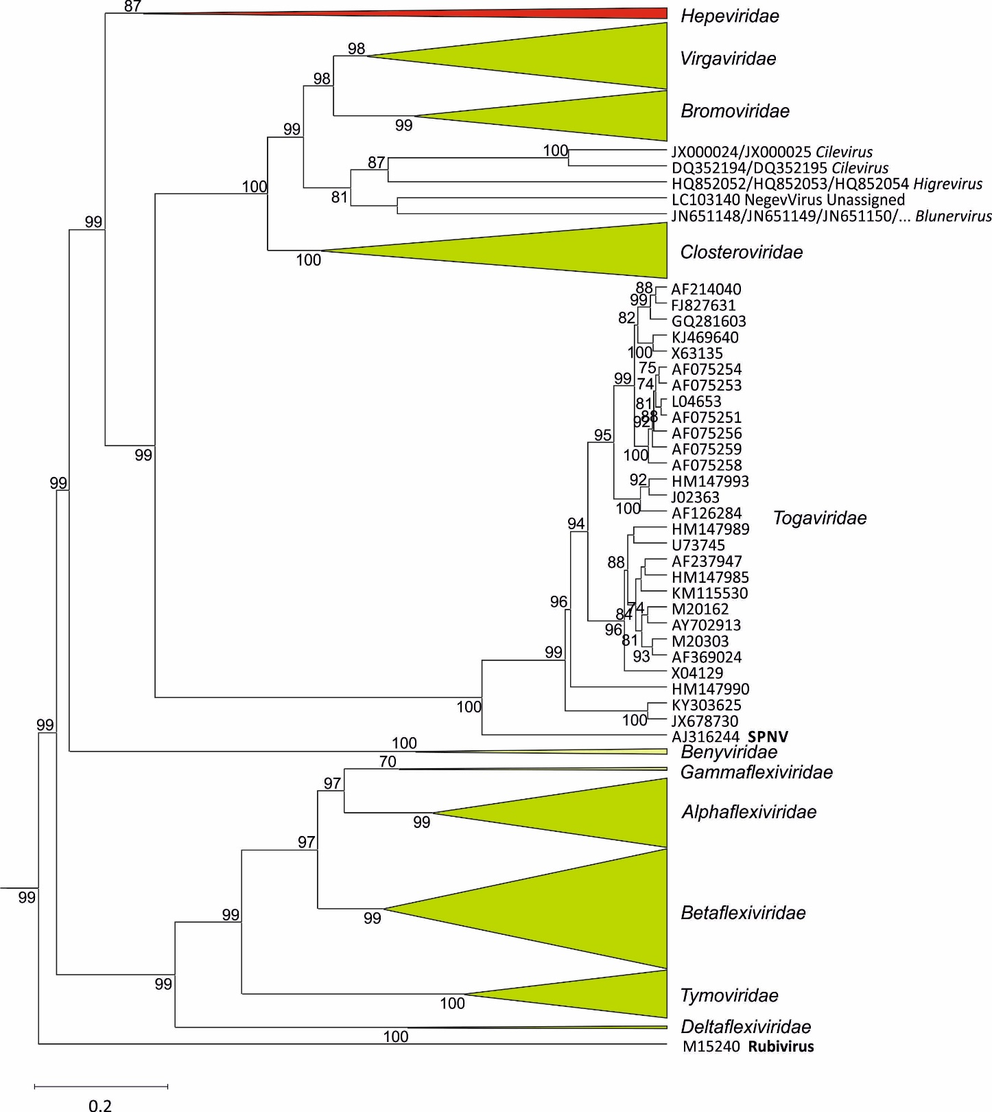

References:
Aiewsakun, P., & Simmonds, P. (2018). The genomic underpinnings of eukaryotic virus taxonomy: creating a sequence-based framework for family-level virus classification. Microbiome, 6(1), 38.

Dominguez, G., Wang, C. Y., & Frey, T. K. (1990). Sequence of the genome RNA of rubella virus: evidence for genetic rearrangement during togavirus evolution. Virology, 177(1), 225-238.

Fenner, F., Pereira, H. G., Porterfield, J. S., Joklik, W. K., & Downie, A. W. (1974). Family and generic names for viruses approved by the International Committee on Taxonomy of Viruses, June 1974. Intervirology, 3(3), 193-198.

Koonin, E. V., and V. V. Dolja. 1993. Evolution and taxonomy of positive-strand RNA viruses: implications of comparative analysis of amino acid sequences. Crit. Rev. Biochem. Mol. Biol. 28:375-430.

Lemoine F, Domelevo Entfellner JB, Wilkinson E, Correia D, Davila Felipe M, De Oliveira T, Gascuel O. 2018. Renewing Felsenstein's phylogenetic bootstrap in the era of big data. Nature 556: 452-456.

Li, L., Jose, J., Xiang, Y., Kuhn, R. J., & Rossmann, M. G. (2010). Structural changes of envelope proteins during alphavirus fusion. Nature, 468(7324), 705.

Prasad, V. M., Klose, T., & Rossmann, M. G. (2017). Assembly, maturation and three-dimensional helical structure of the teratogenic rubella virus. PLoS pathogens, 13(6), e1006377.

Shi, M., Lin, X. D., Chen, X., Tian, J. H., Chen, L. J., Li, K., ... & Holmes, E. C. (2018). The evolutionary history of vertebrate RNA viruses. Nature, 1. https://doi.org/10.1038/s41586-018-0012-7

Tzeng, W. P., & Frey, T. K. (2002). Mapping the rubella virus subgenomic promoter. Journal of virology, 76(7), 3189-3201.

Weaver, S. C., Hagenbaugh, A., Bellew, L. A., Netesov, S. V., Volchkov, V. E., Chang, G. J. J., ... & Holland, J. J. (1993). A comparison of the nucleotide sequences of eastern and western equine encephalomyelitis viruses with those of other alphaviruses and related RNA viruses. Virology, 197(1), 375-390.

