This Word module should be used for all taxonomic proposals.

Please complete **Part 1** and:

either **Part 3** for proposals to create new taxa or change existing taxa

or **Part 2** for proposals of a general nature.

Submit the completed Word module, together with the accompanying Excel module named in Part 3, to the appropriate ICTV Subcommittee Chair.

For guidance, see the notes written in blue, below, and the help notes in file Taxonomic_Proposals_Help_2018.

**Part 1:** **TITLE, AUTHORS, etc**

|  |  |  |  |
| --- | --- | --- | --- |
| **Code assigned:** | ***2018.014S*** | | (to be completed by ICTV officers) |
| **Short title:** (e.g. “6 new species in the genus *Zetavirus”*)  **6 new genera in family *Caliciviridae*** | | | |
|  | | | |
| **Author(s):** | | | |
| Jan Vinjé, Pedro Esteves, Mary Estes, Kim Green, Kazuhiko Katayama, Nick J. Knowles, Yan L’Homme, Vito Martella, Harry Vennema, Peter White. | | | |
| **Corresponding author with e-mail address:** | | | |
| Vinje Jan (jvinje@cdc.gov) | | | |
| **List the ICTV study group(s) that have seen this proposal:** | | | |
| https://talk.ictvonline.org/information/members-606089945/w/members/465/caliciviridae-study-group | | ***Caliciviridae* Study Group** | |
| **ICTV Study Group comments (if any) and response of the proposer:** | | | |
|  | | | |
|  | | | |
| Date first submitted to ICTV: | | | 16/06/2018 |
| Date of this revision (if different to above): | | | 07/01/2019 |

|  |
| --- |
| **ICTV-EC comments and response of the proposer:** |
|  |

**Part 2:** **NON-STANDARD**

Template for any proposal regarding ICTV procedures, rules or policy, not involving the creation of new taxonomy.

| **Text of proposal:** |
| --- |
|  |

**Part 3:** **PROPOSED TAXONOMY**

|  |
| --- |
| **Name of accompanying Excel module:** **2018.014S.A.v2.Caliciviridae_6gen** |

The taxonomic changes you are proposing should be presented on an accompanying Excel module, 2017_TP_Template_Excel_module. Please enter the file name of the completed module in this box.

**Supporting material:**

| additional material in support of this proposal |
| --- |
| Please explain the reasons for the taxonomic changes you are proposing and provide evidence to support them. The following information should be provided, where relevant:   * **Species demarcation criteria**: Explain how new species differ from others in the genus and demonstrate that these differences meet the criteria previously established for demarcating between species. If no criteriahave previously been established, and if there will now be more than one species in the genus, please state the demarcation criteria you are proposing. * **Higher taxa**:   + There is no formal requirement to state demarcation criteria when proposing new genera or other higher taxa. However, a similar concept should apply in pursuit of a rational and consistent virus taxonomy.   + Please indicate the **origin of names** assigned to new taxa at genus level and above.   + For each new genus a **type species** must be designated to represent it. Please explain your choice. * **Supporting evidence**: The use of Figures and Tables is strongly recommended (note that copying from publications will require permission from the copyright holder). For phylogenetic analysis, try to provide a tree where branch length is related to genetic distance. |

1. **Create 1 new species (*Bavaria virus*) in a new genus (*Bavovirus)***

A novel calicivirus named Bavaria virus has been detected in the Intestinal contents from five chickens from flocks in southern Germany (Bavaria).

**Relation to other caliciviruses (Table 1):**

The positive single-stranded RNA genome of the prototype strain Bavaria/04V0021 (HQ010042) is 7,908 nt long, excluding the poly-A tail. Similar to sapovirus, lagovirus and neboviruses, the genome is predicted to contain two coding ORFs (Fig. 1). ORF1 codes for a continuous polyprotein including the NS-proteins and capsid protein (VP1). The putative VP1 protein is predicted to be 578 amino acids long and to have a molecular weight of 59.9 kDa, which is similar to other caliciviruses. VP2 is 864 nucleotides long, and encodes a protein of 287 amino acids with a calculated molecular weight of 30.4 kDa, which is the largest among the caliciviruses. A Maximum Likelihood tree showing the relationships within the *Caliciviridae* is shown in Fig. 2.

**Distinguishing features of *Bavovirus* compared to the closest relatives:**

The genus *Bavovirus* is closest to established genus *Sapovirus*. The sequence divergence (uncorrected p-distances) of VP1 gene of *Bavovirus* with the closest relative, *Sapovirus*, is 0.792.

**Type species of the genus:**

*Bavaria virus*: Bavaria/04V0021 GenBank accession number: HQ010042

Other examples:

CaliciD62 GenBank accession number: KM254170

CaliciQ45 GenBank accession number: KM254171

**Origin of name:**

The first strain was found in the intestinal contents obtained from five chickens from flocks in southern Germany (Bavaria) and the virus was named as Bavaria virus (strain name: Bavaria/04V0021).

**Species demarcation criteria:**

not applicable

| **References:** |
| --- |
| Wolf, S., Reetz, J. and Otto, P. Genetic characterization of a novel calicivirus from chicken. Arch. Virol. 2011; 156: 1143-1150.  Wolf, S., Reetz, J., Hoffmann, K., Gründel, A., Schwarz, B.A., Hänel, I. and Otto, P.H. Discovery and genetic characterization of novel caliciviruses in German and Dutch poultry. Arch Virol. 2012; 157(8):1499-507. |

**2) Create 1 new species (*Minovirus A*) in a new genus (*Minovirus)***

During regulatory sampling of fathead minnows (*Pimephales promelas*), a novel calicivirus was isolated from homogenates of kidney and spleen of fathead minnows.

**Relation to other caliciviruses (Table 1):**

The genome of minovirus contains two ORFs (ORF1 and ORF2). ORF1 encodes a 2,114-aa long polyprotein (Fig. 1). Amino acid motifs and/or nucleotide sequence analysis of ORF1 indicate the presence of conserved calicivirus protein motifs corresponding to both non-structural proteins (NS) and the major capsid protein (VP1). The complete polyprotein shares only 21% identity with Atlantic salmon calicivirus, followed by 11% to 14% identity with mammalian caliciviruses. ORF2 encodes a 117-aa protein. A Maximum Likelihood tree showing the relationships within the *Caliciviridae* is shown in Fig. 2.

D**istinguishing features of *Minovirus* compared to the closest relatives:**

The genus *Minovirus* is closest to established genus *Norovirus*. The sequence divergence (uncorrected p-distances) of VP1 gene of *Bavovirus* with the closest relative Norovirus is 0.805.

**Type species of genus:**

*Minovirus A*: fathead minnow calicivirus. GenBank accession number: KX371097

**Origin of name:** Minovirus refers to the fish fathead minnows in which the virus was detected.

**Species demarcation criteria:**

not applicable

| **References:** |
| --- |
| Mor, S.K., Phelps, N.B.D., Ng, T.F.F., Subramaniam, K., Primus, A., Armien, A.G., McCann, R., Puzach, C., Waltzek, T.B. and Goyal, S.M. (2017). Genomic characterization of a novel calicivirus, FHMCV-2012, from baitfish in the USA. Arch. Virol. 2017 162(12):3619-3627. |

1. **Create 1 new species (*Nacovirus A*) in a new genus (*Nacovirus)***

Nacoviruses are novel avian caliciviruses were isolated from intestinal contents of five turkey, chicken and goose different geographic regions such as the United States, Germany, Netherlands and China.

**Relation to other caliciviruses (Table 1):**

The genome contains two main coding ORFs. ORF1 encodes a polypeptide of 2,304 aa with a calculated molecular weight of 250.6 kDa (Fig. 1). The putative VP1 protein is predicted to be 584 aa long and to have a molecular weight of 61.6 kDa. The 624-nt-long ORF2 encodes a polypeptide of 207 aa with a calculated molecular weight of 21.5 kDa. A Maximum Likelihood tree showing the relationships within the *Caliciviridae* is shown in Fig. 2.

D**istinguishing features of *Nacovirus* compared to the closest relatives:**

The genus *Nacovirus* is closest to established genus *Sapovirus*. The sequence divergence (uncorrected p-distances) of VP1 gene of *Nacovirus* with the closest relative *Sapovirus* is 0.768.

**Type species of genus:**

*Nacovirus A*: Turkey calicivirus L11043. GenBank accession number: JQ347522

Other examples:

Chicken calicivirus F10026n. GenBank accession number: JQ347523

Goose calicivirus N: GenBank accession number: KJ473715

**Origin of name:**

Nacovirus refers to **n**ovel **a**vian **c**alicivirus.

**Species demarcation criteria:**

not applicable

| **References:** |
| --- |
| Day, J.M., Ballard, L.L., Duke, M.V., Schefflerm B.E. and Zsak, L. (2010). Metagenomic analysis of the turkey gut RNA virus community. Virology Journal 7: 313.  Liao, Q., Wang, X., Wang, D. and Zhang, D. (2014). Complete genome sequence of a novel calicivirus from a goose. Arch Virol. 2014 159(9):2529-31.  Wolf, S., Reetz, J., Hoffmann, K., Gründel, A., Schwarz, B.A., Hänel, I. and Otto, P.H. (2012). Discovery and genetic characterization of novel caliciviruses in German and Dutch poultry. Arch Virol. 2012 157(8):1499-507 |

|  |
| --- |

**4) Create 1 new species (*Recovirus A*) in a new genus (*Recovirus)***

A novel calicivirus named Tulane virus has been detected in stool samples of captive juvenile rhesus macaques housed housed in the nursery of the Tulane National Primate Research Center.

**Relation to other caliciviruses (Table 1):**

The complete genome of recoviruses is organized into three ORFs that encode the nonstructural (NS) polyprotein (ORF1); ORF2 encodes for a capsid protein (VP1) with an estimated molecular mass of 57.9 kDa and ORF3 encodes for a minor structural protein (VP2) with a calculated molecular mass of 22.8 kDa (Fig. 1). A Maximum Likelihood tree showing the relationships within the *Caliciviridae* is shown in Fig. 2.

**Distinguishing features of *Recovirus* compared to the closest relatives:**

The genus *Recovirus* is closest to established genus *Norovirus*. The sequence divergence (uncorrected p-distances) of VP1 gene of Recovirus with the closest relative Norovirus is 0.731.

**Type species of genus:**

*Recovirus A*: GenBank accession number: EU391643

Other examples:

Tulane virus-FT205. GenBank accession number: KC662363

WUHARV Calicivirus 1. GenBank accession number: JX627575

Bangladesh289. GenBank accession number: JQ745645

**Origin of name:**

Recovirus is derived from **r**hesus **e**nteric **c**alicivirus

**Species demarcation criteria:**

not applicable

| **References:** |
| --- |
| Farkas, T., Sestak, K., Wei, C. and Jiang, X. (2008). Characterization of a rhesus monkey calicivirus representing a new genus of Caliciviridae. J. Virol. 82: 5408-5416.  Handley SA, Thackray LB, Zhao G, Presti R, Miller AD, Droit L, Abbink P, Maxfield LF, Kambal A, Duan E, Stanley K, Kramer J, Macri SC, Permar SR, Schmitz JE, Mansfield K, Brenchley JM, Veazey RS, Stappenbeck TS, Wang D, Barouch DH, Virgin HW. (2012)Pathogenic simian immunodeficiency virus infection is associated with expansion of the enteric virome. Cell. 2;151(2):253-66.    Smits, S.L., Rahman, M., Schapendonk, C.M., van Leeuwen, M., Faruque, A.S., Haagmans, B.L., Endtz, H.P. and Osterhaus, A.D. (2011). Calicivirus from novel Recovirus genogroup in human diarrhea, Bangladesh. Emerging Infect. Dis. 18: 1192-1195. |

**5) Create 1 new species (*Nordland virus*) in a new genus (*Salovirus)***

A novel calicivirus was detected in heart tissue was sampled from Atlantic salmon in two farms experiencing heart and skeletal muscle inflammation

**Relation to other caliciviruses (Table 1):**

Similar to sapovirus, lagovirus and nebovirus, the genome of salovirus is predicted to contain two ORFs. ORF1 is initiated encode 2361 aa with a predicted molecular mass of 256.5 kDa (Fig. 1). ORF2 encodes VP2 encode a 125 aa protein with a predicted molecular mass is 13.1 kDa. ORF2 overlaps the stop codon of ORF1 by 178 nt with a -1 frameshift. A Maximum Likelihood tree showing the relationships within the *Caliciviridae* is shown in Fig. 2.

**Distinguishing features of *Salovirus* compared to the closest relatives:**

The genus *Salovirus* is closest to established genus *Norovirus*. The sequence divergence (uncorrected p-distances) of VP1 gene of *Salovirus* with the closest relative *Norovirus* is 0.784.

**Type species of genus:**

*Nordland virus*: GenBank accession number: KJ577139

**Origin of name:**

Salovirus refers to Atlantic **sal**mon.

**Species demarcation criteria:**

not applicable

| **References:** |
| --- |
| Mikalsen, A.B., Nilsen, P., Frøystad-Saugen, M., Lindmo, K., Eliassen, T.M., Rode, M. and Evensen, O. (2014). Characterization of a novel calicivirus causing systemic infection in atlantic salmon (Salmo salar L.): proposal for a new genus of Caliciviridae. PLoS One. 9(9): e107132 |

**6) Create 1 new species (*Saint Valerien virus*) in a new genus (*Valovirus)***

A novel calicivirus has been detected in stool samples from pigs in a slaughterhouse in St. Valérien in Quebec, Canada

**Relation to other caliciviruses (Table 1):**

The complete genome of Valovirus reveals one large open reading frame (ORF) (ORF1; 7086 and 7074 nt, respectively) and one small ORF overlapping the 3′ end of ORF1 (ORF2; 378 and 375 nt, respectively) (Fig. 1). ORF1 encodes 2361 aa protein with a predicted molecular mass of 256,5 kDa. ORF2 encodes 125 aa protein, which is in the lower range of the significant variation in length of calicivirus VP2. The predicted molecular mass is 13,1 kDa. A Maximum Likelihood tree showing the relationships within the *Caliciviridae* is shown in Fig. 2.

**Distinguishing features of *Valovirus* compared to the closest relatives:**

The genus *Valovirus* is closest to established genus *Norovirus*. The sequence divergence (uncorrected p-distances) of VP1 gene of *Valovirus* with the closest relative *Norovirus* is 0.714.

**Type species of genus:**

*Saint Valerien virus:* St. Valérien virus AB90. GenBank accession number: FJ355928

Other examples:

St. Valérien virus AB104. GenBank accession number: FJ355930

St. Valérien virus F1510. GenBank accession number: FJ355929

**Origin of name:**

**Valovirus** refers to the slaughterhouse named St **Val**érien in Quebec, Canada

**Species demarcation criteria:**

not applicable

| **References:** |
| --- |
| L'Homme, Y., Sansregret, R., Plante-Fortier, E., Lamontagne, A.M., Ouardani, M., Lacroix, G. and Simard, C. (2009). Genomic characterization of swine caliciviruses representing a new genus of Caliciviridae. Virus Genes 39: 66-75. |

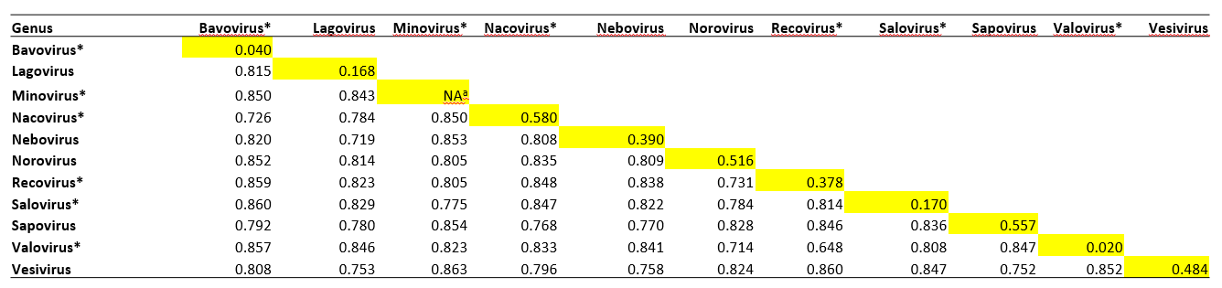

**Table 1.** VP1 gene (amino acid sequence analyisis): Estimates of Mean Evolutionary Divergence in between and within (yellow highlight) established and new calicivirus genera.

* New genus added to *Caliciviridae* family

a Only one strain reported till date

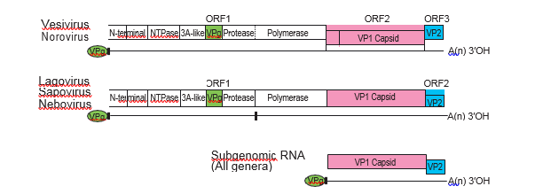

*Bavovirus*

*Minovirus*

*Nacovirus*

*Salovirus*

**Existing:**

**Proposed:**

*Recovirus*

*Valovirus*

**Recovirus**

**Valovirus**

**Fig. 1: Reading frame and gene order in the family *Caliciviridae*.**

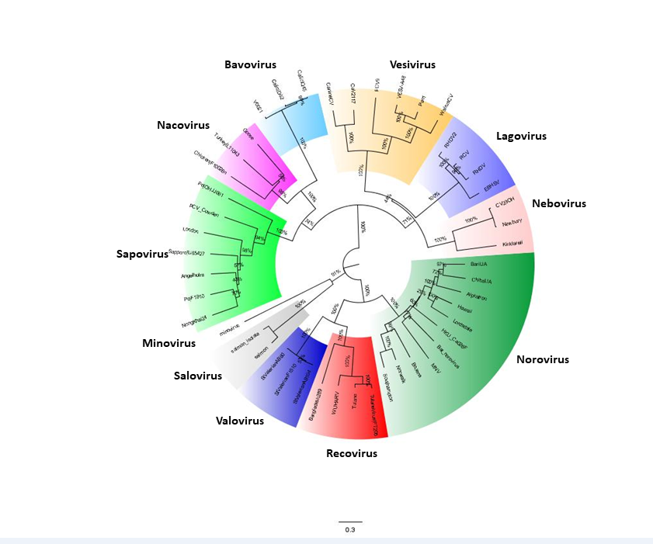**Fig. 2:** Forty seven calicivirus full genome sequences of the *Norovirus*/*Sapovirus*/*Lagovirus*/*Vesivirus*/*Nebovirus*/*Bavovirus*/*Minovirus*/*Nacovirus*/*Recovirus*/*Salovirus*/*Valovirus* genera were retrieved from GenBank and phylogenetic analysis was carried pairwise distance matrices and PhyML. The respective genera distribution was observed in different tree inference methods (NJ, ML).  Final trees were computed using maximum likelihood (ML) with PhyML. The resulting trees were plotted and edited in FigTree (<http://tree.bio.ed.ac.uk/software/figtree/>). The strains in the tree are represented by their common strain names.