This form should be used for all taxonomic proposals. Please complete all those modules that are applicable.
For guidance, see the notes written in blue and the separate document “Help with completing a taxonomic proposal”

Please try to keep related proposals within a single document.

Part 1: TITLE, AUTHORS, etc

Code assigned: | 2017.001S |  |  |  | (to be completed by ICTV officers)
Short title: One new subfamily, genus and species in the family Arteriviridae (Nidovirales)
Modules attached  (Modules 1, 4 and either 2 or 3 are required. |  | 1 2 3 4
Author(s):
Bert Vanmechelen
Valentijn Vergote
Lies Laenen
Jens Kuhn
Piet Maes
Corresponding author with e-mail address:
Piet Maes, piet.maes@kuleuven.be
List the ICTV study group(s) that have seen this proposal:
A list of study groups and contacts is provided at http://www.ictvonline.org/subcommittees.asp . If in doubt, contact the appropriate subcommittee chair (there are six virus subcommittees: animal DNA and retroviruses, animal ssRNA-, animal ssRNA+, fungal and protist, plant, bacterial and archaeal) |  |  | Arteriviridae SG & Nidovirales SG
ICTV Study Group comments (if any) and response of the proposer:
Date first submitted to ICTV: |  |  |  | 8 June 2017
Date of this revision (if different to above): |  |  |  | 22 August 2018

ICTV-EC comments and response of the proposer:
EC49 decision:
Uc/Ud? Consider with 2017.012-015S.

Part 2: PROPOSED TAXONOMY

Name of accompanying spreadsheet: “2017.001S.A.v4.Crocarterivirinae.xlsx”
Please display the taxonomic changes you are proposing on the accompanying spreadsheet module 2017_TP_Template_Excel_module. Submit both this and the spreadsheet to the appropriate ICTV Subcommittee Chair.

Olivier's shrew virus 1 (OSV-1) was discovered by Illumina next-generation sequencing in Olivier’s shrews (Crocidura olivieri guineensis) in Guéckédou, Guinea (3 out of 4 positive) in 2016. The complete genome was verified by Sanger sequencing. Currently, the taxonomy of the family Arteriviridae includes 5 genera with a total of 17 species. Based on previous ICTV Arteriviridae Study Group decisions, the PAirwise Sequence Comparison (PASC) tool (https://www.ncbi.nlm.nih.gov/sutils/pasc/viridty.cgi?textpage=overview) was used for the assessment of OSV-1 as novel arterivirus species.

The closest PASC hit for the complete OSV-1 genome is porcine reproductive and respiratory syndrome virus (Porcine reproductive and respiratory syndrome virus 1, NCBI GenBank KX249752) with 34.01% pairwise identity (i.e. less than 39-41%), thereby justifying the creation of a novel genus and species (Figure 1). Furthermore, DEmARC analysis (new version, unpublished) showed that OSV-1 represents a new species (“Muarterivirus afrigant”) in a new subfamily (“Crocarterivirinae”) and new genus (“Muarterivirus”) in line with the classification guidelines recently proposed by the Arteriviridae Study Group (Prof. Gorbalenya, personal communication).

Proposed classification
Family | Arteriviridae
Subfamily | Crocarterivirinae
Genus | Muarterivirus
Species | Muarterivirus afrigant
Virus | Olivier's shrew virus 1  Olivier's shrew virus 2  Olivier's shrew virus 3

Part 4: APPENDIX: supporting material
additional material in support of this proposal
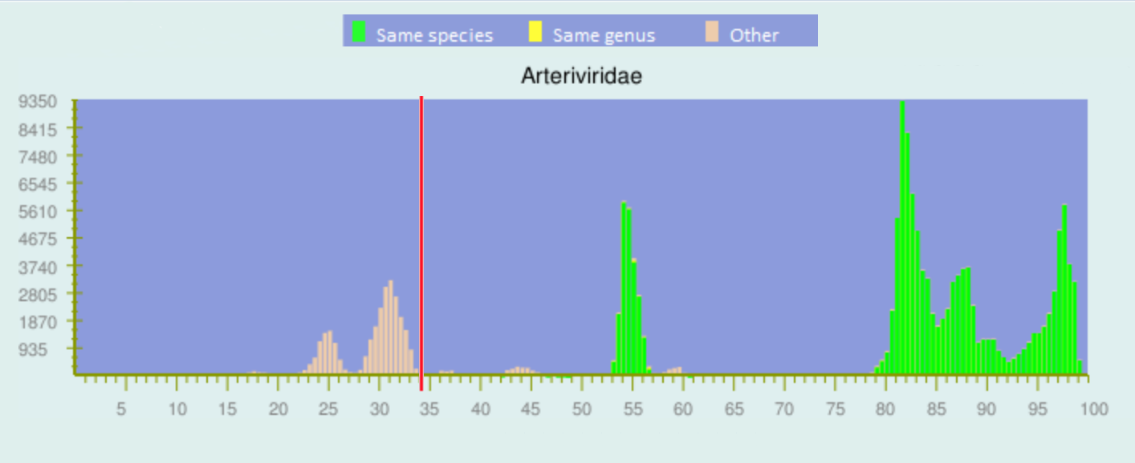
Figure 1: Family Arteriviridae PASC analysis. Top match for OSV-1 is 34.01% (pairwise similarity) with PRRSV-1 suggesting the need for a new genus (“Muarterivirus”) and species (“Muarterivirus afrigant”)

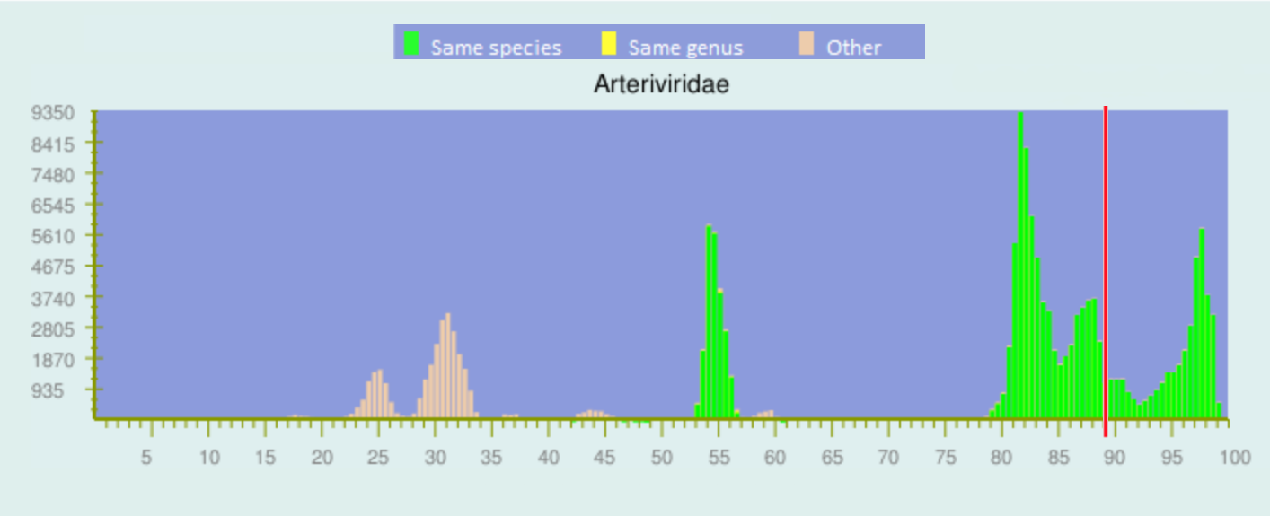
Figure 2: Family Arteriviridae PASC analysis with the 3 complete genome OSV-1 sequences available [MF324848 (NC_035127), MF324849 and MG264317]. Pairwise similarity between sequences is 86.49% indicating the three sequences belong to the same species.
To further confirm the taxonomic position of OSV-1, Bayesian phylogenetic analyses were inferred in BEAST2 employing MCMC with a chain length of 100,000,000 generations using full-length arenavirus genomes). The Markov chain Monte Carlo analysis was run until effective sample sizes above 200 were obtained. A consensus tree was built with TreeAnnotator 2.5.4 using the maximum clade credibility method and visualized in FigTree v1.4.0 (Figure 3).

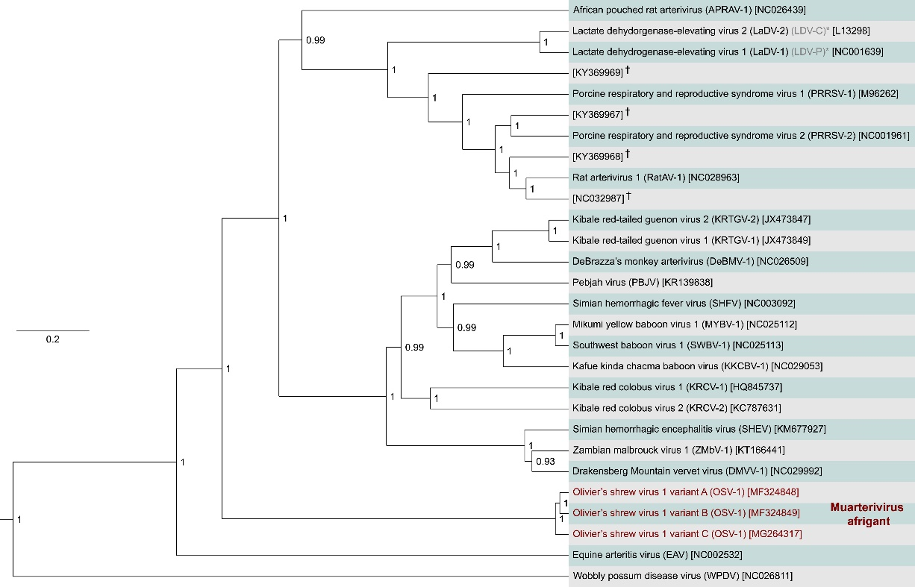
Figure 3: Maximum clade credibility summary tree representations estimated from full length genome sequences of arterivirus species. The MCC analysis confirms the findings of PASC to establish a new genus and species for OSV-1. Numbers next to selected nodes indicate the posterior support, which can be interpreted as the probability of the clade being true given the data, the model and the parameter priors. The tree is drawn to scale, with branch lengths expressed in the number of substitutions per site.

