This Word module should be used for all taxonomic proposals.
Please complete Part 1 and:
either Part 3 for proposals to create new taxa or change existing taxa
or Part 2 for proposals of a general nature.
Submit the completed Word module, together with the accompanying Excel module named in Part 3, to the appropriate ICTV Subcommittee Chair.
For guidance, see the notes written in blue, below, and the help notes in file Taxonomic_Proposals_Help_2018.
Part 1: TITLE, AUTHORS, etc

Code assigned: | 2018.005D |  | (to be completed by ICTV officers)
Short title: 1 new species in the genus Cyclovirus
Author(s):
Enikő Fehér, Eszter Kaszab, György Lengyel, Krisztián Bányai
Corresponding author with e-mail address:
Enikő Fehér, feher.eniko@agrar.mta.hu
List the ICTV study group(s) that have seen this proposal:
A list of study groups and contacts is provided at http://www.ictvonline.org/subcommittees.asp . If in doubt, contact the appropriate subcommittee chair (there are six virus subcommittees: animal DNA and retroviruses, animal ssRNA-, animal ssRNA+, fungal and protist, plant, bacterial and archaeal) |  | Circoviridae Study Group
ICTV Study Group comments (if any) and response of the proposer:
Date first submitted to ICTV: |  |  | 17 May 2018
Date of this revision (if different to above): |  |  | 12 June 2018

ICTV-EC comments and response of the proposer:

Part 3: PROPOSED TAXONOMY

Name of accompanying Excel module: 2018.005D.N.v1.Cyclovirus_sp
The taxonomic changes you are proposing should be presented on an accompanying Excel module, 2017_TP_Template_Excel_module. Please enter the file name of the completed module in this box.
Supporting material:
additional material in support of this proposal
Please explain the reasons for the taxonomic changes you are proposing and provide evidence to support them. The following information should be provided, where relevant:
- Species demarcation criteria: Explain how new species differ from others in the genus and demonstrate that these differences meet the criteria previously established for demarcating between species. If no criteria have previously been established, and if there will now be more than one species in the genus, please state the demarcation criteria you are proposing.
- Higher taxa:
  - There is no formal requirement to state demarcation criteria when proposing new genera or other higher taxa. However, a similar concept should apply in pursuit of a rational and consistent virus taxonomy.
  - Please indicate the origin of names assigned to new taxa at genus level and above.
  - For each new genus a type species must be designated to represent it. Please explain your choice.
- Supporting evidence: The use of Figures and Tables is strongly recommended (note that copying from publications will require permission from the copyright holder). For phylogenetic analysis, try to provide a tree where branch length is related to genetic distance.

Recently, the classification of the family Circoviridae has been updated. The genus Cyclovirus has been established, while the genus Gyrovirus has been removed from the family. The species demarcation threshold has been changed and ˂80% genome-wide pairwise identity represents novel species in both genera Circovirus and Cyclovirus. In addition the names of the species have been standardized (Rosario et al., 2017).

Here we propose a novel species, Duck associated cyclovirus 1 (DuACyV-1, GenBank Accession number KY851116) in the genus Cyclovirus (Fehér et al., 2017). The genome was amplified and directly sequenced from cloacal swab specimen of Anas platyrhynchos and showed the typical structure of cycloviruses (Fehér et al., 2017). Classification of the novel species was supported by genome-wide pairwise identity (Fig. 1; SDT v1.2, Muhire et al., 2014) and phylogenetic analysis (Fig. 2; PhyML, Guindon et al., 2010), furthermore by the unique host (first detection of cyclovirus in Anseriformes).

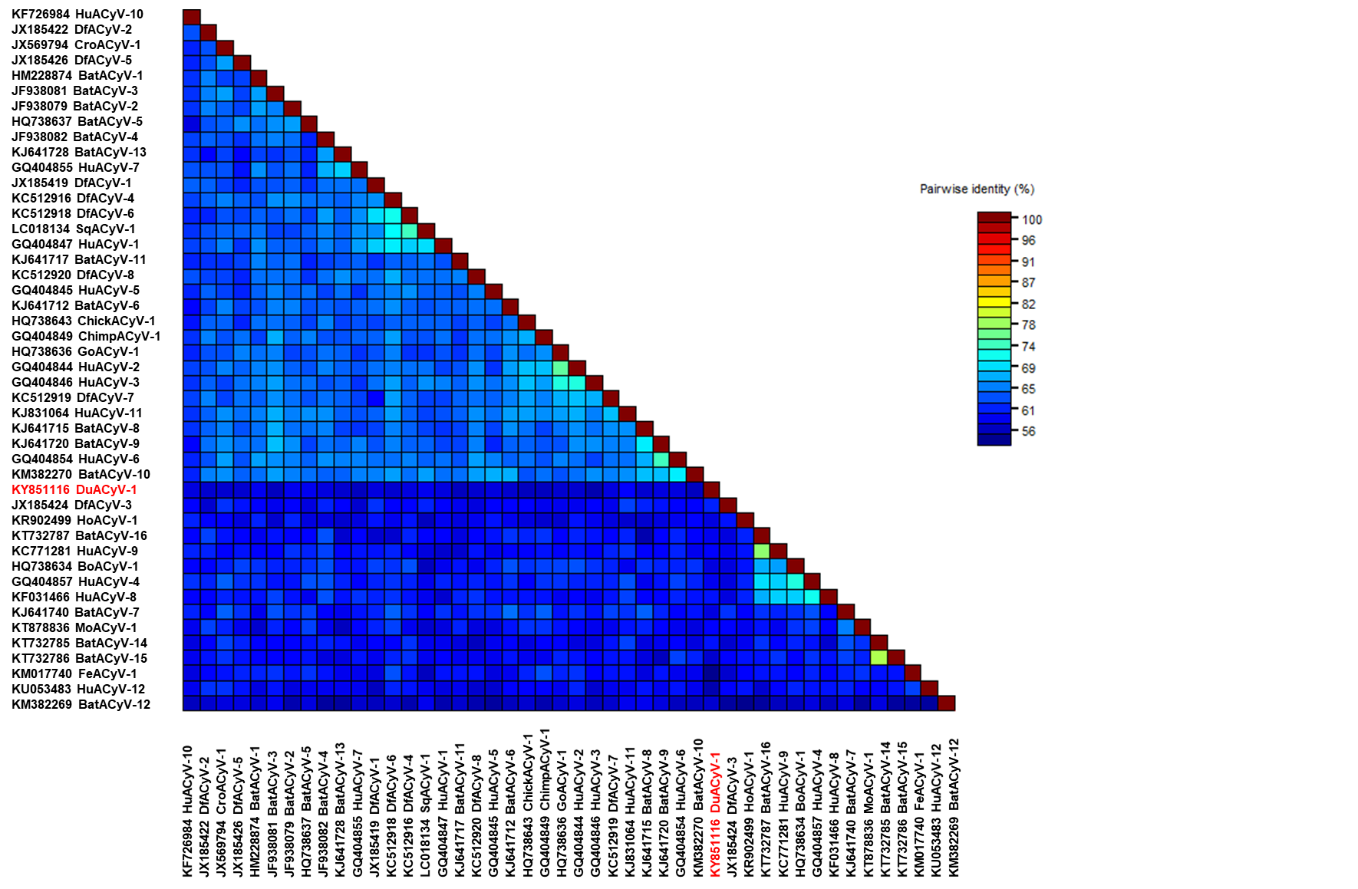

Fig. 1. Genome-wide pairwise identities among cycloviruses generated using SDT v1.2 (Muhire et al., 2014). The highlighted novel species showed ˂80% genome-wide pairwise identity (55.6-59.4%) with the reference species, labelled by acronyms as described by Rosario et al. (2017).

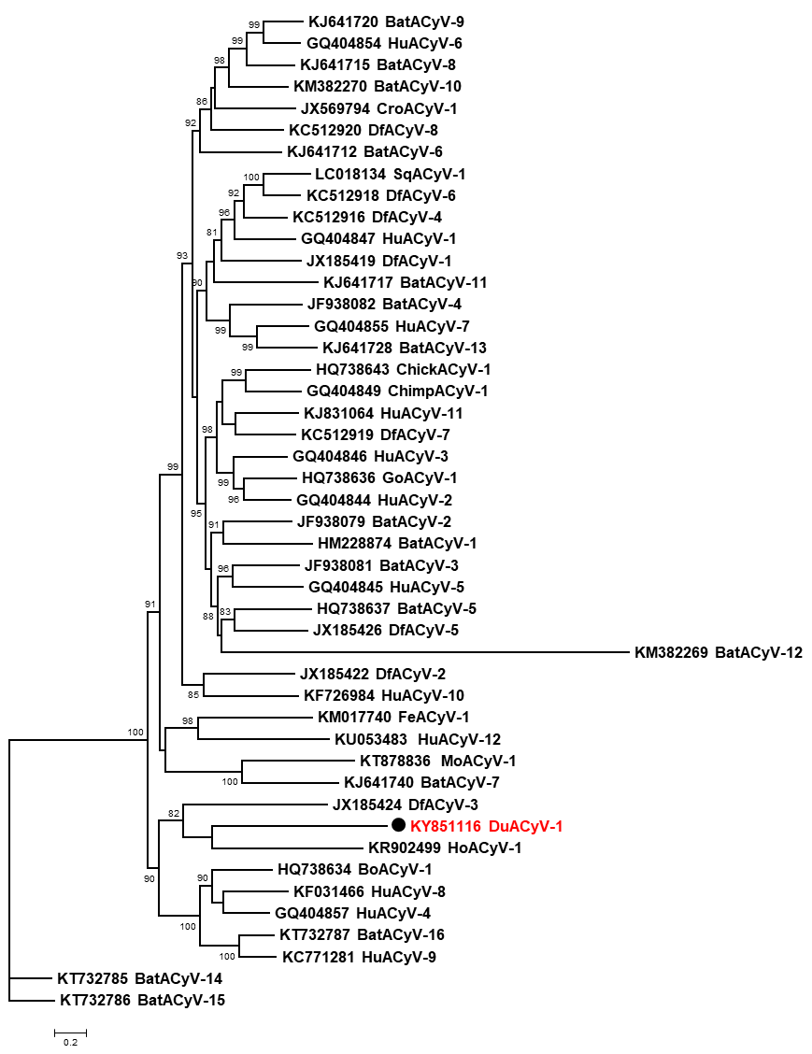

Fig. 2. Maximum likelihood phylogenetic tree of representative cyclovirus strains. The tree was generated from complete genome sequences using PhyML with TN93+G+I model (Guindon et al., 2010). SH-like branch support values ˂80% were hidden. The scale bar shows nucleotide substitutions per site. The novel species was highlighted; reference species were labelled by acronyms according to the report of Rosario et al. (2017).

References:
Fehér E, Kaszab E, Forró B, Bali K, Marton S, Lengyel G, Bányai K. Genome sequence of a mallard duck origin cyclovirus, DuACyV-1. Arch Virol. 2017;162(12):3925-3929.

Guindon S, Dufayard JF, Lefort V, Anisimova M, Hordijk W, Gascuel O. New algorithms and methods to estimate Maximum-Likelihood phylogenies: assessing the performance of PhyML 3.0. Systematic Biology. 2010;59(3):307-321.

Muhire BM, Varsani A, Martin DP. SDT: A virus classification tool based on pairwise sequence alignment and identity calculation. PLoS ONE. 2014;9(9): e108277.

Rosario K, Breitbart M, Harrach B, Segalés J, Delwart E, Biagini P, Varsani A. Revisiting the taxonomy of the family Circoviridae: establishment of the genus Cyclovirus and removal of the genus Gyrovirus. Arch Virol. 2017;162(5):1447-1463.

