This Word module should be used for all taxonomic proposals.
Please complete Part 1 and:
either Part 3 for proposals to create new taxa or change existing taxa
or Part 2 for proposals of a general nature.
Submit the completed Word module, together with the accompanying Excel module named in Part 3, to the appropriate ICTV Subcommittee Chair.
The Word module explains and justifies your proposal. The Excel module is a critical document that will be used to implement the proposed taxonomic changes once they are approved and ratified. If proposals presented in the Word module are not presented accurately in the Excel module, the taxonomic changes cannot proceed.
For guidance, see the notes written in blue, below, and the Help Notes in file Taxonomic_Proposals_Help_2019.
Part 1: TITLE, AUTHORS, etc

Code assigned: | 2019.004D
Short title: Create four new species in the family Polyomaviridae
Author(s) and email address(es):
List authors in a single line Archives of Virology citation format (e.g. Smith AB, Huang C-L, Santos, F) |  | Provide email address for each author in a single line separated by semi-colons
Calvignac-Spencer S, Carr M, Daugherty MD, Feltkamp MCW, Lauber C, Moens U, Verschoor EJ, Ehlers B |  | calvignacs@rki.de; michael.carr@ucd.ie; mddaugherty@ucsd.edu; M.C.W.Feltkamp@lumc.nl; Chris.Lauber@tu-dresden.de; ugo.moens@uit.no; verschoor@bprc.nl; ehlersb@rki.de
Author(s) institutional address(es) (optional):
Provide institutional addresses, each on a single line followed by author(s) initials (e.g. University of Woolloomooloo [SAB, HCL])
Robert Koch Institute, Germany (SCS, BE)
Hokkaido University, Japan (MC)
University of California in San Diego, USA (MDD)
Leiden University Medical Center, The Netherlands (MCWF)
Technical University Dresden, Germany (CL)
The Arctic University of Norway (UM)
Biomedical Primate Research Center, The Netherlands (EV)

Corresponding author
Bernhard Ehlers

List the ICTV study group(s) that have seen this proposal:
A list of study groups and contacts is provided at http://www.ictvonline.org/subcommittees.asp . If in doubt, contact the appropriate subcommittee chair (there are six virus subcommittees: animal DNA and retroviruses, animal ssRNA-, animal ssRNA+, fungal and protist, plant, bacterial and archaeal) |  | Polyomaviridae SG
ICTV Study Group comments (if any) and response of the proposer:
Date first submitted to ICTV: |  |  | 9. May 2019
Date of this revision (if different to above): |  |  | 10. May 2019

ICTV-EC comments and response of the proposer:

Part 3: PROPOSED TAXONOMY

Name of accompanying Excel module: 2019.004D.N.v1.4newsp_Polyomaviridae.xlsx
The taxonomic changes you are proposing should be presented on an accompanying Excel module, 2019_TP_Template_Excel_module. Please enter the file name of the completed module in this box.

Supporting material:
additional material in support of this proposal
Please explain the reasons for the taxonomic changes you are proposing and provide evidence to support them. The following information should be provided, where relevant:
- Species demarcation criteria: Explain how new species differ from others in the genus and demonstrate that these differences meet the criteria previously established for demarcating between species. If no criteria have previously been established, and if there will now be more than one species in the genus, please state the demarcation criteria you are proposing.
- Higher taxa:
  - There is no formal requirement to state demarcation criteria when proposing new genera or other higher taxa. However, a similar concept should apply in pursuit of a rational and consistent virus taxonomy.
  - Please indicate the origin of names assigned to new taxa at genus level and above.
  - For each new genus a type species must be designated to represent it. Please explain your choice.
- Supporting evidence: The use of Figures and Tables is strongly recommended (note that copying from publications will require permission from the copyright holder). For phylogenetic analysis, please provide a tree where branch length is proportional to genetic distance, generated using an appropriate algorithm (Neighbour-Joining, Maximum Likelihood, or Bayesian) and provide evidence of the reliability of the branching (e.g., by bootstrapping).
Please refer to the Help Notes file (Taxonomic_Proposals_Help_2019) for more information.

Reasons to justify the creation and assignment of the new species:

- The complete genomes of Mus musculus polyomavirus 3, human polyomavirus 14, Enhydra lutris polyomavirus 1, and Tupaia belangeri polyomavirus 1 are published¹⁻⁴. This fulfills number 1 of the species definition criteria published in 2016 by the Polyomaviridae Study Group and ratified by ICTV in May 2016 (2015.015a-aaD.A.v2.Polyomaviridae_rev⁵; Calvignac Spencer et al. 2016⁶).
- The above listed 4 mammalian polyomaviruses have a genome organization typical for members of the Polyomaviridae. This fulfills number 2 of the species definition criteria. There is sufficient information about the natural host of the above listed viruses¹⁻⁴. Full genomes are available (deposited in GenBank under the accession numbers MF175082, KY404016, KM282376, MK443498). This fulfills number 3 of the species definition criteria.
- Using the MAFFT module in Geneious 11.1.5., the LTAg CDS of the above listed 4 polyomaviruses display >15 % (30-51 %) observed genetic distance to LTAg CDS of members of existing polyomavirus species. Thus number 4 of the species definition criteria is fulfilled.
- In a phylogenetic analysis of LTAg sequences of members of existing polyomavirus species, the members of Human polyomavirus 14, and Tupaia belangeri polyomavirus 1 cluster with members of the genus Alphapolyomavirus, and the members of Mus musculus polyomavirus 3 and Enhydra lutris polyomavirus 1 cluster with members of the genus Betapolyomavirus (Fig. 1).

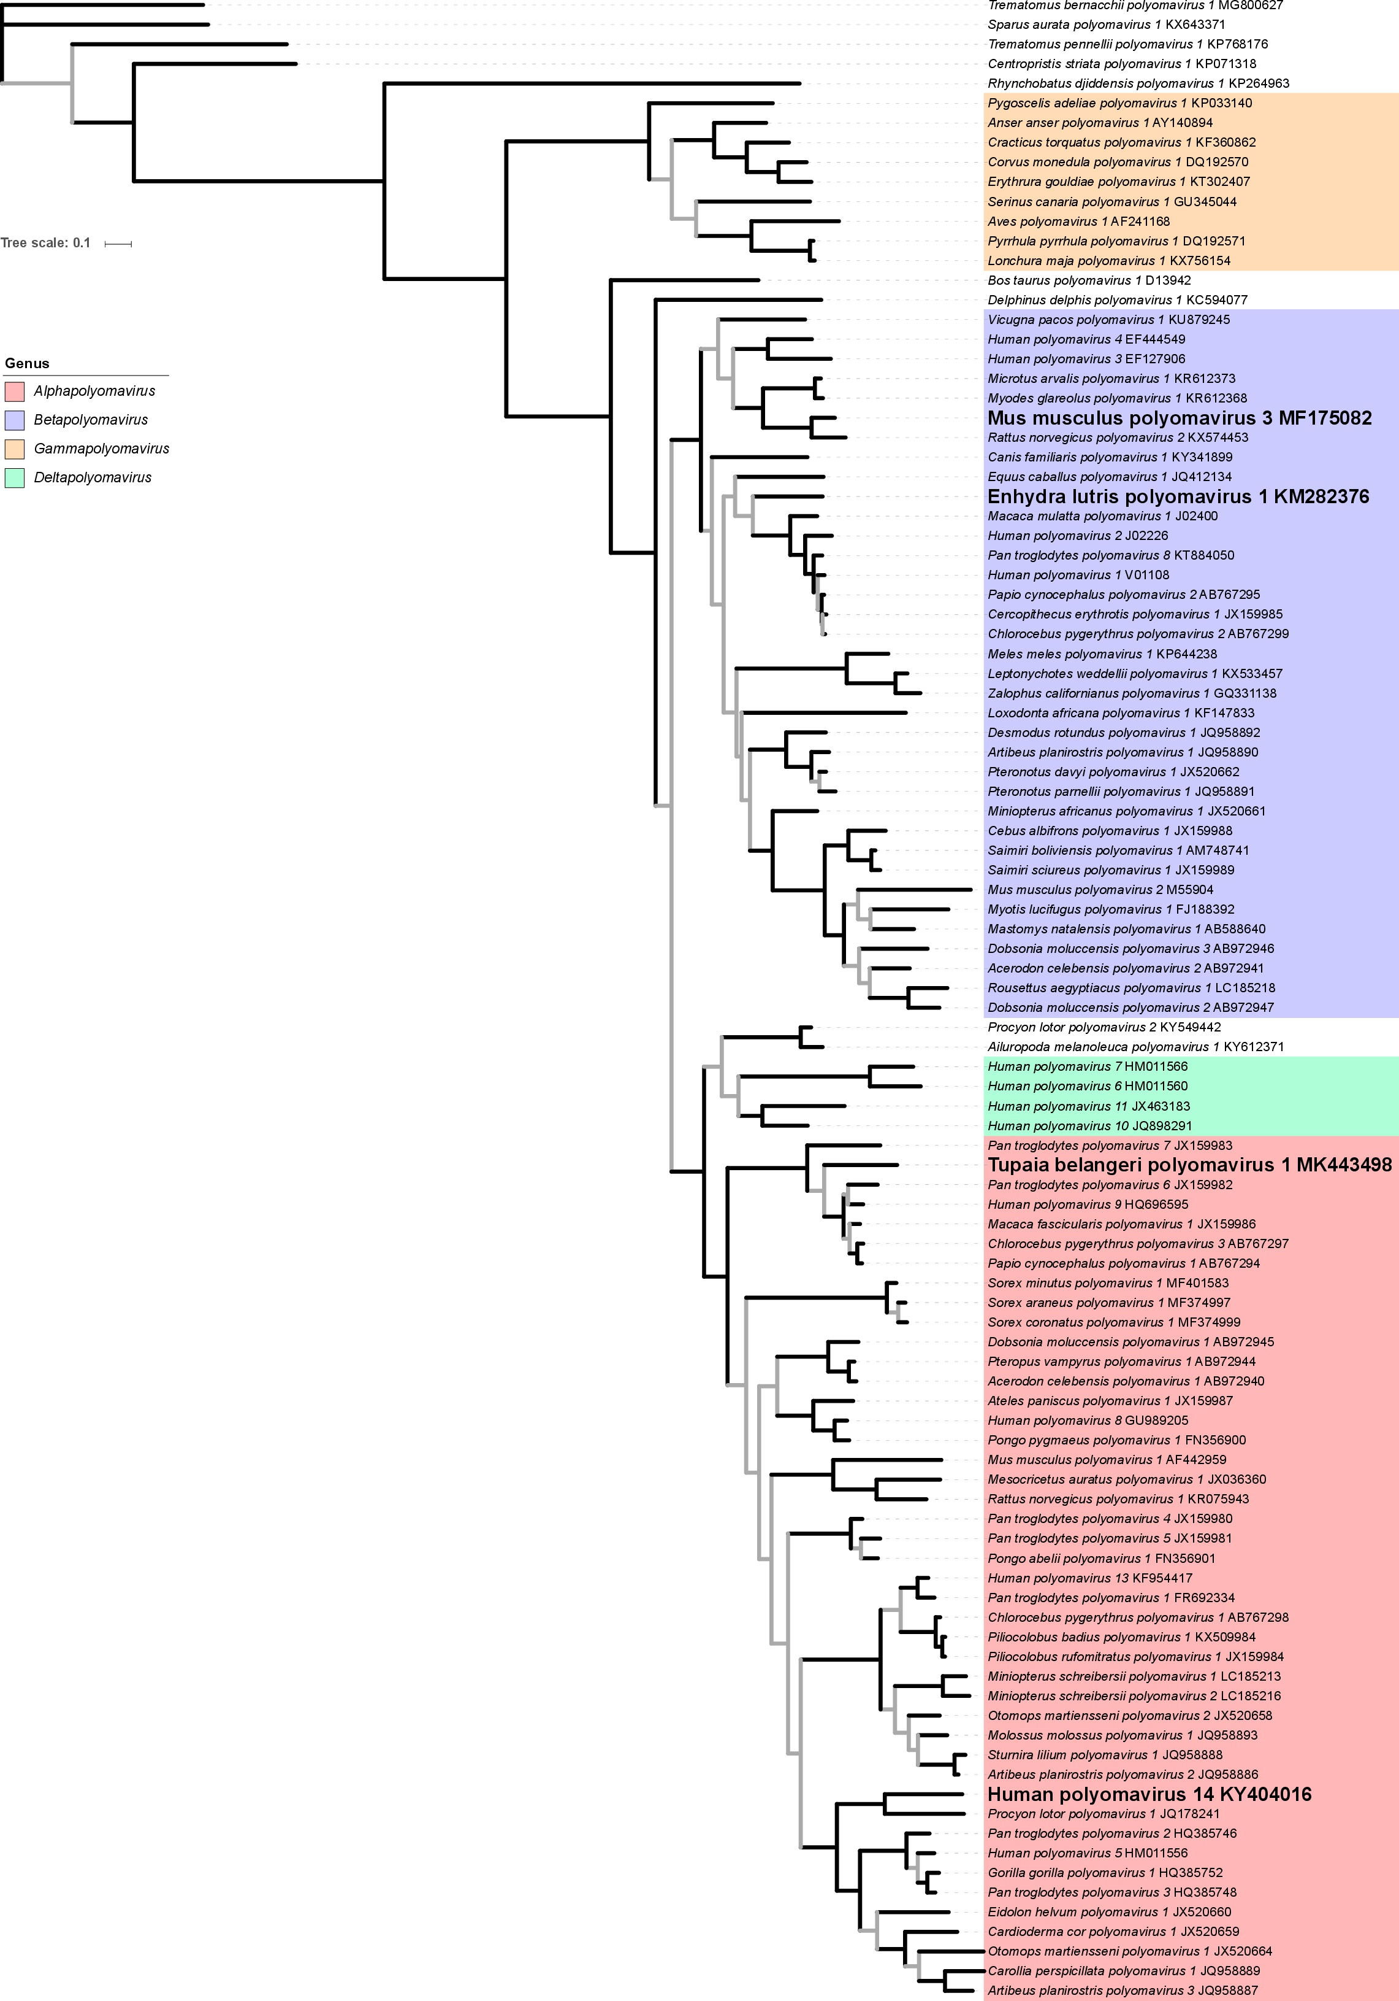

Figure 1. Maximum likelihood tree based on an alignment of large T amino acid sequences (481 amino acid positions) reconstructed with PhyML v3.1. Model of amino acid substitution (determined with smart model selection): LG+I+G+F. Branch support values: Shimodaira-Hasegawa-like approximate likelihood ratio tests (SH-like aLRT), grey branches: <0.95 SH-like aLRT. Proposed novel species are in enlarged, bold font.

References:
¹ Williams, S. H., Che, X., Garcia, J. A., Klena, J. D., Lee, B., Muller, D., ... & Lipkin, W. I. (2018). Viral diversity of house mice in New York City. Mbio, 9(2), e01354-17.
² Gheit, T., Dutta, S., Oliver, J., Robitaille, A., Hampras, S., Combes, J. D., ... & Giuliano, A. R. (2017). Isolation and characterization of a novel putative human polyomavirus. Virology, 506, 45-54.
³ Siqueira, J. D., Ng, T. F., Miller, M., Li, L., Deng, X., Dodd, E., ... & Delwart, E. (2017). Endemic infection of stranded southern sea otters (Enhydra lutris nereis) with novel parvovirus, polyomavirus, and adenovirus. Journal of Wildlife Diseases, 53(3), 532-542.
⁴ Liu, P., Qiu, Y., Xing, C., Zhou, J. H., Yang, W. H., Wang, Q., ... & Ge, X. Y. (2019). Detection and genome characterization of two novel papillomaviruses and a novel polyomavirus in tree shrew (Tupaia belangeri chinensis) in China. Virology Journal, 16(1), 35.
⁵ Calvignac-Spencer, S., Feltkamp, M., Daugherty, M.D., Moens, U., Ramqvist, T., Johne, R., Ehlers, B. (2015). ICTV taxonomic proposal 2015.015a-aaD.A.v2.Polyomaviridae_rev.
⁶ Calvignac-Spencer, S., Feltkamp, M.C., Daugherty, M.D., Moens, U., Ramqvist, T., Johne, R., Ehlers, B. (2016) A taxonomy update for the family Polyomaviridae. Archives of Virology 161(6), 1739-1750.

