This Word module should be used for all taxonomic proposals.
Please complete Part 1 and:
either Part 3 for proposals to create new taxa or change existing taxa
or Part 2 for proposals of a general nature.
Submit the completed Word module, together with the accompanying Excel module named in Part 3, to the appropriate ICTV Subcommittee Chair.
For guidance, see the notes written in blue, below, and the help notes in file Taxonomic_Proposals_Help_2018.
Part 1: TITLE, AUTHORS, etc

Code assigned: | 2018.011D |  | (to be completed by ICTV officers)
Short title:: 1 new species, abolishing 1 species, and correction of a misspelled species name in the subfamily Spumaretrovirinae
Author(s):
Arifa S. Khan
Jens H. Kuhn
Welkin E. Johnson
Corresponding author with e-mail address:
Welkin E. Johnson, welkin.johnson@bc.edu
List the ICTV study group(s) that have seen this proposal:
A list of study groups and contacts is provided at http://www.ictvonline.org/subcommittees.asp . If in doubt, contact the appropriate subcommittee chair (there are six virus subcommittees: animal DNA and retroviruses, animal ssRNA-, animal ssRNA+, fungal and protist, plant, bacterial and archaeal) |  | Retroviridae Study Group
ICTV Study Group comments (if any) and response of the proposer:
Date first submitted to ICTV: |  |  | June 6, 2018
Date of this revision (if different to above): |  |  | June 20, 2018

ICTV-EC comments and response of the proposer:

Part 3: PROPOSED TAXONOMY

Name of accompanying Excel module: 2018.011D.N.v1.Spumaretrovirinae_sps

The taxonomic changes you are proposing should be presented on an accompanying Excel module, 2017_TP_Template_Excel_module. Please enter the file name of the completed module in this box.
Supporting material:
additional material in support of this proposal
This proposal requests three changes to the subfamily Spumaretrovirinae within the Retroviridae. These are 1) the addition of one new species to the genus Simiispumavirus, 2) abolishing one species from the genus Felispumavirus, and 3) the correction of a misspelled species name.
Overview. “Foamy viruses” share several features distinguishing them from other retroviruses, and therefore belong to a distinct subfamily, Spumaretrovirinae, within the family Retroviridae [1, 2]. A unique characteristic of spumaretroviruses (compared to other retroviruses) is an extraordinarily stable, long-term pattern of co-evolution and co-speciation with their respective hosts [3-6]. Consequently, phylogenetic trees of the spumaretrovirus lineage are overall topologically identical to the corresponding trees of their mammalian hosts, with high bootstrap support for the major nodes corresponding to host species splits (Fig. 1) [7]. The discovery of ancient endogenous spumaretrovirus-related sequences in the genomes of animals of several species extends this pattern back millions of years [8]. In addition, natural spumaretrovirus infections are non-pathogenic [9], as expected in cases of long term virus−host coevolution. Although rare instances of cross-species transmissions have been revealed in such analyses, successful emergence is the exception rather than the rule [2, 3, 7]. In contrast, the pattern among retroviruses of the subfamily Orthoretrovirinae is dominated by interspecies-transmission and emergence of new virus−host combinations and there is very low correspondence between virus and host trees.
In 2017, the taxonomy of the Spumaretrovirinae was revised to incorporate multiple genera and type species. The new taxonomy was ratified in 2018 and is now official. The creation of new genera and species was based on congruence with host phylogeny and species demarcation criterion of >5% nucleotide divergence—this cutoff reflects the slow rate of spumaretrovirus sequence evolution, which is more similar to DNA viruses than to other types of retroviruses [4, 10, 11]. This proposal seeks the addition of one further species based on these criteria. We also propose the removal of another species that fails to meet these criteria, and finally, we request the correction of a misspelled species name.
The three proposed changes and justifications follow (colors correspond to branches on the tree in Figure 1):
1. Creation of a new species in the genus Simiispumavirus. The new species is to be called Cynomolgus macaque simian foamy virus, represented by the simian foamy virus Macaca fascicularis (SFVmfa) isolate Cy5061 (SFVmfa_Cy5061; acc.# LC094267). A complete viral genome sequence was published for SFVmfa, a spumaretrovirus isolated from crab-eating macaques (Macaca fascicularis) [12]. SFVmfa has a genome of 12,965 nucleotides, similar to other spumaretroviruses, comprising the U5, U3, and R cis-acting elements and five open reading frames—the latter include the canonical gag, pol, and env genes found in all retroviruses, and the tas and bet genes, which are unique to spumaretroviruses. Analysis of the sequence and incorporation into spumaretrovirus phylogeny indicates that SFVmfa represents a new species (Fig. 1). Based on the low rate of foamy virus genome evolution, a species demarcation cutoff of >5% divergence is used. Importantly, the genome of SFVmfa is >15-16% divergent from those of viruses of other species in the genus, which includes the most closely related spumaretroviruses isolated from macaques of other species. This degree of divergence (and a high level of bootstrap support) holds for the conserved pol gene, which is convenient for analyzing a broad range of divergent spumaretrovirus taxa, and which was used for the attached phylogenetic analysis (Fig. 1).
2. Abolish species Puma feline foamy virus in the genus Felispumavirus. Based on low divergence, the feline foamy virus Puma concolor (FFVpco) is not adequately different from feline foamy virus Felis catus (FFVfca) to be seen as a member of a species separate from the Feline foamy virus. FFVpco may be the result of a rare cross-species host switch. Based on divergence of FFVpco from FFVfca of less than the cutoff of 5%, as well as uncertainty about the origins of FFVpco in pumas, we propose that the species Puma feline foamy virus be abolished.
3. Correction of a misspelled species name in the current taxonomy. The species name Central cimpanzee simian foamy virus is spelled incorrectly. The spelling “cimpanzee” needs to be replaced with the correct spelling, “chimpanzee”. The letter “h” was omitted by mistake and incorporated into the taxonomy in 2017. The complete and correct species name should be Central chimpanzee simian foamy virus reflecting the host, central chimpanzee (Pan troglodytes troglodytes), a subspecies of the common chimpanzee.

References:
[1] A.S. Khan, J. Bodem, F. Buseyne, A. Gessain, W. Johnson, J.H. Kuhn, et al., Spumaretroviruses: Updated taxonomy and nomenclature, Virology. 516 (2018) 158–164. doi:10.1016/j.virol.2017.12.035.
[2] D.M. Pinto-Santini, C.R. Stenbak, M.L. Linial, Foamy virus zoonotic infections, Retrovirology. 14 (2017) 55. doi:10.1186/s12977-017-0379-9.
[3] W.M. Switzer, M. Salemi, V. Shanmugam, F. Gao, M.-E. Cong, C. Kuiken, et al., Ancient co-speciation of simian foamy viruses and primates, Nature. 434 (2005) 376–380. doi:10.1038/nature03341.
[4] M. Schweizer, H. Schleer, M. Pietrek, J. Liegibel, V. Falcone, D. Neumann-Haefelin, Genetic stability of foamy viruses: long-term study in an African green monkey population, J. Virol. 73 (1999) 9256–9265.
[5] A. Rethwilm, J. Bodem, Evolution of foamy viruses: the most ancient of all retroviruses, Viruses. 5 (2013) 2349–2374. doi:10.3390/v5102349.
[6] O.R.P. Bininda-Emonds, M. Cardillo, K.E. Jones, R.D.E. MacPhee, R.M.D. Beck, R. Grenyer, et al., The delayed rise of present-day mammals, Nature. 446 (2007) 507–512. doi:10.1038/nature05634.
[7] A. Katzourakis, P. Aiewsakun, H. Jia, N.D. Wolfe, M. LeBreton, A.D. Yoder, et al., Discovery of prosimian and afrotherian foamy viruses and potential cross species transmissions amidst stable and ancient mammalian co-evolution, Retrovirology. 11 (2014) 61. doi:10.1186/1742-4690-11-61.
[8] A. Katzourakis, R.J. Gifford, M. Tristem, M.T.P. Gilbert, O.G. Pybus, Macroevolution of complex retroviruses, Science. 325 (2009) 1512–1512. doi:10.1126/science.1174149.
[9] W. Heneine, M. Schweizer, P. Sandstrom, T. Folks, Human infection with foamy viruses, Curr. Top. Microbiol. Immunol. 277 (2003) 181–196.
[10] K. Gärtner, T. Wiktorowicz, J. Park, A. Mergia, A. Rethwilm, C. Scheller, Accuracy estimation of foamy virus genome copying, Retrovirology. 6 (2009) 32. doi:10.1186/1742-4690-6-32.
[11] A. Rethwilm, Molecular biology of foamy viruses, Med. Microbiol. Immunol. 199 (2010) 197–207. doi:10.1007/s00430-010-0158-x.
[12] K. Sakai, Y. Ami, Y. Suzaki, T. Matano, First complete genome sequence of a simian foamy virus isolate from a cynomolgus macaque, Genome Announc. 4 (2016) e01332–16. doi:10.1128/genomeA.01332-16.

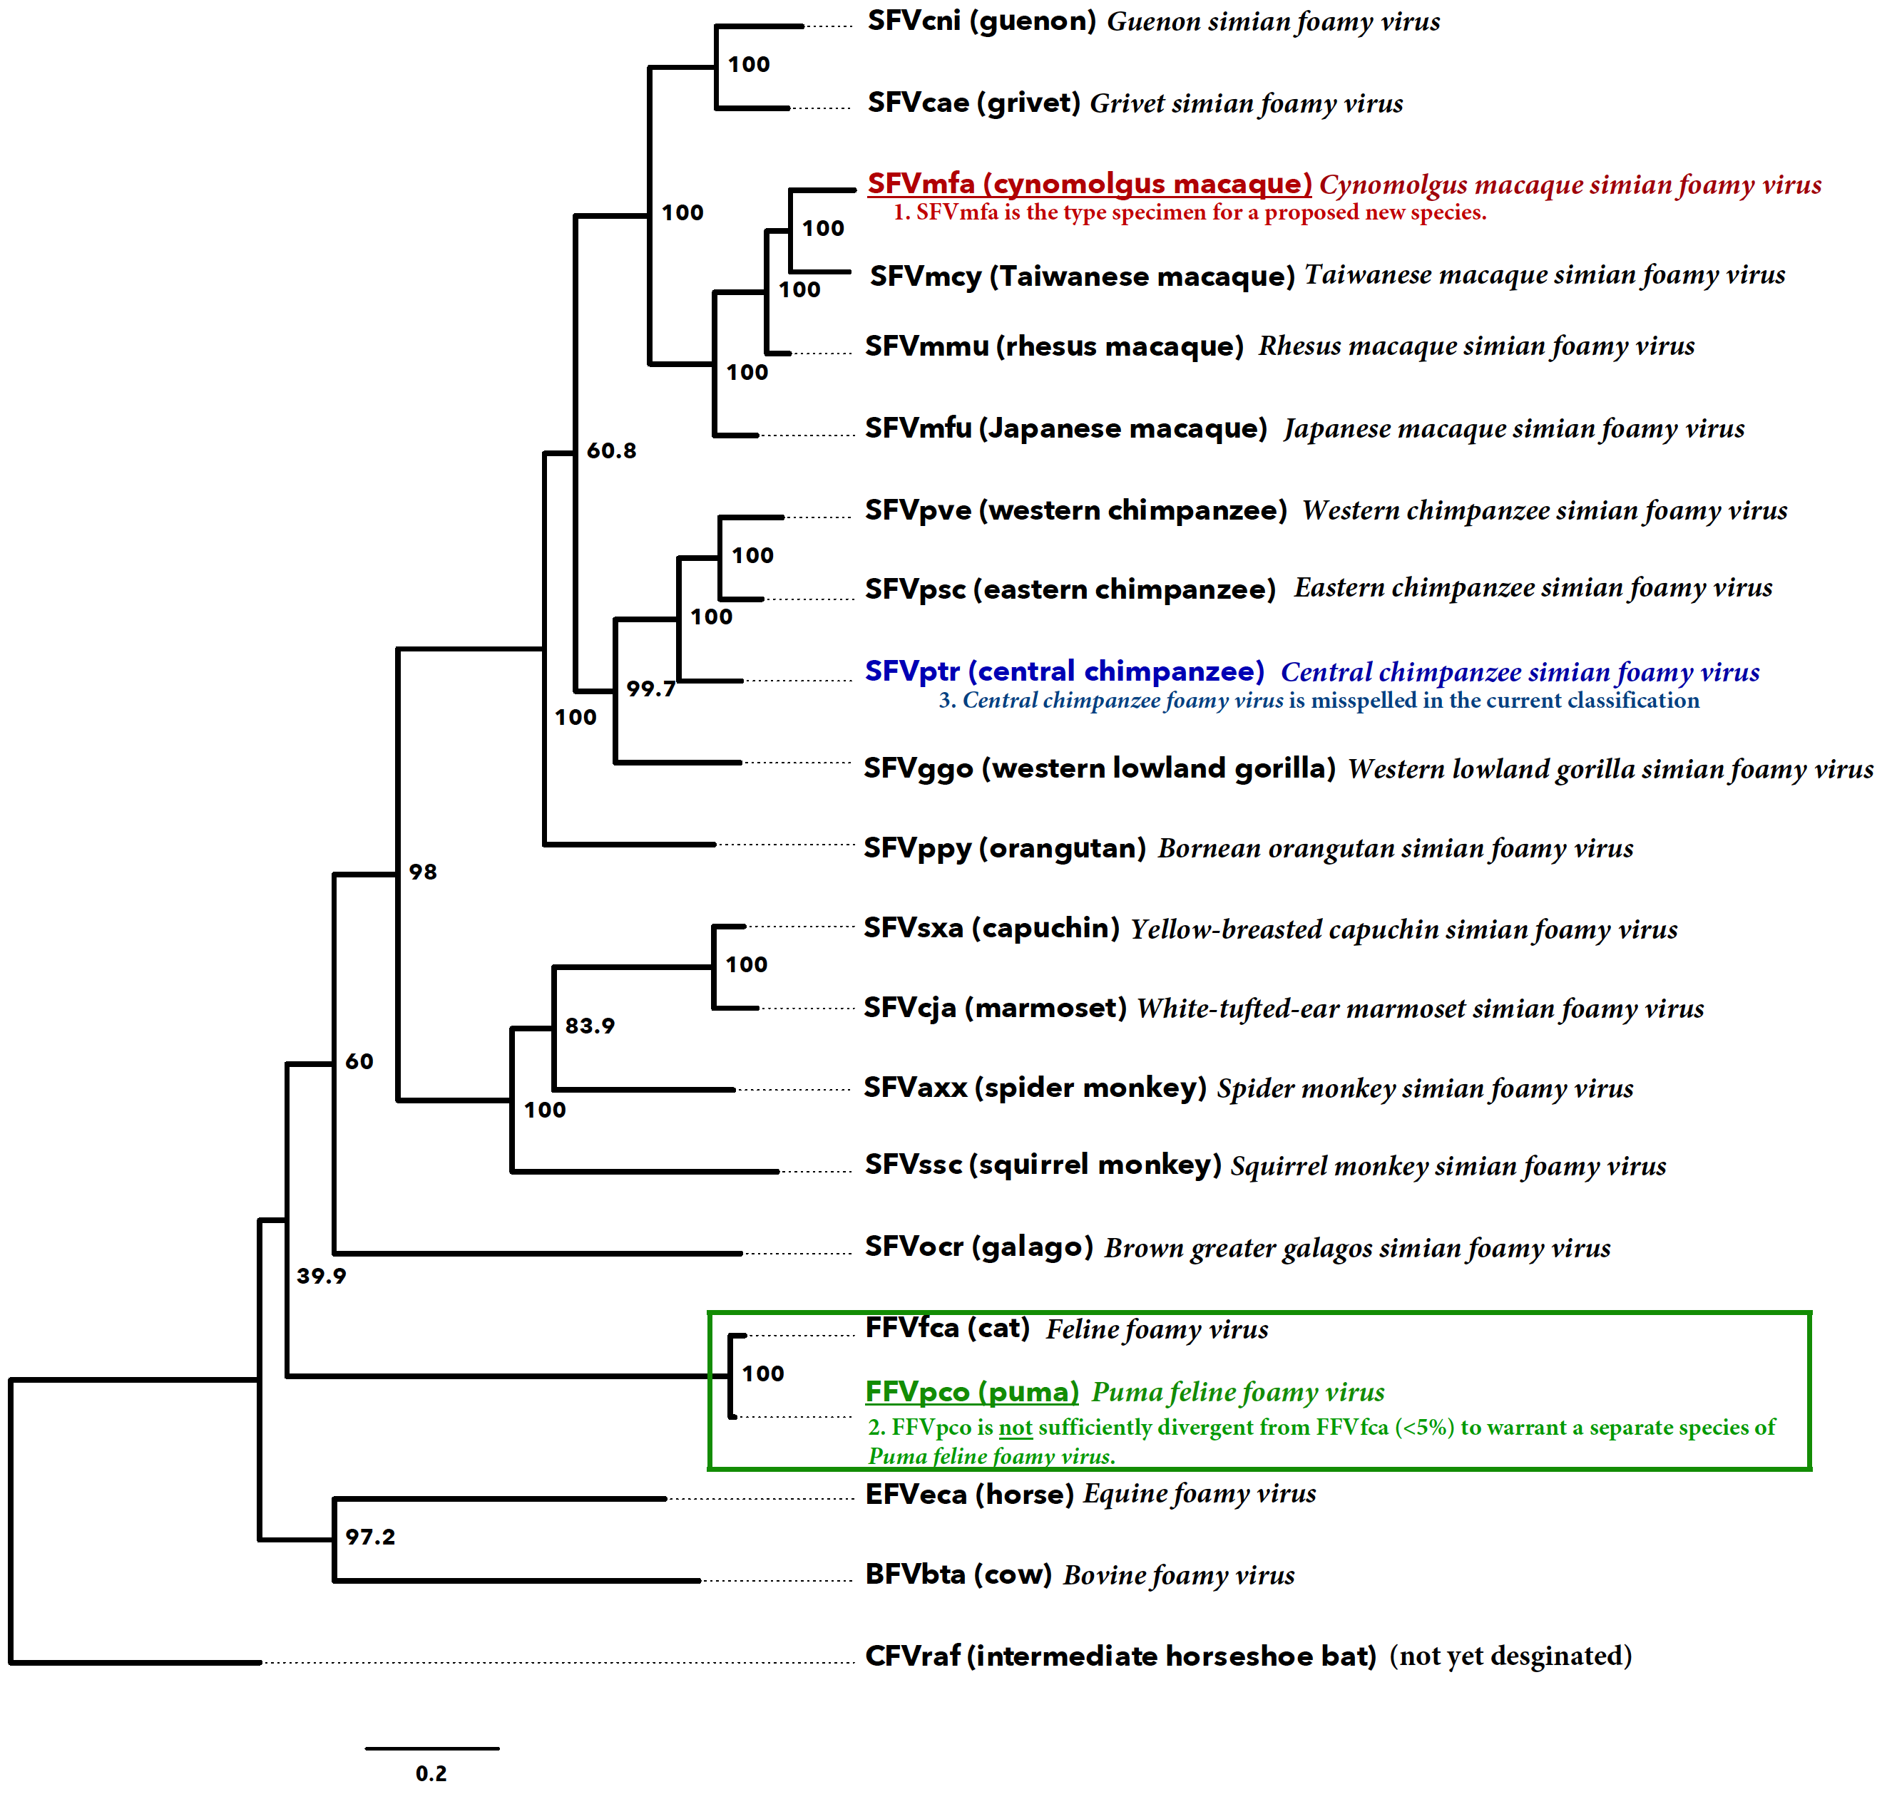
Figure 1. Spumaretrovirus phylogeny with three taxa relevant to the proposal highlighted. The proposal is to 1) create a new species, Cynomolgus macaque simian foamy virus (shown in red), 2) remove an existing species due to low diversity below the demarcation cutoff of the exemplar of the type species (in green), and 3) to correct the spelling of another species (in blue). The figure shows an unrooted maximum likelihood tree based on an alignment of the highly conserved pol gene of 21 spumaretrovirus isolates representing hosts from five mammalian orders/suborders. Branch tips are also labeled with the common name for the host, the name of the representative virus isolate from that organism, and the corresponding virus species name. Nodes are labeled with bootstrap support values (out of 1,000 replicates). Scale bar is proportional to genetic distance. Tree was inferred by using PhyML as implemented in Geneious 10.1.3. Similar trees and related discussion can be found in references [1, 3, and 8].

