This Word module should be used for all taxonomic proposals.
Please complete Part 1 and:
either Part 3 for proposals to create new taxa or change existing taxa
or Part 2 for proposals of a general nature.
Submit the completed Word module, together with the accompanying Excel module named in Part 3, to the appropriate ICTV Subcommittee Chair.
For guidance, see the notes written in blue, below, and the help notes in file Taxonomic_Proposals_Help_2018.
Part 1: TITLE, AUTHORS, etc

Code assigned: | 2018.004D |  | (to be completed by ICTV officers)
Short title: One new genus with one new species in the subfamily Betairidovirinae
Author(s):
V. Gregory Chinchar, Feng Yang, Jie Huang, Trevor Williams, Richard Whittington, James Jancovich, Kuttichantran Subramaniam, Thomas Waltzek, Paul Hick, Ikbal Agah Ince, Rachel Marschang
Corresponding author with e-mail address:
vchinchar@umc.edu
List the ICTV study group(s) that have seen this proposal:
A list of study groups and contacts is provided at http://www.ictvonline.org/subcommittees.asp . If in doubt, contact the appropriate subcommittee chair (there are six virus subcommittees: animal DNA and retroviruses, animal ssRNA-, animal ssRNA+, fungal and protist, plant, bacterial and archaeal) |  | Iridoviridae SG
ICTV Study Group comments (if any) and response of the proposer:
Date first submitted to ICTV: |  |  | 6 June 2018
Date of this revision (if different to above): |  |  | 21 September 2018

ICTV-EC comments and response of the proposer:
Change genus name.
Genus name changed.

Part 3: PROPOSED TAXONOMY

Name of accompanying Excel module: 2018.004D.A.v1.Decapodiridovirus
The taxonomic changes you are proposing should be presented on an accompanying Excel module, 2017_TP_Template_Excel_module. Please enter the file name of the completed module in this box.
Supporting material:
additional material in support of this proposal
Please explain the reasons for the taxonomic changes you are proposing and provide evidence to support them. The following information should be provided, where relevant:
- Species demarcation criteria: Explain how new species differ from others in the genus and demonstrate that these differences meet the criteria previously established for demarcating between species. If no criteria have previously been established, and if there will now be more than one species in the genus, please state the demarcation criteria you are proposing.
- Higher taxa:
  - There is no formal requirement to state demarcation criteria when proposing new genera or other higher taxa. However, a similar concept should apply in pursuit of a rational and consistent virus taxonomy.
  - Please indicate the origin of names assigned to new taxa at genus level and above.
  - For each new genus a type species must be designated to represent it. Please explain your choice.
- Supporting evidence: The use of Figures and Tables is strongly recommended (note that copying from publications will require permission from the copyright holder). For phylogenetic analysis, try to provide a tree where branch length is related to genetic distance.

Rationale for formation of a novel genus containing a single species:

Summary: Putative novel iridoviruses were isolated from farmed shrimp (Qui et al., 2017) and redclaw crayfish (Xu et al, 2016) in China in 2014. Their full genomic sequences have recently been determined (Qiu et al., 2018; Li et al., 2017) and suggest that these viruses, designated shrimp hemocyte iridescent virus (SHIV) and Cherax quadricarinatus iridovirus (CQIV), are members of a novel genus based on their predominant host species and phylogenetic position. Moreover, BLAST analysis of the full genomes indicates that they are 99% identical and likely represent different isolates of the same viral species. Based on their host range we propose the genus be designated Decapodiridovirus to indicate its infectivity toward shrimp, crayfish, and other decapods and that it be considered a third genus within the subfamily Betairidovirinae.

Rationale: The isolation and complete genomic sequence determination of these two viruses represents the most complete description of an iridovirus from shrimp and crayfish to date. BLAST analysis (i.e., blastn) of the complete genomes of SHIV and CQIV indicate that they share 99% sequence identity and are likely isolates of the same viral species. In addition, their genome size and GC content are nearly identical (Table 1).

Features distinguishing the proposed genus from the five existing genera in the family Iridoviridae are as follows: (1) phylogenetic analysis based on Maximum-Likelihood analysis using 27 conserved genes from 15 completely sequenced viruses representing the five recognized genera within the family indicate that these viruses are only distantly related to the existing genera and likely represent a novel genus (Fig. 1), (2) pairwise sequence comparisons of the major capsid protein (MCP) and ATPase proteins show generally less than 50% similarity to members of the other five genera (Qui et al., 2017), and (3) host range, i.e., these isolates infect shrimp and crayfish in contrast to iridoviruses and chloriridoviruses that infect primarily insects. In addition, because of their host range and phylogenetic position, we suggest that they are members of the subfamily Betairidovirinae, members of which infect invertebrates (including insects and terrestrial crustaceans i.e. isopods such as woodlice, pillbugs and sowbugs). We propose the genus designation Decapodiridovirus, derived from the designation of the order Decapoda (Class Malacostraca, Subphylum Crustacea) which encompasses shrimp, crabs, and crayfish and suggest Decapod iridescent virus 1 as the name of the type species.

Table 1. Comparison of viruses within the proposed genus Decapodiridovirus

Genus | Species | Isolate Name, Abbreviation, Isolate Number | Genome  Size (kbp) | No. ORFs | GC% | Acc. Nos.
Decapodiridovirus | Decapod  iridescent virus 1 | shrimp hemocyte iridescent virus, SHIV, 20141215 | 165,809 | 170 | 35% | MF599468
 |  | Cherax quadricarinatus iridovirus, CQIV, CN01 | 165,695 | 178 | 35% | MF197913

Fig. 1. Concatenated phylogenetic tree of viruses within the family Iridoviridae.
Panel a. Twenty-seven conserved genes from 15 other completely sequenced iridoviruses were rearranged as continuous amino acid sequences with the same order as in SHIV. A multiple sequence alignment was carried out using MUSCLE. The tree was reconstructed by the maximum-likelihood method using MEGA 5.0 and the numbers indicate percentage bootstrap support. The new virus (shrimp hemocyte iridescent virus) proposed to be a member of the new genus is shown by red letters. The original publication proposed the genus name Xiairidovirus (which is shown here). A parallel taxonomical proposal suggests invertebrate iridescent virus (IIV) 9, IIV22 and IIV25 are members of three new species within the genus Chloriridovirus. Their anticipated acceptance will solve the disturbing controversy seen also on this figure that presently the members of genus Iridovirus seem not to be monophyletic. Panel b. Sixteen of the 27 conserved genes from 34 completely sequenced iridoviruses underwent the same process to establish a tree that includes most of the completely sequenced viruses of the family Iridoviridae. Percentage bootstrap values (1000 replicates) are shown. Bar, expected nucleotide substitutions per site.

Used with permission: Qiu, L., Chen, M.M., Wang, R.Y. et al. Arch Virol (2018) 163: 781. https://doi.org/10.1007/s00705-017-3642-4

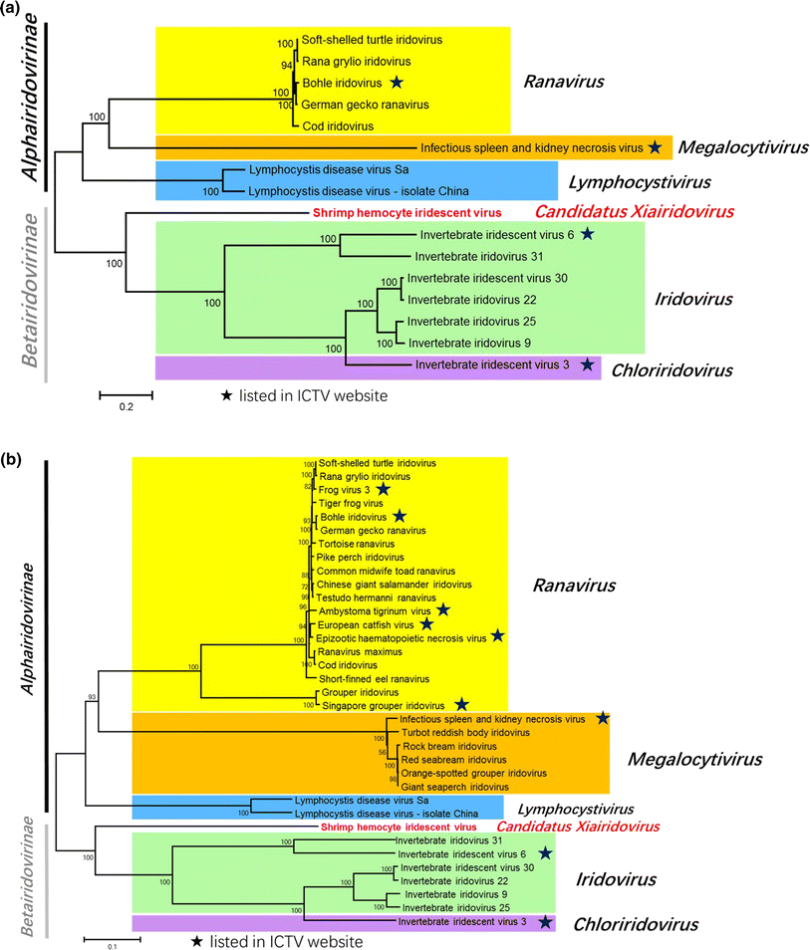

References:
Li F et al., Genomic characterization of a novel iridovirus from redclaw crayfish Cherax quadricarinatus: evidence for a new genus within the family Iridoviridae. J. Gen. Virol. 98: 2589 - 2595, 2017.
Qui L et al., Characterization of a new member of Iridoviridae, shrimp hemocyte iridescent virus (SHIV), found in white leg shrimp (Litopenaeus vannamei). Sci. Rep. 7: 11834, 2017.
Qui L et al., Complete genome sequence of shrimp hemocyte iridescent virus (SHIV) isolated from white leg shrimp, Litopenaeus vannamei. Arch. Virol. 163: 781 - 785, 2018.
Xu L et al., Isolation and preliminary characterization of a new pathogenic iridovirus from redclaw crayfish Cherax quadricarinatus. Dis. Aquat. Organ. 120: 17 - 26, 2016.

