This Word module should be used for all taxonomic proposals.
Please complete Part 1 and:
either Part 3 for proposals to create new taxa or change existing taxa
or Part 2 for proposals of a general nature.
Submit the completed Word module, together with the accompanying Excel module named in Part 3, to the appropriate ICTV Subcommittee Chair.
The Word module explains and justifies your proposal. The Excel module is a critical document that will be used to implement the proposed taxonomic changes once they are approved and ratified. If proposals presented in the Word module are not presented accurately in the Excel module, the taxonomic changes cannot proceed.
For guidance, see the notes written in blue, below, and the Help Notes in file Taxonomic_Proposals_Help_2019.
Part 1: TITLE, AUTHORS, etc

Code assigned: | 2019.002D
Short title: Create four new species in the genus Circovirus and three new species in the genus Cyclovirus
Author(s) and email address(es):
List authors in a single line Archives of Virology citation format (e.g. Smith AB, Huang C-L, Santos, F) |  | Provide email address for each author in a single line separated by semi-colons
Varsani A, Rosario K, Delwart E, Segalés J, Breitbart M |  | arvind.varsani@asu.edu; krosari2@mail.usf.edu; Eric.Delwart@ucsf.edu; Joaquim.Segales@uab.cat; mya@usf.edu
Author(s) institutional address(es) (optional):
Provide institutional addresses, each on a single line followed by author(s) initials (e.g. University of Woolloomooloo [SAB, HCL])
Arizona State University [VA]
University of South Florida [RK, BM]
Blood Systems Research Institute [DE]
Universitat Autònoma de Barcelona [SJ]

Corresponding author
Arvind Varsani

List the ICTV study group(s) that have seen this proposal:
A list of study groups and contacts is provided at http://www.ictvonline.org/subcommittees.asp . If in doubt, contact the appropriate subcommittee chair (there are six virus subcommittees: animal DNA and retroviruses, animal ssRNA-, animal ssRNA+, fungal and protist, plant, bacterial and archaeal) |  | Circoviridae SG
ICTV Study Group comments (if any) and response of the proposer:
Date first submitted to ICTV: |  |  | 16 May 2019
Date of this revision (if different to above): |  |  | 9 June 2019

ICTV-EC comments and response of the proposer:

Part 3: PROPOSED TAXONOMY

Name of accompanying Excel module: 2019.002D.A.v1.7newsp_Circoviridae.xlsx
The taxonomic changes you are proposing should be presented on an accompanying Excel module, 2019_TP_Template_Excel_module. Please enter the file name of the completed module in this box.
Supporting material:

There are two genera in the family Circoviridae, namely Circovirus and Cyclovirus. Viruses within these two genera are classified into species based on genome-wide pairwise identities with a 80% species demarcation threshold (Rosario et al., 2017).

Over the last year 13 new circoviruses in the genus Circovirus (Nishizawa et al., 2018; Sadeghi et al., 2018; Wu et al., 2016) (no publication available on bamboo rat circoviruses) and 5 in the genus Cyclovirus (Lima et al., 2019; Rosario et al., 2018), that can not be assigned to known species within these genera, have been identified. Based on the species demarcation threshold coupled with phylogenetic support, 4 new species for the genus Circovirus (Table 1, Figure 1-2) and 3 new species for the genus Cyclovirus (Table 2, Figure 3-4) are proposed. Details of viruses belonging to these species are summarised in Tables 1 and 2. The term ‘associated’ is used when the host is unknown to maintain consistency with the past species nomenclature.

Table 1: Summary of new species and their members in the genus Circovirus
Species | Accession | Virus name | Virus acronym | Country | Host / isolation source | Isolate
Bat associated circovirus 12 | KJ641716 | bat circovirus | BatACV12 | China | Pipistrellus sp. | CV/GD2012
Civet circovirus | LC416389 | Paguma larvata circovirus | CivCV | Japan | Paguma larvata / serum | Pl-CV3
 | LC416390 | Paguma larvata circovirus | PanCV | Japan | Paguma larvata / serum | Pl-CV8
 | LC416391 | Paguma larvata circovirus | PanCV | Japan | Paguma larvata / serum | Pl-CV9
Rodent associated circovirus 7 | MF497827 | bamboo rat circovirus | RoACV7 | China | Rhizomys pruinosus | FJ01
 | MF497828 | bamboo rat circovirus | RoACV7 | China | Rhizomys pruinosus | FJNP
 | MF497829 | bamboo rat circovirus | RoACV7 | China | Rhizomys pruinosus | Guilin 01
 | MF497830 | bamboo rat circovirus | RoACV7 | China | Rhizomys pruinosus | Guilin 06
 | MF497831 | bamboo rat circovirus | RoACV7 | China | Rhizomys pruinosus | Guilin 03
 | MF497832 | bamboo rat circovirus | RoACV7 | China | Rhizomys pruinosus | GXLA
 | MF497833 | bamboo rat circovirus | RoACV7 | China | Rhizomys pruinosus | GX01
 | MF497834 | bamboo rat circovirus | RoACV7 | China | Rhizomys pruinosus | GXLA2
Mosquito associated circovirus 1 | MH188038 | Culex circovirus-like virus | MosACV1 | USA | Culex sp. | CCirVL/Fresno

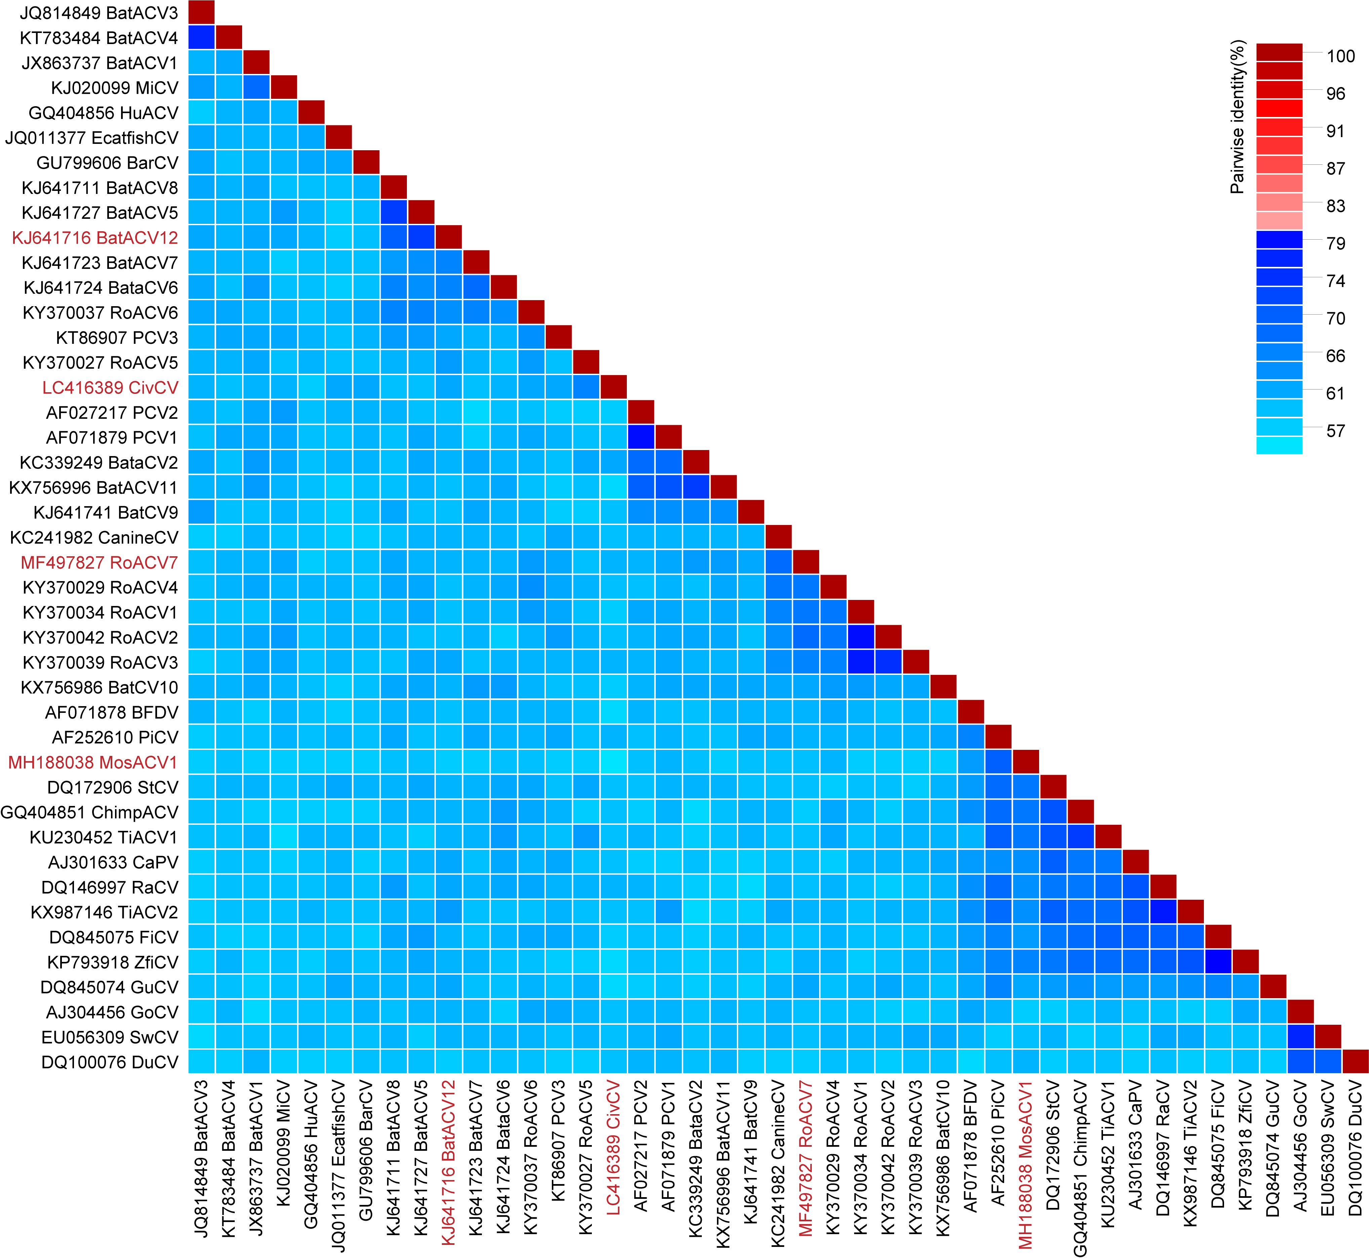

Figure 1: A ‘two colour’ pairwise identity matrix of representative genome-wide comparisons among sequences in the genus Circovirus inferred using SDT v1.2 (Muhire et al., 2014). Representative sequences from the proposed new species are highlighted in red font.

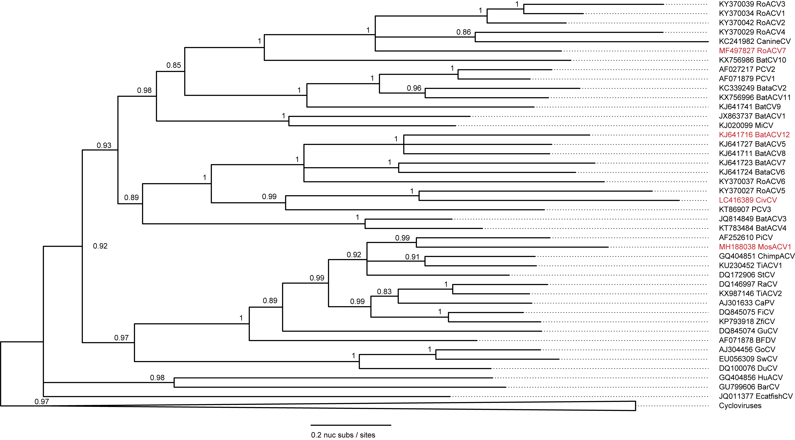

Figure 2: Maximum likelihood phylogenetic tree (rooted with reverse complement sequences of cycloviruses) of representative genomes from each circovirus species inferred using PHYML (Guindon et al., 2010) with GTR+I+G4 chosen as the best fit model. Branches with <0.8 aLRT (approximate likelihood ratio test) branch support have been collapsed.

Table 2: Summary of new species and their members in the genus Cyclovirus
Species | Accession | Organism | Virus acronym | country | Host / isolation source | Isolate
Chicken associated cyclovirus 2 | MG846358 | chicken associated cyclovirus 2 | ChickACyV2 | Brazil | Gallus gallus | RS/BR/2015/4
Ant associated cyclovirus 1 | MH545511 | arboreal ant associated circular virus 1 | AntACyV1 | Kenya | Crematogaster nigriceps | KY_I1338b_D1_CN
 | MH545512 | arboreal ant associated circular virus 1 | AntACyV1 | Kenya | Tetraponera penzigi | KY_I1342_G6_TP
 | MH545513 | arboreal ant associated circular virus 1 | AntACyV1 | Kenya | Crematogaster mimosae | KY_I1347_F1_CM
Spider associated cyclovirus 1 | MH545516 | soft spider associated circular virus 1 | SpACyV1 | Canada | Cybaeidae | BC_I1647E_H3

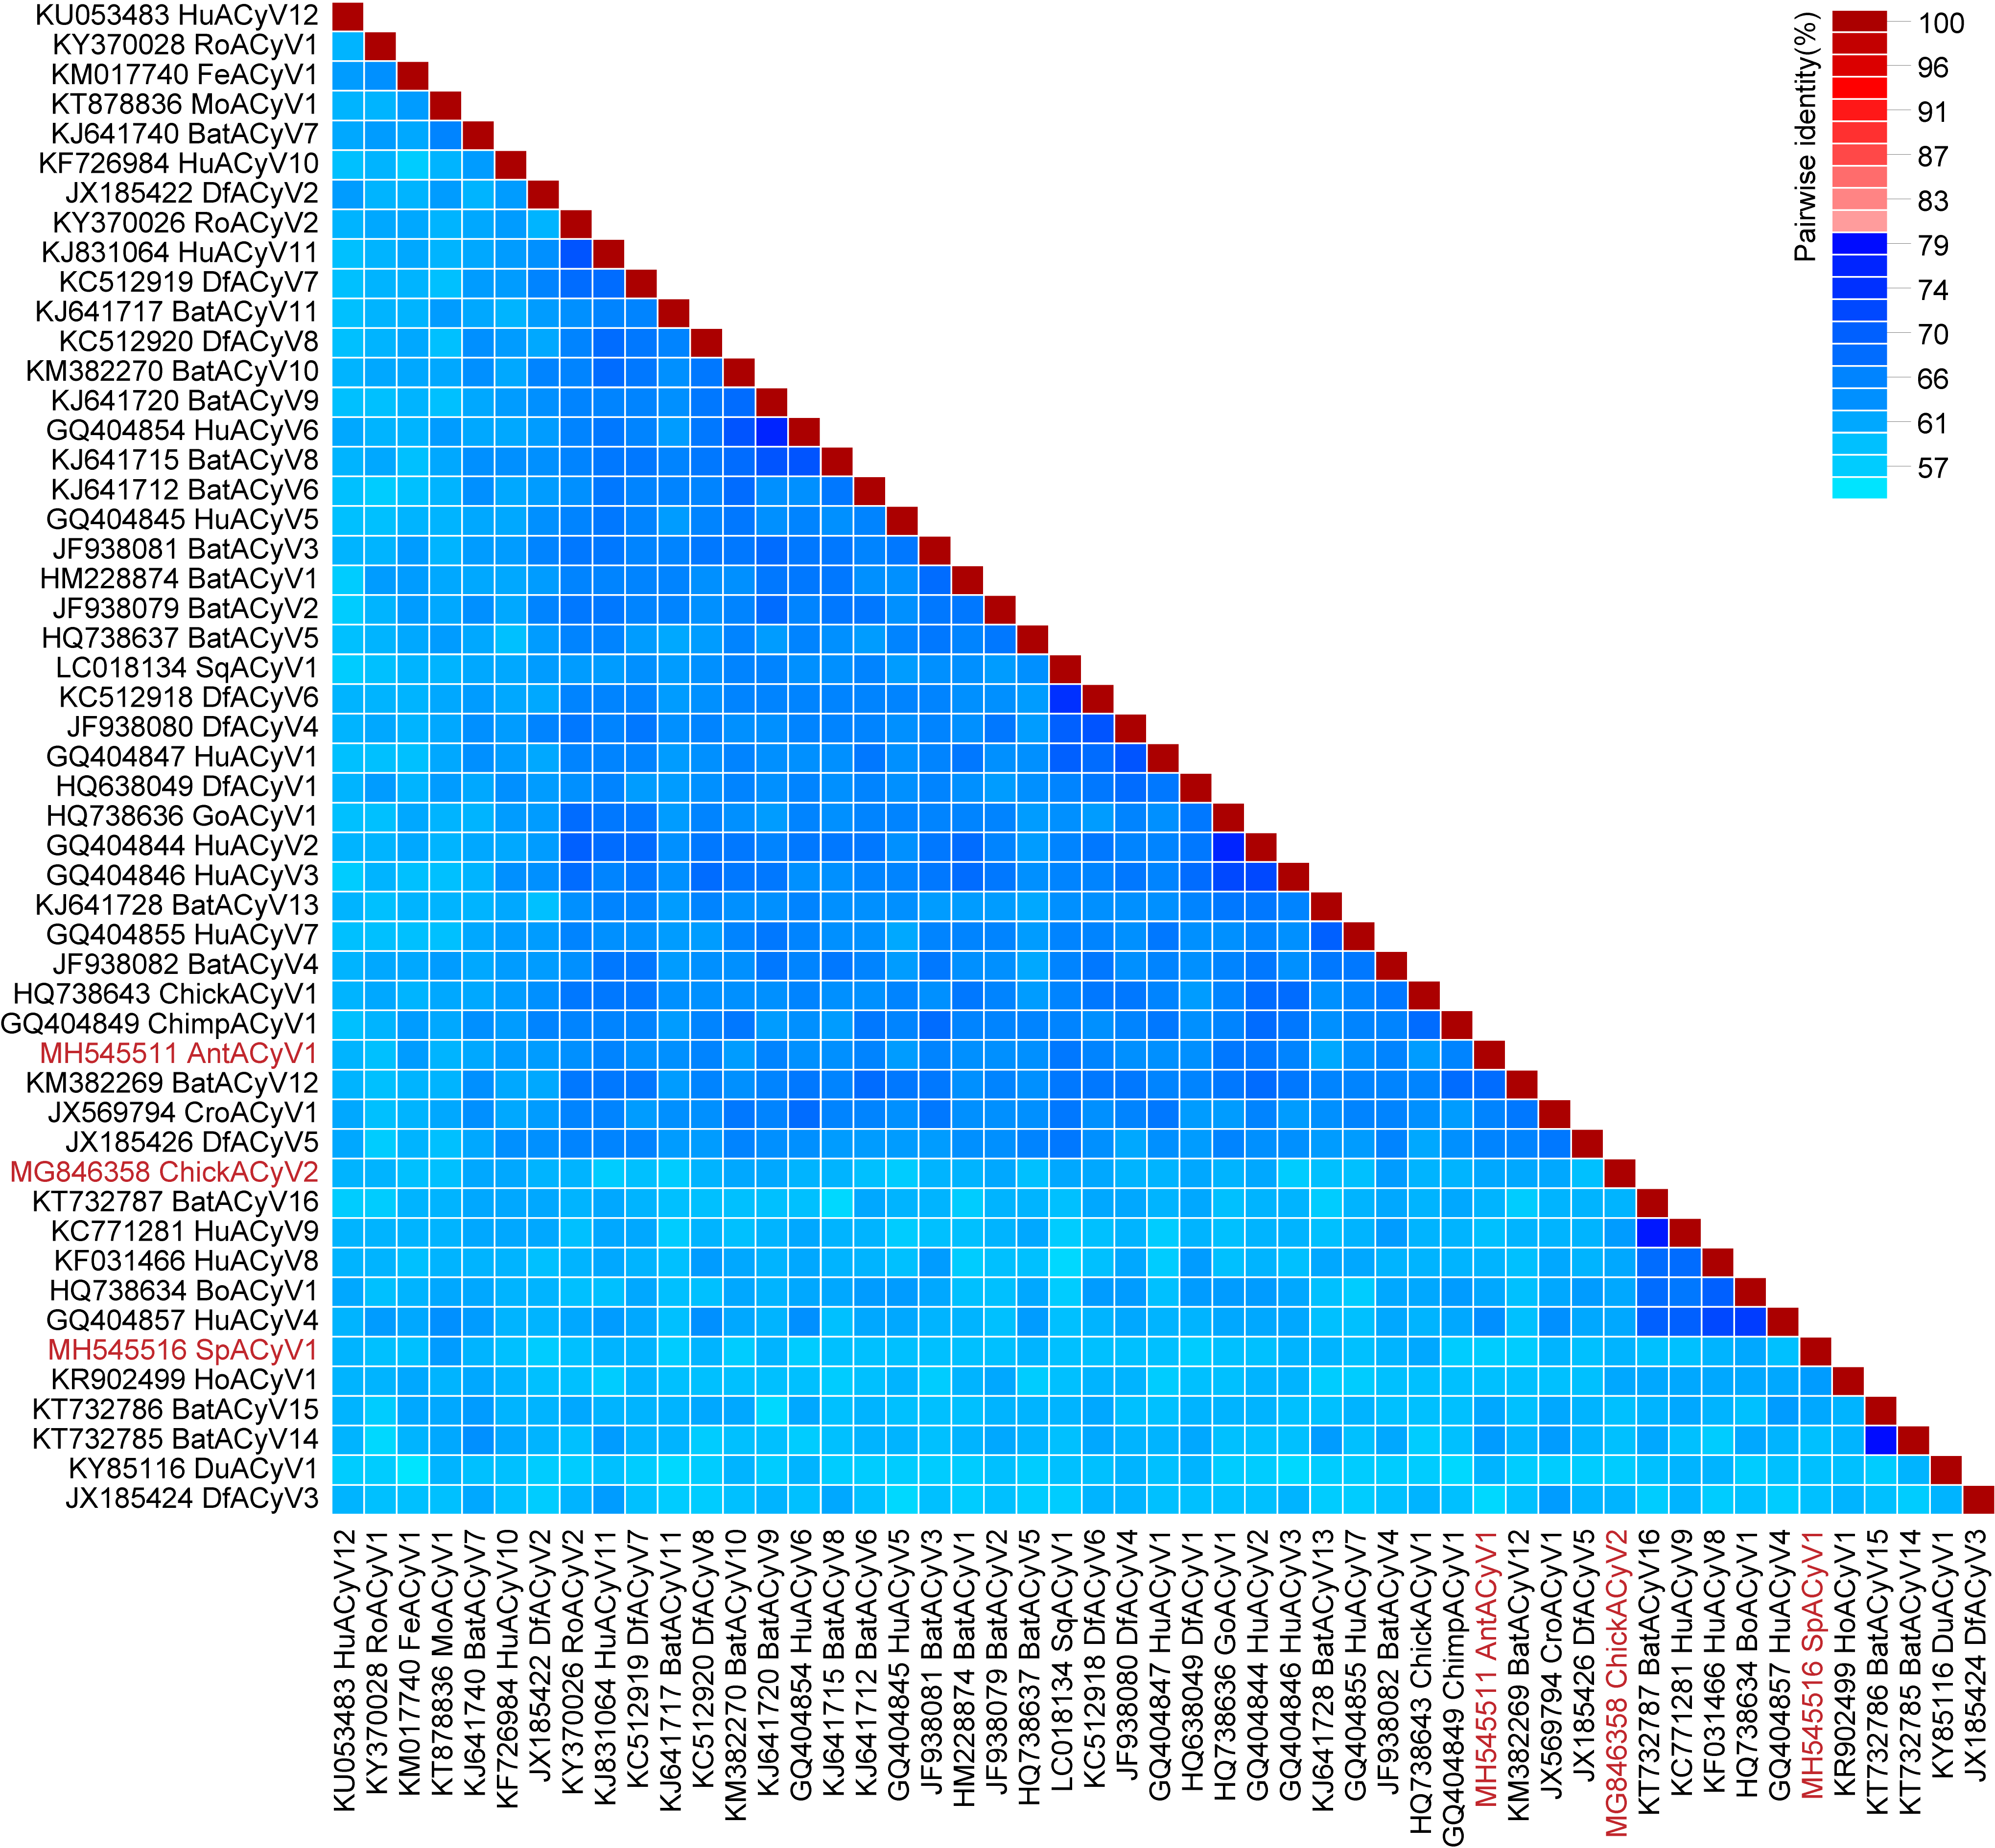

Figure 3: A ‘two colour’ pairwise identity matrix of representative genome-wide comparisons among cyclovirus sequences inferred using SDT v1.2 (Muhire et al., 2014). Representative sequences from the proposed new species are highlighted in red font.

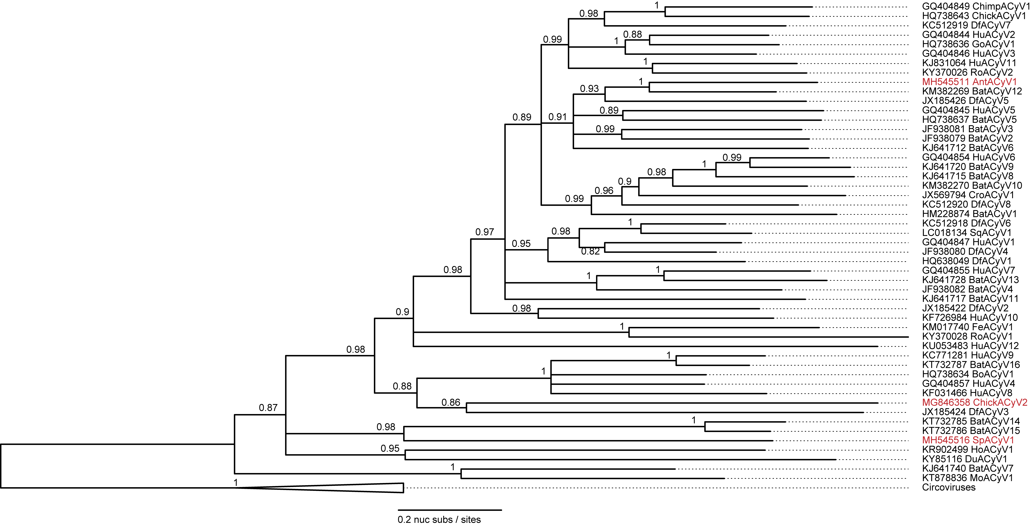
Figure 4: Maximum likelihood phylogenetic tree (rooted with reverse complement sequences of circoviruses) of representative genomes from each cyclovirus species inferred using PHYML (Guindon et al., 2010) with GTR+I+G4 chosen as the best fit model. Branches with <0.8 aLRT (approximate likelihood ratio test) branch support have been collapsed.

References:
Guindon, S., Dufayard, J.F., Lefort, V., Anisimova, M., Hordijk, W., Gascuel, O., 2010. New algorithms and methods to estimate maximum-likelihood phylogenies: assessing the performance of PhyML 3.0. Syst Biol 59, 307-321.
Lima, D.A., Cibulski, S.P., Tochetto, C., Varela, A.P.M., Finkler, F., Teixeira, T.F., Loiko, M.R., Cerva, C., Junqueira, D.M., Mayer, F.Q., Roehe, P.M., 2019. The intestinal virome of malabsorption syndrome-affected and unaffected broilers through shotgun metagenomics. Virus Res 261, 9-20.
Muhire, B.M., Varsani, A., Martin, D.P., 2014. SDT: a virus classification tool based on pairwise sequence alignment and identity calculation. PLoS One 9, e108277.
Nishizawa, T., Sugimoto, Y., Takeda, T., Kodera, Y., Hatano, Y., Takahashi, M., Okamoto, H., 2018. Identification and full-genome characterization of novel circoviruses in masked palm civets (Paguma larvata). Virus Res 258, 50-54.
Rosario, K., Mettel, K.A., Benner, B.E., Johnson, R., Scott, C., Yusseff-Vanegas, S.Z., Baker, C.C., Cassill, D.L., Storer, C., Varsani, A., 2018. Virus discovery in all three major lineages of terrestrial arthropods highlights the diversity of single-stranded DNA viruses associated with invertebrates. PeerJ 6, e5761.
Sadeghi, M., Altan, E., Deng, X., Barker, C.M., Fang, Y., Coffey, L.L., Delwart, E., 2018. Virome of >12 thousand Culex mosquitoes from throughout California. Virology 523, 74-88.
Wu, Z., Yang, L., Ren, X., He, G., Zhang, J., Yang, J., Qian, Z., Dong, J., Sun, L., Zhu, Y., Du, J., Yang, F., Zhang, S., Jin, Q., 2016. Deciphering the bat virome catalog to better understand the ecological diversity of bat viruses and the bat origin of emerging infectious diseases. ISME J 10, 609-620.

