This Word module should be used for all taxonomic proposals.
Please complete Part 1 and:
either Part 3 for proposals to create new taxa or change existing taxa
or Part 2 for proposals of a general nature.
Submit the completed Word module, together with the accompanying Excel module named in Part 3, to the appropriate ICTV Subcommittee Chair.
For guidance, see the notes written in blue, below, and the help notes in file Taxonomic_Proposals_Help_2018.
Part 1: TITLE, AUTHORS, etc

Code assigned: | 2018.001D |  | (to be completed by ICTV officers)
Short title: Create 2 new genera and 8 new species in the family Anelloviridae
Author(s):
Vladimir Celer
Corresponding author with e-mail address:
Vladimir Celer, celerv@vfu.cz
List the ICTV study group(s) that have seen this proposal:
A list of study groups and contacts is provided at http://www.ictvonline.org/subcommittees.asp . If in doubt, contact the appropriate subcommittee chair (there are six virus subcommittees: animal DNA and retroviruses, animal ssRNA-, animal ssRNA+, fungal and protist, plant, bacterial and archaeal) |  | Anelloviridae Study Group
ICTV Study Group comments (if any) and response of the proposer:
Date first submitted to ICTV: |  |  | 15 June 2018
Date of this revision (if different to above): |  |  | 3 July 2018

ICTV-EC comments and response of the proposer:

Part 3: PROPOSED TAXONOMY

Name of accompanying Excel module: 2018.001D.N.v1.Anelloviridae_2gen
The taxonomic changes you are proposing should be presented on an accompanying Excel module, 2017_TP_Template_Excel_module. Please enter the file name of the completed module in this box.

Supporting material:
additional material in support of this proposal
Please explain the reasons for the taxonomic changes you are proposing and provide evidence to support them. The following information should be provided, where relevant:
- Species demarcation criteria: Explain how new species differ from others in the genus and demonstrate that these differences meet the criteria previously established for demarcating between species. If no criteria have previously been established, and if there will now be more than one species in the genus, please state the demarcation criteria you are proposing.
- Higher taxa:
  - There is no formal requirement to state demarcation criteria when proposing new genera or other higher taxa. However, a similar concept should apply in pursuit of a rational and consistent virus taxonomy.
  - Please indicate the origin of names assigned to new taxa at genus level and above.
  - For each new genus a type species must be designated to represent it. Please explain your choice.
- Supporting evidence: The use of Figures and Tables is strongly recommended (note that copying from publications will require permission from the copyright holder). For phylogenetic analysis, try to provide a tree where branch length is related to genetic distance.

The number of anelloviruses identified in different animal species is increasing over time. New anelloviruses recently described in horse (Li et al., 2015) and seal (Bodewes et al., 2013; Fahsbender et al., 2017) display considerable genetic diversity compared to other anelloviruses described so far. The demarcation criteria for new virus genera and species within family Anelloviridae were set to divergence >56% and >35%, respectively. The origin of names assigned to new genera is based on the subsequent letters of the Greek alphabet. The new species got their names by combining “Torque teno” and a tag identifying the host (“equus” or “seal”, the later one referring to two different seal species), plus a numerical identification coming from the name of the virus isolate (thus being not continuous as not all seal anellovirus isolates proved to merit the establishment of independent species for them).

To create new genus Mutorquevirus

Torque teno equus virus 1 (KR902501) shows adequate phylogenetic distance to establish both a new species and a new genus for it. Analysis of the distribution of pairwise identities confirmed the current criteria demarcating species and genera in the family Anelloviridae (cut-off values for sequence divergence: species >35%, genera >56%) for the new isolate KR902501. The corresponding phylogenetic tree (parameters set to: p-distance / Neighbor-joining method) (Figure 1) shows that the isolate meets the species and genus demarcation criteria within family Anelloviridae. The establishment of a separate species and separate genus for torque teno equus virus 1 is further supported by its host, as no other Anelloviridae species have a member isolated from horse.

To create new genus Nutorquevirus

Two newly described seal anelloviruses are proposed to be members of two novel species:
Torque teno seal virus 4 (KM262783)
Torque teno seal virus 5 (KM262782)

These two viruses are proposed to be members of a new genus, named Nutorquevirus.

Analysis of the distribution of pairwise identities confirmed the current criteria demarcating species and genera in the family Anelloviridae (cut-off values for sequence divergence: species >35 %, genera >56%) for the new isolates KM262782 and KM262783 (Table 1). The corresponding phylogenetic tree (parameters set to: p-distance / Neighbor-joining method) (Figure 1) shows that the isolates meet the species and genus demarcation criteria within family Anelloviridae. The viruses of proposed genus Nutorquevirus are most closely related to viruses of genus Thetatorquevirus (Figure 1), but while thetatorqueviruses have been isolated from dogs, the nutorqueviruses have been isolated from seals.

Torque teno seal virus 4 is proposed to be the type species. Justification: First seal anellovirus described in the genus.

To create five species and to assign them to the genus Lambdatorquevirus

Torque teno seal virus 1 (HQ287751)
Torque teno seal virus 2 (KF373760)
Torque teno seal virus 3 (KF373758)
Torque teno seal virus 8 (KY246582)
Torque teno seal virus 9 (KY246547)

Torque teno seal viruses 1, 2, 3, 8, 9 fulfill current criteria demarcating species in the family Anelloviridae (cut-off values for sequence divergence: species >35%) as analyzed by the distribution of pairwise identities. The corresponding phylogenetic tree (parameters set to: p-distance / Neighbor-joining method) (Figure 1) clearly shows relatedness of these new virus species to already established genus Lambdatorquevirus. Justification of these viruses as members of new species but of earlier established genus is thus based on fulfillment of species and genus demarcation criteria and by isolation in separate animal species (seal) different from the phylogenetically closest cat anelloviruses (genus Etatorquevirus).

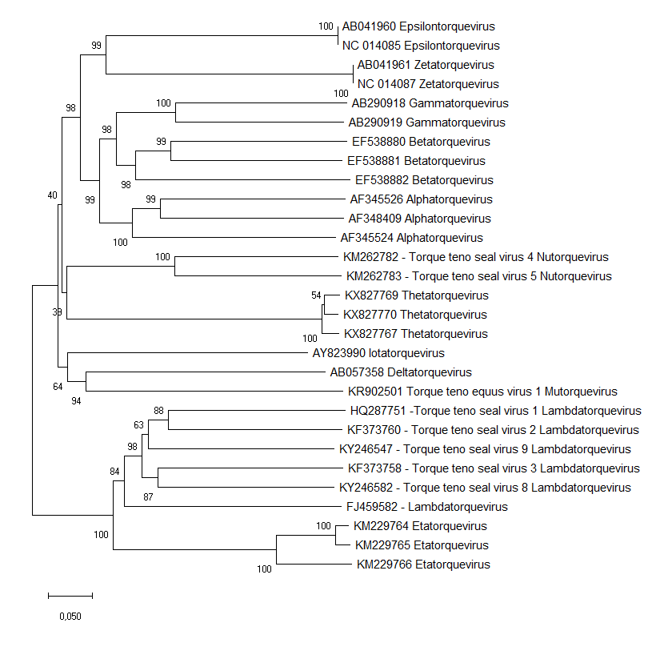

Figure 1. NJ phylogenetic tree built with anellovirus ORF1 sequences showing placement of new genera Mutorquevirus, Nutorquevirus and new lambdatorqueviruses found in seals within family Anelloviridae.
The evolutionary history was inferred using the Neighbor-Joining method. The percentage of replicate trees in which the associated taxa clustered together in the bootstrap test (1000 replicates) are shown next to the branches. The tree is drawn to scale, with branch lengths in the same units as those of the evolutionary distances used to infer the phylogenetic tree. The evolutionary distances were computed using the p-distance method and are in the units of the number of base differences per site. Only virus species proposed in this proposal are by their names.

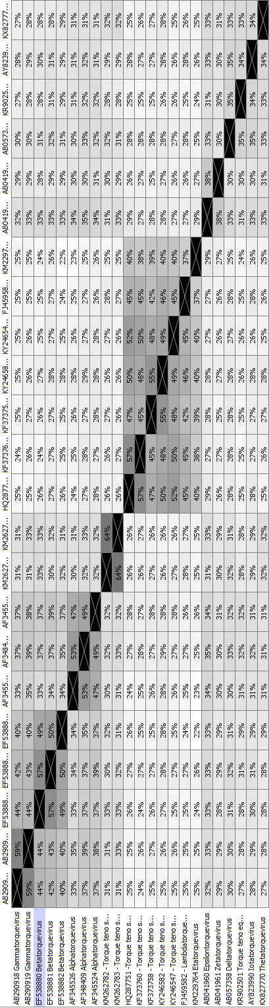
Table 1. Analysis of the distribution of pairwise identities of new proposed anellovirus species and genera.

References:
Bodewes, R., Rubio Garcia, A., Wiersma, L.C., Getu, S., Beukers, M., Schapendonk, C.M., van Run,P.R., van de Bildt, M.W., Poen, M.J., Osinga, N., Sanchez Contreras, G.J., Kuiken, T., Smits, S.L. and Osterhaus, A. (2013) Novel B19-like parvovirus in the brain of a harbor seal. PLoS ONE 8 (11): e79259.
Fahsbender, E., Burns, J.M., Kim, S., Kraberger, S., Frankfurter, G., Eilers, A.A., Shero, M.R., Beltran, R., Kirkham, A., McCorkell, R., Berngartt, R.K., Male, M.F., Ballard, G., Ainley, D.G., Breitbart, M. and Varsani, A. (2017) Diverse and highly recombinant anelloviruses associated with Weddell seals in Antarctica. Virus Evol 3 (1): VEX017.
Li, L., Giannitti, F., Low, J., Keyes, C., Ullmann, L.S., Deng, X., Aleman,M., Pesavento, P.A., Pusterla, N. and Delwart, E., (2015) Exploring the virome of diseased horses. J Gen Virol 96 (9): 2721-2733.

