This Word module should be used for all taxonomic proposals.
Please complete Part 1 and:
either Part 3 for proposals to create new taxa or change existing taxa
or Part 2 for proposals of a general nature.
Submit the completed Word module, together with the accompanying Excel module named in Part 3, to the appropriate ICTV Subcommittee Chair.
For guidance, see the notes written in blue, below, and the help notes in file Taxonomic_Proposals_Help_2018.
Part 1: TITLE, AUTHORS, etc

Code assigned: | 2018.003D |  | (to be completed by ICTV officers)
Short title: 10 new species in the genus Circovirus and 2 new species in the genus Cyclovirus
Author(s):
Arvind Varsani
Corresponding author with e-mail address:
Arvind.varsani@asu.edu
List the ICTV study group(s) that have seen this proposal:
A list of study groups and contacts is provided at http://www.ictvonline.org/subcommittees.asp . If in doubt, contact the appropriate subcommittee chair (there are six virus subcommittees: animal DNA and retroviruses, animal ssRNA-, animal ssRNA+, fungal and protist, plant, bacterial and archaeal) |  | Circoviridae SG
ICTV Study Group comments (if any) and response of the proposer:
Date first submitted to ICTV: |  |  | 28 May 2018
Date of this revision (if different to above): |  |  | 12 June 2018

ICTV-EC comments and response of the proposer:

Part 3: PROPOSED TAXONOMY

Name of accompanying Excel module: 2018.003D.N.v1.circoviridae_12sp
The taxonomic changes you are proposing should be presented on an accompanying Excel module, 2017_TP_Template_Excel_module. Please enter the file name of the completed module in this box.
Supporting material:

Rosario et al. (2017) reviewed the taxonomy of the family Circoviridae and, following analyses of the distribution of percentage pairwise identities (PI) among cyclovirus and circovirus genomes, recommended a 80% PI threshold for species level classification within this family. Currently there are 29 circovirus species and 45 cyclovirus species recognized by ICTV.

Over the last year, 21 new circoviruses and three new cycloviruses which share <80% PI to currently classified viruses have been identified. Using the PI based classification recommended for viruses in the family Circoviridae, the 21 circoviruses can be classified into 10 species (Table 1; Figure 1) and each of the three cycloviruses represent a new species (Table 2; Figure 2)

Circovirus
The 21 new circoviruses have been identified in bats (n=11), rodents (n=7) and ticks (n=3). Based on PIs coupled with phylogenetic support (Figure 1) these can be classified into 10 species

- Bat associated circovirus 10 (10 isolates which share genome-wide 97-98% PI) (Zhu et al., 2018)
- Bat associated circovirus 11 (1 isolate) (Zhu et al., 2018)
- Rodent associated circovirus 1 (1 isolate)
  - Genbank submission information: Wu, Z., Du, J. and Jin, Q. (2017) Virome analysis of rodents and other small animals from China – no publication available
- Rodent associated circovirus 2 (1 isolate)
  - Genbank submission information: Wu, Z., Du, J. and Jin, Q. (2017) Virome analysis of rodents and other small animals from China – no publication available
- Rodent associated circovirus 3 (1 isolate)
  - Genbank submission information: Wu, Z., Du, J. and Jin, Q. (2017) Virome analysis of rodents and other small animals from China – no publication available
- Rodent associated circovirus 4 (2 isolates which share genome-wide 91% identity)
- Rodent associated circovirus 5 (1 isolate)
  - Genbank submission information: Wu, Z., Du, J. and Jin, Q. (2017) Virome analysis of Rodents and other small animals from China – no publication available
- Rodent associated circovirus 6 (1 isolate)
  - Genbank submission information: Wu, Z., Du, J. and Jin, Q. (2017) Virome analysis of rodents and other small animals from China – no publication available
- Tick associated circovirus 1 (1 isolate) (Tokarz et al., 2018)
- Tick associated circovirus 2 (2 isolates which share genome-wide 100% identity) (Wang et al., 2018)

Table 1: Details regarding proposed new isolates and species belonging to the genus Circovirus
Species name | GenBank accession | Virus acronym | isolate ID | Country of isolate | Host/isolation source
Bat associated circovirus 10 | KX756986 | BatACV10 | Acheng30 | China | Vespertilio sinensis
 | KX756987 |  | Acheng1 | China | Vespertilio sinensis
 | KX756992 |  | Acheng8 | China | Vespertilio sinensis
 | KX756988 |  | Acheng3 | China | Vespertilio sinensis
 | KX756993 |  | Daqing7 | China | Vespertilio sinensis
 | KX756991 |  | Acheng27 | China | Vespertilio sinensis
 | KX756989 |  | Acheng10 | China | Vespertilio sinensis
 | KX756995 |  | Acheng2 | China | Cimex adjunctus
 | KX756990 |  | Acheng14 | China | Vespertilio sinensis
 | KX756994 |  | Daqing3 | China | Vespertilio sinensis
Bat associated circovirus 11 | KX756996 | BatACV11 | Mengyuan2 | China | Hipposideros armiger
Rodent associated circovirus 1 | KY370034 | RoACV1 | RtMc-CV-1/Tibet2014 | China | Neodon clarkei
Rodent associated circovirus 2 | KY370042 | RoACV2 | RtAc-CV-2/GZ2015 | China | Apodemus chevrieri
Rodent associated circovirus 3 | KY370039 | RoACV3 | RtMc-CV-2/Tibet2014 | China | Neodon clarkei
Rodent associated circovirus 4 | KY370029 | RoACV4 | RtAs-CV/IM2014 | China | Allactaga sibirica
 | KY370038 |  | RtDs-CV/IM2014 | China | Dipus sagitta
Rodent associated circovirus 5 | KY370027 | RoACV5 | RtNe-CV/YN2013 | China | Niviventer eha
Rodent associated circovirus 6 | KY370037 | RoACV6 | RtAd-CV/SAX2015 | China | Apodemus draco
Tick associated circovirus 1 | KU230452 | TiACV1 | A1 | USA | Ixodes scapularis
Tick associated circovirus 2 | KX987146 | TiACV2 | hlj-Ic.518 | China: Heilongjiang | Ixodes crenulatus
 | KX987147 |  | hlj-hl499 | China: Heilongjiang | Haemaphysalis longicornis

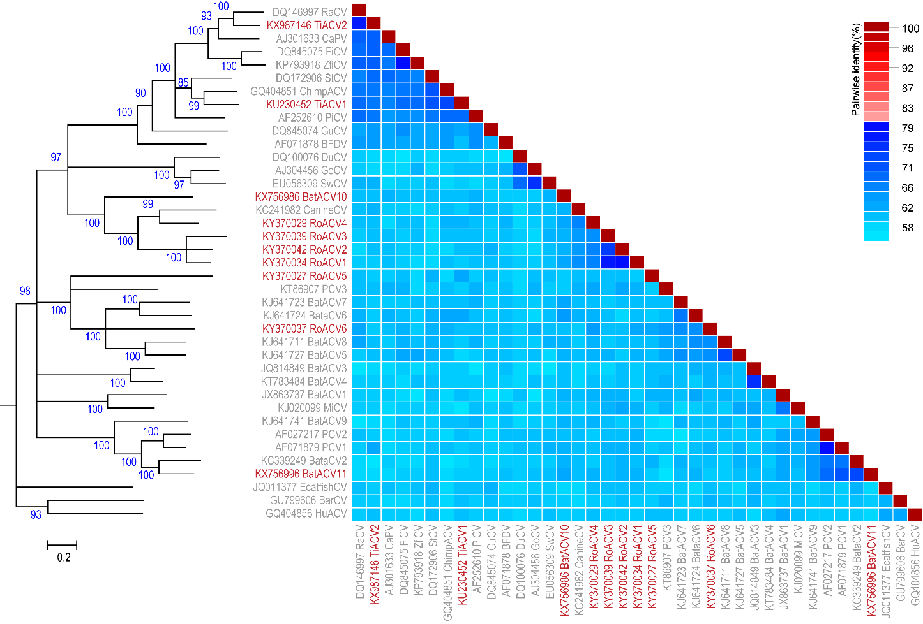
Figure 1: Maximum likelihood phylogenetic tree (rooted with reverse complement sequences of cycloviruses) of representative genomes from each circovirus species inferred using PHYML (Guindon et al., 2010) with GTR+I+G4 chosen as the best fit model and a ‘two colour’ pairwise identity matrix inferred using SDT v1.2 (Muhire et al., 2014). Sequences of representative isolates for each new species are highlighted in red font.

Cyclovirus

The new cyclovirus species have been identified in a duck and rodents. PIs coupled with phylogenetic analyses (Figure 2) support the classification of these viruses into three new species.

- Duck associated cyclovirus 1 (1 isolate) (Feher et al., 2017) – please note that a separate proposal has been submitted by the researchers who identified this virus.
- Rodent associated cyclovirus 1 (1 isolate)
  - Genbank submission information: Wu, Z., Du, J. and Jin, Q. (2017) Virome analysis of rodents and other small animals from China – no publication available
- Rodent associated cyclovirus 2 (1 isolate)
  - Genbank submission information: Wu, Z., Du, J. and Jin, Q. (2017) Virome analysis of rodents and other small animals from China – no publication available

Table 2: Details regarding proposed new isolates and species belonging to the genus Cyclovirus
Species name | GenBank accession | Virus acronym | isolate ID | Country of isolate | Host / isolation source
Duck associated cyclovirus 1 | KY851116 | DuACyV1 | DuACyV-1/1 | Hungary | Anas platyrhynchos  (cloacal swab)
Rodent associated cyclovirus 1 | KY370028 | RoACyV1 | RtRf-CV-2/YN2013 | China | Rattus flavipectus
Rodent associated cyclovirus 2 | KY370026 | RoACyV2 | RtRs-CV/YN2013 | China | Rattus rattus sladeni

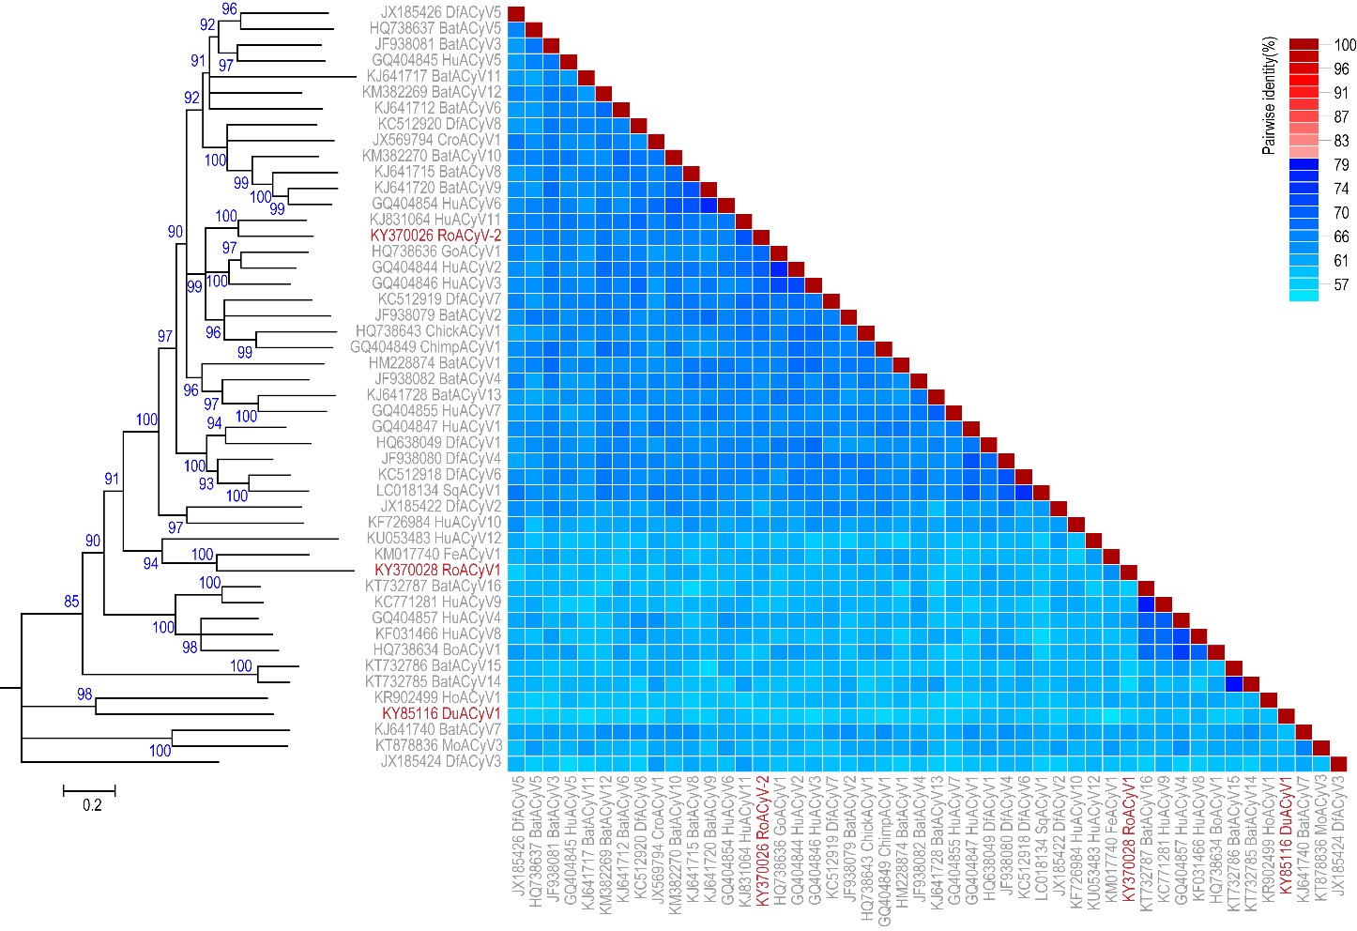
Figure 2: Maximum likelihood phylogenetic tree (rooted with reverse complement sequences of circoviruses) of representative genomes from each cyclovirus species inferred using PHYML (Guindon et al., 2010) with GTR+I+G4 chosen as the best fit model and a ‘two colour’ pairwise identity matrix inferred using SDT v1.2 (Muhire et al., 2014). Sequences of representative isolates for each new species are highlighted in red font.

Notes:

- A separate proposal has been submitted from the scientist that identified duck associated cyclovirus 1.

- A sequence (accession KY370032) labelled as rodent circovirus isolate RtCb-CV-3/HeB2014 is a cyclovirus and shares 82% PI with cyclovirus isolate TsCyV-1_JP-NUBS-2014 (accession # LC018134) which is assigned to species Squirrel associated cyclovirus 1. Hence rodent circovirus isolate RtCb-CV-3/HeB2014 is assigned to the species Squirrel associated cyclovirus 1.

References:
Feher, E., Kaszab, E., Forro, B., Bali, K., Marton, S., Lengyel, G., Banyai, K., 2017. Genome sequence of a mallard duck origin cyclovirus, DuACyV-1. Arch Virol 162, 3925-3929.
Guindon, S., Dufayard, J.F., Lefort, V., Anisimova, M., Hordijk, W., Gascuel, O., 2010. New algorithms and methods to estimate maximum-likelihood phylogenies: assessing the performance of PhyML 3.0. Syst Biol 59, 307-321.
Muhire, B.M., Varsani, A., Martin, D.P., 2014. SDT: a virus classification tool based on pairwise sequence alignment and identity calculation. PLoS One 9, e108277.
Rosario, K., Breitbart, M., Harrach, B., Segales, J., Delwart, E., Biagini, P., Varsani, A., 2017. Revisiting the taxonomy of the family Circoviridae: establishment of the genus Cyclovirus and removal of the genus Gyrovirus. Arch Virol 162, 1447-1463.
Tokarz, R., Sameroff, S., Tagliafierro, T., Jain, K., Williams, S.H., Cucura, D.M., Rochlin, I., Monzon, J., Carpi, G., Tufts, D., Diuk-Wasser, M., Brinkerhoff, J., Lipkin, W.I., 2018. Identification of novel viruses in Amblyomma americanum, Dermacentor variabilis, and Ixodes scapularis ticks. mSphere 3, e00614-17.
Wang, B., Sun, L.D., Liu, H.H., Wang, Z.D., Zhao, Y.K., Wang, W., Liu, Q., 2018. Molecular detection of novel circoviruses in ticks in northeastern China. Ticks Tick Borne Dis 9, 836-839.
Zhu, A., Jiang, T., Hu, T., Mi, S., Zhao, Z., Zhang, F., Feng, J., Fan, Q., He, B., Tu, C., 2018. Molecular characterization of a novel bat-associated circovirus with a poly-T tract in the 3' intergenic region. Virus Res 250, 95-103.

