This Word module should be used for all taxonomic proposals.
Please complete Part 1 and:
either Part 3 for proposals to create new taxa or change existing taxa
or Part 2 for proposals of a general nature.
Submit the completed Word module, together with the accompanying Excel module named in Part 3, to the appropriate ICTV Subcommittee Chair.
The Word module explains and justifies your proposal. The Excel module is a critical document that will be used to implement the proposed taxonomic changes once they are approved and ratified. If proposals presented in the Word module are not presented accurately in the Excel module, the taxonomic changes cannot proceed.
For guidance, see the notes written in blue, below, and the Help Notes in file Taxonomic_Proposals_Help_2019.

Part 1: TITLE, AUTHORS, etc

Code assigned: | 2019.012P
Short title: Establishment of a new genus (Ravavirus) in the family Betaflexiviridae
Author(s) and email address(es):
Thekke-Veetil T, Tzanetakis I |  | thanujatv@gmail.com;  itzaneta@uark.edu
Corresponding author
Thanuja Thekke-Veetil

List the ICTV study group(s) that have seen this proposal:
A list of study groups and contacts is provided at http://www.ictvonline.org/subcommittees.asp . If in doubt, contact the appropriate subcommittee chair (there are six virus subcommittees: animal DNA and retroviruses, animal ssRNA-, animal ssRNA+, fungal and protist, plant, bacterial and archaeal) |  |  | Beta- Gamma-, Deltaflexiviridae Study Group
ICTV Study Group comments (if any) and response of the proposer:
Date first submitted to ICTV:
Date of this revision (if different to above):

ICTV-EC comments and response of the proposer:

Part 2: NON-STANDARD
Template for any proposal regarding ICTV procedures, rules or policy, not involving the creation of new taxonomy.
Text of proposal:

Part 3: PROPOSED TAXONOMY

Name of accompanying Excel module: 2019.012P.A.v1.Betaflexiviridae_1gen.xlsx

A novel virus, named Ribes americanum virus A (RAVA), was discovered from a symptomatic American blackcurrant (Ribes americanum) plant by next-generation sequencing (Thekke-Veetil et al., 2018). RAVA has a unique genome organization sharing the molecular features of members of the family Betaflexiviridae in the order Tymovirales.
The complete genome of RAVA isolate Oregon (Genbank acession number MF166685) is 7106 nucleotides long (excluding the poly-A tail) and encodes five open reading frames (ORFs) (Figure 1). The genome begins with GAAAA_{1–5}, a pentanucleotide motif that is conserved in members of the Betaflexiviridae (Sabanadzovic et al., 2011; Villamor et al., 2013). ORF1 is separated from the other ORFs by an intergenic region, while ORFs 2-5 overlap.
The ORF1 encodes a putative viral replicase of 207K, with methyltransferase, AlkB, helicase, and RNA-dependent RNA polymerase (RdRp) domains that are present in the replicases of members of the Betaflexiviridae. The size of the replicase is characteristic of a ‘carlavirus-like replicase’ (>195 K) compared to the ‘potex-like replicase’ (<195 K) (Adams et al., 2004). However, the replicase of RAVA shares low amino acid (aa) identities with members of the family, showing the highest identity (22%) to the orthologs in carrot Ch virus 1 and apple chlorotic leaf spot virus.
Proteins encoded by ORF2 to ORF4 of RAVA did not exhibit significant homology to any viral proteins. However, the genome organization downstream of the putative replicase resembles that of members of the order Tymovirales with triple gene block (TGB) movement proteins.
Potex-like TGB proteins (TGBp) occur in the order of TGBp1, TGBp2 and TGBp3 (~25 K, ~12K and ~7K respectively) and have certain common molecular features. The TGBp1 has a NTP binding helicase domain of superfamily 1 (SF1) that has ATPase, RNA binding and RNA helicase activity. The TGBp2 has two transmembrane domains while TGBp3 has only one. The ORF2 of RAVA encodes a putative peptide of 4K predicted to contain a single transmembrane domain, whereas the ORF3 product (7K) has two predicted transmembrane domains. The 18K ORF4-encoded protein shows marginal identity (24% identity, blossom 45) with a bacterial SF1 ATP-dependent DNA helicase domain. This protein was predicted to contain positively charged RNA binding amino acids (as in the case of potexviral TGBp1) which are essential for the interaction with RNA (Morozov and Solovyev, 2003). Considering the overlapping arrangement and characteristics of encoded proteins we hypothesize that ORFs 2-4 products of RAVA constitute TGB movement proteins. However, the RAVA TGB proteins differ significantly from potex-like TGB proteins with respect to the proteins’ size and the reverse order of arrangement (Figure 1).

The ORF5 of RAVA encodes a 37K protein that contains several Arg residues predicted to bind RNA, as well as two Glu residues (Glu ₂₈₀,Glu₂₈₃) predicted to be involved in Ca²⁺ binding. Arg-rich RNA binding motifs and calcium cations are important in the assembly and disassembly of virions, respectively (Gajardo et al., 1997). The size of the protein is similar to those of the Tymovirales members that have TGB movement proteins (28-45K; Figure 1). Considering the position of the protein in the genome, predicted size, Arg-rich RNA binding regions, and presence of Ca²⁺ binding sites, we suggest that the 37K protein is the CP of RAVA.

The phylogenetic analysis based on the RAVA CP with representative members of all genera in the Tymovirales yielded an unreliable phylogram due to the highly diverse nature of CPs. The analyses based on RdRp and MTR domains placed RAVA with members of the Betaflexiviridae (Figure 2A and 2B).

RAVA belongs to the tymo-like lineage with respect to its genome organization, number of genes encoded in the genome, presence of the conserved pentanucleotide at the 5′ termini and a carlavirus-like replicase, as well as phylogenetic clustering based on the RdRp and MTR domains. However, RAVA has a unique genome organization and encodes proteins that are not similar to any of the viruses belonging to the established genera in the Tymovirales. Thus, RAVA should be given a new taxonomical status in the Betaflexiviridae:

I. The genome is unique in a way that its polymerase is Trivirinae-like but the remaining of the genome is Quinvirinae-like (Figure 1) in which the TGBp-like proteins’ organization is reversed.
II. The RAVA genome differes significantly from genomes of members of established taxa in the Tymovirales, with no detectable amino acid similarity to any known viral proteins with regards to the putative TGB MP encoded by ORFs2-4 and CP encoded by ORF5.
III. Although RAVA clusters with Betaflexiviridae members in the phylogenetic grouping based on the RdRp and MTR conserved domains, it shares very low aa identity of the replicase protein with members of the family (22% being the highest).

Therefore, we suggest that RAVA should be classified as a new species, named Ribes americanum virus A, in a new, monotypic genus in the family Betaflexiviridae for which the name Ravavirus (from the acronym of the sole and type member of the genus) is proposed.

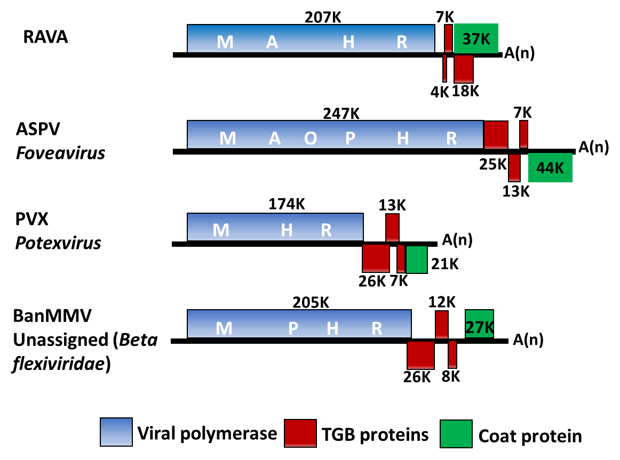

Figure 1. Schematic representation of the genome of Ribes americanum virus A (RAVA) in comparison to the genomes of members of Tymovirales with triple gene block (TGB) movement proteins. M-methyltransferase, A-AlkB, O-OTu-like peptidase, P-papain-like protease, H-helicase, and R-RNA-dependent RNA polymerase. Size of the proteins encoded in the ORFs is indicated. Acronyms: ASPV, apple stem pitting virus; PVX, potato virus X; BanMMV, banana mild mosaic virus.

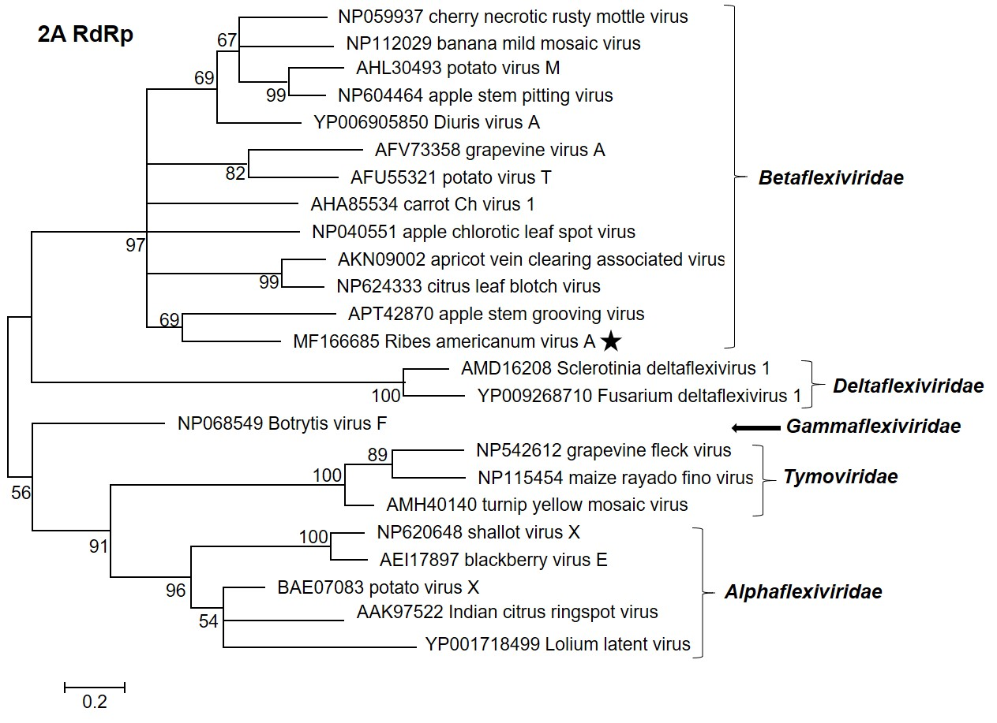

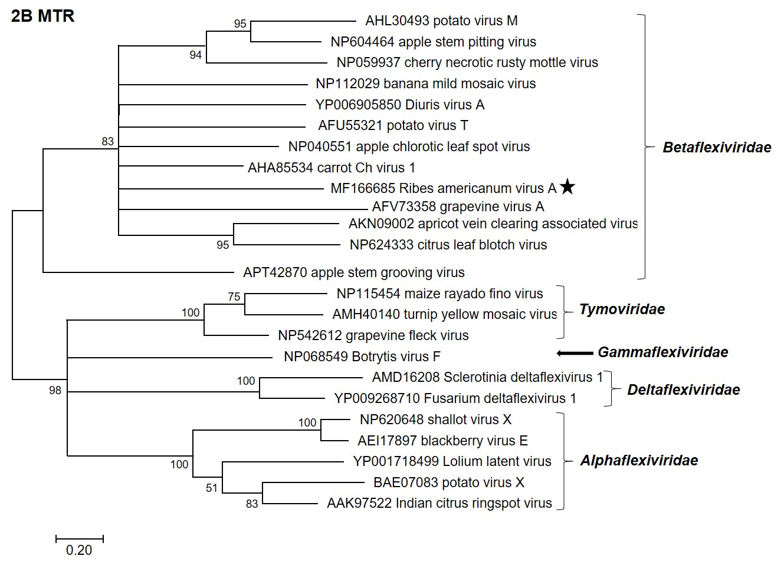

Figure 2. Phylogenetic relationship of Ribes americanum virus A with Tymovirales members. Phylogenetic analyses were performed using the conserved motifs of RNA-dependent RNA polymerase (RdRp; 2A) and methyltransferase (MTR; 2B). The trees were generated by the maximum likelihood method using MEGA 7 and bootstrap values were estimated using 1000 bootstrap replicates.

References:
Adams, M.J.; Antoniw, J.F.; Bar-Joseph, M.; Brunt, A.A.; Candresse, T.; Foster, G.D.; Martelli, G.P.; Milne, R.G.; Fauquet, C.M. The new plant virus family Flexiviridae and assessment of molecular criteria for species demarcation. Arch. Virol. 2004, 149:1045-1060.
Gajardo, R.; Vende, P.; Poncet, D.; Cohen, J. Two proline residues are essential in the calcium-binding activity of rotavirus VP7 outer capsid protein. J. Virol. 1997, 71:2211-2216.
Morozov, S.Y.; Solovyev, A.G. Triple gene block: Modular design of a multifunctional machine for plant virus movement. J. Gen. Virol. 2003, 84:1351-1366.
Sabanadzovic, S.; Abou Ghanem-Sabanadzovic, N.; Tzanetakis, I.E. Blackberry virus E: An unusual flexivirus. Arch. Virol. 2011, 156:1665-1669.
Thekke-Veetil, T.; Ho, T.; Postman, J.D.; Martin, R.R.; Tzanetakis, I.E. A virus in American blackcurrant (Ribes americanum) with distinct genome features reshapes classification in the Tymovirales. Viruses, 2018, 10:406.
Villamor, D.V.; Druffel, K.L.; Eastwell, K.C. Complete nucleotide sequence of a virus associated with rusty mottle disease of sweet cherry (Prunus avium). Arch. Virol. 2013, 158:1805-1810.

