This Word module should be used for all taxonomic proposals.
Please complete Part 1 and:
either Part 3 for proposals to create new taxa or change existing taxa
or Part 2 for proposals of a general nature.
Submit the completed Word module, together with the accompanying Excel module named in Part 3, to the appropriate ICTV Subcommittee Chair.
The Word module explains and justifies your proposal. The Excel module is a critical document that will be used to implement the proposed taxonomic changes once they are approved and ratified. If proposals presented in the Word module are not presented accurately in the Excel module, the taxonomic changes cannot proceed.
For guidance, see the notes written in blue, below, and the Help Notes in file Taxonomic_Proposals_Help_2019.
Part 1: TITLE, AUTHORS, etc

Code assigned: | 2019.011P
Short title: Create one new species (Pistacia emaravirus B) in the genus Emaravirus, family Fimoviridae
Author(s) and email address(es):
Buzkan N, Chiumenti M, Massart S, Sarpkaya K, Karadağd S, Minafra A |  | nbuzkan@ksu.edu.tr;  michela.chiumenti@ipsp.cnr.it;  sebastien.massart@ulg.ac.be;  kamilsarpkaya@gmail.com;  angelantonio.minafra@ipsp.cnr.it
Corresponding author
Minafra A
List the ICTV study group(s) that have seen this proposal:
A list of study groups and contacts is provided at http://www.ictvonline.org/subcommittees.asp . If in doubt, contact the appropriate subcommittee chair (there are six virus subcommittees: animal DNA and retroviruses, animal ssRNA-, animal ssRNA+, fungal and protist, plant, bacterial and archaeal) |  |  | ICTV Emaravirus study group
ICTV Study Group comments (if any) and response of the proposer:
Date first submitted to ICTV:
Date of this revision (if different to above):

ICTV-EC comments and response of the proposer:

Part 2: NON-STANDARD
Template for any proposal regarding ICTV procedures, rules or policy, not involving the creation of new taxonomy.
Text of proposal:

Part 3: PROPOSED TAXONOMY

Name of accompanying Excel module: 2019.011P.A.v1.Emaravirus_1sp.xlxs

Pistacia emaravirus B (PiVB) shares at the molecular and biological levels high similarities with members of the genus Emaravirus, which currently comprises the following species: Fig mosaic emaravirus (virus acronym: FMV), Rose rosette emaravirus (RRV), Raspberry leaf blotch emaravirus (RLBV), Pigeonpea sterility mosaic emaravirus 1 (PPSMV-1), Pigeonpea sterility mosaic emaravirus 2 (PPSMV-2), High Plains wheat mosaic emaravirus (HPWMV), Redbud yellow ringspot-associated emaravirus (RYRSaV), Actinidia chlorotic ringspot-associated emaravirus (AcCRaV) and European mountain ash ringspot-associated emaravirus (EMARaV) as the type species of the genus (Elbeaino et al., 2018; Mielke and Muehlbach, 2007).

Virus properties
- Virus particles: supposed to be similar to those of emaraviruses, i.e. double-membraned bodies (DMB).
- Genome: composed of seven segments of negative sense ssRNA, resembling those of members of the genus Emaravirus. RNA-1, 7,027 nt; RNA-2, 2,244 nt; RNA-3, 1525 nt; RNA-4, 1550 nt; RNA-5, 1711-1716 nt; RNA-6, 1340 nt; RNA-7, 1709 nt (Buzkan et al., 2019). Each segment is monocistronic, encoding a single protein translated from the complementary strand.
- Virus-encoded proteins: RNA-dependent RNA-polymerase (p1), 268.6 kDa; putative glycoprotein precursor (p2), 73.5 kDa (Gn 21.8 kDa and Gc 51.7 kDa); putative nucleocapsid protein (p3), 34.3 kDa; putative movement protein (p4), 40.7 kDa; p5 (function unknown), 56.6-57.3 kDa; p6 (function unknown), 27.8 kDa; p7.
- Phylogenetic relationships: phylogenetic trees based on RdRp and NC proteins resulted in similar topologies, with PiVB as a distinct speciation line outside the subclade which contains RRV, BLMaV, FMV and PPSMV-2 (Figure 1). The aa sequence identity between the PiVB proteins and proteins from these four emaraviruses was from 67.8% to 70.8% for RdRp and NC.
- Experimental transmission: transmission by eriophyid mites is suspected.
- Natural host range: pistachio (Pistacia vera) and P. khinjuk plants.

References:
Buzkan N., Chiumenti M., Massart S., Sarpkaya K., Karadağ S., Minafra A. (2019) A new emaravirus discovered in Pistacia fromTurkey. Virus Research 263:159-163.
Elbeaino T., Digiaro M., Mielke-Ehret N., Muehlbach H.P., Martelli G.P., ICTV Report Consortium (2018) ICTV Virus Taxonomy Profile: Fimoviridae. Journal of General Virology 99:1478-1479.
Mielke N., Muehlbach, H.P. (2007) A novel, multipartite, negative-strand RNA virus is associated with the ringspot disease of European mountain ash (Sorbus aucuparia L.). Journal of General Virology, 88:1337-1346.

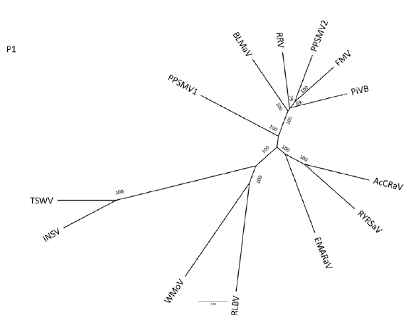
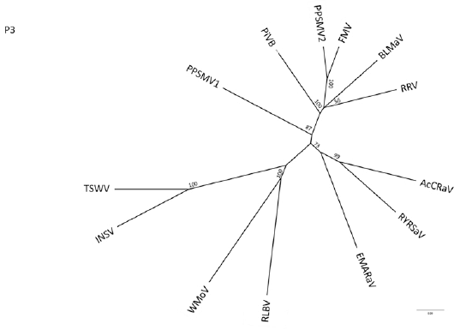

Figure 1. Phylogeny for PiVB p1 and p3 among emaraviruses and tospoviruses. Neighbor-joining tree with reproduced bootstrap replicates indicated at the nodes. Actinidia chlorotic ringspot-associated virus (AcCRaV: p1,YP_009507925; p3,YP_009507928), blackberry leaf mottle- associated virus (BLMaV: p1, AQX45473; p3, AQX45475), European mountain ash ringspot-associated virus (EMARaV: p1, AAS73287; p3, ABH05070), redbud yellow ringspot-associated virus (RYRSaV: p1, AEO95760; p3, AEO95762), pigeonpea sterility mosaic virus 1 (PPSMV-1: p1, CCP46989; p3, CCP46991), pigeonpea sterility mosaic virus 2 (PPSMV-2: p1, CCV01186; p3, CCV01188), fig mosaic virus (FMV: p1, C0H5V4; p3, C7TQB3), rose rosette virus (RRV: p1, YP_004327589; p3, YP_004327591), raspberry leaf blotch virus (RLBV: p1, CBZ42024; p3, CBZ42026), High Plains wheat mosaic virus (HPWMV: p1, AIK23031; p3, AIK23033), Impatiens necrotic spot virus (INSV: p1, NP_619710; p3, NP_619709), tomato spotted wilt virus (TSWV: p1, BAA00955; p3,NP_049361).

