This Word module should be used for all taxonomic proposals.
Please complete Part 1 and:
either Part 3 for proposals to create new taxa or change existing taxa
or Part 2 for proposals of a general nature.
Submit the completed Word module, together with the accompanying Excel module named in Part 3, to the appropriate ICTV Subcommittee Chair.
The Word module explains and justifies your proposal. The Excel module is a critical document that will be used to implement the proposed taxonomic changes once they are approved and ratified. If proposals presented in the Word module are not presented accurately in the Excel module, the taxonomic changes cannot proceed.
For guidance, see the notes written in blue, below, and the Help Notes in file Taxonomic_Proposals_Help_2019.
Part 1: TITLE, AUTHORS, etc

Code assigned: | 2019.008P
Short title: Create three subgenera in the genus Sadwavirus
Author(s) and email address(es):
List authors in a single line Archives of Virology citation format (e.g. Smith AB, Huang C-L, Santos, F) |  | Provide email address for each author in a single line separated by semi-colons
Sanfaçon H, Dasgupta I, Fuchs M, Karasev A, Petrzik K, Thompson JR, Tzanetakis I, van der Vlugt R, Wetzel T, Yoshikawa N |  | Helene.Sanfacon@canada.ca; indranil58@yahoo.co.in; marc.fuchs@cornell.edu; akarasev@uidaho.edu; petrzik@umbr.cas.cz; jrt36@cornell.edu; itzaneta@uark.edu; rene.vandervlugt@wur.nl; thierry.wetzel@dlr.rlp.de; yoshikawa@iwate-u.ac.jp
Author(s) institutional address(es) (optional):
Provide institutional addresses, each on a single line followed by author(s) initials (e.g. University of Woolloomooloo [SAB, HCL])

Corresponding author
Hélène Sanfaçon
List the ICTV study group(s) that have seen this proposal:
A list of study groups and contacts is provided at http://www.ictvonline.org/subcommittees.asp . If in doubt, contact the appropriate subcommittee chair (there are six virus subcommittees: animal DNA and retroviruses, animal ssRNA-, animal ssRNA+, fungal and protist, plant, bacterial and archaeal) |  | Secoviridae
ICTV Study Group comments (if any) and response of the proposer:
Date first submitted to ICTV:
Date of this revision (if different to above):

ICTV-EC comments and response of the proposer:

Part 2: NON-STANDARD
Template for any proposal regarding ICTV procedures, rules or policy, not involving the creation of new taxonomy.
Text of proposal:

Part 3: PROPOSED TAXONOMY

Name of accompanying Excel module: 2019.008P.A.v1.Sadwavirus_3subg.xlxs

Supporting material:
The family Secoviridae in the order Picornavirales is currently composed of eight genera; three in the subfamily Comovirinae (Comovirus, Fabavirus, Nepovirus) and the genera Sadwavirus, Torradovirus, Cheravirus, Sequivirus and Waikavirus (Thompson et al, 2017). Within the family, phylogenetic relationships have been used to distinguish genera and subfamilies. In particular, the so-called “Pro-Pol” sequence, which is defined as the sequence between the conserved catalytic cysteine (or serine) of the 3C-like protease and the GDD motif of the RNA-dependent RNA polymerase has been used to refine the taxonomy of the family Secoviridae and its relationship to other members of the order (Sanfaçon et al, 2009, Le Gall et al, 2008). Other criteria have been used to distinguish genera in the family: (1) number of genomic RNAs (one for sequiviruses and waikaviruses, two for all other genera), (2) the number of protein domains and/or processing sites within the polyproteins, (3) the number of CPs (one CP of 53-60 kDa for nepoviruses; two CPs of 35-40 kDa and 20-25 kDa for comoviruses, fabaviruses and sadwaviruses; and three CPs of 20-25 kDa for cheraviruses, torradoviruses, sequiviruses and waikaviruses), (4) presence of additional ORFs (e.g., one addition ORF on the RNA2 of torradoviruses in addition to the large polyprotein) and/or subgenomic RNAs. Not all criteria need to be met simultaneously.

The genus Sadwavirus was created in 2004 and originally included the species Satsuma dwarf virus (SDV), Strawberry latent ringspot virus (SLRSV) and Strawberry mottle virus (SMoV). At the time, few secovirid sequences were available and phylogenetic relationships could not be clearly established. SDV and SLRSV shared the common property of having two CPs, while the number of CPs of SMoV isolates had not been experimentally determined, owing to difficulties with purifying this virus (Thompson et al, 2002). In 2009, SLRSV and SMoV were demoted from the genus. SLRSV does not branch together with SDV in the Pro-Pol tree, rather it is more closely related (although distantly) to cheraviruses (Le Gall et al, 2007) (see Fig. 1). SMoV was related to SDV in the Pro-Pol tree but the number of protein domains in the RNA2 polyprotein was unclear, in particular the number of CPs. Black raspberry necrosis virus (BRNV) is closely related to Strawberry mottle virus (Halgreen et al, 2007). The number of protein domains in the RNA2 polyprotein (including the CPs) of BRNV has also not been determined experimentally and BRNV was placed as an unassigned species in the family Secoviridae in 2009. In 2016 and 2017, two additional unassigned species were created in the family: Chocolate lily virus A (CLVA) and Dioscorea mosaic associated virus (DMaV) (Wylie et al, 2012; Hayashi et al, 2016). These viruses also showed phylogenetic relationships to SDV, BRNV and SMoV in the Pro-Pol tree (Fig. 1).

Recent analysis of cleavage sites in the polyproteins of SMoV revealed that this virus encodes two proteases: the RNA1-encoded 3C like protease which is common to all viruses in the family (a characteristic also shared with other members of the order) and a novel RNA2-encoded glutamic protease (Mann et al, 2017; Mann et al, 2019). The RNA1 protease cleaves the RNA1 polyprotein at five sites, defining six domains on the polyprotein (Fig. 2). The presence of two protein domains upstream of the NTB (putative helicase) domain is a feature shared with nepoviruses. Examination of the polyproteins of BRNV, CLVA, DMaV and SDV revealed the presence of putative cleavage sites at similar position that would imply a similar organization of the RNA1 polyprotein (Mann et al, 2017) (Fig. 2). The RNA2 polyprotein of a Canadian isolate of SMoV (isolate NsPer3) was cleaved at one site (between the MP and CP domains) by the RNA1 encoded protease. It was also cleaved at two sites by the RNA2-encoded glutamic protease (Fig. 2) (Mann et al, 2019). Sequence comparison of SMoV and BRNV implied a similar genomic organization for BRNV (Fig. 2). These results strongly suggest that SMoV and BRNV have distinct characteristics that distinguish them from SDV. (1) they encode one large CP rather than two CPs, (2) the RNA2 polyprotein possesses additional protein domains downstream of the CP domain, including a glutamic protease domain. Point (2) is a new feature in the family Secoviridae. Signature sequences for the glutamic protease domain were not found in the RNA2 polyprotein of CLVA and DMaV. Prediction of cleavage sites recognized by the RNA1 encoded 3C-like protease suggested the presence of a single large CP for CLVA and DMaV, although this needs to be confirmed experimentally.

It was initially suggested that the presence of a novel protease domain in the RNA2 polyprotein could justify the creation of a new genus to encompass BRNV and SMoV (Mann et al, 2019). However, discussion within the Secoviridae Study Group suggested that phylogenetic relationships between BRNV, SMoV, SDV, CLVA and DMaV should also be recognized. It was finally decided that the best course of action may be to regroup the five species in the genus Sadwavirus and create subgenera to recognize the differences in the genomic organization of RNA2, including the presence (or not) of the glutamic protease.

Recent reexamination of phylogenetic relationships using the deduced amino acid sequence of the Pro-Pol region of type isolates for recognized species in the family confirms that SDV, SMoV, BRNV, CLVA and DMaV branch together as a single branch with a high degree of confidence. In addition, phylogenetic trees based on the CP sequences (which is defined by the mapping of the cleavage sites as shown in Fig. 2), also suggested a common branch for SDV, SMoV, BRNV, CLVA and DMaV although the bootstrap analysis revealed a weaker degree of confidence in the branching than with the Pro-Pol tree (Fig. 3).

Based on the above we propose the following revised taxonomy:

- Expansion of the genus Sadwavirus to include three subgenera (Satsumavirus, Stramovirus and Cholivirus) and five species (SMoV, BRNV, CLVA, DMaV and SDV), SDV remains the type species. Common characteristics of the genus Sadwavirus: group as a single branch in both the Pro-Pol and CP trees. Six protein domains in the RNA1 polyprotein. The name Sadwavirus is kept for the genus. Since SMoV was assigned to Sadwavirus between 2004 and 2009, this will prevent confusion.

- Creation of subgenus Satsumavirus, with SDV as the only species (proposed name derived from Satsuma dwarf virus). Characteristics of the sub-genus: one viral protease (the RNA1-encoded cysteine protease), two CPs, group as a single sub-branch in the Pro-Pol and CP trees.

- Creation of subgenus Stramovirus, encompassing SMoV and BRNV (proposed name derived from strawberry mottle virus, the best characterized virus). Characteristics of the sub-genus: Two viral proteases (the RNA1-encoded cysteine protease and the RNA2-encoded glutamic protease), a single large CP, group as a single sub-branch in the Pro-Pol and CP trees.

- Creation of subgenus Cholivirus, encompassing CLVA and DMaV (proposed name derived from Chocolate lily virus A, the first characterized species). Characteristics of the sub-genus: One viral protease (the RNA1-encoded cysteine protease), probably a single large CP (based on putative cleavage sites), group as a single sub-branch in the Pro-Pol and CP trees.

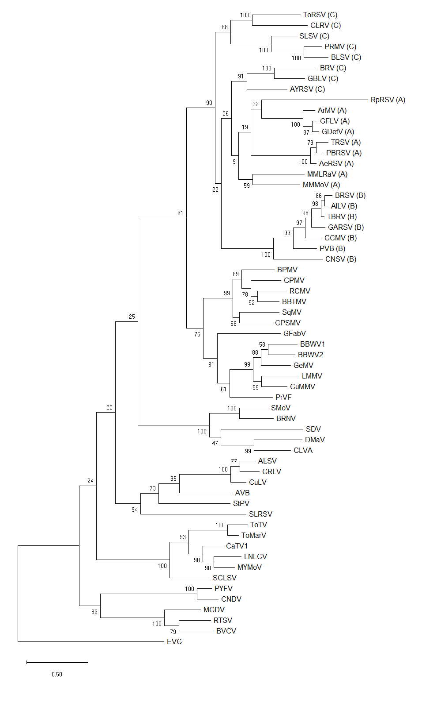
Stramovirus
Cholivirus
Satsumavirus
Sadwavirus
Nepovirus
Comovirus
Fabavirus
Cheravirus
Torradovirus
Sequivirus
Waikavirus
Comovirinae

Enterovirus C, Enterovirus, Picornaviridae (outgroup)

Figure 1. Maximum-likelihood phylogenetic analysis of the Pro-Pol amino acid sequence of type isolates from recognized species in the family Secoviridae. The alignment was generated using ClustalW in Mega X, the tree was also built in Mega X. Bootstrap values for each node are shown (1000 replicates). For each Secoviridae species, the sequence of the type isolate was used (for accession numbers and abbreviations, see the online Secoviridae Chapter of the Tenth ICTV report, https://talk.ictvonline.org/ictv-reports/ictv_online_report/positive-sense-rna-viruses/picornavirales/w/secoviridae). The Pro-Pol sequence of poliovirus (EVC: Enterovirus C, Accession number NP_041277, genus Enterovirus, family Picornaviridae) was used as an outgroup to root the tree. Higher taxa are indicated with the following code: the three proposed sub-genera in red, the genera in blue and the sub-family in green. In the case of nepoviruses, the letter in parenthesis after each virus abbreviation indicates the subgroups.

Figure 2. Protein domains and protease cleavage sites in the polyproteins of members of the proposed expanded genus Sadwavirus. Cleavage sites which were confirmed experimentally by Edman degradation sequencing or by mutagenesis are underlined. Other cleavage sites were deduced based on amino acid alignments of the entire RNA1 or RNA2 polyproteins. The genome organization of two representative members of the genus Nepovirus is shown as a comparison. Cleavage sites recognized by the RNA1-encoded 3C-like protease are shown in black (and blue arrow-heads). Cleavage sites recognized by the RNA2-encoded glutamic protease are shown in red (and red arrow-heads). For SMoV, the genomic organization of Canadian isolate SMoV-NsPer3 is shown. The German isolate SMoV-1134 differs in that it is missing the last protein domain of the RNA2 polyprotein, located after the glutamic protease domain.

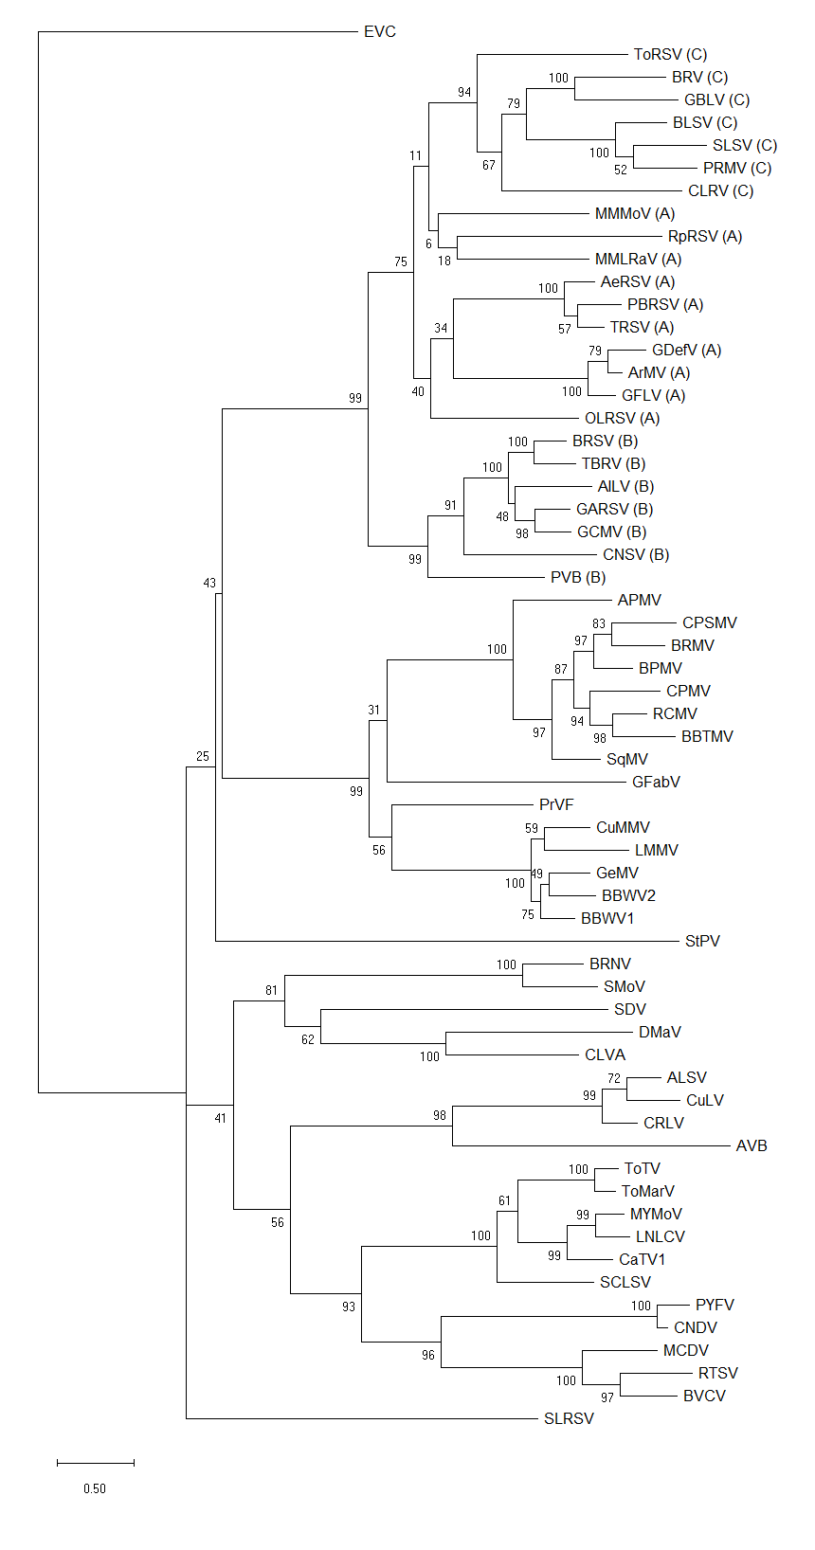
Stramovirus
Cholivirus
Satsumavirus
Sadwavirus
Nepovirus
Comovirus
Fabavirus
Cheravirus
Torradovirus
Sequivirus
Waikavirus
Enterovirus C, Enterovirus, Picornaviridae (outgroup)
Comovirinae
Cheravirus

Figure 3. Maximum-likelihood phylogenetic analysis of the CP amino acid sequence of type isolates from recognized species in the family Secoviridae. The alignment was generated using ClustalW in Mega X, the tree was also built in Mega X. Bootstrap values for each node are shown (1000 replicates). For each species, the sequence of the type isolate was used (for accession numbers and abbreviations, see the online Secoviridae Chapter of the Tenth ICTV report, https://talk.ictvonline.org/ictv-reports/ictv_online_report/positive-sense-rna-viruses/picornavirales/w/secoviridae). The sequences for the single CP (nepoviruses, some sadwaviruses) or the combined sequences for the two or three CPs were used for the alignment. Characterized or putative cleavage sites were used to define the borders of the CP domain(s). The combined sequence of the three CPs from poliovirus (EVC, Enterovirus C, Accession number NP_041277, genus Enterovirus, family Picornaviridae) was used as an outgroup to root the tree. Higher taxa are indicated with the following code: the three proposed sub-genera in red, the genera in blue and the sub-family in green. In the case of nepoviruses, the letter in parenthesis after each virus abbreviation indicates the subgroups.

References:
Halgren, A., Tzanetakis, I.E., Martin, R.R., 2007. Identification, characterization and detection of Black raspberry necrosis virus. Phytopathology 97, 44-50.
Hayashi, E.A., Blawid, R., de Melo, F.L., Andrade, M.S., Pio-Ribeiro, G., de Andrade, G.P., Nagata, T., 2017. Complete genome sequence of a putative new secovirus infecting yam (Dioscorea) plants. Arch Virol 162, 317-319.
Le Gall, O., Christian, P., Fauquet, C.M., King, A.M., Knowles, N.J., Nakashima, N., Stanway, G., Gorbalenya, A.E., 2008. Picornavirales, a proposed order of positive-sense single-stranded RNA viruses with a pseudo-T = 3 virion architecture. Arch Virol 153, 715-727.
Le Gall, O., Sanfacon, H., Ikegami, M., Iwanami, T., Jones, T., Karasev, A., Lehto, K., Wellink, J., Wetzel, T., Yoshikawa, N., 2007. Cheravirus and Sadwavirus: two unassigned genera of plant positive-sense single-stranded RNA viruses formerly considered atypical members of the genus Nepovirus (family Comoviridae). Arch Virol 159, 1767-1774.
Mann, K.S., Walker, M., Sanfacon, H., 2017. Identification of Cleavage Sites Recognized by the 3C-Like Cysteine Protease within the Two Polyproteins of Strawberry Mottle Virus. Front Microbiol 8, 745.
Mann, K.S., Chisholm, J., Sanfacon, H., 2019. Strawberry mottle virus (family Secoviridae, order Picornavirales) encodes a novel glutamic protease to process the RNA2 polyprotein at two cleavage sites, J Virol, 93, e01679-01618.
Sanfacon, H., Wellink, J., Le Gall, O., Karasev, A., van der Vlugt, R., Wetzel, T., 2009. Secoviridae: a proposed family of plant viruses within the order Picornavirales that combines the families Sequiviridae and Comoviridae, the unassigned genera Cheravirus and Sadwavirus, and the proposed genus Torradovirus. Arch Virol 154, 899-907.
Thompson, J.R., Dasgupta, I., Fuchs, M., Iwanami, T., Karasev, A.V., Petrzik, K., Sanfacon, H., Tzanetakis, I., van der Vlugt, R., Wetzel, T., Yoshikawa, N., Ictv Report, C., 2017. ICTV Virus Taxonomy Profile: Secoviridae. J Gen Virol 98, 529-531.
Thompson, J.R., Leone, G., Lindner, J.L., Jelkmann, W., Schoen, C.D., 2002. Characterization and complete nucleotide sequence of Strawberry mottle virus: a tentative member of a new family of bipartite plant picorna-like viruses. J Gen Virol 83, 229-239.
Wylie, S.J., Luo, H., Li, H., Jones, M.G., 2012. Multiple polyadenylated RNA viruses detected in pooled cultivated and wild plant samples. Arch Virol 157, 271-284.

