This Word module should be used for all taxonomic proposals.
Please complete Part 1 and:
either Part 3 for proposals to create new taxa or change existing taxa
or Part 2 for proposals of a general nature.
Submit the completed Word module, together with the accompanying Excel module named in Part 3, to the appropriate ICTV Subcommittee Chair.
The Word module explains and justifies your proposal. The Excel module is a critical document that will be used to implement the proposed taxonomic changes once they are approved and ratified. If proposals presented in the Word module are not presented accurately in the Excel module, the taxonomic changes cannot proceed.
For guidance, see the notes written in blue, below, and the Help Notes in file Taxonomic_Proposals_Help_2019.
Part 1: TITLE, AUTHORS, etc

Code assigned: | 2019.002P
Short title: Create one new species in the genus Mastrevirus (Geminiviridae)
Author(s) and email address(es):
Lett J-M, Martin DP, Roumagnac P, Varsani A |  | lett@cirad.fr; darrenpatrickmartin@gmail.com;  philippe.roumagnac@cirad.fr;  arvind.varsani@asu.edu
Corresponding author
Jean-Michel Lett (lett@cirad.fr)
List the ICTV study group(s) that have seen this proposal:
A list of study groups and contacts is provided at http://www.ictvonline.org/subcommittees.asp . If in doubt, contact the appropriate subcommittee chair (there are six virus subcommittees: animal DNA and retroviruses, animal ssRNA-, animal ssRNA+, fungal and protist, plant, bacterial and archaeal) |  |  | Geminiviridae and Tolecusatellitidae SG
ICTV Study Group comments (if any) and response of the proposer:
Date first submitted to ICTV:
Date of this revision (if different to above):

ICTV-EC comments and response of the proposer:
Part 2: NON-STANDARD
Template for any proposal regarding ICTV procedures, rules or policy, not involving the creation of new taxonomy.
Text of proposal:

Part 3: PROPOSED TAXONOMY

Name of accompanying Excel module: 2019.002P.A.v1.Mastrevirus_1sp.xlsx

Supporting material:

One new species in the genus Mastrevirus (family Geminiviridae)

There are currently 40 species in the genus Mastrevirus (family Geminiviridae). Of these, members of eight species infect dicotyledonous plants and the remaining 32 members infect monocotyledonous plants. Based on the framework for classification of mastreviruses outlined in Muhire et al. (2013), where a 78% genome-wide pairwise identity (PI) threshold coupled with phylogenetic support are used as species demarcation criteria, four new viruses have recently been identified that represent a new species from Africa infecting maize (Guadie et al., 2019).

Maize streak dwarfing virus

Four isolates of maize streak dwarfing virus (Table 1) have been identified in Zea mays (Guadie et al., 2019). The four sequences (MK329300 - MK329303) share 99-100% genome-wide pairwise identity with each other and less than 70.4% with all other known mastreviruses within currently established species (Figures 1 and 2).

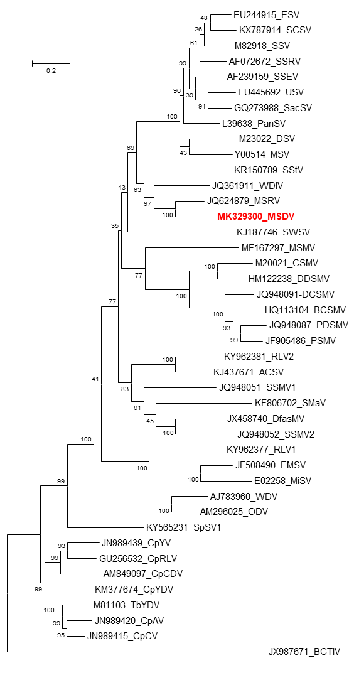

Figure 1. Maximum likelihood phylogenetic tree of representative genomes from members of each mastrevirus species inferred using MEGA6 (Tamura et al., 2013) and rooted with the sequence of the becurtovirus beet curly top Iran virus (JX987671).

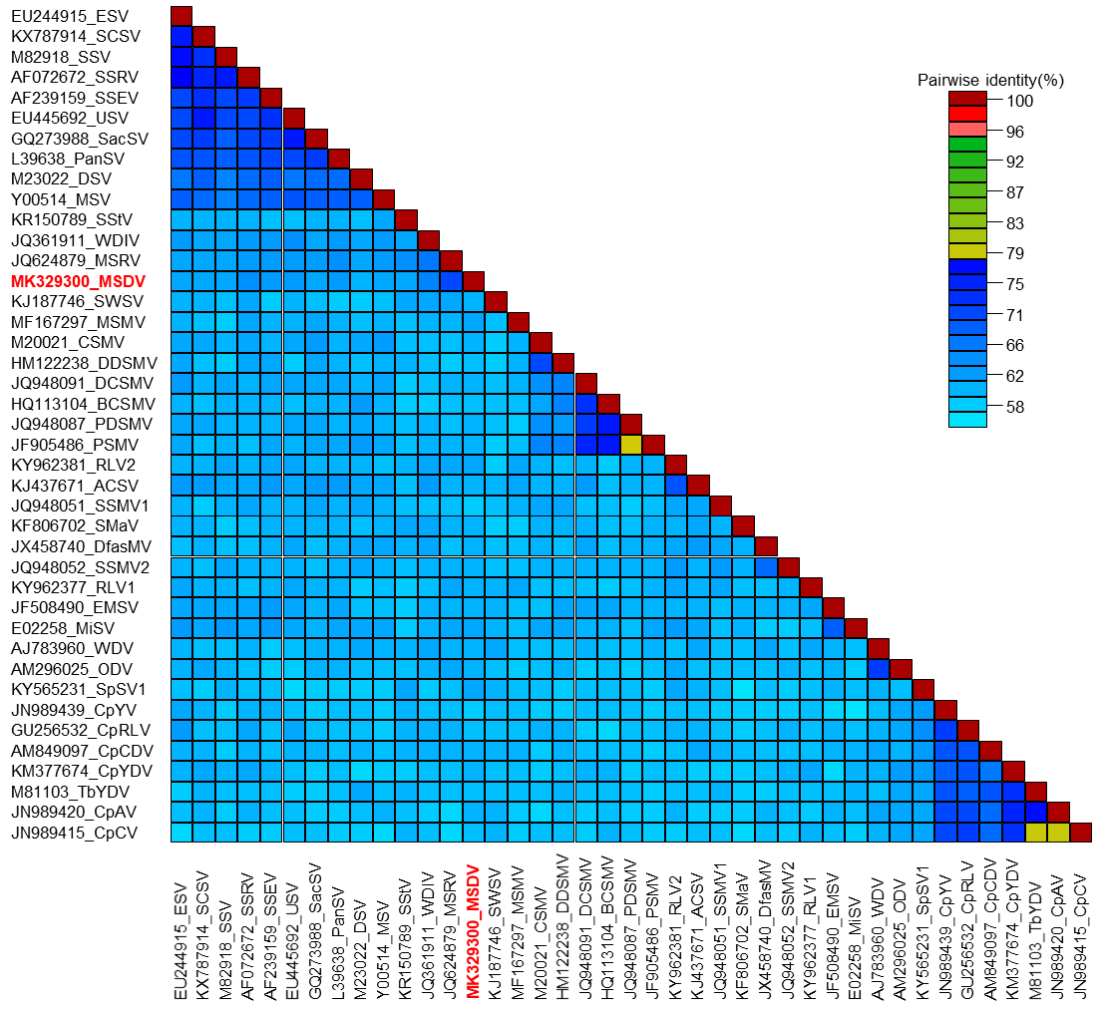

Figure 2. Two-color pairwise identity matrix inferred using SDT v1.2 (Muhire et al., 2014). The sequence of the isolate representative of the new species Maize streak dwarfing virus is shown in red font.

Table 1. Details of isolates of Maize streak dwarfing virus, a proposed new species in the genus Mastrevirus.

Species name | Virus name / acronym | Isolates | GenBank accession | Country | Host
Maize streak dwarfing virus | maize streak dwarfing virus (MSDV) | ET-Adama Zuria-MV1-16 | MK329300 | Ethiopia | Zea mays
 | maize streak dwarfing virus (MSDV) | ET-Shevaba-MV56-16 | MK329301 | Ethiopia | Zea mays
 | maize streak dwarfing virus (MSDV) | ET-Boset-MV66-16 | MK329302 | Ethiopia | Zea mays
 | maize streak dwarfing virus (MSDV) | ET-Analume-MV74-16 | MK329303 | Ethiopia | Zea mays

References:
Guadie D, Tesfaye K, Knierim D, Winter S, Abraham A, 2019. Molecular analysis of maize (Zea mays L.)-infecting mastreviruses in Ethiopia reveals marked diversity of virus genomes and a novel species. Virus Genes 55:339-345.

Muhire B, Martin DP, Brown JK, Navas-Castillo J, Moriones E, Zerbini FM, Rivera-Bustamante R, Malathi VG, Briddon RW, Varsani A, 2013. A genome-wide pairwise-identity-based proposal for the classification of viruses in the genus Mastrevirus (family Geminiviridae). Arch Virol 158:1411-1424.

Muhire BM, Varsani A, Martin DP, 2014. SDT: a virus classification tool based on pairwise sequence alignment and identity calculation. PLoS One 9:e108277.

Tamura K, Stecher G, Peterson D, Filipski A, Kumar S, 2013. MEGA6: Molecular Evolutionary Genetics Analysis Version 6.0. Mol Biol Evol 30:2725-2729.

