This Word module should be used for all taxonomic proposals.
Please complete Part 1 and:
either Part 3 for proposals to create new taxa or change existing taxa
or Part 2 for proposals of a general nature.
Submit the completed Word module, together with the accompanying Excel module named in Part 3, to the appropriate ICTV Subcommittee Chair.
The Word module explains and justifies your proposal. The Excel module is a critical document that will be used to implement the proposed taxonomic changes once they are approved and ratified. If proposals presented in the Word module are not presented accurately in the Excel module, the taxonomic changes cannot proceed.
For guidance, see the notes written in blue, below, and the Help Notes in file Taxonomic_Proposals_Help_2019.
Part 1: TITLE, AUTHORS, etc

Code assigned: | 2019.010P
Short title: Create one new species (Blackberry leaf mottle associated virus) in the genus Emaravirus, family Fimoviridae
Author(s) and email address(es):
Hassan M, Martin RR, Di Bello PL, Keller KE, Sabanadzovic S, Tzanetakis IE |  | maa22@fayoum.edu.eg;  Bob.Martin@ars.usda.gov;  dibellop@oregonstate.edu;  Karen.Keller@ars.usda.gov;  ss501@msstate.edu;  itzaneta@uark.edu
Corresponding author
Tzanetakis IE
List the ICTV study group(s) that have seen this proposal:
A list of study groups and contacts is provided at http://www.ictvonline.org/subcommittees.asp . If in doubt, contact the appropriate subcommittee chair (there are six virus subcommittees: animal DNA and retroviruses, animal ssRNA-, animal ssRNA+, fungal and protist, plant, bacterial and archaeal) |  |  | ICTV Fimoviridae study group
ICTV Study Group comments (if any) and response of the proposer:
Date first submitted to ICTV:
Date of this revision (if different to above):

ICTV-EC comments and response of the proposer:

Part 2: NON-STANDARD
Template for any proposal regarding ICTV procedures, rules or policy, not involving the creation of new taxonomy.
Text of proposal:

Part 3: PROPOSED TAXONOMY

Name of accompanying Excel module: 2019.010P.A.v1.Emaravirus_1sp.xlxs

Supporting material:
Blackberry leaf mottle-associated virus (BLMaV) possesses all molecular and biological features to be considered as a new member of the genus Emaravirus, which currently comprises the following species: Fig mosaic emaravirus (virus acronym: FMV), Rose rosette emaravirus (RRV), Raspberry leaf blotch emaravirus (RLBV), Pigeonpea sterility mosaic emaravirus 1 (PPSMV-1), Pigeonpea sterility mosaic emaravirus 2 (PPSMV-2), High Plains wheat mosaic emaravirus (HPWMV), Redbud yellow ringspot-associated emaravirus (RYRSaV), Actinidia chlorotic ringspot-associated emaravirus (AcCRaV) and European mountain ash ringspot-associated emaravirus (EMARaV) as the type species of the genus (Elbeaino et al., 2018; Mielke and Muehlbach, 2007). BLMaV is transmitted by eriophyid mites distantly related to those of the genus Aceria. The RNA-dependent RNA polymerase (RdRp), glycoprotein precursor (GP), nucleocapsid (NC) and P4 proteins show different levels of sequence identity with ortholog proteins of other emaraviruses (Table 1).

Virus properties
- Virus particles: supposed to be similar to those of emaraviruses, i.e. double-membraned bodies (DMB).
- Genome: resembles that of members of the genus Emaravirus. It is composed of five segments of negative sense ssRNA. RNA-1, 7050 nt; RNA-2, 2271 nt; RNA-3, 1510 nt; RNA-4, 1504 nt; RNA-5, 1224 nt (Figure 1). In order from RNA-1 to RNA-5, GenBank accession numbers are KY056657 to KY056661 (Hassan et al., 2017). Each segment is monocistronic, encoding a single protein translated from the complementary strand (Figure 1). Untranslated regions (UTRs) at the 5’ and 3’ termini of all RNA segments extended from 47 to 97 nt and from 91 to 473 nt, respectively.
- Virus-encoded proteins: RNA-directed RNA-polymerase (p1), 268.0 kDa; putative glycoprotein precursor (p2), 75.0 kDa (Gn 23.0 kDa and Gc 52.0 kDa); putative nucleocapsid protein (p3), 35.0 kDa; putative movement protein (p4), 41.0 kDa; p5 (function unknown), 26.0 kDa (Figure 1).
- Phylogenetic relationships: phylogenetic trees based on RdRp, GP and NC proteins resulted in similar topologies, with BLMaV clustering in a clade close to RRV, FMV and PPSMV-2 (Figure 2). The aa sequence identity between the BLMaV proteins and those of other emaraviruses was 66-67%, 51-54% and 58-62% for the RdRP, GP and NC, respectively (Table 1).
- Experimental transmission: BLMaV was transmitted onto ‘Natchez’ blackberry plants by a yet to be described eriophyid mite, distantly related to those of the eriophyid genus Aceria, representing a possible new species or even genus within the family Eriophyidae.
- Natural host range: Blackberry plants.

References:
Elbeaino T., Digiaro M., Mielke-Ehret N., Muehlbach H.P., Martelli G.P. and ICTV Report Consortium, 2018. ICTV Virus Taxonomy Profile: Fimoviridae. Journal of General Virology 99:1478-1479.
Hassan M., Di Bello P.L., Keller K.E., Martin R.R., Sabanadzovic S., Tzanetakis I.E., 2017. A new, widespread emaravirus discovered in blackberry. Virus Research 235:1-5.
Mielke N., Muehlbach, H.P., 2007. A novel, multipartite, negative-strand RNA virus is associated with the ringspot disease of European mountain ash (Sorbus aucuparia L.). Journal of General Virology 88:1337-1346.

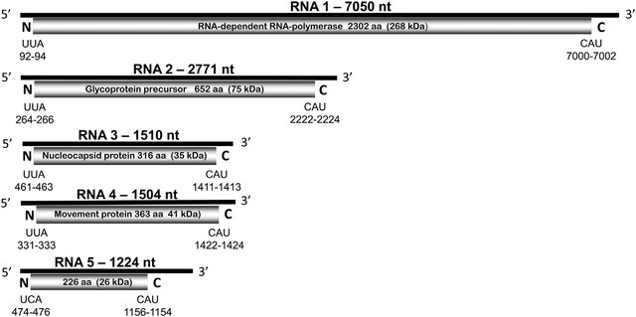

Figure 1 Schematic representation of the blackberry leaf mottle-associated virus genome. Expression product of each RNA is presented by a gray box; their aa length, estimated molecular mass (kDa), and function of the putative protein are indicated. Figure not drawn to scale.

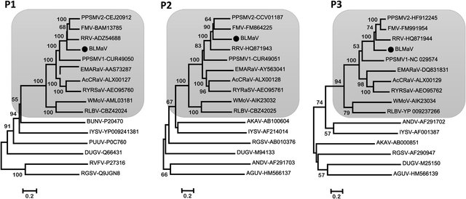

Figure 2 Neighbor joining phylogenetic trees generated based on the deduced amino acid sequences of the RNA-dependent RNA polymerase (p1), glycoprotein precursor (p2) and nucleoprotein (p3) of blackberry leaf mottle associated virus (BLMaV), recognized and putative members of the genus Emaravirus, and orthologs of representative members in the order Bunyavirales and genus Tenuivirus. Bars represent the number of amino acid substitutions per site. Shaded boxes highlight the genus Emaravirus clade; the position of BLMaV within this clade is indicated by a black dot (•). Abbreviations: Iris yellow spot virus (IYSV, genus Orthotospovirus, family Tospoviridae); Dugbe virus (DUGV, genus Orthonairovirus, family Nairoviridae); Puumala virus (PUUV, genus Orthoantavirus, family Hantaviridae); Rift Valley fever virus (RVFV) and Aguacate virus (AGUV), both genus Phlebovirus, family Phenuiviridae; Bunyamwera virus (BUNV) and Akabane virus (AKAV), both genus Orthobunyavirus, family Peribunyaviridae; rice grassy stunt virus (RGSV) (genus Tenuivirus, family Phenuiviridae). GenBank accession numbers are indicated. Members of the genus Emaravirus include actinidia chlorotic ringspot-associated virus (AcCRaV); European mountain ash ringspot-associated virus (EMARaV); fig mosaic virus (FMV); wheat mosaic virus (WMoV); pigeon pea sterility mosaic virus (PPSMV); pigeon pea sterility mosaic virus 2 (PPSMV-2); raspberry leaf blotch virus (RLBV); redbud yellow ringspot-associated virus (RYRSaV); rose rosette virus (RRV).

Table 1 Amino acid identities between blackberry leaf mottle-associated virus (BLMaV) putative proteins and emaraviruses orthologs.
Emaraviruses | BLMaV proteins
 | P1 | P2 | P3 | P4 | P5
EMARaV | 48 | 33 | 31 | - | 10
FMV | 67 | 54 | 61 | 55 | 26
RRV | 67 | 5 | 58 | 52 | 29
RLBV | 32 | 21 | 19 | 17 | -
PPSMV-1 | 53 | 41 | 41 | 39 | -
PPSMV-2 | 66 | 54 | 62 | 54 | 27
RYRSaV | 46 | 36 | 38 | 32 | 14
AcCRaV | 46 | 35 | 35 | 31 | -
HPWMV | 30 | 20 | 15 | 16 | -

