This Word module should be used for all taxonomic proposals.
Please complete Part 1 and:
either Part 3 for proposals to create new taxa or change existing taxa
or Part 2 for proposals of a general nature.
Submit the completed Word module, together with the accompanying Excel module named in Part 3, to the appropriate ICTV Subcommittee Chair.
The Word module explains and justifies your proposal. The Excel module is a critical document that will be used to implement the proposed taxonomic changes once they are approved and ratified. If proposals presented in the Word module are not presented accurately in the Excel module, the taxonomic changes cannot proceed.
For guidance, see the notes written in blue, below, and the Help Notes in file Taxonomic_Proposals_Help_2019.
Part 1: TITLE, AUTHORS, etc

Code assigned: | 2019.006P
Short title: Create eight new species in the genus Orthotospovirus, family Tospoviridae
Author(s) and email address(es):
Adkins S, Naidu R, Resende R, Turina M, Whitfield A, Lambert A, Zerbini FM |  | scott.adkins@ars.usda.gov;  naidu.rayapati@wsu.edu;  rresende@unb.br; massimo.turina@ipsp.cnr.it; awhitfi@ncsu.edu; ahk7@cdc.gov;  zerbini@ufv.br
Corresponding author
Adkins, Scott | scott.adkins@ars.usda.gov

List the ICTV study group(s) that have seen this proposal:
A list of study groups and contacts is provided at http://www.ictvonline.org/subcommittees.asp . If in doubt, contact the appropriate subcommittee chair (there are six virus subcommittees: animal DNA and retroviruses, animal ssRNA-, animal ssRNA+, fungal and protist, plant, bacterial and archaeal) |  |  | Tospovirus Study Group
ICTV Study Group comments (if any) and response of the proposer:
Date first submitted to ICTV: |  |  |  | June 19, 2019
Date of this revision (if different to above):

ICTV-EC comments and response of the proposer:

Part 2: NON-STANDARD
Template for any proposal regarding ICTV procedures, rules or policy, not involving the creation of new taxonomy.
Text of proposal:

Part 3: PROPOSED TAXONOMY

Name of accompanying Excel module: 2019.006P.A.v1.Orthotospovirus_8sp.xlsx

The genus Orthotospovirus in the family Tospoviridae is comprised of insect- and plant-infecting viruses with tripartite, single-stranded RNA genomes. The three genomic RNA segments are designated as S (small), M (medium) or L (large). The S and M RNAs are ambisense encoding two open reading frames (ORFs) each, whereas the L RNA is negative sense and encodes one ORF. The S RNA encodes the nucleocapsid (N) and nonstructural (NSs, silencing suppressor) proteins. The M RNA encodes a glycoprotein precursor (proteolytically processed to yield two viral glycoproteins, G_{N} and G_{C}) and a second nonstructural protein (NSm, cell-to-cell movement). The L RNA encodes the viral RNA-dependent RNA polymerase (L). Eight terminal nucleotides of each RNA are conserved among family members, and show complementarity facilitating base-pairing of the termini of each RNA to form a panhandle-like structure. Particles are pleomorphic or quasi-spherical, 80-120 nm in diameter, and enveloped with a host-derived membrane in which the two glycoproteins (G_{N} and G_{C}) are embedded to appear as ‘spike-like’ structures on the virion surface. Members of the family are transmitted by thrips of one or more species (Thysanoptera: Thripidae) in a persistent, propagative manner. Phylogenetic analyses of the genomic RNAs show segregation of orthotospovirus species into Old World and New World clades.

Species demarcation criteria for the genus Orthotospovirus:
• Genome sequence relatedness: different species have N protein amino acid pairwise sequence identity less than 90%.
• Thrips vector specificity.
• Plant host range.
• Antigenic properties: serological relatedness of N protein.

The eight viruses described below are proposed to represent new species in the genus Orthotospovirus. For each virus, there is at least one complete coding region or genome sequence in the public domain revealing the expected ORFs and conserved nucleotide and/or amino acid motifs. The molecular criteria of pairwise sequence identity values to create new species have been fulfilled. Phylogenetic analyses of the complete S, M and L RNA genome segment sequences (Figures 1-3) support recognition of these viruses as representatives of new species within the genus Orthotospovirus.

Eight proposed new species in genus Orthotospovirus

- Alstroemeria necrotic streak virus

Alstroemeria necrotic streak virus (ANSV) is endemic in Colombia where it was originally found naturally infecting the ornamental crop Alstroemeria (Alstroemeria sp.) in 2008 (Hassani-Mehraban et al., 2010). Experimental mechanical inoculation studies showed that ANSV has a moderate plant host range (Hassani-Mehraban et al., 2010). Surveys in Colombia have also identified natural infections of solanaceous crop plants including tomato (Solanum lycopersicum), bell pepper (Capsicum annuum) and lulo (Solanum quitoense) (Gallo et al., 2018; 2019; Olaya et al., 2017). The natural thrips vector remains to be determined but experimental transmission of ANSV by western flower thrips (Frankliniella occidentalis) has been reported (Hassani-Mehraban et al., 2010). The complete coding region sequence (MG696853, MG696852 and MG696851) is located within 3113, 4839 and 8756 nt, respectively, on three ssRNAs with a genome organization typical of orthotospoviruses (Gallo et al., 2018). Comparison of data on serological relationships and N gene sequences revealed that ANSV is most closely related to but distinct from the tomato spotted wilt virus (TSWV) serogroup of orthotospoviruses. This includes 75-83% identity of aligned N protein sequences for TSWV, tomato chlorotic spot virus, groundnut ringspot virus, chrysanthemum stunt virus and zucchini lethal chlorosis virus, which is sufficient to establish ANSV as a representative of a distinct orthotospovirus species. Phylogenetic analyses showed that each of the three ANSV genomic RNAs grouped most closely with these same orthotospoviruses in the New World clade (Figures 1-3). For future reference, ANSV shared the highest (87%) identity of aligned N protein sequence with pepper necrotic spot virus, another tentative orthotospovirus found in South America for which only S RNA sequence is currently available.

The ICTV Tospovirus Study Group proposes that Alstroemeria necrotic streak virus represents a new species, named Alstroemeria necrotic streak orthotospovirus, within the genus Orthotospovirus, with ANSV isolate San Vicente 3 as the exemplar isolate.

- Alstroemeria yellow spot virus
Alstroemeria yellow spot virus (AYSV) was isolated from the ornamental crop Alstroemeria (Alstroemeria sp.; Hassani-Mehraban et al., 2019). Experimental mechanical inoculation studies showed that AYSV has a relatively narrow plant host range (Hassani-Mehraban et al., 2019). Experimental transmission of AYSV by onion thrips (Thrips tabaci) has been demonstrated (Hassani-Mehraban et al., 2019). The first complete genome sequence (MF469035, MF469034 and MF469033) of an AYSV isolate from Alstroemeria comprises three ssRNAs of 2734, 4797 and 8865 nt, respectively, with a genome organization typical of orthotospoviruses (Hassani-Mehraban et al., 2019). No serological reaction was found with antisera raised against other orthotospoviruses, and AYSV shared the highest (69.5%) identity of aligned N protein sequence with polygonum ringspot virus (PolRSV), which is sufficient to establish AYSV as a representative of a distinct orthotospovirus species. Phylogenetic analyses showed that each of the three AYSV genomic RNAs grouped most closely with PolRSV, iris yellow spot virus and viruses of several other proposed orthotospovirus species (see #4 Hippeastrum chlorotic ringspot virus and #7 tomato yellow ring virus below) identified in Europe and Asia in the Old World clade (Figures 1-3).

The ICTV Tospovirus Study Group proposes that Alstroemeria yellow spot virus represents a new species, named Alstroemeria yellow spot orthotospovirus, within the genus Orthotospovirus, with AYSV isolate Als-2000 as the exemplar isolate.

- Groundnut chlorotic fan-spot virus
Groundnut chlorotic fan-spot virus (GCFSV) was first characterized from groundnut (peanut, Arachis hypogaea) in Taiwan in the early 1990s (Chen and Chiu, 1996). Originally described as peanut chlorotic fan-spot virus, serological comparisons suggested GCFSV to be a novel orthotospovirus (Chu et al., 2001; Yeh et al., 1996). Mechanical inoculation studies showed that GCFSV has a relatively narrow experimental host range that includes typical solanaceous indicator plants (Chen & Chiu, 1996). Experimental transmission of GCFSV by yellow tea thrips (Scirtothrips dorsalis) was demonstrated (Chen and Chiu, 1996). The first complete genome sequence (AF080526, KP146141 and KP146140) is available for a GCFSV isolate from groundnut and comprises three ssRNAs of 2734, 4857 and 8796 nt, respectively, with a genome organization typical of orthotospoviruses (Chou et al., 2017; Chu et al., 2001). No serological reaction was found with antisera raised against other orthotospoviruses. GCFSV shared the highest (67.5%) identity of aligned N protein sequence with groundnut yellow spot virus (GYSV) and 22.3 to 28.1% with all other orthotospoviruses, which is sufficient to establish GCFSV as a representative of distinct orthotospovirus species. Phylogenetic analysis showed that the GCFSV S RNA grouped with the GYSV S RNA on a distinct branch within the Old World clade (Figure 1), consistent with the N protein analysis. The GCFSV M and L RNAs were each on their own branch distinct from the Old and New World clades (Figures 2-3); we note that currently no GYSV M or L RNA sequences are available for comparison.

Thus, the ICTV Tospovirus Study Group proposes that groundnut chlorotic fan-spot virus represents a new species within the genus Orthotospovirus, named Groundnut chlorotic fan-spot orthotospovirus, with GCFSV isolate PD2 as the exemplar isolate.

- Hippeastrum chlorotic ringspot virus
Hippeastrum chlorotic ringspot virus (HCRV) was first isolated from amaryllis (Hippeastrum sp.) with necrotic and chlorotic ringspots in 2007 and later from spider lily (Hymenocallis littoralis) with similar symptoms in 2011 in southwestern China (Dong et al., 2013; Xu et al., 2013). Electron microscopy showed typical orthotospovirus particles (Dong et al., 2013). Isolated HCRV virions infected multiple plant species including tomato (Solanum lycopersicum), pepper (Capsicum annuum), tobacco (Nicotiana tabacum), amaryllis (Hippeastrum sp.), orchid (Phalaenopsis sp.) and lettuce (Lactuca sativa) by mechanical inoculation (Dong et al., 2013; Xu et al., 2013). Surveys in southwestern China have also identified widespread natural infections of spider lily, amaryllis, philodendron (Philodendron bipinnatifidum) and tobacco (Xu et al., 2013). Multiple thrips vectors of orthotospoviruses are known in this region of China but the HCRV vector has not yet been determined (Dong et al., 2013). The complete genome sequence (JX833564, JX833565 and HG763861) of HCRV comprises three ssRNAs of 2724, 4741 and 8908 nt, respectively, with a genome organization typical of orthotospoviruses (Xu et al., 2013; 2014). No serological reaction was found with antisera raised against other orthotospoviruses. HCRV shared the highest identity of aligned N protein sequence with Polygonum ringspot virus (PolRSV; 86.1%), tomato yellow ring virus (TYRV; 82.1%; see #7 below) and iris yellow spot virus (IYSV; 70%), and 18.5 to 48.2% with all other orthotospoviruses, which is sufficient to establish HCRV as a representative of a distinct orthotospovirus species. Phylogenetic analysis showed that each of the three HCRV genomic RNAs grouped most closely with PolRSV, TYRV, IYSV and the orthotospovirus of the proposed species Alstroemeria yellow spot orthotospovirus (see #2 above) identified in Europe and Asia in the Old World clade (Figures 1-3).

The ICTV Tospovirus Study Group proposes that Hippeastrum chlorotic ringspot virus represents a new species within the genus Orthotospovirus, named Hippeastrum chlorotic ringspot orthotospovirus, with HCRV isolate HLS1-2 as the exemplar isolate.

- Mulberry vein banding-associated virus
Mulberry vein banding-associated virus (MVBaV) was first identified in mulberry (Morus alba) samples with vein banding symptoms collected in Guangxi Province of China in 2011 (Meng et al., 2013). The natural and experimental host range is limited to mulberry. MVBaV was graft transmitted to mulberry but was not mechanically transmitted to any tested plant species (Meng et al., 2015). Surveys showed that MVBaV was widespread in mulberry orchards in China (Meng et al., 2013). To date, MVBaV has only been detected in China and the vector remains unknown. Electron microscopy showed typical orthotospovirus particles (Meng et al., 2015). The complete genome sequence (KM819701, KM819699 and KM819698) of isolate XCSY-3 comprises three ssRNAs of 3294, 4731 and 8905 nt, respectively, with an organization typical of orthotospoviruses (Meng et al., 2015). Serological characterization demonstrated that MVBaV reacted strongly with a commercially available mixture of watermelon silver mottle virus (WSMoV) and groundnut bud necrosis virus (GBNV) antisera in ELISA assays; no reaction was observed with antisera raised against other orthotospoviruses. MVBaV shared the highest identity of aligned N protein sequence with Capsicum chlorosis virus (CaCV; 74.4%), watermelon bud necrosis virus (WBNV; 71.8%), GBNV (71.5%) and WSMoV (70%), and 19.9 to 61.5% with all other orthotospoviruses, which is sufficient to establish MVBaV as a representative of a distinct orthotospovirus species. Phylogenetic analysis showed that each of the three MVBaV genomic RNAs grouped most closely with CaCV, WBNV, GBNV and WSMoV in the Old World clade (Figures 1-3).

The ICTV Tospovirus Study Group proposes that mulberry vein banding-associated virus represents a new species within the genus Orthotospovirus, named Mulberry vein banding-associated orthotospovirus, with MVBaV isolate XCSY-3 as the exemplar isolate.

- Pepper chlorotic spot virus
Pepper chlorotic spot virus (PCSV) was initially isolated from sweet pepper (Capsicum annuum) plants with chlorotic and necrotic leaf spots, bud necrosis, and fruit mottle and deformation in 2011 in Taiwan (Cheng et al., 2014). PCSV was subsequently detected in similarly symptomatic chili pepper (C. annuum) and tomato (Solanum lycopersicum) in 2014 in southwestern China. Mechanical inoculation studies showed that PCSV has a moderate experimental host range that includes typical solanaceous indicator plants, and sweet and chili pepper, in addition to cowpea (Vigna unguiculata) and pak choi (Brassica rapa Chinensis group) (Cheng et al., 2014; Zheng et al. 2017). The vector remains unknown. Electron microscopy showed typical orthotospovirus particles (Cheng et al., 2014; Zheng et al., 2017). The complete genome sequence (KX247377, KX247378 and KX247379) of PCSV isolate 14YV733 comprises three ssRNAs of 3310, 4711 and 8913 nt, respectively, with an organization typical of orthotospoviruses (Zheng et al., 2017). Serological characterization demonstrated that PCSV reacted strongly with watermelon silver mottle virus (WSMoV) and Capsicum chlorosis virus (CaCV) antisera in ELISA assays; no reaction was observed with antisera raised against other orthotospoviruses (Cheng et al., 2014). Similarly, PCSV reacted with WSMoV antisera in immunoblotting assays, although it did not react with CaCV antisera (Zheng et al., 2017). PCSV shared the highest identity of aligned N protein sequence with watermelon bud necrosis virus (WBNV; 59.7%), groundnut bud necrosis virus (GBNV; 59.3%), CaCV (58.4%), calla lily chlorotic spot virus (CCSV; 58.0%), and mulberry vein banding-associated virus (MVBaV; member of another proposed orthotospovirus species see #5 above) and WSMoV (both at 57.5%); and 15.0 to 55.8% with all other orthotospoviruses, which is sufficient to establish PCSV as the representative of a distinct orthotospovirus species. Phylogenetic analysis showed that each of the three PCSV genomic RNAs grouped most closely with CCSV, MVBaV and tomato zonate spot virus (see #8 below) in the Old World clade (Figures 1-3). For future reference, PCSV shared the highest (88.5%) identity of aligned N protein sequence with tomato necrotic ringspot virus (TNRV), a tentative orthotospovirus found in Thailand for which only complete S and M RNA sequences are currently available. PCSV shared a similar identity (88.6%) of aligned NSm protein sequence with TNRV, but only 80.5% and 83.9% for NSs and the G_{N}G_{C} precursor protein sequences, respectively, indicating that PCSV and TNRV are likely to belong to distinct species.

The ICTV Tospovirus Study Group proposes that pepper chlorotic spot virus represents a new species within the genus Orthotospovirus, named Pepper chlorotic spot orthotospovirus, with PCSV isolate 14YV733 as the exemplar isolate.

- Tomato yellow ring virus
Tomato yellow ring virus was originally described from tomato (Solanum lycopersicum) in Iran in the early 2000s as tomato Varamin virus (ToVV; Ghotbi et al., 2005; Winter et al., 2003). However, when these authors deposited the initial partial genome sequences (AJ493270, AJ493271) in 2002 the organism was listed in GenBank as tomato yellow fruit ring virus (TYFRV). Further complicating matters, these same authors subsequently proposed the name of tomato fruit yellow ring virus (TFYRV) in a 2006 report (Winter et al., 2006). In 2005, another group of authors reported the complete S RNA sequence and biological characterization of another isolate of this same virus under the name of tomato yellow ring virus (TYRV; Hassani-Mehraban et al., 2005). The complete L and M RNA sequences of this same isolate were subsequently published (Chen et al., 2013). Tomato yellow ring virus (TYRV) has since become the most commonly accepted name for this orthotospovirus in the literature. Recent work has shown unequivocally that ToVV, TYFRV, TFYRV and TYRV are isolates of the same orthotospovirus, coupled with a suggestion to use TYFRV or ToVV as the name for this virus (Golnaraghi et al., 2018). While historical precedent is usually followed in virus naming, the confusion in the original description resulting from the use of three different proposed names, and the subsequent acceptance of TYRV by much of the virology community, lead us to put use tomato yellow ring virus for naming the species in this proposal.

Following the original description from tomato, field surveys and mechanical inoculation studies have demonstrated that TYRV has a wide host range among weeds and agricultural crops, including peanut (Arachis hypogaea), soybean (Glycine max), potato (Solanum tuberosum) and many ornamental species in Iran (Beikzadeh et al. 2012; Ghotbi et al., 2005; Golnaraghi et al., 2018; Hassani-Mehraban et al., 2005; 2007; Rasoulpour and Izadpanah, 2007). TYRV has also been reported in Africa and Europe (Birithia et al., 2012; Zarzyńska-Nowak et al., 2015). Electron microscopy showed typical orthotospovirus particles (Hassani-Mehraban et al., 2005; Winter et al., 2003). Onion thrips (Thrips tabaci) have been demonstrated to be a vector of TYRV (Rasoulpour and Izadpanah, 2007). The complete genome sequence (AY686718, JN560177 and JN560178) of isolate TYRV-t comprises three ssRNAs of 3061, 4786 and 8877 nt, respectively, with an organization typical of orthotospoviruses (Chen et al., 2013; Hassani-Mehraban et al., 2005). Sequence analysis and host range studies indicate diversity within TYRV isolates, especially between isolates from different host plants (Golnaraghi et al., 2018; Hassani-Mehraban et al., 2007). Serological characterization demonstrated that TYRV reacted with Polygonum ringspot virus (PolRSV) antisera in ELISA assays (Ciuffo et al., 2008). TYRV shared the highest identity of aligned N protein sequence with iris yellow spot virus (IYSV; 74%), and 17 to 45% with all other orthotospoviruses, which is sufficient to establish TYRV as the representative of a distinct orthotospovirus species. Phylogenetic analysis showed that each of the three TYRV genomic RNAs grouped most closely with IYSV, PolRSV, and two other proposed orthotospoviruses: Alstroemeria yellow spot virus and Hippeastrum chlorotic ringspot virus (see #2 and #4 above) in the Old World clade (Figures 1-3).

The ICTV Tospovirus Study Group proposes that tomato yellow ring virus represents a new species within the genus Orthotospovirus, named Tomato yellow ring orthotospovirus, with TYRV isolate TYRV-t as the exemplar isolate.

- Tomato zonate spot virus
Tomato zonate spot virus (TZSV) was originally isolated from tomato (Solanum lycopersicum) and chili pepper (Capsicum annuum) with typical orthotospovirus symptoms of necrotic rings on leaves, and concentric zoned rings and chlorotic ringspots on fruits collected in 2005 and 2006 in Yunnan Province in southwestern China (Dong et al., 2008). Mechanical inoculation studies and field surveys demonstrated that TZSV has a wide host range among agricultural crops, weeds and indicator hosts (Dong et al., 2008), including crinum lily (Crinum asiaticum), a Chinese medicinal herb (Iris tectorum) and potato (Solanum tuberosum) (Huang et al., 2015; Liu et al., 2014; Wu et al., 2015). Electron microscopy showed typical orthotospovirus particles (Dong et al., 2008). Western flower thrips (Frankliniella occidentalis) have been demonstrated to be the main vector of TZSV (Zheng et al., 2014). The complete genome sequence (NC_010489, NC_010490 and NC_010491) comprises three ssRNAs of 3279, 4945 and 8919 nt, respectively, with a genome organization typical of orthotospoviruses (Dong et al., 2008). Serological characterization demonstrated that TZSV reacted strongly with a commercially available mixture of watermelon silver mottle virus and groundnut bud necrosis virus antisera in ELISA assays; no reaction was observed with antisera raised against other orthotospoviruses (Dong et al., 2008). TZSV shared the highest identity of aligned N protein sequence with calla lily chlorotic spot virus (CCSV; 80.9%), and 17.9 to 63.6% with all other orthotospoviruses, which is sufficient to establish TZSV as the representative of a distinct orthotospovirus species. Phylogenetic analysis showed that each of the three PCSV genomic RNAs grouped most closely with CCSV, and two other proposed orthotospoviruses: mulberry vein banding virus and pepper chlorotic spot virus (see #5 and #6 above) in the Old World clade (Figures 1-3).

The ICTV Tospovirus Study Group proposes that tomato zonate spot virus represents a new species within the genus Orthotospovirus, named Tomato zonate spot orthotospovirus, with TZSV isolate Tomato-YN as the exemplar isolate.

References:
Beikzadeh, N., Bayat, H., Jafarpour, B., Rohani, H., Peters, D. and Hassani-Mehraban, A. 2012. Infection of Alstroemeria plants with Tomato yellow ring virus in Iran. Journal of Phytopathology, 160:45-47.

Birithia, R., Subramanian, S., Villinger, J., Muthomi, J.W., Narla, R.D. and Pappu, H.R. 2012. First report of Tomato yellow ring virus (Tospovirus, Bunyaviridae) infecting tomato in Kenya. Plant Disease, 96:1384.

Chen, C.C. and Chiu, R.J. 1996. A tospovirus infecting peanut in Taiwan. Acta Horticulturae, 431:57-67.

Chen, T.-C., Li, J.-T., Fan, Y.-S., Yeh, Y.-C., Yeh, S.-D. and Kormelink, R. 2013. Molecular characterization of the full-length L and M RNAs of Tomato yellow ring virus, a member of the genus Tospovirus. Virus Genes, 46:487-495.

Cheng, Y.-H., Zheng, Y.-X., Tai, C.-H., Yen, J.-H., Chen, Y.-K. and Jan, F.-J. 2014. Identification, characterization and detection of a new tospovirus on sweet pepper. Annals of Applied Biology, 164:107-115.

Chou, W.-C., Lin, S.-S., Yeh, S.-D., Li, S.-L., Peng, Y.-C., Fan, Y.-H. and Chen, T.-C. 2017. Characterization of the genome of a phylogenetically distinct tospovirus and its interactions with the local lesion-induced host Chenopodium quinoa by whole-transcriptome analyses. PLoS ONE, 12(8):e012425. https://doi.org/10/1371/journal.pone/0182425.

Chu, F.-H., Chao, C.-H., Pen, Y.-C., Lin, S.-S., Chen, C.-C. and Yeh, S.-D. 2001. Serological and molecular characterization of Peanut chlorotic fan-spot virus, a new species of the genus Tospovirus. Phytopathology, 91:856-863.

Ciuffo, M., Tavella, L., Pacifico, D., Masenga, V. and Turina, M. 2008. A member of a new Tospovirus species isolated in Italy from wild buckwheat (Polygonum convolvulus). Archives of Virology, 153:2059-2068.

Dong, J.-H., Cheng, X.-F., Yin, Y.-Y., Fang, Q., Ding, M., Li, T.-T., Zhang, L.-Z., Su, X.-X., McBeath, J.H. and Zhang, Z.-K. 2008. Characterization of tomato zonate spot virus, a new tospovirus in China. Archives of Virology, 153:855-864.

Dong, J.H., Yin, Y.Y., Fang, Q., McBeath, J.J. and Zhang, Z.K. 2013. A new tospovirus causing chlorotic ringspot on Hippeastrum sp. in China. Virus Genes, 46:567-570.

Gallo, Y., Sierra, A., Muñoz, L, Marín, M. and Gutiérrez, P.A. 2019. Genome characterization of three Alstroemeria necrotic streak orthotospovirus (ANSV) isolates naturally infecting bell pepper (Capsicum annuum) in Antioquia (Colombia). Tropical Plant Pathology, In press (https://doi.org/10.1007/s40858-019-00292-1).

Gallo, Y., Toro. L.F., Jaramillo, H., Gutiérrez. P. and Marín, M. 2018. Identificación y caracterización molecular del genoma completo de tres virus en cultivos de lulo (Solanum quitoense) de Antioquia (Colombia). Revista Colombiana de Ciencias Hortícolas, 12:281-292.

Ghotbi, T., Shahraeen, N. and Winter, S. 2005. Occurrence of tospoviruses in ornamental and weed species in Markazi and Tehran provinces in Iran. Plant Disease, 89:425-429.

Golnaraghi, A., Shahraeen, N. and Nguyen, H.D. 2018. Characterization and genetic structure of a Tospovirus causing chlorotic ring spots and chlorosis disease on peanut; comparison with Iranian and Polish populations of Tomato yellow fruit ring virus. Plant Disease, 102:1509-1519.

Hassani-Mehraban, A., Botermans, M., Verhoeven, J.Th.J., Meekes, E., Saaijer, J., Peters, D., Goldbach, R. and Kormelink, R. 2010. A distinct tospovirus causing necrotic streak on Alstroemeria sp. in Colombia. Archives of Virology, 155:423-428.

Hassani-Mehraban, A., Dullemans, A.M., Verhoeven, J.Th.J., Roenhorst, J.W., Peters, D., van der Vlugt, R.A.A. and Kormelink, R. 2019. Alstroemeria yellow spot virus (AYSV): a new orthotospovirus within a growing Eurasian clade. Archives of Virology, 164:117-126.

Hassani-Mehraban, A., Saaijer, J., Peters, D., Goldbach, R. and Kormelink, R. 2005. A new tomato-infecting tospovirus from Iran. Phytopathology, 95:852-858.

Hassani-Mehraban, A., Saaijer, J., Peters, D., Goldbach, R. and Kormelink, R. 2007. Molecular and biological comparison of two Tomato yellow ring virus (TYRV) isolates: challenging the Tospovirus species concept. Archives of Virology, 152:85-96.

Huang, C.J., Liu, Y., Yu, H.Q. and Li, B.L. 2015. Occurrence of Tomato zonate spot virus on potato in China. Plant Disease, https://doi.org/10.1094/PDIS-08-14-0851-PDN.

Liu, Y., Huang, C.J., Tao, X.R. and Yu, H.Q. 2014. First report of Tomato zonate spot virus in Iris tectorum in China. Plant Disease, https://doi.org/10.1094/PDIS-09-14-0885-PDN.

Meng, J., Liu, P., Zhu, L., Zou, C., Li, J. and Chen, B. 2015. Complete genome sequence of mulberry vein banding associated virus, a new tospovirus infecting mulberry. PLoS ONE, 10(8):e0136196. https://doi.org/10/1371/journal.pone/0136196.

Meng, J.R., Liu, P.P., Zou, C.W., Wang, Z.Q., Liao, Y.M., Cai, J.H., Qin, B.X. and Chen, B.S. 2013. First report of a Tospovirus in mulberry. Plant Disease, 97:1001.

Olaya, C., Velásquez, N., Betancourt, M., Cuellar, W.J. and Pappu, H.R. 2017. First report of natural infection of Alstroemeria necrotic streak virus on tomato (Solanum lycopersicum) and bell pepper (Capsicum annuum) in Colombia. Plant Disease, 101:1065.

Rasoulpour, R. and Izadpanah, K. 2007. Characterisation of cineraria strain of Tomato yellow ring virus from Iran. Australasian Plant Pathology, 36:286-294.

Winter, S., Koerbler, M., Shahraeen, N., Katul, L. and Lesemann, D.-E. 2003. Characterization of a new tospovirus species infecting tomato in Iran. Journal of Plant Diseases and Protection, 110:74.

Winter, S., Shahraeen, N., Koerbler, M. and Lesemann, D.-E. 2006. Characterization of Tomato fruit yellow ring virus: a new Tospovirus species infecting tomato in Iran. Plant Pathology, 55:287.

Wu, K., Zheng, K.Y., Zhang, Z.K., McBeath, J.H. and Dong, J.H. 2015. First report of Crinum asiaticum as a natural host of tomato zonate spot virus in China. Journal of Plant Pathology, 97(Supplement):S76.

Xu, Y., Lou, S.-G., Li, Q.-F., Hu, Q., Sun, L.-P., Li, Z.-Y., Li, Y.-Z. and Liu, Y-T. 2014. Molecular characterization of the hippeastrum chlorotic ringspot virus L segment and its protein. Archives of Virology, 159:2805-2807.

Xu, Y., Lou, S.-G., Li, X.-L., Zheng, Y.-X., Wang, W.-C. and Liu, Y.-T. 2013. The complete S RNA and M RNA nucleotide sequences of a hippeastrum chlorotic ringspot virus (HCRV) isolate from Hymenocallis littoralis (Jacq.) Salisb in China. Archives of Virology, 158:2597-2601.

Yeh, S.D., Chao, C.H., Cheng, Y.H. and Chen, C.C. 1996. Serological comparison of four distinct tospoviruses by polyclonal antibodies to purified nucleocapsid proteins. Acta Horticulturae, 431:122-134.

Zarzyńska-Nowak, A., Rymelska, N., Borodynko, N. and Hasiów-Jaroszewska, B. 2016. The occurrence of Tomato yellow ring virus on tomato in Poland. Plant Disease, 100:234.

Zheng, K., Chen, T.-C., Yeh, S.-D., Rahman, M.S., Su, X., Wu, K., Li, T., Zhang, Z. and Dong, J. 2017. Characterization of a new isolate of pepper chlorotic spot virus from Yunnan province, China. Archives of Virology, 162:2809-2814.

Zheng, X., Zhang, J., Chen, Y., Dong, J. and Zhang, Z. 2014. Effects of Tomato zonate spot virus infection on the development and reproduction of its vector Frankliniella occidentalis (Thysanoptera: Thripidae). Florida Entomologist, 97:549-554.

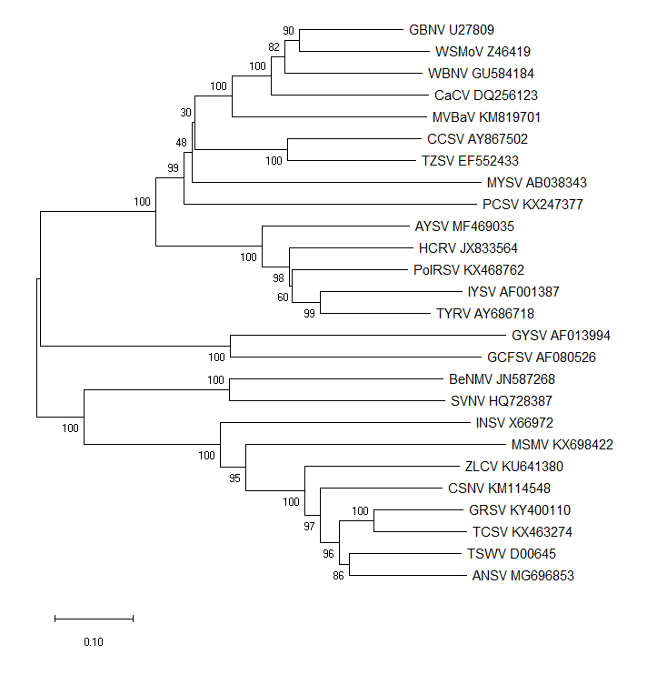

Figure 1 - Estimated phylogeny of the complete S RNA genome segment sequences of viruses belonging to recognized and proposed species within the genus Orthotospovirus in the family Tospoviridae. The eight viruses proposed to represent new species are indicated with yellow highlighting. The midpoint-rooted tree was deduced in MEGA X v. 10.0.5 after alignment in Muscle, using the neighbor-joining method based on the maximum composite likelihood substitution model with uniform rates and 1000 bootstrap replications. The scale bar indicates the number of substitutions per site. Bootstrap support for branches is shown at the junctions of branches where it was >50%. Accession numbers correspond to the nucleotide sequence of each virus genome sequence used in the tree: ANSV, Alstroemeria necrotic streak virus; AYSV, Alstroemeria yellow spot virus. BeNMV, bean necrotic mosaic virus; CCSV, calla lily chlorotic spot virus; CaCV, Capsicum chlorosis virus; CNSV, chrysanthemum stem necrosis virus; GBNV, groundnut bud necrosis virus; GCFSV, groundnut chlorotic fan-spot virus; GRSV, groundnut ringspot virus; GYSV, groundnut yellow spot virus; HCRV, Hippeastrum chlorotic spot virus; INSV, impatiens necrotic spot virus; IYSV, iris yellow spot virus; MSMV, melon severe mosaic virus; MYSV, melon yellow spot virus; MVBaV, mulberry vein banding-associated virus; PCSV, pepper chlorotic spot virus; PolRSV, Polygonum ringspot virus; SVNV, soybean vein necrosis virus; TCSV, tomato chlorotic spot virus; TSWV, tomato spotted wilt virus; TYRV, tomato yellow ring virus; TZSV, tomato zonate spot virus; WBNV, watermelon bud necrosis virus; WSMoV, watermelon silver mottle virus; ZLCV, zucchini lethal chlorosis virus.
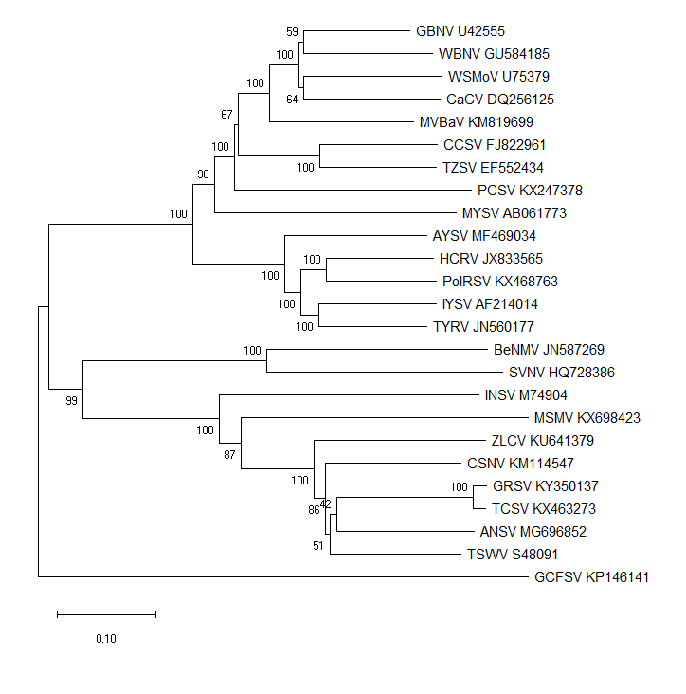

Figure 2 - Estimated phylogeny of the complete M RNA genome segment sequences of viruses belonging to recognized and proposed species within the genus Orthotospovirus in the family Tospoviridae. The eight viruses proposed to represent new species are indicated with yellow highlighting. The midpoint-rooted tree was deduced in MEGA X v. 10.0.5 after alignment in Muscle, using the neighbor-joining method based on the maximum composite likelihood substitution model with uniform rates and 1000 bootstrap replications. The scale bar indicates the number of substitutions per site. Bootstrap support for branches is shown at the junctions of branches where it was >50%. Accession numbers correspond to the nucleotide sequence of each virus genome sequence used in the tree: ANSV, Alstroemeria necrotic streak virus; AYSV, Alstroemeria yellow spot virus. BeNMV, bean necrotic mosaic virus; CCSV, calla lily chlorotic spot virus; CaCV, Capsicum chlorosis virus; CNSV, chrysanthemum stem necrosis virus; GBNV, groundnut bud necrosis virus; GCFSV, groundnut chlorotic fan-spot virus; GRSV, groundnut ringspot virus; HCRV, Hippeastrum chlorotic spot virus; INSV, impatiens necrotic spot virus; IYSV, iris yellow spot virus; MSMV, melon severe mosaic virus; MYSV, melon yellow spot virus; MVBaV, mulberry vein banding-associated virus; PCSV, pepper chlorotic spot virus; PolRSV, Polygonum ringspot virus; SVNV, soybean vein necrosis virus; TCSV, tomato chlorotic spot virus; TSWV, tomato spotted wilt virus; TYRV, tomato yellow ring virus; TZSV, tomato zonate spot virus; WBNV, watermelon bud necrosis virus; WSMoV, watermelon silver mottle virus; ZLCV, zucchini lethal chlorosis virus.
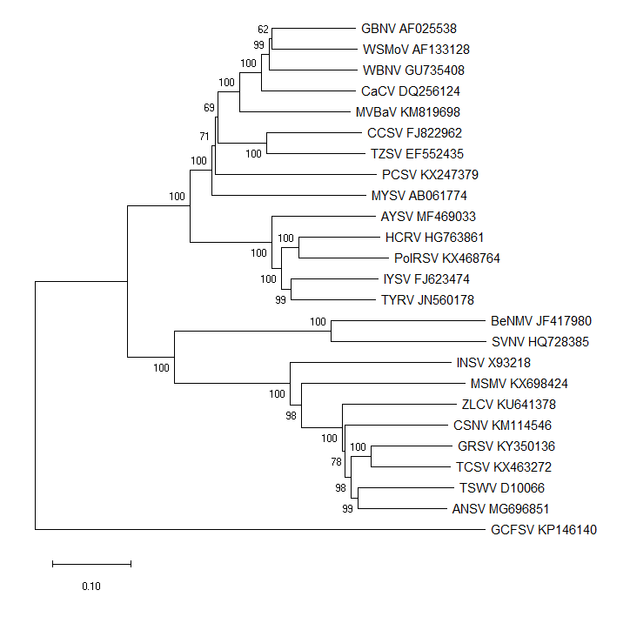

Figure 3 - Estimated phylogeny of the complete L RNA genome segment sequences of viruses belonging to recognized and proposed species within the genus Orthotospovirus in the family Tospoviridae. The eight viruses proposed to represent new species are indicated with yellow highlighting. The midpoint-rooted tree was deduced in MEGA X v. 10.0.5 after alignment in Muscle, using the neighbor-joining method based on the maximum composite likelihood substitution model with uniform rates and 1000 bootstrap replications. The scale bar indicates the number of substitutions per site. Bootstrap support for branches is shown at the junctions of branches where it was >50%. Accession numbers correspond to the nucleotide sequence of each virus genome sequence used in the tree: ANSV, Alstroemeria necrotic streak virus; AYSV, Alstroemeria yellow spot virus. BeNMV, bean necrotic mosaic virus; CCSV, calla lily chlorotic spot virus; CaCV, Capsicum chlorosis virus; CNSV, chrysanthemum stem necrosis virus; GBNV, groundnut bud necrosis virus; GCFSV, groundnut chlorotic fan-spot virus; GRSV, groundnut ringspot virus; HCRV, Hippeastrum chlorotic spot virus; INSV, impatiens necrotic spot virus; IYSV, iris yellow spot virus; MSMV, melon severe mosaic virus; MYSV, melon yellow spot virus; MVBaV, mulberry vein banding-associated virus; PCSV, pepper chlorotic spot virus; PolRSV, Polygonum ringspot virus; SVNV, soybean vein necrosis virus; TCSV, tomato chlorotic spot virus; TSWV, tomato spotted wilt virus; TYRV, tomato yellow ring virus; TZSV, tomato zonate spot virus; WBNV, watermelon bud necrosis virus; WSMoV, watermelon silver mottle virus; ZLCV, zucchini lethal chlorosis virus.

