This Word module should be used for all taxonomic proposals.
Please complete Part 1 and:
either Part 3 for proposals to create new taxa or change existing taxa
or Part 2 for proposals of a general nature.
Submit the completed Word module, together with the accompanying Excel module named in Part 3, to the appropriate ICTV Subcommittee Chair.
The Word module explains and justifies your proposal. The Excel module is a critical document that will be used to implement the proposed taxonomic changes once they are approved and ratified. If proposals presented in the Word module are not presented accurately in the Excel module, the taxonomic changes cannot proceed.
For guidance, see the notes written in blue, below, and the Help Notes in file Taxonomic_Proposals_Help_2019.
Part 1: TITLE, AUTHORS, etc

Code assigned: | 2019.001P
Short title: Create one new species in the genus Turncurtovirus (family Geminiviridae)
Author(s) and email address(es):
Fiallo-Olivé E |  | efiallo@eelm.csic.es
Corresponding author
Fiallo-Olivé E; efiallo@eelm.csic.es
List the ICTV study group(s) that have seen this proposal:
A list of study groups and contacts is provided at http://www.ictvonline.org/subcommittees.asp . If in doubt, contact the appropriate subcommittee chair (there are six virus subcommittees: animal DNA and retroviruses, animal ssRNA-, animal ssRNA+, fungal and protist, plant, bacterial and archaeal) |  |  | Geminiviridae and Tolecusatellitidae SG
ICTV Study Group comments (if any) and response of the proposer:
Date first submitted to ICTV:
Date of this revision (if different to above):

ICTV-EC comments and response of the proposer:

Part 2: NON-STANDARD
Template for any proposal regarding ICTV procedures, rules or policy, not involving the creation of new taxonomy.
Text of proposal:

Part 3: PROPOSED TAXONOMY

Name of accompanying Excel module: 2019.001P.A.v1.Turncurtovirus_1sp.xlsx

Supporting material:

One new species in the genus Turncurtovirus

There are currently two species in the genus Turncurtovirus in the family Geminiviridae, Turnip curly top virus (Briddon et al. 2010) and Turnip leaf roll virus (Kamali et al. 2016). Isolates of these species have only been found so far in Iran and are transmitted by the leafhopper Circulifer haematoceps.

Based on the distribution of pairwise identities, a tentative species demarcation threshold of 80% has been proposed and is currently used (Varsani et al. 2014; Kamali et al. 2016). Thus, pairs of turncurtovirus isolates that have full genome sequences with >80% pairwise identity are considered as members of the same species. Based on this framework, one new species needs to be established to allow the classification of new turncurtovirus isolates that have been recently characterized from Pakistan and Iran.

Sesame curly top virus

Thirteen isolates of sesame curly top virus (Table 1) have been identified from sesame (Sesamum indicum) in Pakistan (n=1) and Iran (n=1) and the leafhopper Circulifer haematoceps collected from sesame plants also in Iran (n=11) (Hasanvand et al. 2018). The 12 isolates from Iran share >98% identity between them and 87-88% with the isolate from Pakistan. Also, the isolates share <70% with isolates of TCTV and TLRV (Figure 1), being under the 80% turncurtovirus demarcation criteria. Phylogenetically, the 13 isolates constitute a separate cluster with 100% bootstrap support (Figure 2).

The isolate from Pakistan, whose sequence is not published but deposited in GenBank with accession number MF344550, was named as sesame yellow mosaic virus and those from Iran (MH595443-MH595454) were named as sesame curly top virus. The name Sesame curly top virus is proposed for the new species based on: i) the literature contains the name sesame yellow mosaic virus as a tentative name for a potyvirus, and ii) its formal publication (Hasanvand et al. 2018).

Table 1. Details of sesame curly top virus isolates

Species name | Virus acronym | GenBank Acc. No. | Isolate | Source | Country | Reference
Sesame curly top virus | SeCTV | MF344550 | PK-Lay-Se386-12 | S. indicum | Pakistan | Unpublished
 |  | MH595443 | IR-Jir-Jir36-17 | S. indicum | Iran | Hasanvand et al. (2018)
 |  | MH595444 | IR-Sir-LH_1-13-14 | C. haematoceps | Iran | Hasanvand et al. (2018)
 |  | MH595445 | IR-Orz-LH_4-2-14 | C. haematoceps | Iran | Hasanvand et al. (2018)
 |  | MH595446 | IR-Orz-LH_4-5-14 | C. haematoceps | Iran | Hasanvand et al. (2018)
 |  | MH595447 | IR-Orz-LH_4-3-14 | C. haematoceps | Iran | Hasanvand et al. (2018)
 |  | MH595448 | IR-Orz-LH_4-15-14 | C. haematoceps | Iran | Hasanvand et al. (2018)
 |  | MH595449 | IR-Jir-JK_1-6-14 | C. haematoceps | Iran | Hasanvand et al. (2018)
 |  | MH595450 | IR-Jir-JK_6-2-14 | C. haematoceps | Iran | Hasanvand et al. (2018)
 |  | MH595451 | IR-Jir-JK_7-4-14 | C. haematoceps | Iran | Hasanvand et al. (2018)
 |  | MH595452 | IR-Jir-JK_10-2-14 | C. haematoceps | Iran | Hasanvand et al. (2018)
 |  | MH595453 | IR-Jir-JK_10-3-14 | C. haematoceps | Iran | Hasanvand et al. (2018)
 |  | MH595454 | IR-Orz-LH_4-14 | C. haematoceps | Iran | Hasanvand et al. (2018)

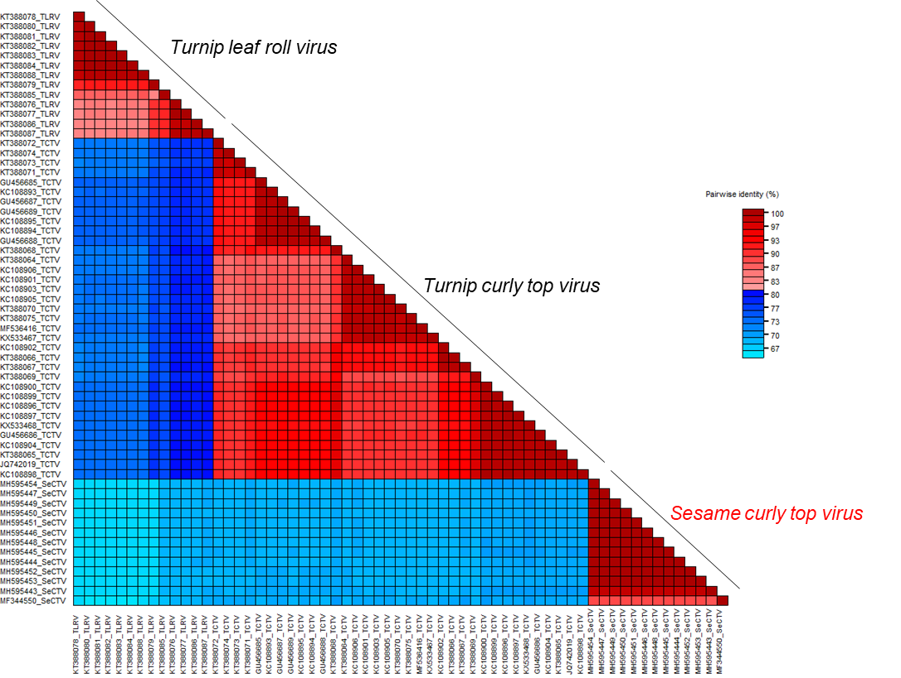

Figure 1. Two-color pairwise identity matrix inferred using SDT v1.2 (Muhire et al. 2014) including isolates of Turnip leaf roll virus and Turnip curly top virus (the two previously recognized species in the genus Turncurtovirus) and those of the proposed species, Sesame curly top virus.
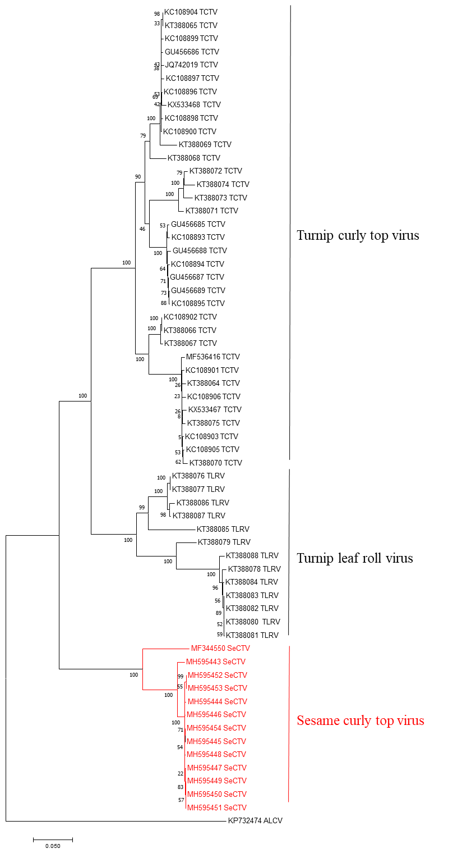
Figure 2. Neighbour-Joining phylogenetic tree (rooted with the sequence of the capulavirus alfalfa leaf curl virus, ALCV) of all turncurtovirus genomes. Sesame curly top virus isolates are highlighted in red.
References:

Briddon RW, Heydarnejad J, Khosrowfar F, Massumi H, Martin DP, Varsani A (2010) Turnip curly top virus, a highly divergent geminivirus infecting turnip in Iran. Virus Res 152:169-175.
Hasanvand V, Kamali M, Heydarnejad J, Massumi H, Kvarnheden A, Varsani A (2018) Identification of a new turncurtovirus in the leafhopper Circulifer haematoceps and the host plant species Sesamum indicum. Virus Genes 54:840-845.
Kamali M, Heydarnejad J, Massumi H, Kvarnheden A, Kraberger S, Varsani A (2016) Molecular diversity of turncurtoviruses in Iran. Arch Virol 161:551-561.
Muhire, BM, Varsani, A, Martin, DP (2014) SDT: a virus classification tool based on pairwise sequence alignment and identity calculation. PLoS One 9:e108277.
Varsani A, Navas-Castillo J, Moriones E, Hernández-Zepeda C, Idris A, Brown JK, Zerbini FM, Martin DP (2014) Establishment of three new genera in the family Geminiviridae: Becurtovirus, Eragrovirus and Turncurtovirus. Arch Virol 159:2193-2203.

