This Word module should be used for all taxonomic proposals.
Please complete Part 1 and:
either Part 3 for proposals to create new taxa or change existing taxa
or Part 2 for proposals of a general nature.
Submit the completed Word module, together with the accompanying Excel module named in Part 3, to the appropriate ICTV Subcommittee Chair.
The Word module explains and justifies your proposal. The Excel module is a critical document that will be used to implement the proposed taxonomic changes once they are approved and ratified. If proposals presented in the Word module are not presented accurately in the Excel module, the taxonomic changes cannot proceed.
For guidance, see the notes written in blue, below, and the Help Notes in file Taxonomic_Proposals_Help_2019.
Part 1: TITLE, AUTHORS, etc

Code assigned: | 2019.009P
Short title: Create six new species in the subfamily Geminialphasatellitinae and two new species in the subfamily Nanoalphasatellitinae, in the family Alphasatellitidae
Author(s) and email address(es):
Varsani A, Roumagnac P, Lett J-M, Martin DP |  | arvind.varsani@asu.edu; philippe.roumagnac@cirad.fr; lett@cirad.fr; darrenpatrickmartin@gmail.com
Corresponding author
Arvind Varsani: arvind.varsani@asu.edu

List the ICTV study group(s) that have seen this proposal:
A list of study groups and contacts is provided at http://www.ictvonline.org/subcommittees.asp . If in doubt, contact the appropriate subcommittee chair (there are six virus subcommittees: animal DNA and retroviruses, animal ssRNA-, animal ssRNA+, fungal and protist, plant, bacterial and archaeal) |  |  | Geminiviridae and Tolecusatellitidae SG
ICTV Study Group comments (if any) and response of the proposer:
Date first submitted to ICTV:
Date of this revision (if different to above):

ICTV-EC comments and response of the proposer:

Part 2: NON-STANDARD
Template for any proposal regarding ICTV procedures, rules or policy, not involving the creation of new taxonomy.
Text of proposal:

Part 3: PROPOSED TAXONOMY

Name of accompanying Excel module: 2019.009P.A.v1.Alphasatellitidae_8sp.xlsx

Briddon et al. (2018) established the taxonomy of the family Alphasatellitidae. Within this family two subfamilies and various genera were established as detailed below in Table 1.

Table 1. List of genera in the subfamilies Geminialphasatellitinae (geminivirus-associated alphasatellites) and Nanoalphasatellitinae (nanovirus-associated alphasatellites) of the family Alphasatellitidae.
Subfamily | Genera
Geminialphasatellitinae | Ageyesisatellite
 | Clecrusatellite
 | Colecusatellite
 | Gosmusatellite
Nanoalphasatellitinae | Babusatellite
 | Clostunsatellite
 | Fabenesatellite
 | Milvetsatellite
 | Mivedwarsatellite
 | Sophoyesatellite
 | Subclovsatellite

Subfamily Geminialphasatellitinae
Within the subfamily Geminialphasatellitinae, a genera demarcation threshold of 70% and a species demarcation threshold of 88%, both based on genome-wise pairwise identity, were recommended (Briddon et al., 2018). Based on these thresholds and the sequence data available in public databases in 2018, four genera (Table 1) and 43 species were established (Briddon et al., 2018). Subsequently, 128 geminialphasatellite sequences have been made publicly available. Analysis of pairwise identities (Figure 1) of these coupled with phylogenetic support (Figure 2) and based on the criteria set out in Briddon et al. (2018), we propose to establish six new species and to classify some of the sequences that cannot be assigned to established genera (Table 2).

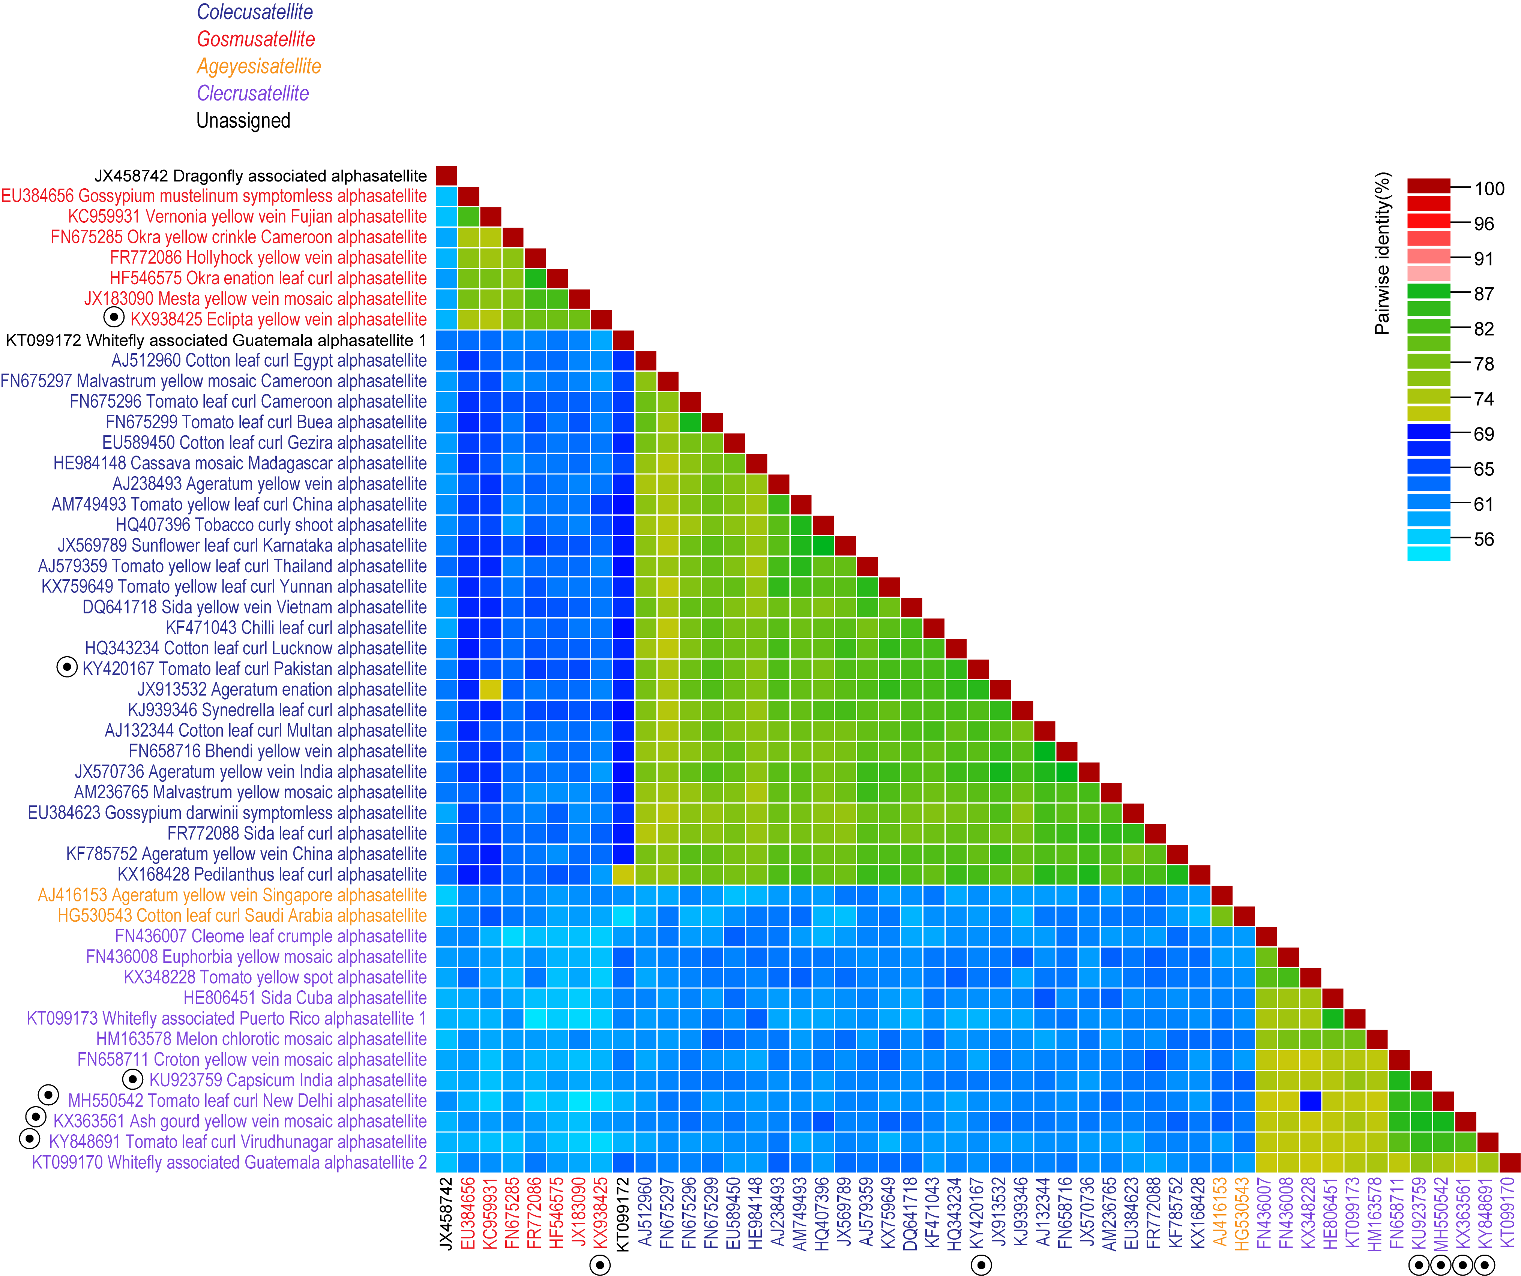

Figure 1. A ‘three colour’ pairwise identity matrix inferred using SDT v1.2 (Muhire et al., 2014) showing that both, the genera demarcation threshold of 70% and the species demarcation threshold at 88%, are supported. Representatives of new species are highlighted with a circle.

Table 2. Summary of the six new proposed species in the subfamily Geminialphasatellitinae.
Genera | Species | Accession # | Virus name | Acronym | Isolate | Country | Host
Clecrusatellite | Capsicum India alphasatellite | KU923759 | begomovirus-associated alphasatellite sp. | CIA | IN-PJ-Cap-15 | India | Capsicum annuum
 | Ash gourd yellow vein mosaic alphasatellite | KX363561 | ash gourd yellow vein mosaic alphasatellite | AsGYVMA | IN-UdA-15 | India | Benincasa hispida
 | Tomato leaf curl New Delhi alphasatellite | MH550542 | tomato leaf curl New Delhi alphasatellite | ToLNDA | IN-VNS_SP4-Luf-15 | India | Luffa aegyptiaca
 | Tomato leaf curl Virudhunagar alphasatellite | KY848691 | tomato leaf curl Virudhunagar alphasatellite | ToLCViA | IN-sev-Mom-16 | India | Momordica charantia
Gosmusatellite | Eclipta yellow vein alphasatellite | KX938425 | Eclipta yellow vein alphasatellite | EcYVA | PK-AlYVA-S3-13 | Pakistan | Eclipta sp.
Colecusatellite | Tomato leaf curl Pakistan alphasatellite | KY420167 | tomato leaf curl alphasatellite | ToLCPKA | PK-SZ_258-Gos-15 | Pakistan | Gossypium hirsutum

The sequences with the following accession numbers are classified into the following species:

Clecrusatellite
- Capsicum India alphasatellite: KU923759 (exemplar isolate sequence) and KU923760
- Ash gourd yellow vein mosaic alphasatellite: KX363561 (exemplar isolate sequence)
- Tomato leaf curl New Delhi alphasatellite: MH550542 (exemplar isolate sequence)
- Tomato leaf curl Virudhunagar alphasatellite: KY848691 (exemplar isolate sequence)

Gosmusatellite
- Eclipta yellow vein alphasatellite: KX938425 (exemplar isolate sequence)

Colecusatellite
- Tomato leaf curl Pakistan alphasatellite: KY420167 (exemplar isolate sequence), KX656850, KY420165, KY797664, KY797665, KY797666, KY797667, KY848800, KY933713, KY933714, KY937948, LN829149, LN829150, LN829151, LN829154, LN829155, LN829156, LN829157, LN886538, LN901462, LT600698, LT600699, LT600701, LT600702, LT600703, LT600704, LT600705, LT600706, LT600707, LT600719, LT600720, LT600721, LT600722, LT600723, LT600724, LT600746, LT600747, LT600748, LT600749, LT600750, LT600751, LT600758, LT674453, LT674455, LT674456, LT674457, LT674458, LT674459, LT674460, LT674461, LT674462, LT674463, LT674464, LT674465, LT674466, LT716982, LT716987, LT840048, LT840049, LT840050, LT840051, LT840052, LT840053, LT840054, LT840055, LT840056, LT840057, LT840058, LT840059, LT840060, LT840061, LT840062, LT840063, LT840064, LT840065, LT840066, LT840069, MF344549, MF496371, MF929022, MF929025, MF929026, MF929027, MF929028, MF929030, MF929031, MF929033, MF929034, MF929035, MF929036.

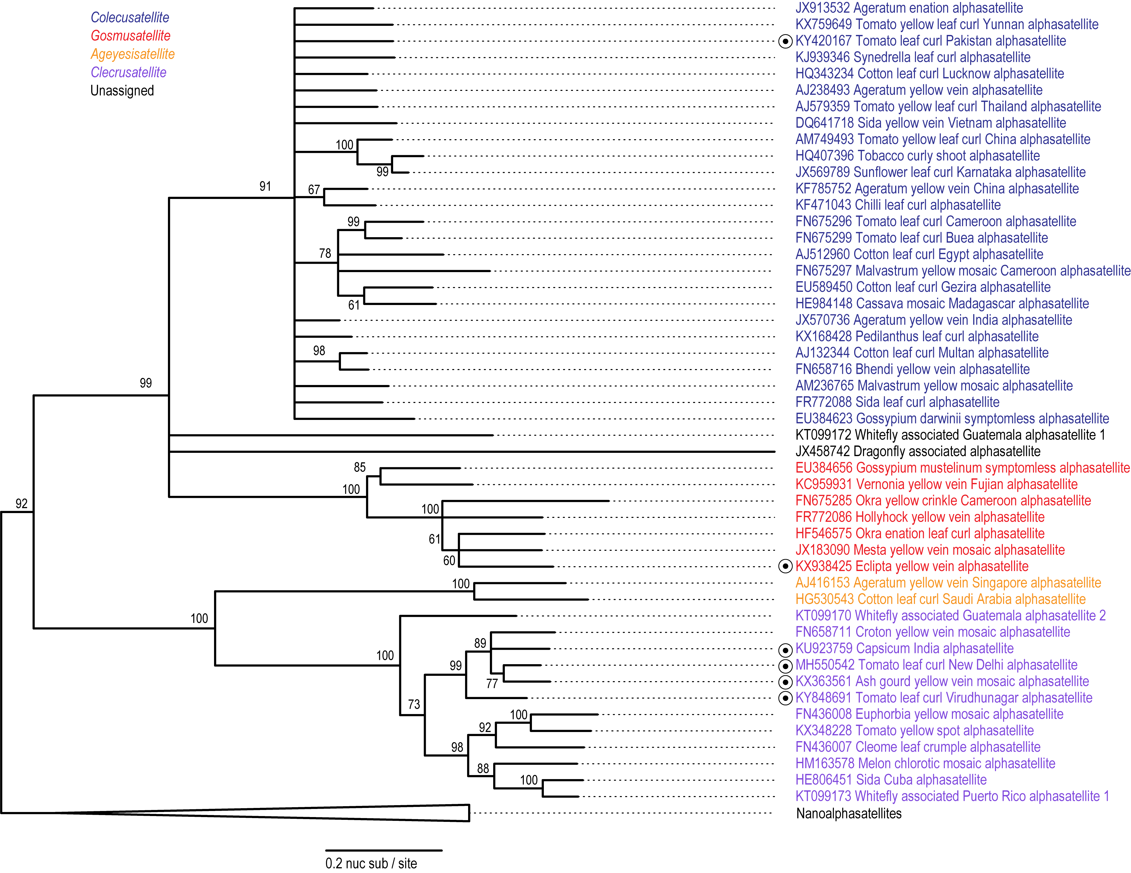

Figure 2. Maximum likelihood phylogenetic tree of representative geminivirus-associated alphasatellite sequences (subfamily Geminialphasatellitinae) from each species inferred using PhyML 3 (Guindon et al. 2010) with GTR+I+G4 chosen as the best-fit model. Branches with <60% bootstrap support have been collapsed. Representatives of new species are highlighted with a circle.

Subfamily Nanoalphasatellitinae
Within the subfamily Nanoalphasatellitinae, a genera demarcation threshold of 67% and a species demarcation threshold of 80%, both based on genome-wise pairwise identity, were previously recommended (Briddon et al., 2018). Based on these and the sequence data available in public databases in 2018, seven genera (Table 1) and 21 species were established (Briddon et al., 2018). Subsequently, 17 nanoalphasatellite sequences have been made publicly available. Based both on the analysis of pairwise identities (Figure 3) coupled with phylogenetic support (Figure 4), and on the criteria set out in Briddon et al. (2018), we propose to establish two new species (Table 3).

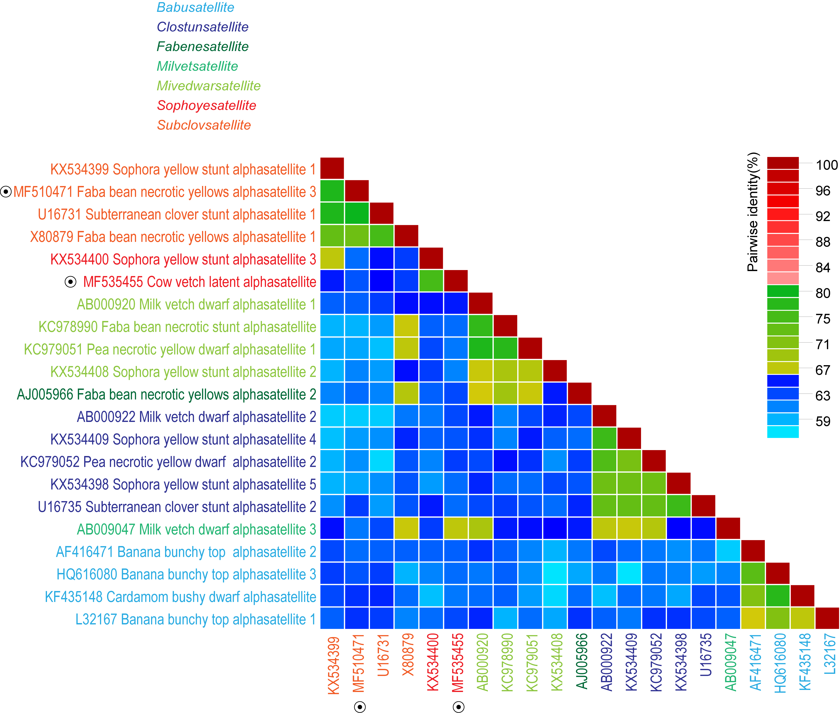

Figure 3: A ‘three colour’ pairwise identity matrix inferred using SDT v1.2 (Muhire et al., 2014) showing that both the genera demarcation threshold of ~65% and the species demarcation threshold of 80% are supported. Representatives of new species are highlighted with a circle.

Table 3. Summary of the six proposed new species in the subfamily Nanoalphasatellitinae.
Genus | Species | Accession # | Virus name | Acronym | Isolate | Country | Host
Subclovsatellite | Faba bean necrotic yellows alphasatellite 3 | MF510471 | faba bean necrotic yellows virus associated alphasatellite 1 | FBNYA 3 | TN-Tuf9_1-15 | Tunisia | Vicia faba
Sophoyesatellite | Cow vetch latent alphasatellite | MF535455 | cow vetch latent virus alphasatellite | CVLA | FR-VcLV_Sambuc-10 | France | Vicia cracca

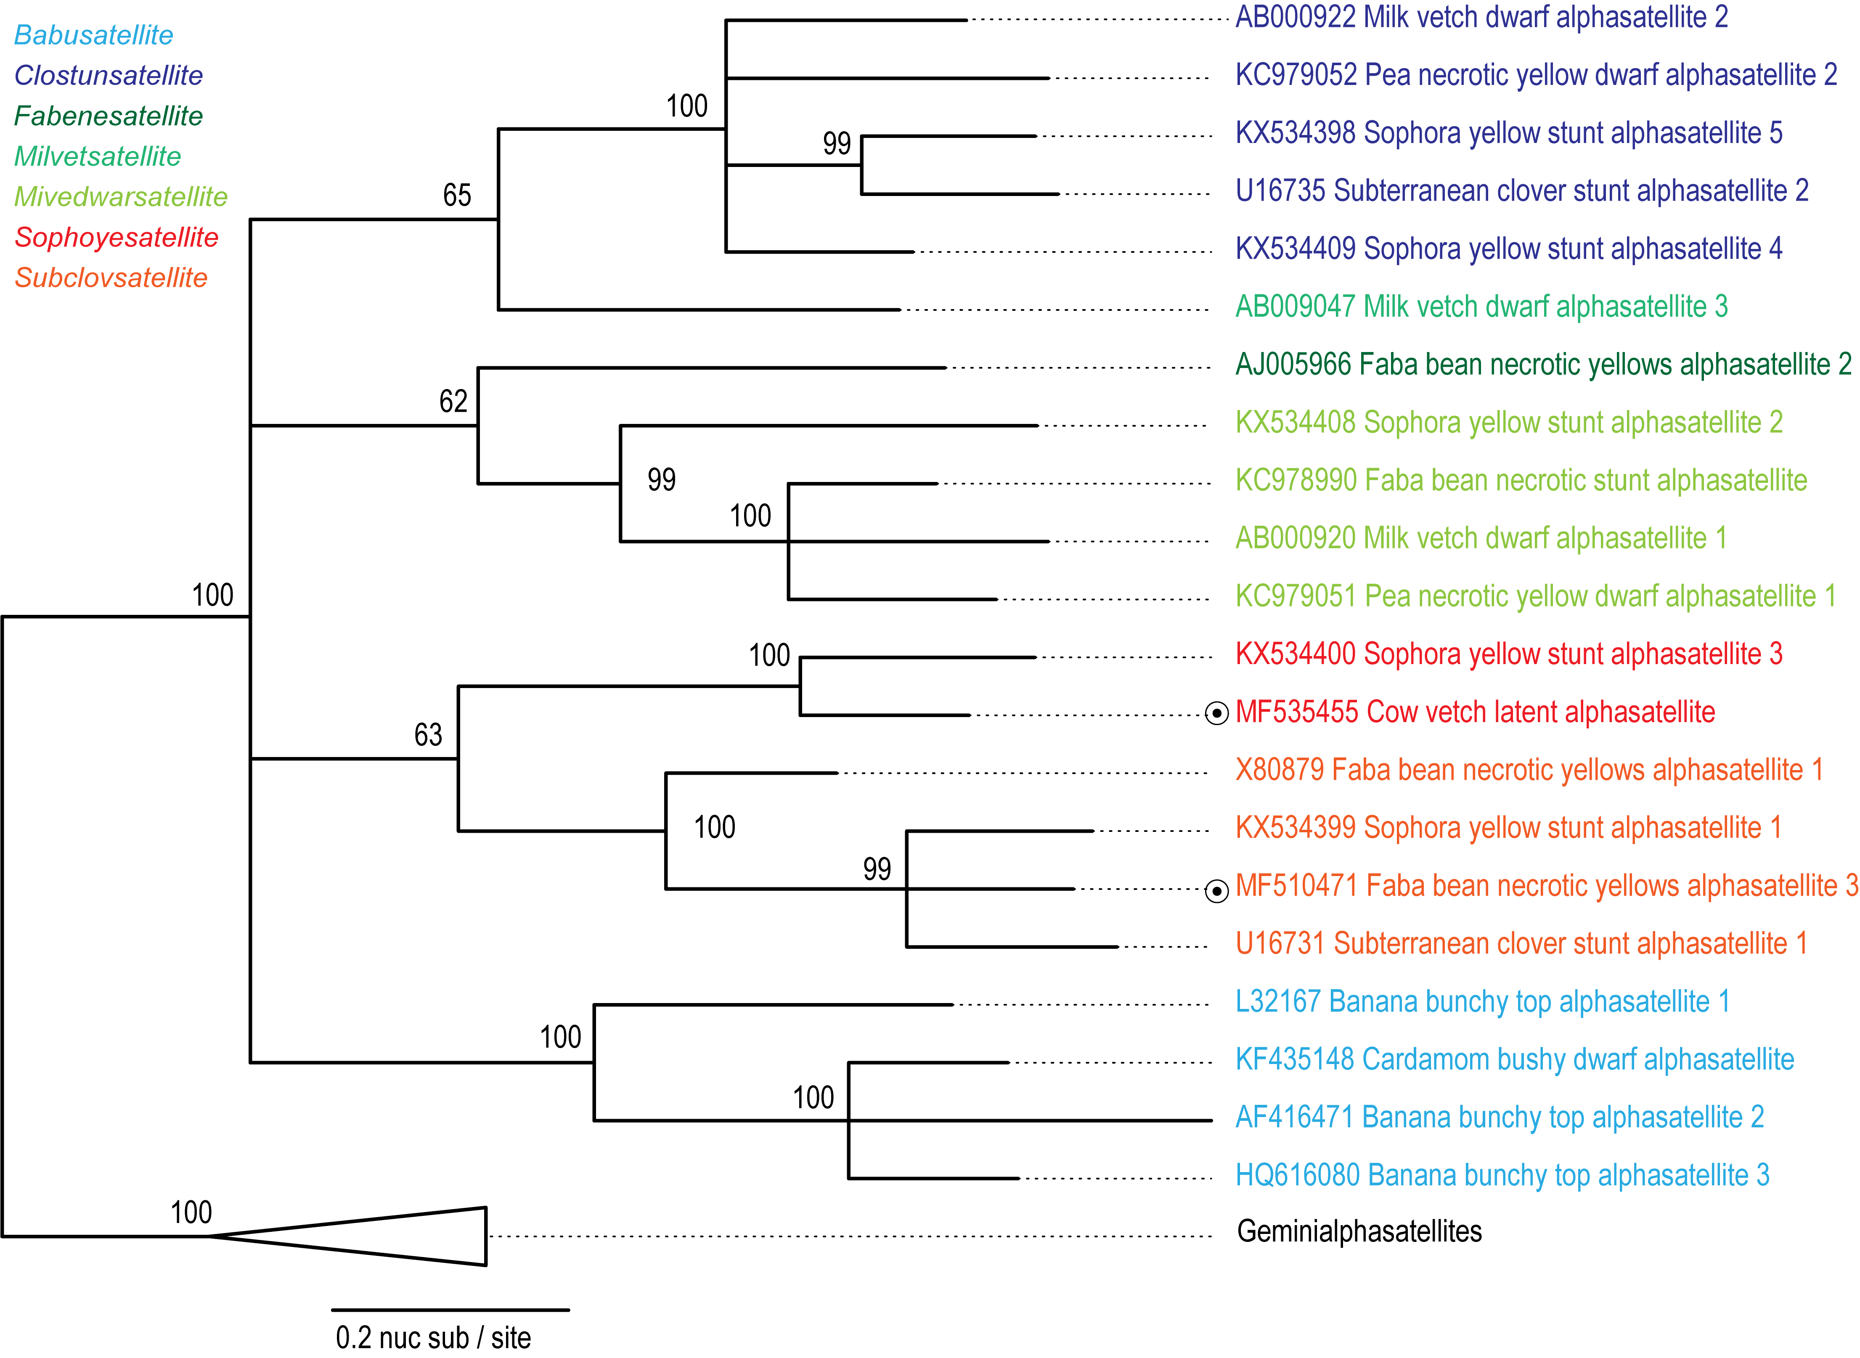

Figure 4: Maximum likelihood phylogenetic tree of representative geminivirus-associated alphasatellite sequences from each species inferred using PhyML 3 (Guindon et al. 2010) with GTR+I+G4 chosen as the best-fit model. Branches with <60% bootstrap support have been collapsed. Representatives of new species are highlighted with a circle.

The sequences with the following accession numbers are classified into the following species.

Subclovsatellite
- Faba bean necrotic yellows alphasatellite 3: MF510471 (exemplar isolate sequence), MF510472, MF510473

Sophoyesatellite
- Cow vetch latent alphasatellite: MF535455 (exemplar isolate sequence)

References:
Briddon RW, Martin DP, Roumagnac P, Navas-Castillo J, Fiallo-Olive E, Moriones E, Lett JM, Zerbini FM, Varsani A. 2018. Alphasatellitidae: a new family with two subfamilies for the classification of geminivirus- and nanovirus-associated alphasatellites. Arch Virol 163:2587-2600
Guindon S, Dufayard J-F, Lefort V, Anisimova M, Hordijk W, Gascuel O (2010) New algorithms and methods to estimate maximum-likelihood phylogenies: Assessing the performance of PhyML 3.0. Syst Biol 59:307-321
Muhire BM, Varsani A, Martin DP (2014) SDT: a virus classification tool based on pairwise sequence alignment and identity calculation. PLoS One 9:e108277

