This Word module should be used for all taxonomic proposals.
Please complete Part 1 and:
either Part 3 for proposals to create new taxa or change existing taxa
or Part 2 for proposals of a general nature.
Submit the completed Word module, together with the accompanying Excel module named in Part 3, to the appropriate ICTV Subcommittee Chair.
The Word module explains and justifies your proposal. The Excel module is a critical document that will be used to implement the proposed taxonomic changes once they are approved and ratified. If proposals presented in the Word module are not presented accurately in the Excel module, the taxonomic changes cannot proceed.
For guidance, see the notes written in blue, below, and the Help Notes in file Taxonomic_Proposals_Help_2019.
Part 1: TITLE, AUTHORS, etc

Code assigned: | 2019.013P
Short title: Create one new species (Birdsfoot trefoil enamovirus 1) in the genus Enamovirus, family Luteoviridae
Author(s) and email address(es):
Debat H, Bejerman N |  | debat.humberto@inta.gob.ar; bejerman.nicolas@inta.gob.ar
Corresponding author
Humberto Debat; debat.humberto@inta.gob.ar
List the ICTV study group(s) that have seen this proposal:
A list of study groups and contacts is provided at http://www.ictvonline.org/subcommittees.asp . If in doubt, contact the appropriate subcommittee chair (there are six virus subcommittees: animal DNA and retroviruses, animal ssRNA-, animal ssRNA+, fungal and protist, plant, bacterial and archaeal) |  | Luteoviridae
ICTV Study Group comments (if any) and response of the proposer:
Approved by SG member Peter Waterhouse
Date first submitted to ICTV: |  |  | April 2019
Date of this revision (if different to above): |  |  | June 19, 2019

ICTV-EC comments and response of the proposer:

Part 2: NON-STANDARD
Template for any proposal regarding ICTV procedures, rules or policy, not involving the creation of new taxonomy.
Text of proposal:

Part 3: PROPOSED TAXONOMY

Name of accompanying Excel module: 2019.013P.A.v1.Enamovirus_1sp.xlxs

This proposal suggests that birdsfoot trefoil enamovirus 1 (BFTEV1) should be considered as a member of a new species in the genus Enamovirus, family Luteoviridae.
The analysis of a transcriptomic dataset from bird's-foot trefoil, which is available in the NCBI Sequence Read Archive (SRA) database (SRA: SRS271068) revealed the presence of a virus related to the enamoviruses alfalfa enamovirus 1 and pea enation mosaic virus 1 [1]. The GenBank accession number of this new assembled sequence is BK010825. In a recent consensus statement report, Simmonds et al. [2] report that viruses that are known only from metagenomic data can be, should be, and have been incorporated into the official classification scheme of the International Committee on Taxonomy of Viruses (ICTV).
We are not aware of specific criteria to demarcate enamoviruses. Nevertheless, we understand that criteria used to demarcate species in the Luteovirus and Polerovirus genera [3] could be implemented to demarcate species in the Enamovirus genus, which include differences in amino acid sequence identity of any gene product greater than 10%.
BFTEV1 genome organization (Figure 1) resembles that described for enamoviruses. This virus, unlike poleroviruses, does not encode putative P3a or P4 movement proteins, whereas it encodes a P0, which is lacking in members of the genus Luteovirus [3].
Nucleotide (nt) and amino acid (aa) sequence identities were determined by comparing the BFTEV1 ORFs/gene products with the those of all enamoviruses and proposed enamoviruses available in GenBank. The maximum nt sequence identity for any ORF was 77.1%, whereas the maximum aa sequence identity was 85.3% (Table 1). Therefore, the differences in aa sequence identity for each gene product were greater than 10 %, which, as stated above, is one of the criteria used by the International Committee on Taxonomy of Viruses to demarcate species in the Luteoviridae family [3].
In a phylogenetic analysis based on the P1-P2 fusion protein aa sequence of viruses of the family Luteoviridae, BFTEV1 clustered with alfalfa enamovirus, pea enation mosaic virus 1 and red clover enamovirus 1 in a monophyletic clade of legume-associated enamoviruses within the enamovirus complex (Figure 2).
Therefore, based upon the above-mentioned comparisons of BTFEV1 with extant enamoviruses, we propose the creation of a new species in the genus Enamovirus (family Luteoviridae), named Birdsfoot trefoil enamovirus 1.

References:
- Debat H, Bejerman N (2019) Novel bird's-foot trefoil RNA viruses provide insights into a clade of legume-associated enamoviruses and rhabdoviruses. Arch Virol, doi: 10.1007/s00705-019-04193-1.
- Simmonds P, Adams MJ, Benkő M, Breitbart M, Brister JR, Carstens EB, Hull R et al (2017) Consensus statement: virus taxonomy in the age of metagenomics. Nat Rev Microbiol 15:161
- Domier, LL (2011). Family Luteoviridae, in: King, AMQ Adams, MJ, Carstens, EB, Lefkowitz, EJ (Eds), Virus Taxonomy, Ninth Report of the International Committee on Taxonomy of Viruses. Elsevier, Oxford, pp. 1045-1053.

Table 1. Amino acid (aa)/nucleotide (nt) sequence identities (%) of birdsfoot trefoil enamovirus 1 (BFTEV-1) ORFs/predicted proteins compared with those of enamoviruses available in GenBank. AEV1, alfalfa enamovirus 1; PEMV1, pea enation mosaic virus 1; CVEV, citrus vein enation virus; PEPV, pepper enamovirus; GEV1, grapevine enamovirus 1; RCEV1, Red clover enamovirus 1.

Virus/Gene | ORF0 | ORF1 | ORF1-2 | ORF3 | ORF3-5
AEV1 | 48.5/61.5 | 51.4/61.0 | 61.7/66.7 | 85.3/75.6 | 73.4/70.3
PEMV1 | 50.8/61.7 | 48.7/60.0 | 60.2/65.8 | 82.6/77.1 | 69.2/68.9
RCEV1 | 51.2/67.2 | 50.6/64.3 | 57.5/69.0 | 78.9/74.3 | 72.8/71.5
CVEV | 18.9/35.2 | 21.9/34.4 | 35.8/41.4 | 25.0/38.6 | 37.1/45.6
PEPV | 21.5/34.9 | 14.7/40.4 | 35.7/46.4 | 24.8/39.1 | 38.9/43.2
GEV1 | 14.4/35.7 | 19.1/31.3 | 29.6/38.3 | 43.5/46.2 | 30.1/38.8

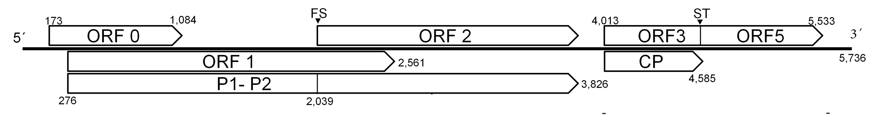
Figure 1. Putative genome organization of birdsfoot trefoil enamovirus 1 (BFTEV1). Positions are marked at the extremities. FS, -1 ribosomal frameshifting signal; ST, signal of translation read-through of a UGA stop codon.

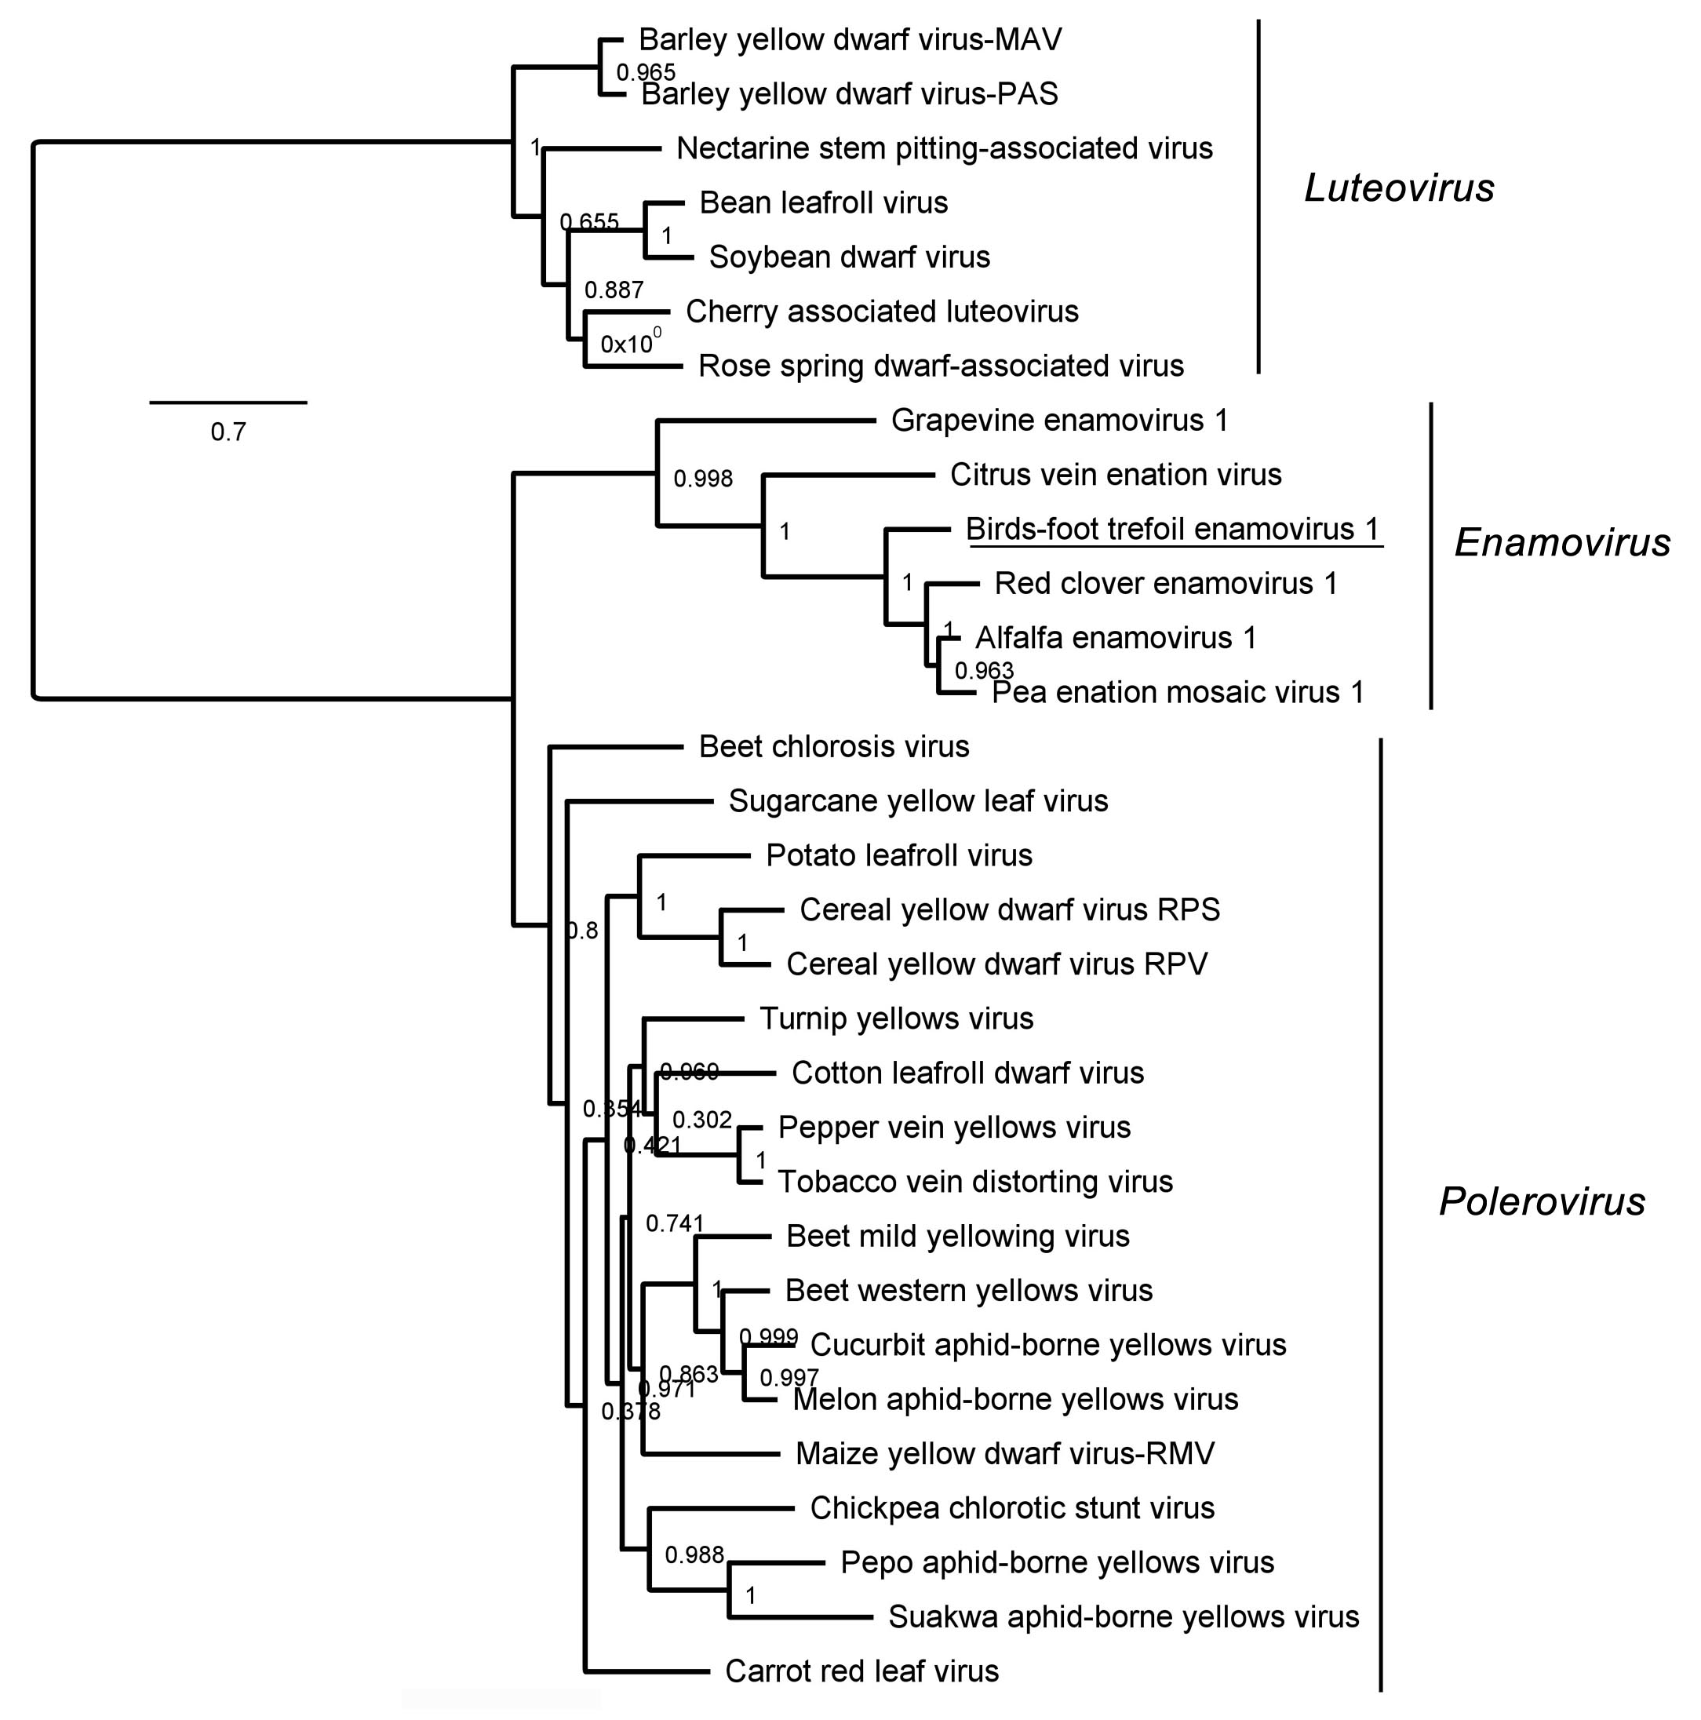

Figure 2. Maximum likelihood phylogenetic tree based on amino acid sequence alignments of the P1-P2 polymerase of BFTEV1 and other enamoviruses. The Luteovirus genus was used as tree root. Enamovirus, Polerovirus and Luteovirus clades are indicated. The scale bar indicates the number of substitutions per site. Node labels indicate FastTree support values. The viruses used to construct the tree, and their accession numbers are as follows: Alfalfa enamovirus 1 (YP_009249823), Barley yellow dwarf virus-MAV (NC_003680), Barley yellow dwarf virus-PAS (NC_002160), Bean leafroll virus (NC_003369), Beet chlorosis virus (NP_114361), Beet mild yellowing virus (NP_620479), Beet western yellows virus (NP_840097), Carrot red leaf virus (YP_077186), Cereal yellow dwarf virus RPS (NP_054685), Cereal yellow dwarf virus RPV (NP_840022), Cherry associated luteovirus (KY686298), Chickpea chlorotic stunt virus (YP_667838), Citrus vein enation virus (YP_008130302), Cotton leafroll dwarf virus (YP_003915148), Cucurbit aphid-borne yellows virus (NP_620101), Grapevine enamovirus-1 (YP_009373263), Maize yellow dwarf virus-RMV (YP_008083739), Melon aphid-borne yellows virus (YP_001949870), Nectarine stem-pitting associated virus (KP638562), Pea enation mosaic virus 1 (NP_620026), Pepo aphid-borne yellows virus (YP_009254738), Pepper vein yellows virus (YP_004207916), Potato leafroll virus (NP_056748), Red clover enamovirus 1 (MG596231), Rose spring dwarf-associated virus (NC_010806), Soybean dwarf virus (NC_003056), Suakwa aphid-borne yellows virus (YP_006666506), Sugarcane yellow leaf virus (NP_050007), Tobacco vein distorting virus (YP_001931931), Turnip yellows virus (NP_620485).

