This Word module should be used for all taxonomic proposals.
Please complete Part 1 and:
either Part 3 for proposals to create new taxa or change existing taxa
or Part 2 for proposals of a general nature.
Submit the completed Word module, together with the accompanying Excel module named in Part 3, to the appropriate ICTV Subcommittee Chair.
The Word module explains and justifies your proposal. The Excel module is a critical document that will be used to implement the proposed taxonomic changes once they are approved and ratified. If proposals presented in the Word module are not presented accurately in the Excel module, the taxonomic changes cannot proceed.
For guidance, see the notes written in blue, below, and the Help Notes in file Taxonomic_Proposals_Help_2019.
Part 1: TITLE, AUTHORS, etc

Code assigned: | 2019.014P
Short title: Create one new species (Faba bean polerovirus 1) in the genus Polerovirus, family Luteoviridae
Author(s) and email address(es):
Filardo FF, Thomas JE, Webb M, Sharman M |  | fiona.filardo@daf.qld.gov.au;  j.thomas2@uq.edu.au;  Matthew.Webb@daf.qld.gov.au;  Murray.Sharman@daf.qld.gov.au
Corresponding author
F. F. Filardo; fiona.filardo@daf.qld.gov.au
List the ICTV study group(s) that have seen this proposal:
A list of study groups and contacts is provided at http://www.ictvonline.org/subcommittees.asp . If in doubt, contact the appropriate subcommittee chair (there are six virus subcommittees: animal DNA and retroviruses, animal ssRNA-, animal ssRNA+, fungal and protist, plant, bacterial and archaeal) |  |  | Luteoviridae Study Group
ICTV Study Group comments (if any) and response of the proposer:
Approved by SG member Peter Waterhouse
Date first submitted to ICTV:
Date of this revision (if different to above):

ICTV-EC comments and response of the proposer:

Part 2: NON-STANDARD
Template for any proposal regarding ICTV procedures, rules or policy, not involving the creation of new taxonomy.
Text of proposal:

Part 3: PROPOSED TAXONOMY

Name of accompanying Excel module: 2019.014P.A.v1.Polerovirus_1sp.xlxs
Faba bean polerovirus 1 (FBPV1) is a novel virus recently identified in Australia infecting pulses such as chickpea (Cicer arietinum), causing reddening, as well as lentil (Lens Culinaris), pea (Pisum sativum), and faba bean (Vicia faba). FBPV1 was also found in the weeds Malva parviflora and Sonchus oleraceus (Filardo et al 2019).

Illumina MiSeq sequencing was used to determine the full genome sequence of two FBPV1 isolates, isolate 5253 from faba bean and isolate 5249 from chickpea. The sequence of the 5’ end was determined, for both isolates, by ligating an adaptor to the 5’ end followed by semi nested PCRs. The untranslated 3’ terminal sequence was determined by addition of a poly (A) tail to purified RNA, followed by cDNA synthesis and PCRs with specific primers.

The complete linear single-stranded positive sense RNA genome was found to be 5,631 nucleotides (nt) in length for both isolates, composed of 6 main open reading frames (ORFs) and a small ORF 3a. The genome organization of FBPV1 is similar to that of members of the genus Polerovirus (family Luteoviridae) (Figure 1). The start of ORF 0 follows a 27 nt 5’ untranslated region and extends to 807 nt downstream to code for a 268 aa sequence. ORF 1, which is translated in a different reading frame to ORF 2, has a putative “shifty” sequence upstream of the ORF 1 stop codon involved in a -1 frame shift to code for the P1-P2 RdRp fusion protein (Mayo & Miller 1999). ORFs 3, 4 and 5 are 3’-proximal and code for the CP, MP and the CP-RTD proteins, respectively. A small ORF 3a is predicted to start at a non-AUG site (AUA) at nt 3348 and extend to nt 3494 to produce a small 49 aa protein.

BLAST analysis against the nucleotide database of NCBI showed high identity values to members of the genus Polerovirus (69-39 % nt sequence identity with poleroviruses and 34-26 % nt sequence identity with luteoviruses). Full genome nucleotide sequence analyses showed that FBPV1 shares high similarity to turnip yellows virus (TuYV) in the 3’ portion of the genome, encoding the coat protein, movement protein and P5 (Table 1). However, the 5’ portion of FBPV1, encoding P0, P1 and the RdRp (P1-P2) showed very little identity to TuYV with the closest match by BLAST being chickpea chlorotic stunt virus (CpCSV; Table 1).

Species demarcation criteria
Currently a virus is considered a member of a new species within the Luteoviridae family if the amino acid sequence of any gene product differs by >10%. FBPV1 differs from all other poleroviruses for ORFs 0, 1 & 2 by more than 10%. Therefore, FBPV1 isolates 5253 and 5249 should be considered isolates of a new virus species in the genus Polerovirus for which the name Faba bean polerovirus 1 is proposed. FBPV1-5253 is the exemplar isolate.

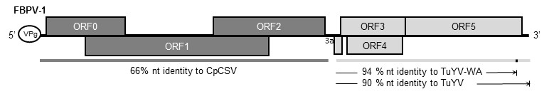

Figure 1. Schematic representation of the FBPV-1 genome, with the six main ORFs (ORF 0-5) and a small ORF3a. The dark grey ORFs depict the 5’ portion that is from a currently unknown virus, which shares some similarity to chickpea chlorotic stunt virus (CpCSV; NC_008249). The light grey ORFs depict the 3’ open reading frames that are highly similar to turnip yellows virus (TuYV; reference sequence NC_003743, and TuYV-WA-1 isolate; JQ862472)

 | FBPV1 – isolate 5253
Virus | Whole genome | ORF 0 | ORF 1+ ORF 2 | ORF 3 | ORF 4 | ORF 5
FBPV1 - 5249 | 98 % | 99 % | 99 % | 99 % | 97 % | 96 %
TuYV | 69 % | 15 % | 48 % | 95 % | 90 % | 90 %
TuYV-WA | 68 % | 15 % | 43 % | 100 % | 95 % | **
CpCSV | 49% | 35 % | 64 % | 70 % | 47 % | 21 %
Table 1. Percent nucleotide and amino acid sequence identities between FBPV1 isolate 5253 and FBPV1 isolate 5249, TuYV (NC_003743), TuYV-WA (JQ862472) and CpCSV (NC_008249). Values indicate percent nucleotide identities for whole-genome comparisons, whereas amino acid sequence identities are used for each ORF-encoded protein comparison. ** Note that the TuYV-WA isolate from GenBank appears to have an error, or an anomaly, in the ORF 5 region leading to a premature stop codon which interferes with the proper translation of the ORF 5 protein. We therefore have not compared this region to FBPV1s ORF 5.

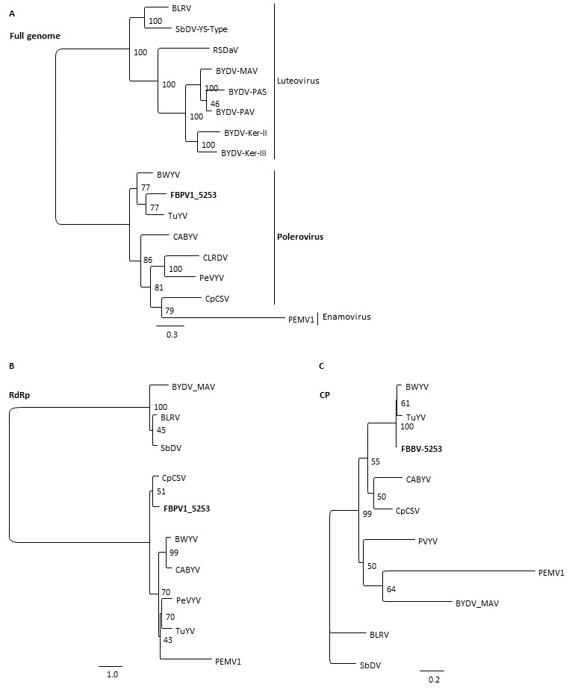

Figure 2. Phylogenetic relationship of faba bean polerovirus 1 (FBPV1) with members of the family Luteoviridae based on the full genome (A), RdRP (B) and coat protein (C). Maximum-likelihood phylogenic trees were based on nucleotide (A) or amino acid (B, C) sequence alignments and created in Geneious generated with RAxML using the GTR GAMMA (A) or GAMMA WAG (B,C) model with rapid bootstrapping and search for the best scoring ML tree algorithm and 100 bootstrap replicates. bean leafroll virus (BLRV; NC_003369), soybean dwarf virus (SbDV; NC_003056), rose spring dwarf-associated virus (RSDaV; EU024678), barley yellow dwarf virus –MAV (BYDV-MAV; NC_003680), barley yellow dwarf virus-PAS (BYDV-PAS; NC_002160), barley yellow dwarf virus-PAV (BYDV-PAV; NC_004750), barley yellow dwarf virus-KER-II (BYDV-KER-II; KC571999), barley yellow dwarf virus-KER-III (BYDV-KER-III; KC559092), beet western yellows virus (BWYV; NC_004756), turnip yellows virus (TuYV; NC_003743), cucurbit aphid borne yellows virus (CABYV; NC_003688), cotton leafroll dwarf virus (CLRDV; NC_014545), pepper vein yellows virus (PeVYV; NC_015050), chickpea chlorotic stunt virus (CpCSV; NC_008249), pea enation mosaic virus 1 (PEMV1; NC_003629).

References:
FF Filardo, JE Thomas, M Webb, M Sharman (2019) Faba bean polerovirus 1 (FBPV-1): a new polerovirus infecting legume crops in Australia. Archives Virology doi 10.1007/s00705-019-04233-w

MA Mayo, WA Miller (1999) The structure and expression of Luteoviridae genomes. In: Smith HG, Barker H (eds) The Luteoviridae. CAB International, Wallingford, pp 23-42.

