This Word module should be used for all taxonomic proposals.
Please complete Part 1 and:
either Part 3 for proposals to create new taxa or change existing taxa
or Part 2 for proposals of a general nature.
Submit the completed Word module, together with the accompanying Excel module named in Part 3, to the appropriate ICTV Subcommittee Chair.
The Word module explains and justifies your proposal. The Excel module is a critical document that will be used to implement the proposed taxonomic changes once they are approved and ratified. If proposals presented in the Word module are not presented accurately in the Excel module, the taxonomic changes cannot proceed.
For guidance, see the notes written in blue, below, and the Help Notes in file Taxonomic_Proposals_Help_2019.
Part 1: TITLE, AUTHORS, etc

Code assigned: | 2019.005P
Short title: Create one new species in the genus Blunervirus

Author(s) and email address(es):
Melzer M, Freitas-Astua J, Rodrigues JCV, Roy A |  | melzer@hawaii.edu; juliana.astua@embrapa.br; jose_carlos@mac.com; Avijit.Roy@usda.gov
Corresponding author
Michael Melzer
List the ICTV study group(s) that have seen this proposal:
A list of study groups and contacts is provided at http://www.ictvonline.org/subcommittees.asp . If in doubt, contact the appropriate subcommittee chair (there are six virus subcommittees: animal DNA and retroviruses, animal ssRNA-, animal ssRNA+, fungal and protist, plant, bacterial and archaeal) |  | Blunervirus, Cilevirus and Higrevirus Study Group
ICTV Study Group comments (if any) and response of the proposer:
Date first submitted to ICTV:
Date of this revision (if different to above):

ICTV-EC comments and response of the proposer:

Part 2: NON-STANDARD
Template for any proposal regarding ICTV procedures, rules or policy, not involving the creation of new taxonomy.
Text of proposal:

Part 3: PROPOSED TAXONOMY

Name of accompanying Excel module: 2019.005P.A.v2.Blunervirus_1sp.xlxs

The genus Blunervirus was established in 2016 and is currently represented by a single member species, Blueberry necrotic ring blotch virus. This genus is one of the founding taxa of the newly established family Kitaviridae. Blueberry necrotic ring blotch virus (BNRBV) is a non-systemic pathogen of blueberry in the USA (Robinson et al. 2016). The genome is quadripartite, composed of linear, positive-sense ssRNA molecules (Quito-Avila et al. 2013). RNA1 and RNA2 each possess a single open reading frame (ORF) which encode polyproteins that cleave into replication-associated products (methyltransferase, RNA-dependent RNA polymerase, two helicases, and a protease domain). RNA3 encodes 4 or 5 ORFs of unknown function (Cantu-Iris et al. 2013; Quito-Avila et al. 2013), although one of these, p22, is homologous to similarly-sized proteins in other kitavirids and putatively represents a structural protein component of the virion (Kuchibhatla et al. 2014). RNA4 encodes a single ORF with motifs conserved in the 3A family/30K clan of movement proteins. The 3’ termini of these RNAs were not found to be polyadenylated for one BNRBV isolate and had predicted stem-loop secondary structures (Quito-Avila et al. 2013), but the 3’ termini were found to be polyadenylated for the isolate BNRBV-RL (Cantu-Iris et al. 2013). At present, no species demarcation criteria exist for the genus Blunervirus since only one species has been characterized.

Tea plant necrotic ring blotch virus
In 2018, a virus associated with necrotic ring blotch symptoms on tea (Camellia sinensis) was described from China and designated as tea plant necrotic ring blotch virus (TPNRBV) (Hao et al. 2018). The genome of a TPNRBV isolate was characterized by high-throughput sequencing and validated by conventional cDNA synthesis and sequencing. The quadripartite genome of TPNRBV is most similar to that of BNRBV-RL, with 3’-polyadenylated genomic RNAs and four predicted ORFs encoded by RNA3. The polyproteins encoded by RNA1 and RNA2 have 22.6 and 30.9% amino acid identity with homologs encoded by BNRBV, respectively. Putative proteins encoded by RNA3 of TPNRBV and BNRBV share between 10.6 and 26.5% amino acid identity, and the 30K movement proteins are 37.3% identical (Hao et al. 2018). Transmission electron microscopy (TEM) revealed the presence of cytoplasmic spherical particles ~85 nm in diameter associated with virus infection (no published TEM work has been conducted on BNRBV, so its virion structure remains unknown). RT-PCR-based detection assays could detect all four genomic RNA sequences in both symptomatic and asymptomatic tissues, indicating systemic movement. Based on these results, tea plant necrotic ring blotch virus is proposed as a member of a new species in the genus Blunervirus, named Tea plant necrotic ring blotch virus.

Proposed species demarcation criteria for the genus Blunervirus
Based on the discovery of a second putative member of the genus Blunervirus, we propose that new species in the genus must be distinct in at least two of the following species demarcation criteria:
- The extent of the serological relationship as determined by immunodiffusion and/or ELISA
- Less than 75% aa sequence identity for the polyprotein
- Natural host range
- Experimental host range symptom reactions

With the limited amino acid sequence identity between TPNRBV and BNRBV, natural infection of different host plant species, and a difference in the ability to move systemically in their natural host, we propose that tea plant necrotic ring blotch virus represents a new species of the genus Blunervirus.

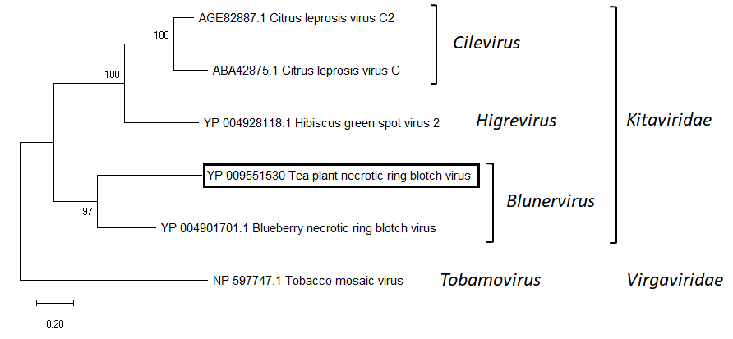
Figure 1. Phylogenetic placement of tea plant necrotic ring blotch virus with current members of the family Kitaviridae using the RNA-dependent RNA polymerase amino acid sequence in a neighbour-joining algorithm. Tobacco mosaic virus represents a phylogenetic outgroup. Node numbers indicate branch support following 1000 bootstrap replications. The scale bar represents the number of substitutions per given branch length.

Figure 2. Schematic genome organization of the RL isolateof blueberry necrotic ring blotch virus (BNRBV-RL), the type member of the genus Blunervirus, and tea plant necrotic ring blotch virus (TPNRBV), a newly proposed member of the same genus. Boxes represent open reading frames. Boxes are labeled with either the predicted molecular weight (kDa) of the protein product or its function: MTR, methyltransferase; C-PRO, cysteine-like protease; HEL, helicase; RdRp, RNA-dependent RNA polymerase; and MP, movement protein.

References
Cantu-Iris, M., Harmon, P.F., Londoño, A., and Polston, J.E. 2013. A variant of blueberry necrotic ring blotch virus associated with red lesions in blueberry. Archives of Virology 158:2197-2200
Hao, X., Zhang, W., Zhao, F., Liu, Y., Qian, W., Wang, Y., Wang, L., Zeng, J., Yang, Y., and Wang, X. 2018. Discovery of plant viruses from tea plant (Camellia sinensis (L.) O. Kuntze) by metagenomic sequencing. Frontiers in Microbiology 9:2175
Kuchibhatla, D.B., Sherman, W.A., Chung, B.Y.W., Cook, S., Schneider, G., Eisenhaber, B., and Karlin, D.G. 2014. Powerful sequence similarity search methods and in-depth manual analyses can identify remote homologs in many apparently “orphan” viral proteins. Journal of Virology 88:10-20
Quito-Avila, D., Brannen, P.M., Cline, W.O., Harmon, P.F., and Martin, R.R. 2013. Genetic characterization of blueberry necrotic ring blotch virus, a novel RNA virus with unique genetic features. Journal of General Virology 94:1426-1434
Robinson, T.S., Scherm, H., Brannen, P.M., Allen, R., and Deom, C.M. 2016. Blueberry necrotic ring blotch virus in southern high bush blueberry: insights into in planta and in-field movement. Plant Disease 100:1575-1579

