This Word module should be used for all taxonomic proposals.
Please complete Part 1 and:
either Part 3 for proposals to create new taxa or change existing taxa
or Part 2 for proposals of a general nature.
Submit the completed Word module, together with the accompanying Excel module named in Part 3, to the appropriate ICTV Subcommittee Chair.
The Word module explains and justifies your proposal. The Excel module is a critical document that will be used to implement the proposed taxonomic changes once they are approved and ratified. If proposals presented in the Word module are not presented accurately in the Excel module, the taxonomic changes cannot proceed.
For guidance, see the notes written in blue, below, and the Help Notes in file Taxonomic_Proposals_Help_2019.

Part 1: TITLE, AUTHORS, etc

Code assigned: | 2019.004P
Short title: Create one new species in the genus Coguvirus
Author(s) and email address(es):
Navarro B, Minutolo M, Alioto D, Di Serio F |  | beatriz.navarro@ipsp.cnr.it; minutolm@unina.it; alioto@unina.it; francesco.diserio@ipsp.cnr.it
Corresponding author
Beatriz Navarro, beatriz.navarro@ipsp.cnr.it
List the ICTV study group(s) that have seen this proposal:
A list of study groups and contacts is provided at http://www.ictvonline.org/subcommittees.asp . If in doubt, contact the appropriate subcommittee chair (there are six virus subcommittees: animal DNA and retroviruses, animal ssRNA-, animal ssRNA+, fungal and protist, plant, bacterial and archaeal) |  |  | Bunyavirales Study Group
ICTV Study Group comments (if any) and response of the proposer:
Date first submitted to ICTV:
Date of this revision (if different to above):

ICTV-EC comments and response of the proposer:

Part 2: NON-STANDARD
Template for any proposal regarding ICTV procedures, rules or policy, not involving the creation of new taxonomy.
Text of proposal:

Part 3: PROPOSED TAXONOMY

Name of accompanying Excel module: 2019.004P.A.v1.Coguvirus_1sp.xlxs

Proposal of the new species Coguvirus eburi
A novel virus has been identified in citrus and named citrus virus A (CiVA, Navarro et al., 2018a). CiVA is an RNA virus with a bisegmented genome: RNA1 (6691 nt) encodes the RNA-dependent RNA polymerase (RdRp, p250) in the viral complementary (vc) strand, while RNA2 (2740 nt) is a bicistronic ambisense RNA that encodes a putative movement protein (MP, p44) in the viral (v) strand and the nucleoprotein (NP, p42) in the vc strand (Figure 1).

RNA1 and 2 of CiVA have 5′ and 3′ termini (up to 18-nt at each terminus) identical to each other and to those of citrus concave gum-associated virus (CCGaV, Navarro et al., 2018b), a member of the type species (Citrus coguvirus) of the genus Coguvirus. CiVA RNA2 contains an AU-rich intergenic region (IR) of 310 nt (AU content: 74.2%) that assumes, in both polarity strands, a compact hairpin conformation. An IR assuming a similar hairpin conformation, with a potential role of transcription termination signal (TTS) during genome transcription, has been previously reported in the v and in the vc strands of CCGaV RNA2 (Navarro et al, 2018b).

BlastP analysis identified the RdRp encoded by CCGaV as the closest related protein of CiVA p250 (Table 1) and multiple alignments revealed that this protein contains the typical six motifs (premotif A and motifs A–E) highly conserved in the RdRp core of members of the order Bunyavirales, showing the highest identity with CCGaV RdRp core (Figure 2 and Table 1).

Pairwise analyses showed that CiVA and CCGaV RdRp share 78.48% amino acid (aa) sequence identity, while the sequence identity with the homologous protein of watermelon crinkle leaf-associated virus 1 (WCLaV-1) and watermelon crinkle leaf-associated virus 2 (WCLaV-2), two plant-infecting bunyaviruses reported recently and not yet classified, was lower (63,1% and 57,6%, respectively, Table 1). Also the CiVA MP and NP share the highest sequence identity with CCGaV (67.18 and 60.64%, respectively) and, to a lower extent, with the homologous proteins encoded by WCLaV-1 and WCLaV-2 (Table 1).

ML phylogenetic trees were generated using the conserved core of RdRp and the complete sequence of MP and NP of CiVA, CCGaV and other representative members of several genera in the order Bunyavirales. In these trees CiVA and CCGaV always clustered together in a clade clearly separated from the other bunyavirales (Fig. 3-5).

Based on pairwise analyses, the aa sequence identity between the RdRP core of CiVA and CCGaV is 84.11 %, thus being below the threshold of <90% identity indicated as a species demarcation criterion within the new genus Coguvirus (Di Serio et al., ICTV proposal 2018.020P).

Based on these data, we propose to classify citrus virus A as a member of a novel species named Coguvirus eburi, in the genus Coguvirus.

Origin of the name of the species: the name includes the latin name (Eburum) of the Italian area in which the virus has been first identified and the name of the genus in which the species should be classified according to the virus molecular and phylogenetic characteristics.

TABLE 1. Amino acid sequence identities between CiVA and other related (-)ssRNA viruses. From Navarro et al., Frontiers in Microbiology 9:2340 (doi: 10.3389/fmicb.2018.02340).
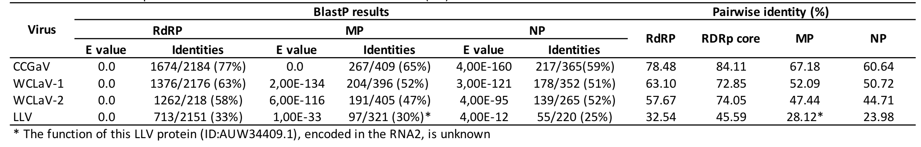

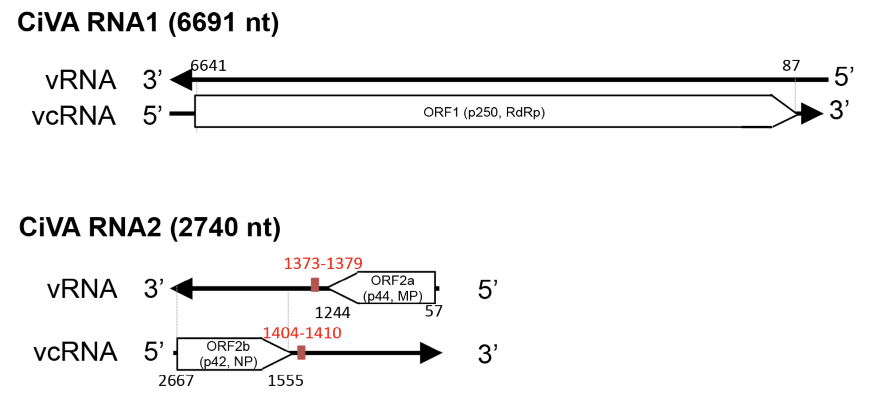

FIGURE 1. Citrus virus A genome organization and expression strategy. (a) Schematic diagram. MP, movement protein; NP, nucleocapsid protein; ORF, open reading frame; RdRp, RNA-dependent RNA polymerase; vRNA, viral RNA; vcRNA, viral complementary RNA. From Navarro et al., Frontiers in Microbiology 9:2340 (doi: 10.3389/fmicb.2018.02340).

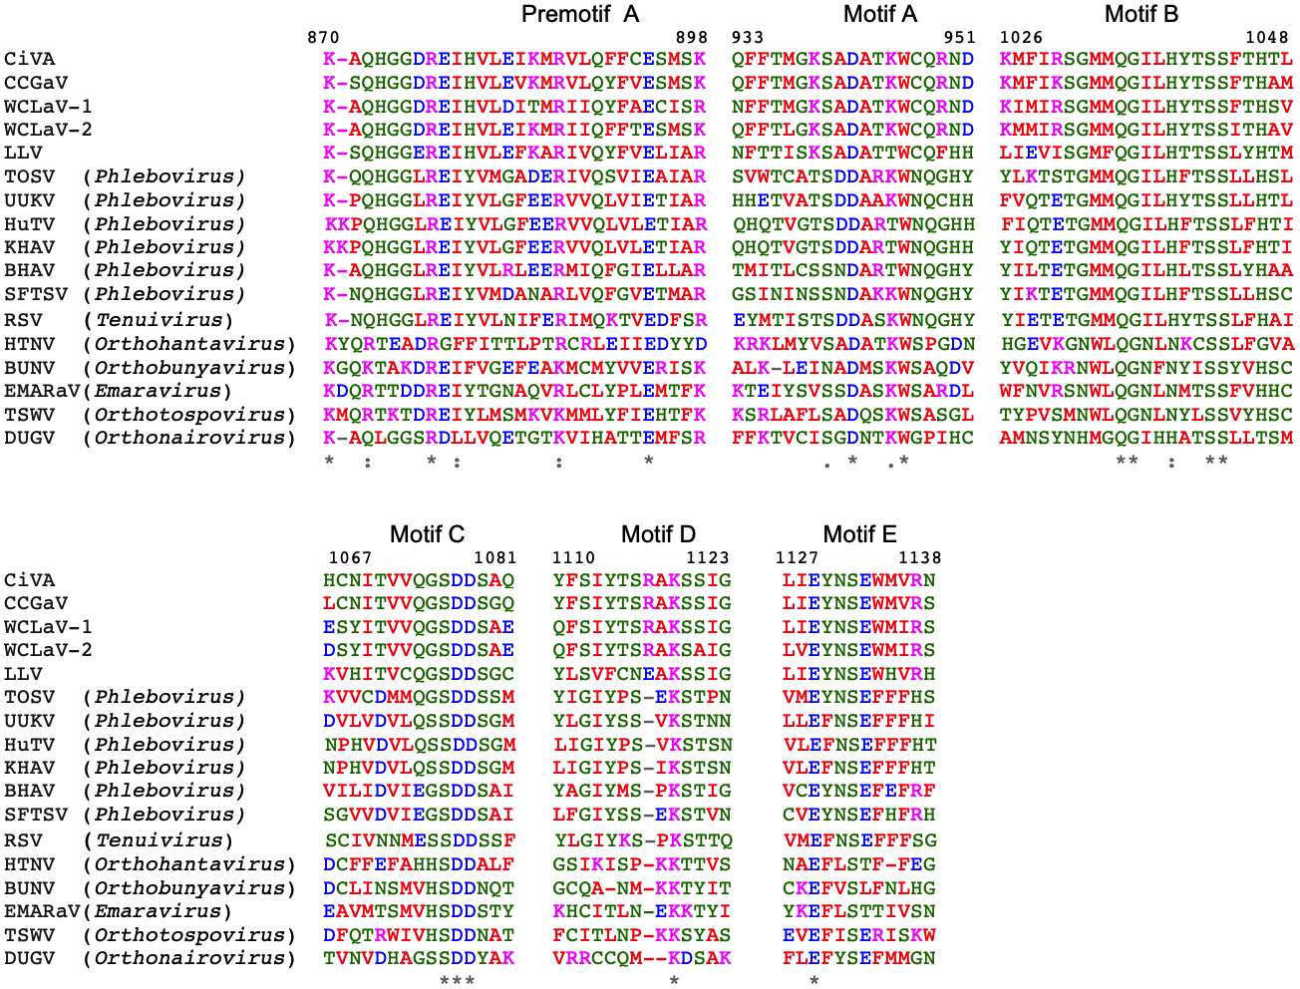

FIGURE 2. Multiple alignment of RdRp conserved motifs of citrus virus A (CiVA) and other (-)ssRNA viruses. Positions in the CiVA RdRp are reported. In red, small and hydrophobic amino acids (aa), including aromatic ones (AVFPMILW); in blue, acidic aa (DE); in magenta, basic aa (RK); in green, polar (STNQ), aromatic (YH), cystein (C) and glycine (G). BHAV, Bhanja virus (AFO66272); BUNV, Bunyamwera virus (NP_047211); CCGaV, concave gum-associated virus (YP_009422199); DUGV, Dugbe virus (NP_690576); EMARaV, European mountain ash ringspot-associated virus (YP_003104764); HTNV, Hantaan virus (NP_941982); HuTV, Huángpí tick virus 2 (AJG39238); KHAV, Khasan virus (AII79370); LLV, Laurel Lake virus (ASU47549); RSV, rice stripe virus (NP_620522); SFTSV, severe fever with thrombocytopenia syndrome virus (YP_006504091); TOSV, Toscana virus (P37800); TSWV, tomato spotted wilt virus (NP_049362); UUKV, Uukuniemi virus (NP_941973); WCLaV-1, watermelon crinkle leaf associated virus 1 (ASY01340.1); WCLaV-2, watermelon crinkle leaf associated virus 2 (ASY01343). From Navarro et al., Frontiers in Microbiology 9:2340 (doi: 10.3389/fmicb.2018.02340).
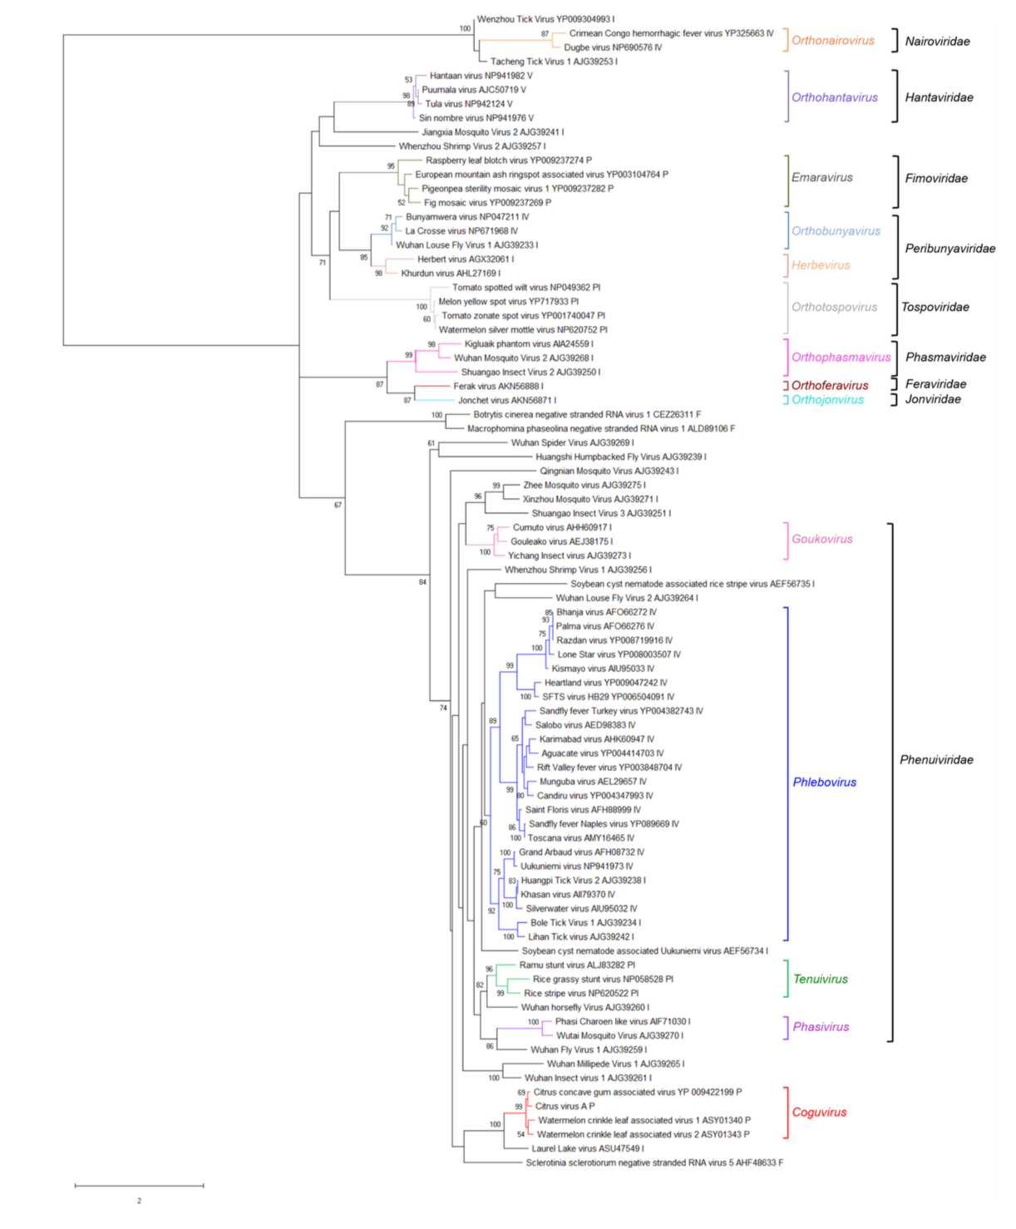
FIGURE 3. Phylogenetic tree of the RNA-dependent RNA polymerase (RdRp) conserved core domain of citrus virus A (CiVA) and 81 (-)ssRNA viruses, representative of the order Bunyavirales and several related unclassified viruses. The maximum likelihood method using the LG+G amino acid substitution model was used to infer the phylogenetic tree. Bootstrap probability values (500 replicates) above 50% are shown at branch nodes. Tree branches are proportional to the genetic distances, with the scale bar indicating substitutions per amino acid site. The names of the viruses, the accession numbers and the respective host organisms (invertebrate, I; vertebrate, V; invertebrate and vertebrate, IV; plant, P; plant and invertebrate, PI; fungus, F) are shown at the branch tip. Recognized genera and families and the genus Coguvirus are reported on the right. From Navarro et al., Frontiers in Microbiology 9:2340 (doi: 10.3389/fmicb.2018.02340).

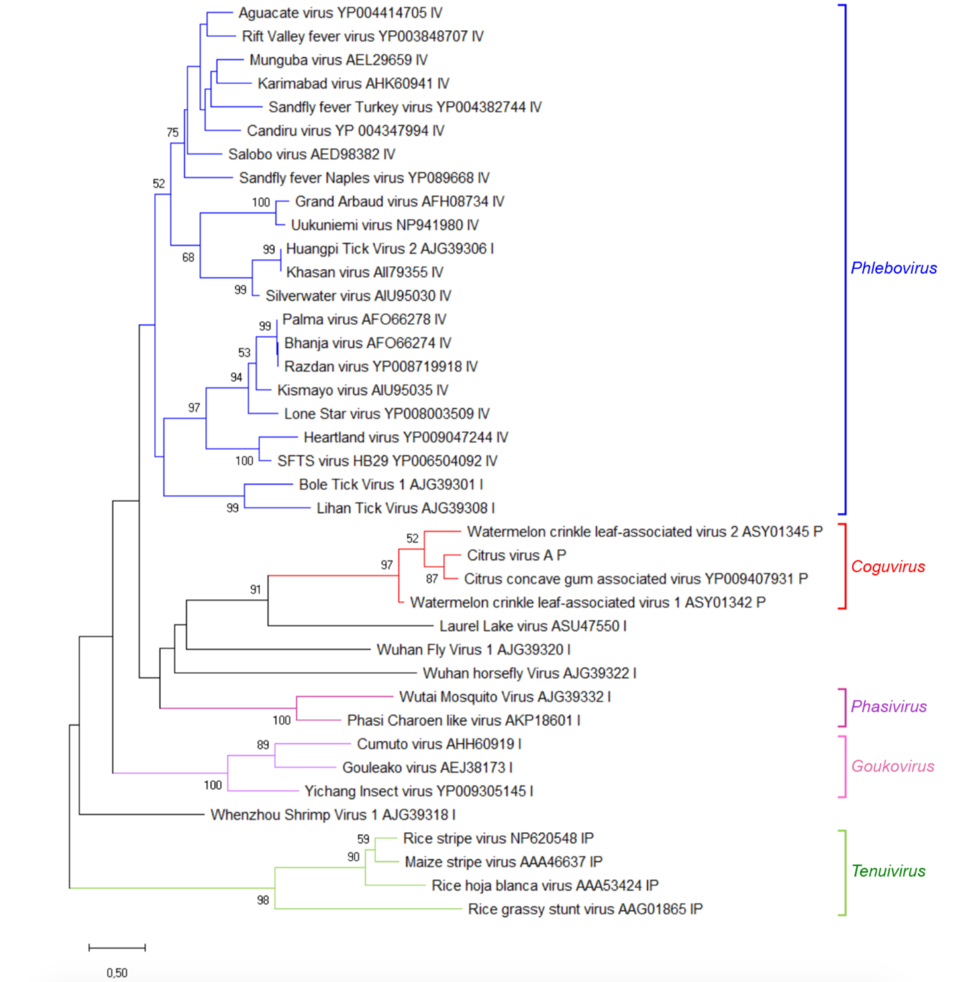
FIGURE 4. Phylogenetic tree generated using the nucleocapsid protein sequences of citrus virus A (CiVA), representative members of the family Phenuiviridae, and several related unclassified bunyaviruses. The maximum likelihood method using the LG+G amino acid substitution model was used to infer the phylogenetic tree. Recognized genera and the genus Coguvirus are reported on the right. Information on bootstrap values, distances and other symbols are reported in the legend of Figure 3. From Navarro et al., Frontiers in Microbiology 9:2340 (doi: 10.3389/fmicb.2018.02340).

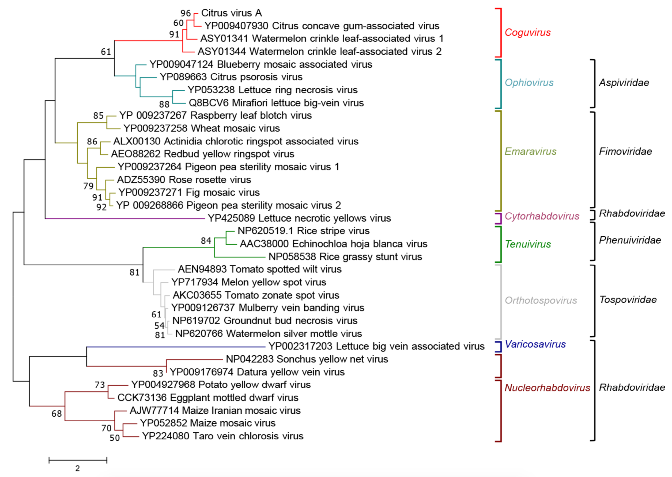
FIGURE 5. Maximum likelihood phylogenetic tree inferred with the putative movement protein sequences of citrus virus A (CiVA), other coguviruses and representative plant-infecting viruses of the genera Emaravirus (family Fimoviridae), Ophiovirus (family Aspiviridae), Tenuivirus (family Phenuiviridae), Orthotospovirus (family Tospoviridae), Nucleorhabdovirus, Cytorhabdovirus, and Varicosavirus (family Rhabdoviridae). The tree was generated using the WAG+G+F amino acid substitution model. Information on bootstrap values, distances and other symbols are reported in the legend of Figure 3. From Navarro et al., Frontiers in Microbiology 9:2340 (doi: 10.3389/fmicb.2018.02340).

References:
Navarro B, Zicca S, Minutolo M, Saponari M, Alioto D, Di Serio F. (2018a) A negative-stranded RNA virus infecting citrus trees: the second member of a new genus within the order Bunyavirales. Frontiers in Microbiology 9:2340 (doi: 10.3389/fmicb.2018.02340).

Navarro B, Minutolo M, De Stradis A, Palmisano F, Alioto D, Di Serio F (2018b) The first phlebo-like virus infecting plants: a case study on the adaptation of negative-stranded RNA viruses to new hosts. Molecular Plant Pathology 19:1075-1089 (doi: 10.1111/mpp.12587).

