This Word module should be used for all taxonomic proposals.
Please complete Part 1 and:
either Part 3 for proposals to create new taxa or change existing taxa
or Part 2 for proposals of a general nature.
Submit the completed Word module, together with the accompanying Excel module named in Part 3, to the appropriate ICTV Subcommittee Chair.
The Word module explains and justifies your proposal. The Excel module is a critical document that will be used to implement the proposed taxonomic changes once they are approved and ratified. If proposals presented in the Word module are not presented accurately in the Excel module, the taxonomic changes cannot proceed.
For guidance, see the notes written in blue, below, and the Help Notes in file Taxonomic_Proposals_Help_2019.
Part 1: TITLE, AUTHORS, etc

Code assigned: | 2019.022P
Short title: Create sixteen new species and abolish one species in the genus Begomovirus, family Geminiviridae

Author(s) and email address(es):
Fiallo-Olivé E, Navas-Castillo J |  | efiallo@eelm.csic.es;  jnavas@eelm.csic.es
Corresponding author
Elvira Fiallo-Olivé
List the ICTV study group(s) that have seen this proposal:
A list of study groups and contacts is provided at http://www.ictvonline.org/subcommittees.asp . If in doubt, contact the appropriate subcommittee chair (there are six virus subcommittees: animal DNA and retroviruses, animal ssRNA-, animal ssRNA+, fungal and protist, plant, bacterial and archaeal) |  |  | Geminiviridae and Tolecusatellitidae Study Group
ICTV Study Group comments (if any) and response of the proposer:
Date first submitted to ICTV:
Date of this revision (if different to above):

ICTV-EC comments and response of the proposer:

Part 2: NON-STANDARD
Template for any proposal regarding ICTV procedures, rules or policy, not involving the creation of new taxonomy.
Text of proposal:

Part 3: PROPOSED TAXONOMY

Name of accompanying Excel module: 2019.022P.A.v1.Begomovirus_16sp.xlxs
Supporting material:

The remarkable diversity of begomoviruses (genus Begomovirus, family Geminiviridae) is in part a reflection of the easiness with which their genomes can be currently cloned and completely sequenced. Begomoviruses have one or two small (2.6 kb) circular ssDNA genome components which replicate using a dsDNA intermediate. Both forms (ss and ds) can be readily amplified using rolling-circle amplification (RCA), a sequence-unbiased method which has been widely embraced by the geminivirus community since it was shown to be applicable to these viruses (Inoue-Nagata et al., 2004). Most genomes of the viruses to classify into proposed species were obtained after RCA, full-length cloning and Sanger sequencing.

Current species demarcation criteria for the genus Begomovirus are those established by Brown et al. (2015). Pairwise genome sequence comparison is used as the main criterion, although phylogenetic support is highly desirable due to frequent occurrence of recombination among begomoviruses. Using these criteria, 16 new species are being proposed in the genus (see Table 1 and accompanying Excel module). Members of these 16 species have <91% nucleotide sequence identity for the complete genome (or the complete DNA-A in the case of bipartite viruses) with members of existing species, which is the cut off value established. The proposed begomovirus species contain 1 to 9 completely sequenced isolates. Also, phylogenetic support is shown for all 16 cases (Figures 1 and 2).

The new begomoviruses have been isolated from cultivated (n=12, including food and ornamental crops) and non-cultivated (n=4) plants. Phylogenetically, they belong to the New World (n=6), Old World (n=9) and sweepovirus (n=1) clusters.

Following the species demarcation criteria in the genus Begomovirus (Brown et al., 2015), one species is also being proposed to be abolished in this proposal, Mesta yellow vein mosaic virus (Table 2). Recently, an isolate of this begomovirus has been deposited in GenBank (MH538339). This isolate has also 91% nt identity with an isolate of Hollyhock leaf curl virus (GQ478343), a previously established species. Thus, both species should be merged, maintaining the name Hollyhock leaf curl virus.

Table 1. Details of the 16 proposed begomovirus species.
Species name | Virus acronym | GenBank Acc. No.* | Isolate | Highest nt sequence identity with (%) | Reference
Ageratum leaf curl Sichuan virus | ALCScV | MG917697 | CN-Sc-SC770-16 | KF150142 (90) | Li et al. (2018)
 |  | MG917698 | CN-Sc-SC782-16 | KF150142 (89)
Bitter gourd yellow mosaic virus | BgYMV | KY860899 | IN-16 | KM244719 (80)  KY979591 (80) | Unpublished
 |  | MH481856 | IN-Coi-17 | KM244719 (79)  KY979591 (79) | Manivannan et al. (2019)
Cowpea bright yellow mosaic virus | CoBYMV | MH469731 | BR-PE–088-11 | KX691396 (87) | Naito et al. (2019)
Croton golden mosaic virus | CroGMV | KX156613 | CO-Fl_Va-14 | JN411687 (81) | Vaca-vaca et al. (2018)
Emilia yellow vein Fujian virus | EYVFjV | MH035670 | CN-Fj-Zz01-17 | AF307861 (87) | Unpublished
Hibiscus golden mosaic virus | HGMV | MK558061 | BR-IgM1-16 | DQ875872 (79) | Quadros et al (2019)
Hollyhock yellow vein virus | HoYVV | MG373552 | IN-ND-VIRO 881-16 | JQ327840 (86)  KY001639 (86)  KY001640 (86)  KY001641 (86) | Unpublished
Malvastrum yellow vein Lahore virus | MalYVLahV | MF683828 | PK-Lah-J47-13 | MF409174 (90) | Unpublished
Melon yellow mosaic virus | MeYMV | MH665365 | TH-Me-MS-9-15 | KC513822 (87)  KM383736 (87) | Unpublished
Passionfruit leaf curl virus | PLCV | MK087122  MK087124 | IN-Kar-Fb-18  IN-Kar-Pf-18 | AM698011 (90)  FN794201 (89) | Unpublished
Pepper yellow leaf curl Aceh virus | PepYLCAV | LC387327  LC387328  LC465989  LC465990  LC465991  LC465992 | ID-BAPep-V2-17  ID-BAPep-V4-17  ID-BATa-9-17  ID-BATa-10-17  ID-BATo-46-17  ID-BATo-50-17 | KT809345 (89)  KT809345 (89)  KT809345 (89)  KT809345 (89)  KT809345 (89)  KT809345 (90) | Kesumawati et al. (2019)
Tobacco leaf curl Dominican Republic virus | TbLCDOV | MH514011 | DO-CG-15 | KU562963 (86) | Unpublished
Tomato chlorotic leaf curl virus | ToCLCV | MK558058 | BR-Alt1-16 | JF694482 (84)  JQ805781 (84) | Quadros et al. (2019)
 |  | MK558060 | BR-Alt3-16 | JF694482 (84)  JQ805781 (84)
Tomato leaf curl Mahe virus | ToLCMahV | MH410152 | SC-Pra-SC8-1b-17 | AM701758 (85)  AM701761 (85) | Scussel et al. (2018)
 |  | MH410153 | SC-Pra-SC8-10d-17 | AM701758 (85)
 |  | MH410154 | SC-Mah-SC9-8d-17 | AM701758 (85)  AM701761 (85)
 |  | MH410155 | SC-Mah-SC9-4b-17 | AM701758 (85)  AM701761 (85)
 |  | MH410156 | SC-Mah-SC9-8e-17 | AM701758 (85)  AM701761 (85)
 |  | MH410157 | SC-Mah-SC7-12d-17 | AM701758 (85)  AM701761 (85)
 |  | MH410158 | SC-Mah-SC7-9g-17 | AM701758 (85)  AM701761 (85)
 |  | MH410159 | SC-Mah-SC7-9f-17 | AM701758 (85)  AM701761 (85)
 |  | MH410160 | SC-Mah-SC7-12b-17 | AM701758 (85)  AM701761 (85)
Tomato twisted leaf virus | ToTLV | MK440292 | VE-Be6.6H-05 | KU165788 (82) | Romay et al. (2019)
Sweet potato leaf curl Hubei virus | SPLCHbV | MH577011 | CN-Hubei22-17 | HQ393477 (73) | Unpublished
*GenBank accession numbers correspond to complete genomes (monopartite begomoviruses) or DNA-A (bipartite begomoviruses).

Table 2. Details of the begomovirus species to be abolished.

Abolished species | GenBank Acc. No.* | Merges with | GenBank Acc. No.* | % nt identity
Mesta yellow vein mosaic virus | MH538339 | Hollyhock leaf curl virus | GQ478343 | 91

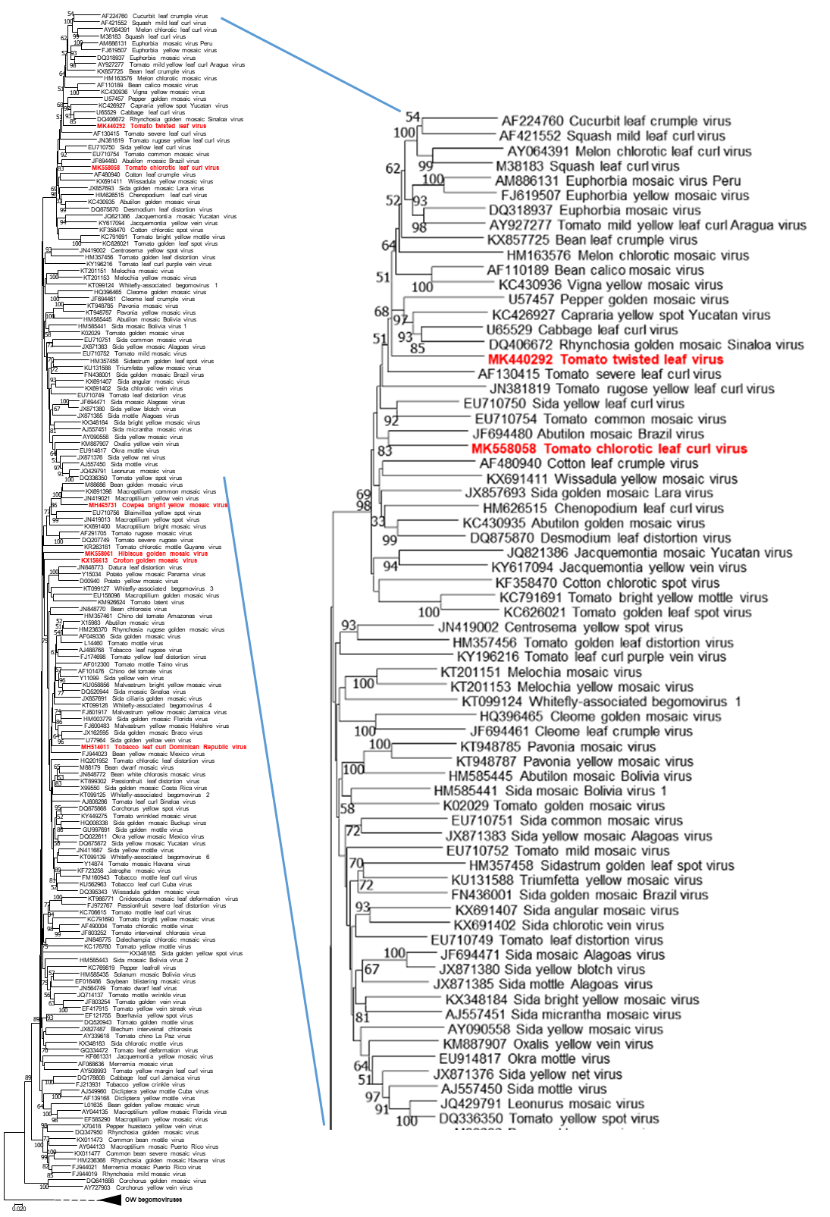
Figure 1. Neighbour-joining phylogenetic tree based on the complete nucleotide sequences (genomic DNA for monopartite viruses, DNA-A component for bipartite viruses) of New World begomoviruses. Branch length is related to genetic distance (p-distance method by using MEGA7 [Kumar et al., 2016]). Numbers at the nodes indicate bootstrap values (1000 replications) and only values ≥50% are shown. A set of Old World begomoviruses was used to root the tree. The new species listed in this proposal are in bold and highlighted in red.

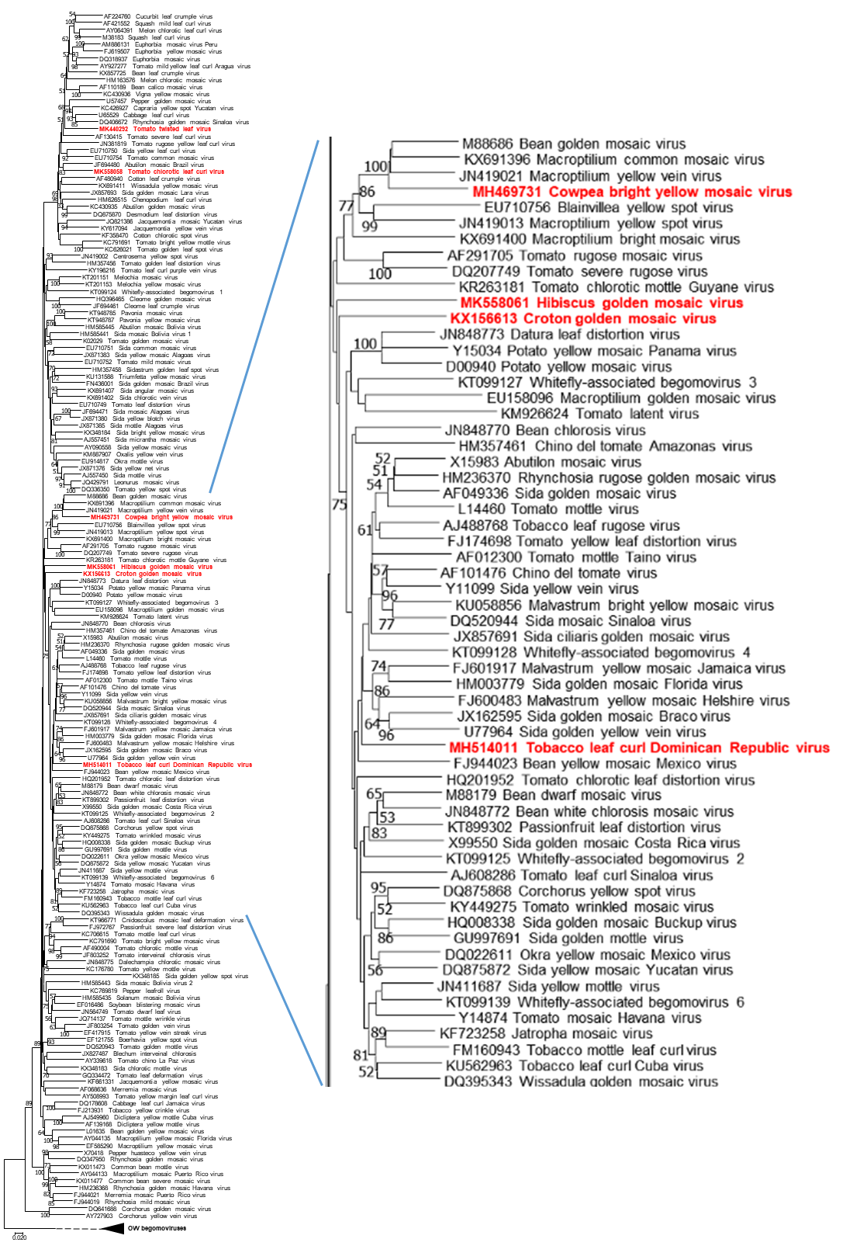

Figure 1 (cont.).

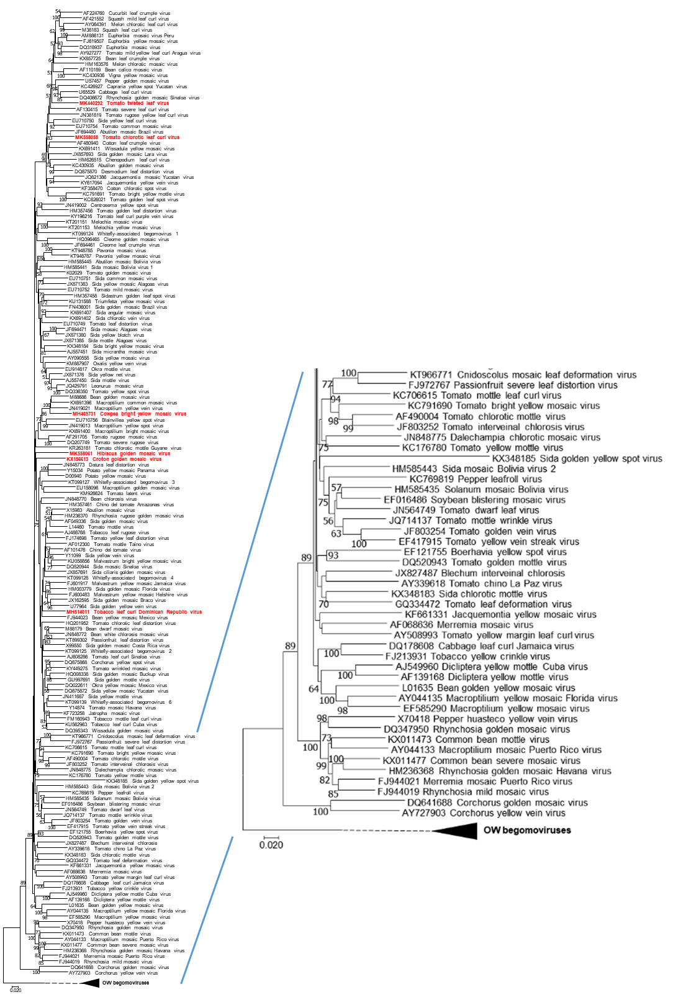

Figure 1 (cont.).

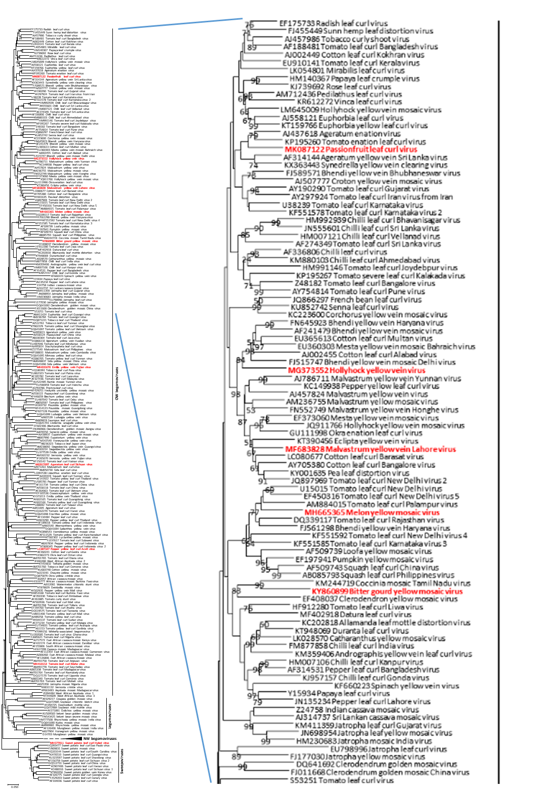

Figure 2. Neighbour-joining phylogenetic tree based on the complete nucleotide sequences (genomic DNA for monopartite viruses, DNA-A component for bipartite viruses) of Old World begomoviruses, sweepoviruses and legumoviruses. Branch length is related to genetic distance (p-distance method by using MEGA7 [Kumar et al., 2016]). Numbers at the nodes indicate bootstrap values (1000 replications) and only values ≥50% are shown. A set of New World begomoviruses was used as outgroup. The new species listed in this proposal are in bold and highlighted in red.
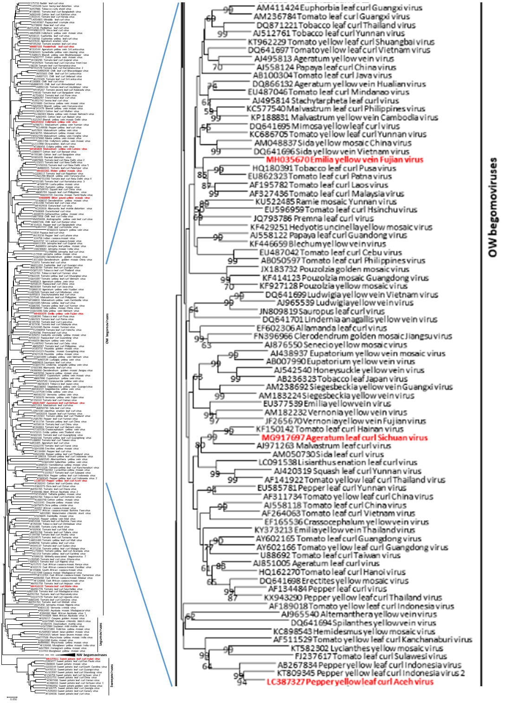

Figure 2 (cont.)

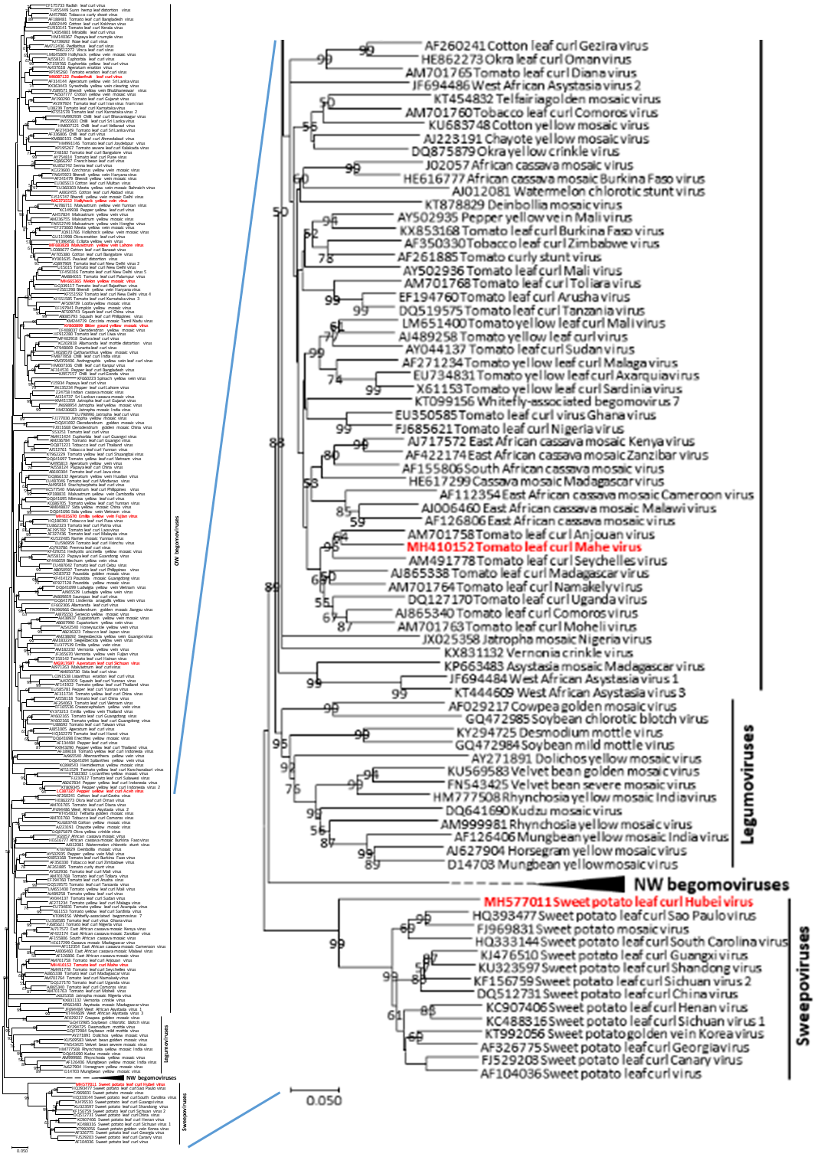

Figure 2 (cont.)

References:
Brown JK, Zerbini FM, Navas-Castillo J, Moriones E, Ramos-Sobrinho R, Silva JC, Fiallo-Olivé E, Briddon RW, Hernández-Zepeda C, Idris A, Malathi VG, Martin DP, Rivera-Bustamante R, Ueda S, Varsani A (2015) Revision of begomovirus taxonomy based on pairwise sequence comparisons. Arch Virol 160:1593-1619.
Inoue-Nagata AK, Albuquerque LC, Rocha WB, Nagata T (2004) A simple method for cloning the complete begomovirus genome using the bacteriophage phi 29 DNA polymerase. J Virol Methods 116:209-211.
Kesumawati E, Okabe S, Homma K, Fujiwara I, Zakaria S, Kanzaki S, Koeda S. 2019. Pepper yellow leaf curl Aceh virus: A novel bipartite begomovirus isolated from chili pepper, tomato, and tobacco plants in Indonesia. Arch Virol, doi doi.org/10.1007/s00705-019-04316-8
Kumar S, Stecher G, Tamura K (2016) MEGA7: Molecular Evolutionary Genetics Analysis version 7.0 for bigger datasets. Mol Biol Evol 33:1870-1874.
Li P, Jing C, Wang R, Du J, Wu G, Li M, Qing L. 2018. Complete nucleotide sequence of a novel monopartite begomovirus infecting Ageratum conyzoides in China. Arch Virol 163:3443-3446.
Manivannan K, Renukadevi P, Malathi VG, Karthikeyan G, Balakrishnan N. 2019. A new seed-transmissible begomovirus in bitter gourd (Momordica charantia L.). Microb Pathog 128:82-89.
Naito FYB, Melo FL, Fonseca MEN, Santos CAF, Chanes CR, Ribeiro BM, Gilbertson RL, Boiteux LS, Pereira‑Carvalho RC. 2019. Nanopore sequencing of a novel bipartite New World begomovirus infecting cowpea. Arch Virol 164:1097-1010.
Quadros AFF, Silva JP, Xavier CAD, Zerbini FM, Boari AJ. 2019. Two new begomoviruses infecting tomato and Hibiscus sp. in the Amazon region of Brazil. Arch Virol 164:1897-1901.
Romay G, Geraud-Pouey F, Chirinos DT, Mahillon M, Gillis A, Mahillon J, Bragard C. 2019. Tomato twisted leaf virus: a novel indigenous New World monopartite begomovirus infecting tomato in Venezuela. Viruses 11:327.
Scussel, S., Claverie, S., Hoareau, M, Moustache R, Delatte H, Lefeuvre P, Lett J-M. 2018. Tomato leaf curl Mahé virus: a novel tomato-infecting monopartite begomovirus from the Seychelles. Arch Virol 163:3451.
Vaca-Vaca, J. C., Jara-Tejada, F., y López-López, K. 2018. Croton golden mosaic virus: a new bipartite begomovirus isolated from Croton hirtus in Colombia. Arch Virol 163:3199-3202.

