The International Committee on Taxonomy of Viruses
Taxonomy Proposal Form, 2024
Part 1a: Details of taxonomy proposals

Title: | Move free-floating negarnaviricot family Tosoviridae into bunyaviricete order Hareavirales
Code assigned: | <to be assigned by ICTV officers>

Author(s), affiliation and email address(es):
Name | Affiliation | Email address | Corresponding author(s)
Kuhn JH | Integrated Research Facility at Fort Detrick, National Institute of Allergy and Infectious Diseases, National Institutes of Health, Fort Detrick, Frederick, Maryland, USA | kuhnjens@mail.nih.gov
Koonin EV | National Center for Biotechnology Information, National Library of Medicine, National Institutes of Health, Bethesda, Maryland, USA | koonin@ncbi.nlm.nih.gov
Krupovic M | Institut Pasteur, Université Paris Cité, Archaeal Virology Unit, Paris, France | mart.krupovic@pasteur.fr
Wolf Y | National Center for Biotechnology Information, National Library of Medicine, National Institutes of Health, Bethesda, Maryland, USA | wolf@ncbi.nlm.nih.gov | X
Part 1b: Taxonomy Proposal Submission <To be completed on initial submission>
ICTV Subcommittee:
Animal DNA Viruses and Retroviruses |  | Bacterial viruses
Animal minus-strand and dsRNA viruses | X | Fungal and protist viruses | X
Animal positive-strand RNA viruses |  | Plant viruses
Archaeal viruses |  | General -Submit to Proposals Secretary

List the ICTV Study Group(s) that have seen or have been involved in creating this proposal:
ICTV Negarnaviricota Study Group
Optional – complete only if formally voted on by an ICTV Study Group:
Study Group | Number of members
 | Votes in support | Votes against | No vote
ICTV Negarnaviricota Study Group | 4 | 0 | 0

Submission date: | 21/06/2024
Enter date of the initial submission

Part 1c: Feedback from ICTV Executive Committee (EC) meeting <To be completed by the subcommittee chair after EC evaluation>
Executive Committee Meeting Decision code: | X
A – Accept
Ac – Accept subject to revision by relevant subcommittee chair. No further vote required
U – Accept without revision but with re-evaluation and email vote by the EC
Uc – Accept subject to revision and re-evaluation and email vote by the EC
Ud – Deferred to the next EC meeting, with an invitation to revise based on EC comments
J - Reject
W - Withdrawn

Comments from the Executive Committee:

Part 1d: Revised Taxonomy Proposal Submission <To be completed for the revised version>
Response of proposer: Please describe in detail how you have responded to the EC meeting feedback
Revision date: | DD/MM/YYYY

Enter date of the revised version.

Part 3: TAXONOMIC PROPOSAL

Name of accompanying Excel module:
2024.018M.Tosoviridae_move

Taxonomic changes proposed:
Establish new taxon |  | Split taxon
Abolish taxon |  | Merge taxon
Move taxon | X | Promote taxon
Rename taxon |  | Demote taxon
Move and rename

Is any taxon name used here derived from that of a living person: . |  | N
Taxon name | Person from whom the name is derived | Attached X

Abstract of Taxonomy Proposal:
Taxonomic rank(s) affected: Family (Tosoviridae)

Description of current taxonomy: Riboviria: Orthornavirae: Negarnaviricota: Tosoviridae

Proposed taxonomic change(s): Move family (Riboviria: Orthornavirae: Negarnaviricota: Polyploviricotina: Bunyaviricetes: Hareavirales: Tosoviridae)

Justification: Updated RdRp phylogeny unambiguously groups tosovirids with hareavirals (sister to hareaviral families Nairoviridae and Wupedeviridae)

Text of Taxonomy proposal:

Taxonomic rank(s) affected: Family (Tosoviridae)

Description of current taxonomy: Riboviria: Orthornavirae: Negarnaviricota: Tosoviridae

Proposed taxonomic change(s): Move family (Riboviria: Orthornavirae: Negarnaviricota: Polyploviricotina: Bunyaviricetes: Hareavirales: Tosoviridae)

Demarcation criteria: Negarnaviricota megataxonomy is determined by RNA-directed RNA polymerase (RdRp) phylogeny/clustering.

Justification: Tosovirids (free-floating negarnaviricot family Tosovirdae) are bisgegmented negative-sense RNA viruses with a genomic organization identical to those of arenavirids (Riboviria: Orthornavirae: Negarnaviricota: Polyploviricotina: Bunyaviricetes: Hareavirales) (1). However, after their discovery, global RdRp trees failed to unambiguously assign tosovirids to either of the subphyla of Negarnaviricota (Haploviricotina and Polyploviricotina) (1), and hence the family was assigned “free-floating” (unassigned) status (2, 3). An updated RdRp phylogeny, expanded by numerous RdRps discovered since the discovery of tosovirids, unambiguously groups them with hareavirals (sister to hareaviral families Nairoviridae and Wupedeviridae, the families most closely related to arenavirids; Figure 1).
References:
1. Waltzek TB, Stacy BA, Ossiboff RJ, Stacy NI, Fraser WA, Yan A, Mohan S, Koonin EV, Wolf YI, Rodrigues TCS, Viadanna PHO, Subramaniam K, Popov VL, Guzman-Vargas V, Shender LA. 2022. A novel group of negative-sense RNA viruses associated with epizootics in managed and free-ranging freshwater turtles in Florida, USA. PLoS Pathog 18:e1010258.
2. Kuhn JH, Abe J, Adkins S, Alkhovsky SV, Avšič-Županc T, Ayllón MA, Bahl J, Balkema-Buschmann A, Ballinger MJ, Baranwal VK, Beer M, Bejerman N, Bergeron, Biedenkopf N, Blair CD, Blasdell KR, Blouin AG, Bradfute SB, Briese T, Brown PA, Buchholz UJ, Buchmeier MJ, Bukreyev A, Burt F, Büttner C, Calisher CH, Cao M, Casas I, Chandran K, CharrelI RN, Kumar K, Chaturvedi, Chooi KM, Crane A, Bó ED, Torre JCdl, Souza WMd, Swart RLd, Debat H, Dheilly NM, Paola ND, Serio FD, Dietzgen RG, Digiaro M, Drexler JF, Duprex WP, Dürrwald R, Easton AJ, Elbeaino T, Ergünay K, et al. 2023. Annual (2023) taxonomic update of RNA-directed RNA polymerase-encoding negative-sense RNA viruses (realm Riboviria: kingdom Orthornavirae: phylum Negarnaviricota). J Gen Virol 104:001864.
3. Zerbini FM, Siddell SG, Lefkowitz EJ, Mushegian AR, Adriaenssens EM, Alfenas-Zerbini P, Dempsey DM, Dutilh BE, García ML, Hendrickson RC, Junglen S, Krupovic M, Kuhn JH, Lambert AJ, Łobocka M, Oksanen HM, Robertson DL, Rubino L, Sabanadzovic S, Simmonds P, Smith DB, Suzuki N, Van Dooerslaer K, Vandamme A-M, Varsani A. 2023. Changes to virus taxonomy and the ICTV Statutes ratified by the International Committee on Taxonomy of Viruses (2023). Arch Virol 168:175.

Tables, Figures:

Figure 1. Global phylogeny of negarnaviricot RdRps.
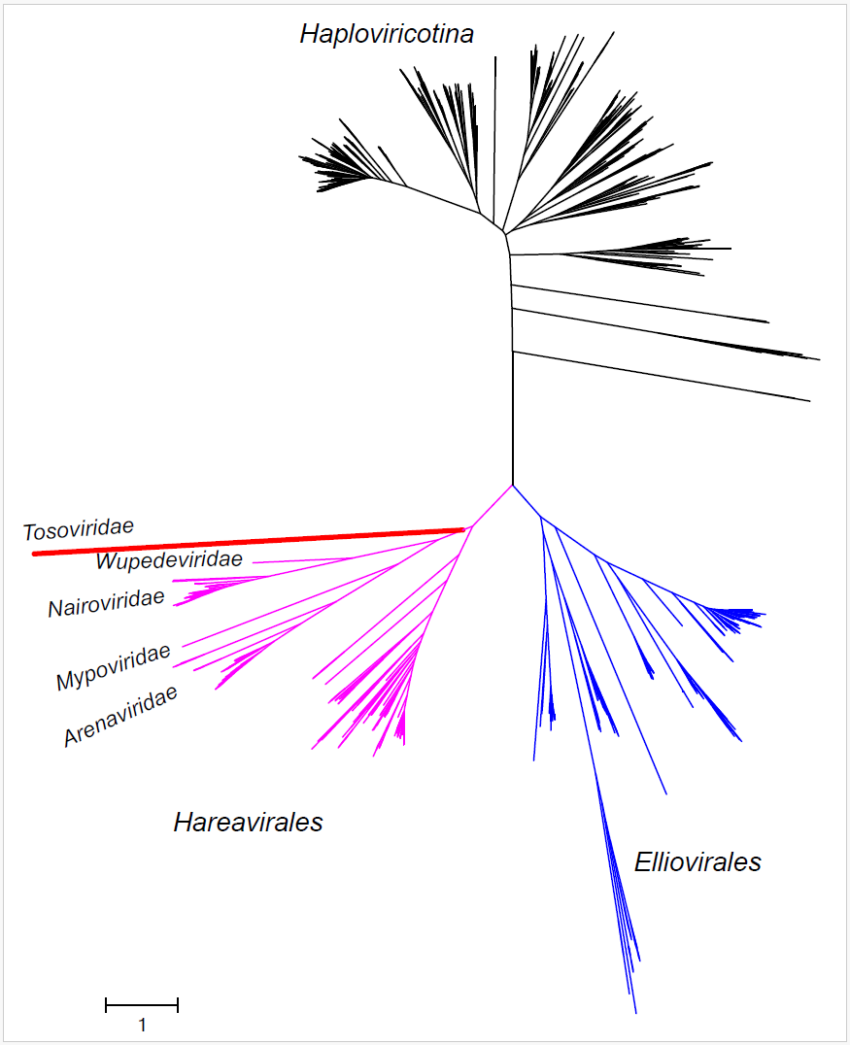
1,144 full-length RNA-directed RNA polymerase (RdRp) cores of Negarnaviricota exemplar genomes per the ICTV_Master_Species_List_2023_MSL39.v1 combined with their associated species exemplars (VMR_MSL38_v3) were extracted and assigned to their current 36 family ranks. Then, the consensus sequences were aligned, expanded, and filtered (removing columns with too many gaps or low homogeneity) to build the tree. Both FastTree and IQ-Tree agree in that Bunyaviricetes (according to MSL39.v1) are currently paraphyletic with respect to Tosoviridae (orange), and that Tosoviridae should be included in bunyaviricete order Hareavirales.

