The International Committee on Taxonomy of Viruses
Taxonomy Proposal Form, 2024
Part 1a: Details of taxonomy proposals

Title: | Create four new species, abolish two species, and rename two species in the family Phasmaviridae
Code assigned:

Author(s), affiliation and email address(es):
Name | Affiliation | Email address | Corresponding author(s)
Ballinger MJ | Biological Sciences, Mississippi State University, Mississippi State, USA | ballinger@biology.msstate.edu | X
Junglen S | Institute of Virology, Charité – Berlin University Medicine, Berlin, Germany | sandra.junglen@charite.de
De Coninck L | Division of Clinical and Epidemiological Virology, KU Leuven, Leuven, Belgium | lander.deconinck@kuleuven.be

Part 1b: Taxonomy Proposal Submission <To be completed on initial submission>
ICTV Subcommittee:
Animal DNA Viruses and Retroviruses |  | Bacterial viruses
Animal minus-strand and dsRNA viruses | X | Fungal and protist viruses
Animal positive-strand RNA viruses |  | Plant viruses
Archaeal viruses |  | General -Submit to Proposals Secretary

List the ICTV Study Group(s) that have seen or have been involved in creating this proposal:.
Phasmaviridae Study Group

Optional – complete only if formally voted on by an ICTV Study Group:
Study Group | Number of members
 | Votes in support | Votes against | No vote
Phasmaviridae | 3 | 0 | 0

Submission date: | 06/06/2024

Part 1c: Feedback from ICTV Executive Committee (EC) meeting <To be completed by the subcommittee chair after EC evaluation>
Executive Committee Meeting Decision code: | X
A – Accept
Ac – Accept subject to revision by relevant subcommittee chair. No further vote required
U – Accept without revision but with re-evaluation and email vote by the EC
Uc – Accept subject to revision and re-evaluation and email vote by the EC
Ud – Deferred to the next EC meeting, with an invitation to revise based on EC comments
J - Reject
W - Withdrawn

Comments from the Executive Committee:

Part 1d: Revised Taxonomy Proposal Submission <To be completed for the revised version>
Response of proposer: Please describe in detail how you have responded to the EC meeting feedback
Revision date: | DD/MM/YYYY

Enter date of the revised version.

TAXONOMIC PROPOSAL

Name of accompanying Excel module:
2024.###M.S.v1.Phasmaviridae.4nsp3ab2rn.xlsx

Taxonomic changes proposed:
Establish new taxon | X | Split taxon
Abolish taxon | X | Merge taxon
Move taxon |  | Promote taxon
Rename taxon | X | Demote taxon
Move and rename

Is any taxon name used here derived from that of a living person: | N

Abstract of Taxonomy Proposal:
Taxonomic rank(s) affected:
Species

Description of current taxonomy:
The family Phasmaviridae includes 29 species organized across seven genera.

Proposed taxonomic change(s):
Create four new species, abolish three species established previously, and rename two species established previously.

Justification:
Coding-complete virus genome sequences are available to justify creation of four new species. Each exhibits < 95% L protein amino acid sequence identity to other exemplar viruses in the family Phasmaviridae. Three species were previously established in error due to an oversight; the available genomes are not coding-complete. Two previously established species epithets erroneously referred to places and are renamed here using appropriate suffixes.

Text of Taxonomy proposal:
The species demarcation criterion in the family Phasmaviridae is < 95% identity in the amino acid (aa) sequence of the complete L protein (the RNA-dependent RNA polymerase [RdRp]). The maximum aa identities shared between proposed new exemplar viruses and established phasmavirids ranges from 87.9% to 38.2%.

We propose the creation of two new species in the genus Jonvirus:

Jonvirus spilikinsis and Jonvirus mikadosis are represented by exemplar viruses Spilikins virus (SPLKV; isolate A28-CI-2004) and Mikado virus (MIKV; isolate D35-CI-2004), respectively. These viruses were both discovered in mosquitoes collected from Côte d’Ivoire. Jonvirus spilikinsis is associated with Culex nebulosus and Jonvirus mikadosis is associated with Culex annulioris (Hermanns et al. 2023). Both viruses are named for the appearance of their virions, which are long and thin, resembling the pick-up sticks used in the games spillikins and Mikado.

We propose the creation of two new species in the genus Orthophasmavirus:

Orthophasmavirus obscurae is represented by the exemplar virus North Esk phasmavirus (NESKV), which is associated with several fly host species in the obscura group of the genus Drosophila (Wallace 2021). Orthophasmavirus stecellulae is represented by Anopheles stephensi orthophasmavirus (AsOV), which persistently infects the Anopheles stephensi cell line MSQ43 (Matsumura et al. 2024).

We propose to abolish three species, one in the genus Feravirus and two in the genus Orthophasmavirus:

Feravirus hemipterus is not represented by a coding complete genome, the L segment does not encode a complete L protein. Orthophasmavirus flenense is not represented by a coding-complete genome, the S segment does not encode a complete nucleoprotein. Orthophasmavirus coleopterus is not represented by a coding-complete genome, the M segment does not encode a complete glycoprotein.

We propose renaming two species in the genus Orthophasmavirus:

Orthophasmavirus barstukense and Orthophasmavirus miglotasense were named using suffixes for places, inconsistent with their respective name derivations. We propose Orthophasmavirus barstukorius (from Lithuanian Barstukas, a mythical dragon-like creature, and -orius, pertaining to) and Orthophasmavirus miglotalis (from Lithuanian miglotas, meaning obscura, foggy or misty, and -alis, having the nature of).

References:
Hermanns K, Marklewitz M, Zirkel F, Kopp A, Kramer-Schadt S, and Junglen S. 2023. Mosquito community composition shapes virus prevalence patterns along anthropogenic disturbance gradients. Elife. 12:1–33. doi: 10.7554/ELIFE.66550.
Matsumura R, Kobayashi D, Faizah AN, Sasaki T, Itoyama K, and Isawa H. 2024. Screening and identification of persistent viruses in cell lines derived from medically important arthropods. J. Med. Entomol. 61:741–755. doi: 10.1093/jme/tjae011.
Wallace MA. 2021. Virus discovery and dynamics in a wild Drosophila community. The University of Edinburgh.

Tables, Figures:
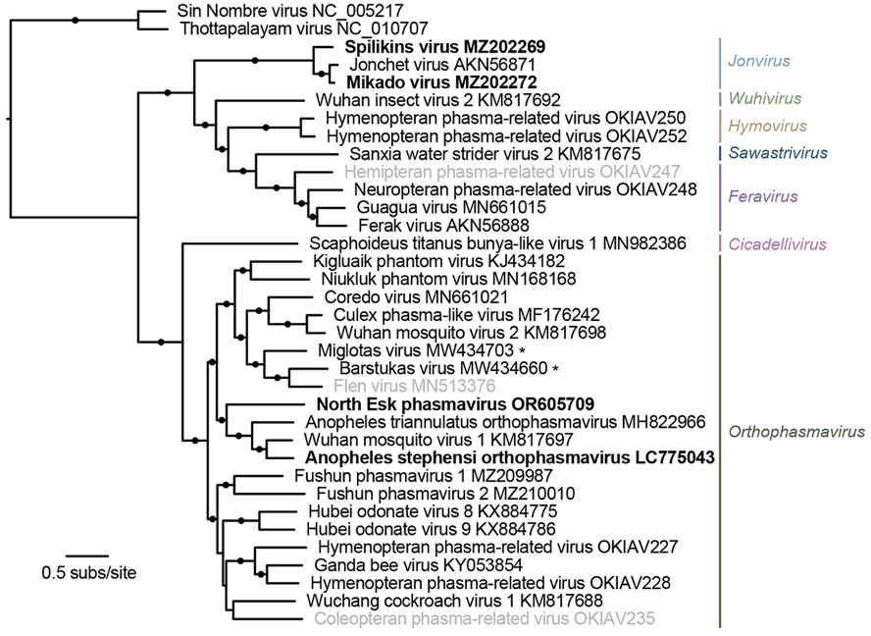
Figure 1. Phylogenetic relationships of proposed and established virus taxa in the family Phasmaviridae. A phylogram of L protein amino acid sequences of exemplar phasmavirids. Two members of the family Hantaviridae are included as an outgroup. Branches with SH-like FastTree support values >0.95 are labeled with a black circle. Tips are labeled with names of exemplar viruses. Clade labels on the right are genus names. Exemplar names of four proposed species are shown in bold typeface. Exemplar names of the two virus species to be renamed in this proposal are marked with asterisks. Exemplar names of the three virus species to be abolished in this proposal are colored gray.

