The International Committee on Taxonomy of Viruses
Taxonomy Proposal Form, 2024
Part 1a: Details of taxonomy proposals

Title: | Create two new species in genus Peropuvirus and two new species in genus Hexartovirus (Mononegavirales: Artoviridae)
Code assigned: | <to be assigned by ICTV officers>

Author(s), affiliation and email address(es):
Name |  | Email address | Corresponding author(s)
Økland, AL | Pharmaq Analytiq, Bergen, Norway | arnfinn.lodden.okland@zoetis.com | X
Kuhn, J | NIH/NIAID/DCR/Integrated Research Facility at Fort Detrick,  Frederick, Maryland, USA | kuhnjens@mail.nih.gov
Ye, G | Institute of Insect Sciences, Zhejiang University, Hangzhou, Zhejiang Province, China | chu@zju.edu.cn
Vasilakis, N | Department of Pathology and Center for Vector Borne and Zoonotic Diseases, University of Texas Medical Branch at Galveston, Galveston, Texas, USA | nivasila@utmb.edu

Part 1b: Taxonomy Proposal Submission
ICTV Subcommittee:
Animal DNA Viruses and Retroviruses |  | Bacterial viruses
Animal minus-strand and dsRNA viruses | X | Fungal and protist viruses
Animal positive-strand RNA viruses |  | Plant viruses
Archaeal viruses |  | General -Submit to Proposals Secretary

List the ICTV Study Group(s) that have seen or have been involved in creating this proposal:.
ICTV Artoviridae Study Group
Optional – complete only if formally voted on by an ICTV Study Group:
Study Group | Number of members
 | Votes in support | Votes against | No vote
Artoviridae Study Group | 4 | 0 | 0

Submission date: | 21/06/2024

Part 1c: Feedback from ICTV Executive Committee (EC) meeting
Executive Committee Meeting Decision code: | X
A – Accept
Ac – Accept subject to revision by relevant subcommittee chair. No further vote required
U – Accept without revision but with re-evaluation and email vote by the EC
Uc – Accept subject to revision and re-evaluation and email vote by the EC
Ud – Deferred to the next EC meeting, with an invitation to revise based on EC comments
J – Reject
W – Withdrawn

Comments from the Executive Committee:

Part 1d: Revised Taxonomy Proposal Submission <To be completed for the revised version>
Response of proposer: Please describe in detail how you have responded to the EC meeting feedback
Revision date: | DD/MM/YYYY

Enter date of the revised version.

Part 3: TAXONOMIC PROPOSAL

Name of accompanying Excel module:
2024.00xM.Artoviridae _4nsp.xlsx

Taxonomic changes proposed:
Establish new taxon | X | Split taxon
Abolish taxon |  | Merge taxon
Move taxon |  | Promote taxon
Rename taxon |  | Demote taxon
Move and rename

Is any taxon name used here derived from that of a living person: |  | N
Taxon name | Person from whom the name is derived | Attached X

Abstract of Taxonomy Proposal:
Taxonomic rank(s) affected:
Species

Description of current taxonomy:
The family Artoviridae currently includes two genera, Hexartovirus (2 species) and Peropuvirus (7 species).

Proposed taxonomic change(s):
Create two new species in genus Hexartovirus and two new species in genus Peropuvirus.

Justification:
The viruses proposed to be assigned to novel species have a minimum amino acid divergence of 44 % in their L proteins compared to classified family members and occupy different ecological niches.

Text of Taxonomy proposal:
Taxonomic rank(s) affected:
Genera Hexartovirus and Peropuvirus, species

Description of current taxonomy:
The family Artoviridae currently includes two genera, Hexartovirus (2 species) and Peropuvirus (7 species). The viruses of genus Hexartovirus infect crustaceans such as barnacles and copepods. The viruses of genus Peropuvirus infect parasitoid wasps, pillworms, woodlice, odonates or plants.

Proposed taxonomic change(s):
We propose to classify Caligus clemensi hexartovirus 1 in the new species Hexartovirus caligi, brine shrimp artovirus 1 in the new species Hexartovirus artemiae, Wùfēng shrew peropuvirus 1 in the new species Peropuvirus wufengense and bat faecal associated arto-like virus 2 in the new species Peropuvirus pteropi.

Demarcation criteria:
The viruses proposed to be assigned to novel species have a minimum amino acid divergence of 44 % in their L proteins compared to classified family members and occupy different ecological niches.

Justification:
The viruses Caligus clemensi hexartovirus 1 (Chang et al., 2023), brine shrimp artovirus 1 (Dong et al., 2024), Wùfēng shrew peropuvirus 1 (Chen et al., 2023) and bat faecal associated arto-like virus 2 (Van Brussel et al., 2022) all show at least 28.1 % amino acid identity with other members of the family Artoviridae and phylogenetic analysis shows that the new viruses clearly cluster with the established species (Figure 1). The L proteins of all four viruses are at least 44% divergent. This significant difference supports the formation of new species. In addition, the new viruses infect or are associated with hosts (sea lice, brine shrimp, shrews, and bats, respectively) that have not been previously reported in the family Artoviridae.

References:
CHANG, T., HUNT, B., HIRAI, J. & SUTTLE, C. 2023. Divergent RNA viruses infecting sea lice, major ectoparasites of fish. PLoS Pathogens, 19, e1011386.
CHEN, Y. M., HU, S. J., LIN, X. D., TIAN, J. H., LV, J. X., WANG, M. R., LUO, X. Q., PEI, Y. Y., HU, R. X., SONG, Z. G., HOLMES, E. C. & ZHANG, Y. Z. 2023. Host traits shape virome composition and virus transmission in wild small mammals. Cell, 186, 4662-4675.e12.
DONG, X., LI, C., WANG, Y., HU, T., ZHANG, F., MENG, F., GAO, M., HAN, X., WANG, G., QIN, J., NAUWYNCK, H., HOLMES, E. C., SORGELOOS, P., SUI, L., HUANG, J. & SHI, W. 2024. Diversity and connectedness of brine shrimp viruses in global hypersaline ecosystems. Science China Life Sciences, 67, 188-203.
VAN BRUSSEL, K., MAHAR, J. E., ORTIZ-BAEZ, A. S., CARRAI, M., SPIELMAN, D., BOARDMAN, W. S. J., BAKER, M. L., BEATTY, J. A., GEOGHEGAN, J. L., BARRS, V. R. & HOLMES, E. C. 2022. Faecal virome of the Australian grey-headed flying fox from urban/suburban environments contains novel coronaviruses, retroviruses and sapoviruses. Virology, 576, 42-51.

Tables, Figures:

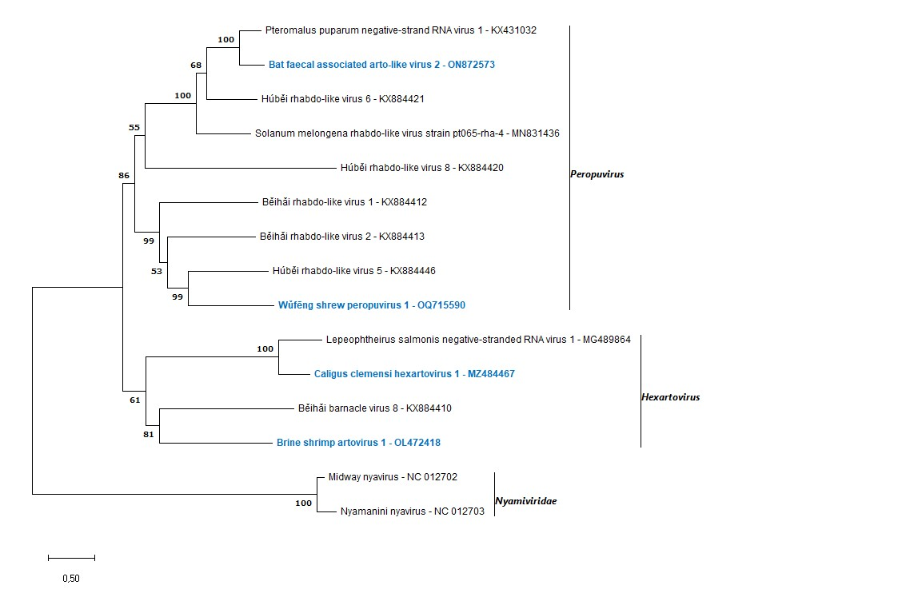
Figure 1. Phylogenetic analysis of viruses in the family Artoviridae. Maximum likelihood tree of L protein amino acid sequences utilizing LG+G+I+F model and 1,000 bootstraps. Nyamiviridae is used as outgroup. Model test and phylogeny based on complete deletion of gaps.

