The International Committee on Taxonomy of Viruses
Taxonomy Proposal Form, 2024
Part 1a: Details of taxonomy proposals

Title: | Create one new species in genus Antennavirus (Hareavirales; Arenaviridae)
Code assigned: | <to be assigned by ICTV officers>

Author(s), affiliation and email address(es):
Name | Affiliation | Email address | Corresponding author(s)
Grimwood RG | Department of Microbiology and Immunology, University of Otago, Dunedin, New Zealand | rebecca.grimwood@postgrad.otago.ac.nz | X
Geoghegan JL | Department of Microbiology and Immunology, University of Otago, Dunedin, New Zealand | jemma.geoghegan@otago.ac.nz
Kuhn JH | NIH/NIAID/DCR/Integrated Research Facility at Fort Detrick, Fort Detrick, Frederick, Maryland, USA | kuhnjens@mail.nih.gov
Part 1b: Taxonomy Proposal Submission
ICTV Subcommittee:
Animal DNA Viruses and Retroviruses |  | Bacterial viruses
Animal minus-strand and dsRNA viruses | X | Fungal and protist viruses
Animal positive-strand RNA viruses |  | Plant viruses
Archaeal viruses |  | General -Submit to Proposals Secretary

List the ICTV Study Group(s) that have seen or have been involved in creating this proposal:.
ICTV Arenaviridae Study Group

Optional – complete only if formally voted on by an ICTV Study Group:
Study Group | Number of members
 | Votes in support | Votes against | No vote
Arenaviridae Study Group | 8 |  | 2

Submission date: | 06/06/2024

Part 1c: Feedback from ICTV Executive Committee (EC) meeting <To be completed by the subcommittee chair after EC evaluation>
Executive Committee Meeting Decision code: | X
A – Accept
Ac – Accept subject to revision by relevant subcommittee chair. No further vote required
U – Accept without revision but with re-evaluation and email vote by the EC
Uc – Accept subject to revision and re-evaluation and email vote by the EC
Ud – Deferred to the next EC meeting, with an invitation to revise based on EC comments
J - Reject
W - Withdrawn

Comments from the Executive Committee:

Part 1d: Revised Taxonomy Proposal Submission <To be completed for the revised version>
Response of proposer: Please describe in detail how you have responded to the EC meeting feedback
Revision date: | DD/MM/YYYY

Enter date of the revised version.

Part 3: TAXONOMIC PROPOSAL

Name of accompanying Excel module:
2024.00xM.Antennavirus_1nsp.xlsx

Taxonomic changes proposed:
Establish new taxon | X | Split taxon
Abolish taxon |  | Merge taxon
Move taxon |  | Promote taxon
Rename taxon |  | Demote taxon
Move and rename

Is any taxon name used here derived from that of a living person: |  | N
Taxon name | Person from whom the name is derived | Attached X

Abstract of Taxonomy Proposal:
Taxonomic rank(s) affected: Hareavirales: Arenaviridae: Antennavirus

Description of current taxonomy: There are currently three recognised species in the Antennavirus genus.

Proposed taxonomic change(s): Establishment of one new species in genus Antennavirus for Ross Sea rockcod virus, identified in a scaly rockcod (Trematomus loennbergii Regan, 1913 ) and a slender scalyhead (Trematomus lepidorhinus (Paul Pappenheim, 1911)) from the Ross Sea, Antarctica.

Justification: Divergence of the coding-complete genome sequence of Ross Sea rockcod virus meets the established species demarcation criteria for genus Antennavirus.

Text of Taxonomy proposal:
Proposed taxonomic change(s): Addition of a new species to arenavirid genus Antennavirus.

A distinct antennavirus was detected in fish of two Trematomus species: scaly rockcod (Trematomus loennbergii (Regan, 1913)) and a slender scalyhead (Trematomus lepidorhinus (Paul Pappenheim, 1911)), both caught in the Ross Sea, Antarctica (Grimwood et al., 2024). Metatranscriptomic sequencing recovered coding-complete genome sequences.
The virus, named Ross Sea rockcod virus (RSRCV; previous, provisional name “Trematomus arenavirus” (Grimwood et al., 2024)), is hosted by two sympatric Trematomus hosts not known to host other antennaviruses (demarcation criterion: association of the virus with a distinct main host or group of sympatric hosts).

PAirwise Sequence Comparison (PASC) analysis of isolate TLO_L (https://www.ncbi.nlm.nih.gov/sutils/pasc/viridty.cgi) shows that the large (L) genomic segment shares 55% nucleotide sequence identity (demarcation criterion: <76%) and the small (S) genomic segments share 11% identity (demarcation: <80%) with salmon pescarenavirus 1 (SPAV1; Antennavirus salmonis). The nucleoprotein (NP) ORF is split on a third genomic segment with the individual parts separated by 65 nucleotides, thus dividing NP into its two constituent domains. As this segmentation of the NP was identified independently in both host species/sequencing libraries with good read coverage across the entire sequences and was reproduced by multiple assembly programs, we are confident that this split is genuine as opposed to a sequencing or assembly error. The deduced amino acid sequences of the two NP sequences share 37% and 40% identities with the NP from SPAV1, respectively (demarcation criterion: <88%). RSRCV therefore meets the ICTV requirements to be assigned to a new antennavirus species, Antennavirus trematomi.
References:
Grimwood, R. M., Waller, S. J., Wierenga, J. R., Lim, L., Dubrulle, J., Holmes, E. C., & Geoghegan, J. L. (2024). Viromes of Antarctic fish resembles the diversity found at lower latitudes. BioRxiv. https://www.biorxiv.org/content/10.1101/2024.04.29.591789v1.full.pdf
Radoshitzky, S. R., Buchmeier, M. J., Charrel, R. N., Gonzalez, J.-P. J., Günther, S., Hepojoki, J., Kuhn, J. H., Lukashevich, I. S., Romanowski, V., Salvato, M. S., Sironi, M., Stenglein, M. D., & de la Torre, J. C. (2023). ICTV Virus Taxonomy Profile: Arenaviridae 2023. Journal of General Virology, 104(9), 001891 . https://doi.org/ 10.1099/jgv.0.001891

Tables, Figures:

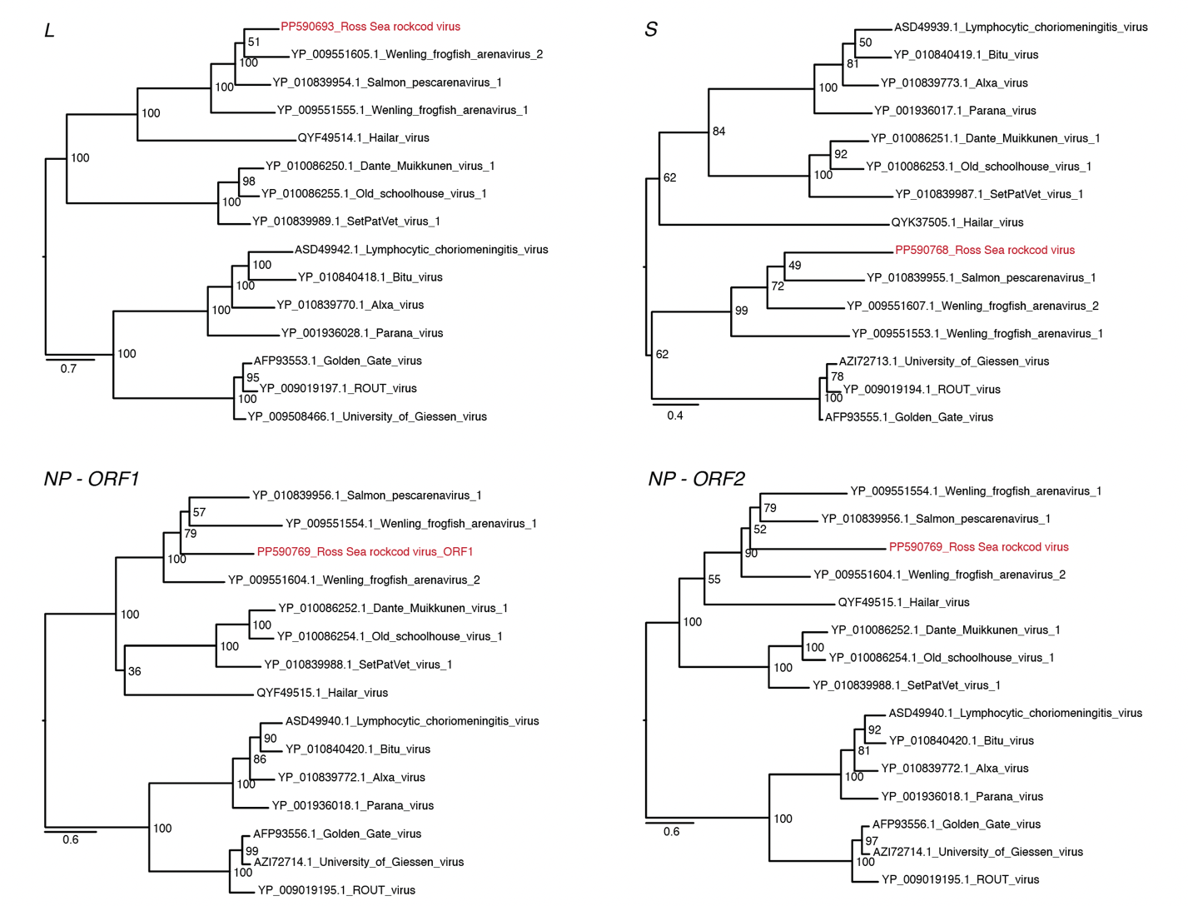
Figure 1: L segment, S segment, and NP maximum likelihood phylogenetic trees based on translated amino acid sequences. The trees were inferred using IQ-Tree v1.6.12 using the MFP option to select the most appropriate amino acid substitution model and 1,000 ultra-fast bootstrapping replicates. Trees were visualized in FigTree (http://tree.bio.ed.ac.uk/software/figtree/). The bars indicate amino acid substitutions per site and the numbers at the end of the nodes represent ultra-fast bootstrap support values. RSRCV sequences are indicated in red.

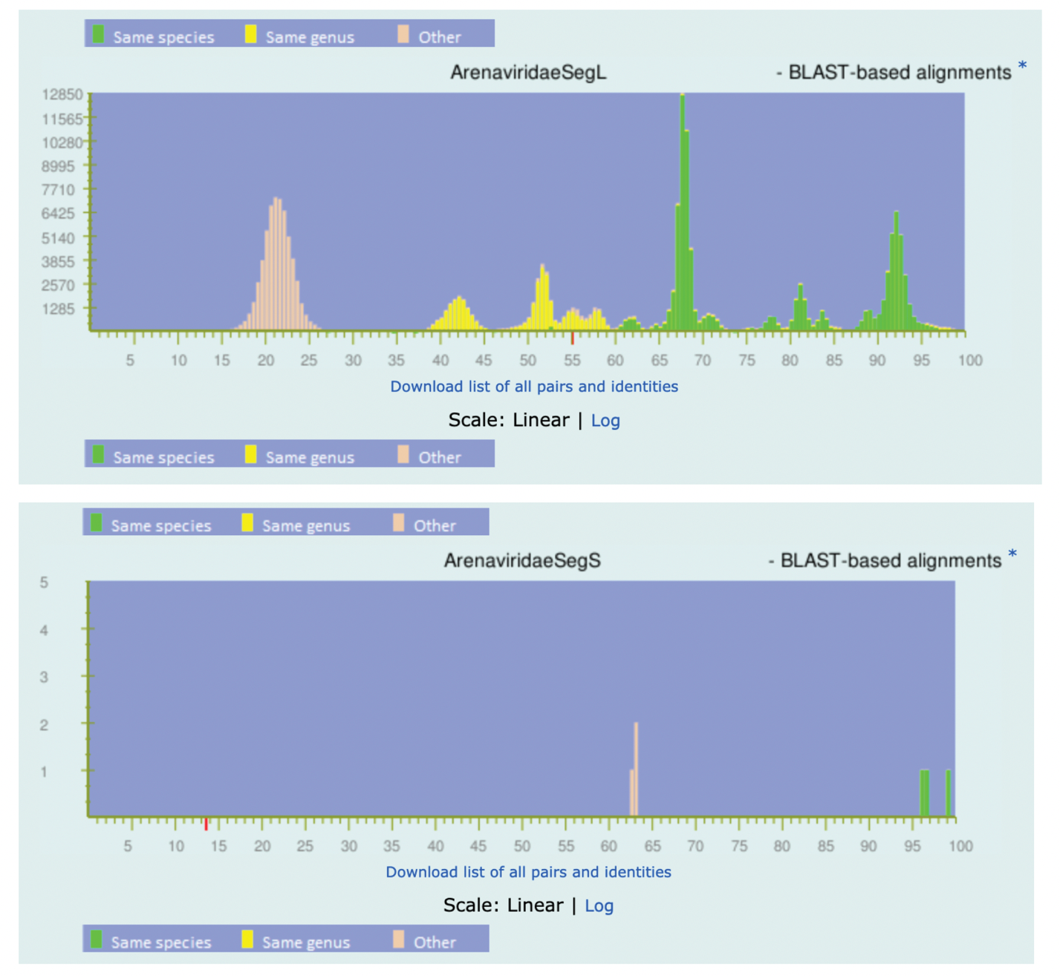
Figure 2: PAirwise Sequence Alignment (PASC) figures. PASC webtool histogram of pre-computed pairwise identities of known arenavirus sequences. The best hit for the L segment was salmon pescarenavirus 1 (MK611982.1), marked by a red stripe on the x-axis in the top graph. The S segment had less than 20% nucleotide identity to other known arenavirids (bottom graph).

