The International Committee on Taxonomy of Viruses
Taxonomy Proposal Form, 2024
Part 1a: Details of taxonomy proposals

Title: | Create ten new species in genus Shilevirus (Bunyaviricetes: Hareavirales: Leishbuviridae)
Code assigned: | <to be assigned by ICTV officers>

Author(s), affiliation and email address(es):
Name | Affiliation | Email address | Corresponding author(s)
Yurchenko, V | University of Ostrava, Ostrava, Czechia | Vyacheslav.Yurchenko@osu.cz | X
Kuhn, JH | NIH/NIAID/DCR/Integrated Research Facility at Fort Detrick, Frederick, Maryland, USA | kuhnjens@mail.nih.gov
Kostygov, AYu | University of Ostrava, Ostrava, Czechia | Alexej.Kostygov@osu.cz

Part 1b: Taxonomy Proposal Submission
ICTV Subcommittee:
Animal DNA Viruses and Retroviruses |  | Bacterial viruses
Animal minus-strand and dsRNA viruses | X | Fungal and protist viruses | X
Animal positive-strand RNA viruses |  | Plant viruses
Archaeal viruses |  | General -Submit to Proposals Secretary

List the ICTV Study Group(s) that have seen or have been involved in creating this proposal:.
None. There is currently no Study Group for family Leishbuviridae.
Optional – complete only if formally voted on by an ICTV Study Group: <
Study Group | Number of members
 | Votes in support | Votes against | No vote

Submission date: | 21/06/2024

Part 1c: Feedback from ICTV Executive Committee (EC) meeting <
Executive Committee Meeting Decision code: | X
A – Accept
Ac – Accept subject to revision by relevant subcommittee chair. No further vote required
U – Accept without revision but with re-evaluation and email vote by the EC
Uc – Accept subject to revision and re-evaluation and email vote by the EC
Ud – Deferred to the next EC meeting, with an invitation to revise based on EC comments
J - Reject
W - Withdrawn

Comments from the Executive Committee:

Part 1d: Revised Taxonomy Proposal Submission <To be completed for the revised version>
Response of proposer: Please describe in detail how you have responded to the EC meeting feedback
Revision date: | DD/MM/YYYY

Enter date of the revised version.

Part 3: TAXONOMIC PROPOSAL

Name of accompanying Excel module:
2024.00xM.Shilevirus_10nsp.xlsx

Taxonomic changes proposed:
Establish new taxon | X | Split taxon
Abolish taxon |  | Merge taxon
Move taxon |  | Promote taxon
Rename taxon |  | Demote taxon
Move and rename

Is any taxon name used here derived from that of a living person: |  | N
Taxon name | Person from whom the name is derived | Attached X

Abstract of Taxonomy Proposal:
Taxonomic rank(s) affected: leishbuvirid genus Shilevirus

Description of current taxonomy: 1 species (Shilevirus leptomonadis)

Proposed taxonomic change(s): add 10 new species

Justification: Discovery of novel shileviruses in various hosts from various habitats with sufficient genetic divergence.

Text of Taxonomy proposal:
Taxonomic rank(s) affected: leishbuvirid genus Shilevirus

Description of current taxonomy: 1 species (Shilevirus leptomonadis)

Proposed taxonomic change(s): add 10 new species

Demarcation criteria: None established at the moment. Proposed to be “Less than 90% identity in the complete amino acid sequence of the L protein”.

Justification: Family Leishbuviridae (Bunyaviricetes: Hareavirales) currently includes a single genus with a single species (Shilevirus leptomonadis) (1) for Leptomonas moramango virus (LEPMV), a virus infecting a trypanosomatid protist (Leptomonas moramango Yurchenko et al., 2014) (2). Numerous related viruses have been discovered in diverse protists (2-14), of which at least 10 are associated with coding-complete genome sequences (1-7), the minimum requirement for classification:
- Blechmonas luni leishbunyavirus 1 (BlunLBV1);
- Blechomonas ayalai leishbunyavirus 1 (BayaLBV1);
- Blechomonas maslovi leishbunyavirus 1 (BmasLBV1);
- Crithidia abscondita leishbunyavirus (CabsLBV1);
- Crithidia bombi leishbuvirus 1 (CbomLBV1);
- Crithidia otongatchiensis leishbunyavirus (CotoLBV1);
- Leptomonas pyrrhocoris leishbunyavirus 3 (LeppyrLBV3);
- Leptomonas pyrrhocoris leishbunyavirus 4 (LeppyrLBV4);
- Leishmania martiniquensis leishbunyavirus 1 (LmarLBV1); and
- Leptomonas moramango leishbunyavirus isolate LepmorLBV1b (LmorLBV1b).
We propose to classify these 10 viruses into 10 novel shilevirus species based on their relationships in RNA-directed RNA polymerase (RdRp) phylogeny (Figure 1) and overall genomic sequence divergence.

References:
1. Adkins S, Brown K, de la Torre JC, Digiaro M, Hughes HR, Junglen S, Lambert AJ, Maes P, Marklewitz M, Palacios G, Sasaya T, Turina M, Zhang Y-Z, Kuhn JH. 2023. ICTV virus taxonomy profile: Leishbuviridae 2023. J Gen Virol 104:001934.
2. Akopyants NS, Lye L-F, Dobson DE, Lukeš J, Beverley SM. 2016. A novel bunyavirus-like virus of trypanosomatid protist parasites. Genome Announc 4:e00715-16.
3. Neri U, Wolf YI, Roux S, Camargo AP, Lee B, Kazlauskas D, Chen IM, Ivanova N, Zeigler Allen L, Paez-Espino D, Bryant DA, Bhaya D, RNA Virus Discovery Consortium, Krupovic M, Dolja VV, Kyrpides NC, Koonin EV, Gophna U. 2022. Expansion of the global RNA virome reveals diverse clades of bacteriophages. Cell 185:4023-4037.e18.
4. Grybchuk D, Kostygov AY, Macedo DH, Votýpka J, Lukeš J, Yurchenko V. 2018. RNA viruses in Blechomonas (Trypanosomatidae) and evolution of Leishmaniavirus. mBio 9:e01932-18.
5. Grybchuk D, Akopyants NS, Kostygov AY, Konovalovas A, Lye LF, Dobson DE, Zangger H, Fasel N, Butenko A, Frolov AO, Votýpka J, d'Avila-Levy CM, Kulich P, Moravcová J, Plevka P, Rogozin IB, Serva S, Lukeš J, Beverley SM, Yurchenko V. 2018. Viral discovery and diversity in trypanosomatid protozoa with a focus on relatives of the human parasite Leishmania. Proc Natl Acad Sci U S A 115:E506-e515.
6. Klocek D, Grybchuk D, Macedo DH, Galan A, Votýpka J, Schmid-Hempel R, Schmid-Hempel P, Yurchenko V, Kostygov AY. 2023. RNA viruses of Crithidia bombi, a parasite of bumblebees. J Invertebr Pathol 201:107991.
7. Macedo DH, Grybchuk D, Režnarová J, Votýpka J, Klocek D, Yurchenko T, Ševčík J, Magri A, Dolinská MU, Záhonová K, Lukeš J, Servienė E, Jászayová A, Serva S, Malysheva MN, Frolov AO, Yurchenko V, Kostygov AY. 2023. Diversity of RNA viruses in the cosmopolitan monoxenous trypanosomatid Leptomonas pyrrhocoris. BMC Biol 21:191.
8. Remnant EJ, Shi M, Buchmann G, Blacquière T, Holmes EC, Beekman M, Ashe A. 2017. A diverse range of novel RNA viruses in geographically distinct honey bee populations. J Virol 91:e00158-17.
9. Zhang W, Zhang Y-C, Wang Z-G, Gu Q-Y, Niu J-Z, Wang J-J. 2022. The diversity of viral community in invasive fruit flies (Bactrocera and Zeugodacus) revealed by meta-transcriptomics. Microb Ecol 83:739-752.
10. Mahar JE, Shi M, Hall RN, Strive T, Holmes EC. 2020. Comparative analysis of RNA virome composition in rabbits and associated ectoparasites. J Virol 94:e02119-19.
11. Ortiz-Baez AS, Holmes EC, Charon J, Pettersson JH-O, Hesson JC. 2022. Meta-transcriptomics reveals potential virus transfer between Aedes communis mosquitoes and their parasitic water mites. Virus Evol 8:veac090.
12. Li C-X, Shi M, Tian J-H, Lin X-D, Kang Y-J, Chen L-J, Qin X-C, Xu J, Holmes EC, Zhang Y-Z. 2015. Unprecedented genomic diversity of RNA viruses in arthropods reveals the ancestry of negative-sense RNA viruses. Elife 4:e05378.
13. Shi M, Lin X-D, Tian J-H, Chen L-J, Chen X, Li CX, Qin X-C, Li J, Cao J-P, Eden J-S, Buchmann J, Wang W, Xu J, Holmes EC, Zhang Y-Z. 2016. Redefining the invertebrate RNA virosphere. Nature 540:539-543.
14. Grybchuk D, Macedo DH, Kleschenko Y, Kraeva N, Lukashev AN, Bates PA, Kulich P, Leštinová T, Volf P, Kostygov AY, Yurchenko V. 2020. The first non-LRV RNA virus in Leishmania. Viruses 12:168.

Tables, Figures:

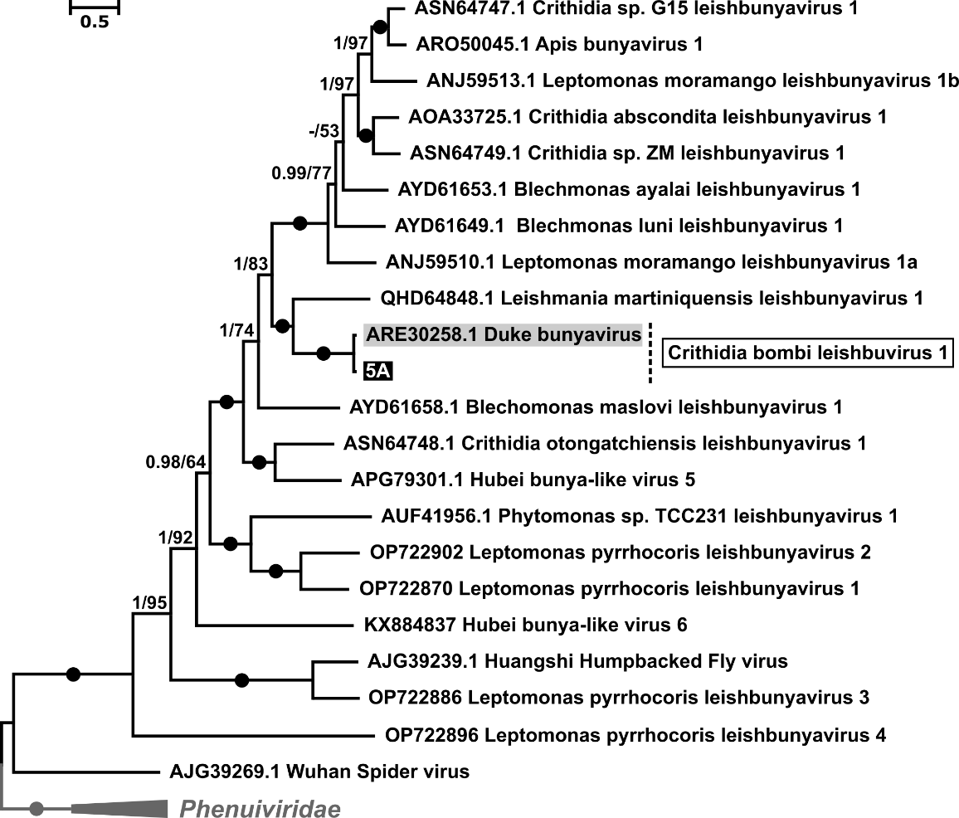
Maximum likelihood phylogenetic tree of Leishbuviridae based on amino acid sequences of RDRP, rooted using Phenuiviridae as outgroup. Posterior probabilities and bootstrap supports are shown at branches, their respective values below 0.5 and 50 are omitted or replaced with dashes. Branches with absolute (1/100) supports are marked with black circles. Scale bar corresponds to the number of substitutions per site (6).

