Part 1: TITLE, AUTHORS, APPROVALS, etc

Code assigned: | 2023.002A
Short title: Create 5 new families for classification of viruses infecting methanogenic archaea found in gut environment
Author(s) and email address(es)
Medvedeva S, Borrel G, Krupovic M, Gribaldo S. | sofia.medvedeva@pasteur.fr; guillaume.borrel@pasteur.fr; mart.krupovic@pasteur.fr; simonetta.gribaldo@pasteur.fr
Author(s) institutional address(es) (optional)
Corresponding author
Sofia Medvedeva

List the ICTV Study Group(s) that have seen this proposal

ICTV Study Group comments and response of proposer
ICTV Study Group votes on proposal

Study Group | Number of members
 | Votes support | Votes against | No vote

Authority to use the name of a living person

Is any taxon name used here derived from that of a living person (Y/N) | N

Taxon name | Person from whom the name is derived | Permission attached (Y/N)

Submission dates
Date first submitted to SC Chair
Date of this revision (if different to above)
ICTV-EC comments and response of the proposer
The GenBank accessions were not available during the EC meeting. Thus, the EC voted Ac for this proposal. This revised version contains the GenBank accessions for all new species. No other changes were requested.
Part 3: TAXONOMIC PROPOSAL.
Name of accompanying Excel module
2023.002A.N.v1.Caudoviricetes_5nf.xlsx
Abstract
Here we propose five new families for classification of tailed viruses (class Caudoviricetes) infecting methanogenic archaea from the orders Methanobacteriales and Methanomassiliicoccales. These viruses were identified in metagenomic data of human and animal gut microbiomes.
Text of proposal
Methanogenic archaea (methanogens) thrive in diverse artificial and natural anoxic environments, including animal gut microbiomes. Until now, viruses of methanogenic archaea have been represented by five families of tailed viruses, all infecting environmental hosts. Using a collection of human and animal gut metagenomic data and a database of CRISPR spacers of methanogenic archaea, we have identified five complete sequences of viruses distinct from previously reported ones [1]. These viruses encode HK97-fold major capsid protein, portal, large subunit of the terminase and various tail proteins, and therefore can be unequivocally assigned to the class Caudoviricetes.
Genome-wide proteomic comparison using ViPTree showed that these methanogenic viruses (and related proviruses, which are included in the analysis, but are not classified herein) form five family-level groups when considering the same genetic distance (branch length of 0.05) separating all other families within archaeal Caudoviricetes (Figure 1A). Moreover, phylogenetic analysis of the portal sequences (Figure 1B) places new viruses in different clades from previously reported families of archaeal tailed viruses. Thus, we propose to create 5 new genera and 5 new families for the classification of these viruses. ViPTree analysis shows that 3 new families of viruses infecting Methanobacteriales archaea (Kairosviridae, Armatusviridae, Pigerviridae) are forming a clade with Anaerodiviridae and Leisingerviridae, members of the order Methanobavirales. Thus, we propose placing these three new families in the order Methanobavirales. Notably, proteomic-based tree and phylogenetic tree of the portal proteins are not congruent, in particular, Armatusviridae and Pigerviridae do not form a monophyletic clade with Kairosviridae and members of the order Methanobavirales, likely underscoring the mosaic nature of the tailed virus genomes.

Below we describe five viruses of methanogenic archaea in detail (Figures 2-7).

Kairosviridae
Methanobrevibacter tailed virus 2 (MbTV2) has a linear genome of 34,179 bp in length and contains 44 ORFs (Figure 2). It was assembled as a circular molecule (indicative of genome completeness) from a goat fecal pellet sample. Terminase large subunit, pseudomurein endopeptidase and DNA methyltransferase show 22-42% identity to tailed viruses of Leisingerviridae and Anaerodiviridae families. MbTV2 encodes two copies of MCP proteins (55% identical to each other, portal, prohead protease, small and large terminase subunits). MbTV2 likely has a podovirus-like morphology: it encodes preneck appendage protein and five potential fiber proteins consisting of Ig-like domains. The endolysin of MbTV2 contains a peptidase_C71 catalytic domain with pseudomurein-binding repeat sequences. No pseudomurein-degradation domains associated with tail proteins were found, similar to viruses of Leisingerviridae family. Two related proviruses, sharing 26/44 ORFs with 29-97% identity are found in Methanobrevibacter millerae SM9 and Methanobrevibacter sp. YE315 genomes (both isolated from rumen fluid) (Figure 3). However, no tyrosine integrase has been found in MbTV2 or proviruses. MbTV2 and related proviruses do not show appreciable similarity to other characterized viruses at the nucleotide or protein sequence level.

Armatusviridae
Methanobrevibacter tailed virus 3 (MbTV3) has a linear genome of 51,140 bp in length and encodes 67 ORFs [2] (Figure 2). It was assembled as a circular molecule (indicative of genome completeness) from human gut metagenome. MbTV3 is targeted by CRISPR spacers from 156 different Methanobrevibacter smithii and Methanobrevibacter intestini genomes, due to either a broad host range or an overrepresentation of these two host species in human gut metagenomes. The MbTV3 genome has clearly distinct head module (terminase small and large subunits, portal, head morphogenesis, head scaffolding protein, prohead protease and MCP), tail module (major tail protein, tail assembly chaperone, tail tape measure protein, tail spike and several Ig-like domains containing proteins), and replication module (MCM-like helicase accompanied by a virus-encoded proofreading exonuclease, small subunit of primase and DNA polymerase sliding clamp). In addition, several nucleotide-synthesis genes are present: thymidylate synthase, dCTP deaminase, guanylate kinase. An endolysin (peptidase_C71) domain is found in the tail module. The MbTV3 genome encodes two exolysins associated with tail proteins: the C-terminal region of tail tape measure protein contains a peptidase_C71 domain, and the tail spike contains four peptidase_C71 domains, which might contribute to broad host range (Figure 2). Almost complete and fully complete viral sequences related to the same family are found in human gut and animal gut metagenomes [3] (Figure 4). MbTV3 and related viruses do not show appreciable similarity to other characterized viruses at the nucleotide or protein sequence level.

Pigerviridae
Methanobrevibacter tailed virus 4 (MbTV4) has a linear genome of 53,200 bp in length and encodes 72 ORFs (Figure 2). It was assembled as a circular molecule (indicative of genome completeness) from human gut metagenome. MbTV4 encodes proteins for contractile tails with a baseplate and are thus predicted to have a myovirus-like morphology (Figure 2). For replication, MbTV4 encodes the primase, DNA helicase and ssDNA-binding protein. The endolysin contains a peptidase_C39 domain (peiR-like), the exolysin is represented by a baseplate protein with peptidase_C71 domain.
Several related proviruses were identified (Figure 4) [1][2][4], including a provirus from the gut metagenome of an ocellated lizard which shares genomic regions with >95% nucleotide identity with MbTV4, while the rest of the genome is considerably more divergent (average identity of 65%). The shared region contains genes encoding the receptor-binding protein and endolysin which might indicate a possible host switch for the recipient of these genes (Figure 5). MbTV4 and related viruses do not show appreciable similarity to other characterized viruses at the nucleotide or protein level.

Lugdunumviridae
Methanomassiliicoccales tailed virus 1 (MxTV1) has a linear genome of 37,696 bp in length and encodes 72 ORFs (Figure 1) [5]. It was assembled as a circular molecule (indicative of genome completeness) from human gut metagenome. MxTV1 is predicted to have a non-contractile tail with a baseplate. By CRISPR spacer analysis, MxTV1 was assigned to Methanomethylophilaceae sp. UBA71 (Methanomassiliicoccales). Tail structural proteins include both Ig-like and Flg_new domains. An Ig-like domain is encoded in -1 reading frame from the major tail protein and may be added through a programmed frameshift mechanism. MxTV1 encodes a DGR element including a reverse transcriptase gene and a potential receptor-binding protein [1]. Multiple related viruses are present in human [2][3] and animal (goat, roe deer, water deer) metagenomes [4] (Figure 6). MxTV1 and related viruses do not show appreciable similarity to other characterized viruses at the nucleotide or protein level.

Lutetiaviridae
Methanomassiliicoccales tailed virus 1 (MxTV2) has a linear genome of 83,070 bp in length and encodes 108 ORFs (Figure 1) [5]. It was assembled as a circular molecule (indicative of genome completeness) from human gut metagenome. Primase, DNA helicase and ssDNA-annealing protein constitute the replication module of this virus. Ig-like domains and Flg_new domains are present in tail proteins (possibly tail fibers). MxTV2 encodes thymidylate synthase, nucleotide kinase and dUTPase. The amber stop codon is depleted (only 1 ORF is ending with a TAG codon). Two almost complete viral genomes related to MxTV2 are found in human gut metagenomic samples (Figure 7). Head and tail modules are related to MxTV2, while the non-structural module of proteins potentially involved in virus-host relationships differ from MxTV2. MxTV2 and related viruses do not show appreciable similarity to other characterized viruses at the nucleotide or protein sequence level.

Classification and etymology
Methanobrevibacter tailed virus 2 (MbTV2):
We propose classifying Methanobrevibacter tailed virus 2 into a species Nadirvirus capraenecum within a genus Nadirvirus in the new family Kairosviridae.
- Kairosviridae, from greek Kairos for the “time of opportunity” – referring to the finding of related proviruses in Methanobrevibacter genomes.
- Nadirvirus, from the « nadir » - the time of the day opposite to the zenith.
- capraenecum, because MbTV2 was found in the goat feces metagenomic sample.

Methanobrevibacter tailed virus 3 (MbTV3):
We propose classifying Methanobrevibacter tailed virus 3 into a species Ariesvirus gravis within a genus Ariesvirus in the new family Armatusviridae.
- Armatusviridae, from Latin armatus for “armed”, referring to the exolysin carring multiple pseudomurein degradation domains.
- Ariesvirus, from Latin aries for “battering-ram”, referring to the exolysin used for the destruction of pseudomurein cell wall.
- gravis, from Latin gravis for “heavy”, referring to the exolysin used for the destruction of pseudomurein cell wall.

Methanobrevibacter tailed virus 4 (MbTV4):
We propose classifying Methanobrevibacter tailed virus 4 into a species Somnumvirus timidum within a genus Somnumvirus in the new family Pigerviridae.
- Pigerviridae, from Latin piger for “lazy” referring to the presence of these viruses mostly as integrated elements.
- Somnumvirus, from Latin somnum for “sleep” referring to the presence of these viruses mostly as integrated elements.
- timidum, from Latin timidus for “shy” referring to the presence of these viruses mostly as integrated elements.

Methanomassiliicoccales tailed virus 1 (MxTV1):
We propose classifying Methanomassiliicoccales tailed virus 1 into a species Ventrumvirus gergoviense within a genus Ventrumvirus in the new family Clermontviridae.
- Clermontviridae, for Clermont-Ferrand, France. Viruses of this family infect Methanomassiliicoccales archaea, which were co-discovered in this city.
- Ventrumvirus, from the Latin ventrum for “gut”, referring to the origin of the virus from a human gut microbiome.
- gergoviense – for the Gergovia - a famous battle site in Clermont-Ferrand.

Methanomassiliicoccales tailed virus 2 (MxTV2):
We propose classifying Methanomassiliicoccales tailed virus 2 into a species Classicovirus victor within a genus Classicovirus in the new family Lutetiaviridae.
Lutetiaviridae, for the “Lutetia” - old name of city Paris, France.
Classicovirus – referring to the football rivalry between Paris and Marseille.
victor - referring to the football rivalry between Paris and Marseille

Species demarcation
For future members of the families, we propose using 95% sequence identity as a species demarcation criterion, to be consistent with the classification of other bacterial and archaeal viruses in the class Caudoviricetes.

Supporting evidence

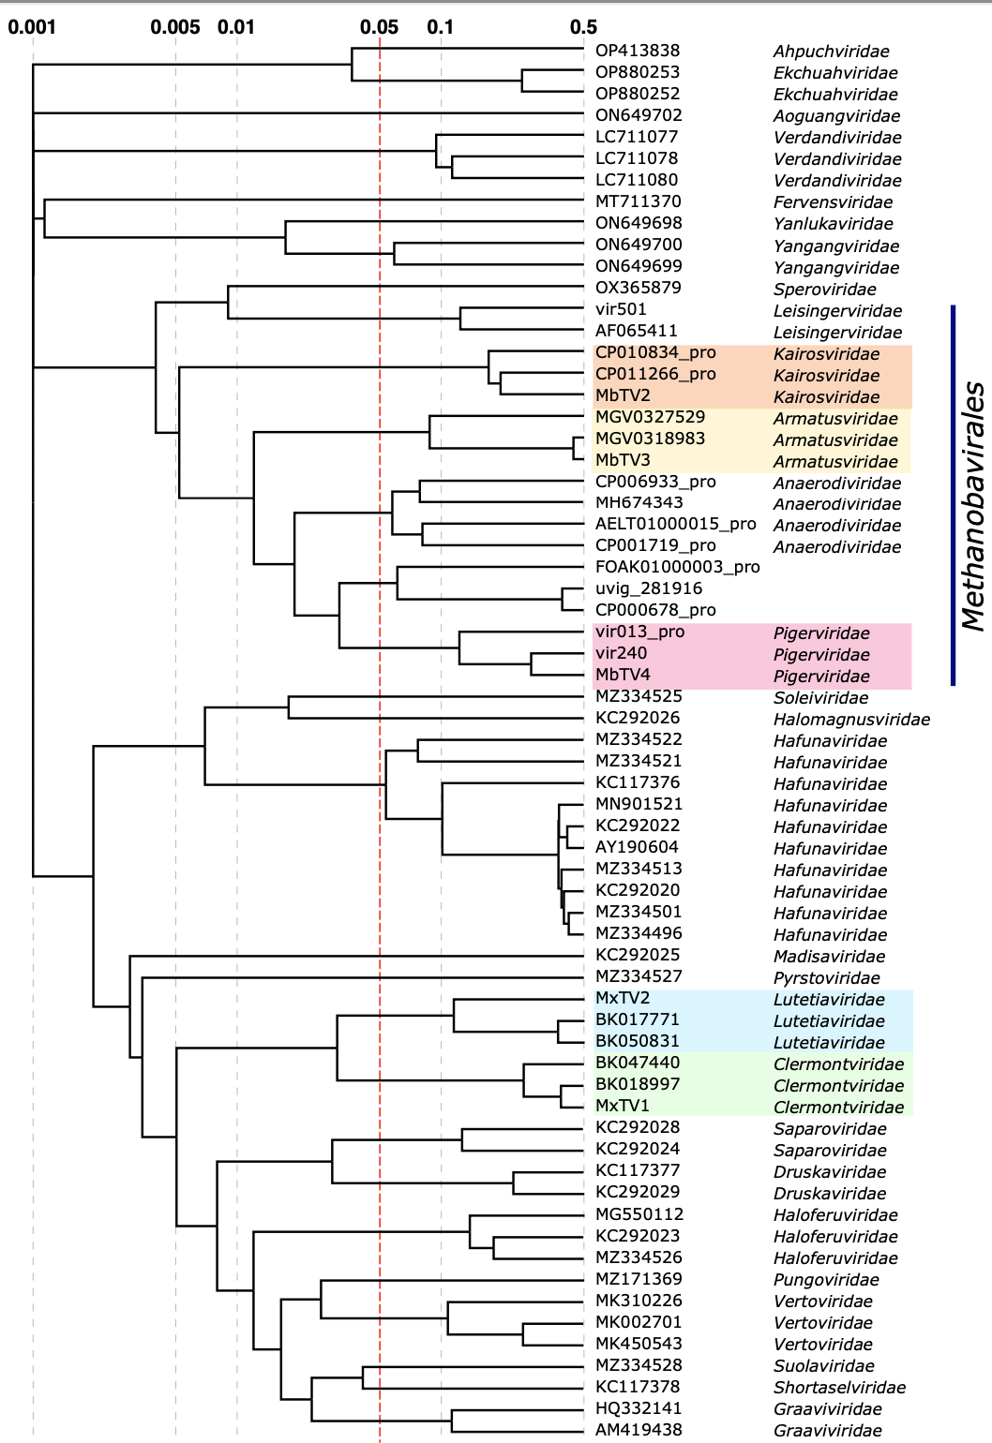
Figure 1A. The Viral Proteomic Tree (ViPTree) of archaeal tailed viruses. The tree is constructed using BIONJ based on all-versus-all genomic similarity matrix, and mid-point rooted. Branch lengths are log-scaled. The branch length for family-level demarcation is around 0.05. The five new families described in the proposal are highlighted with colored backgrounds.

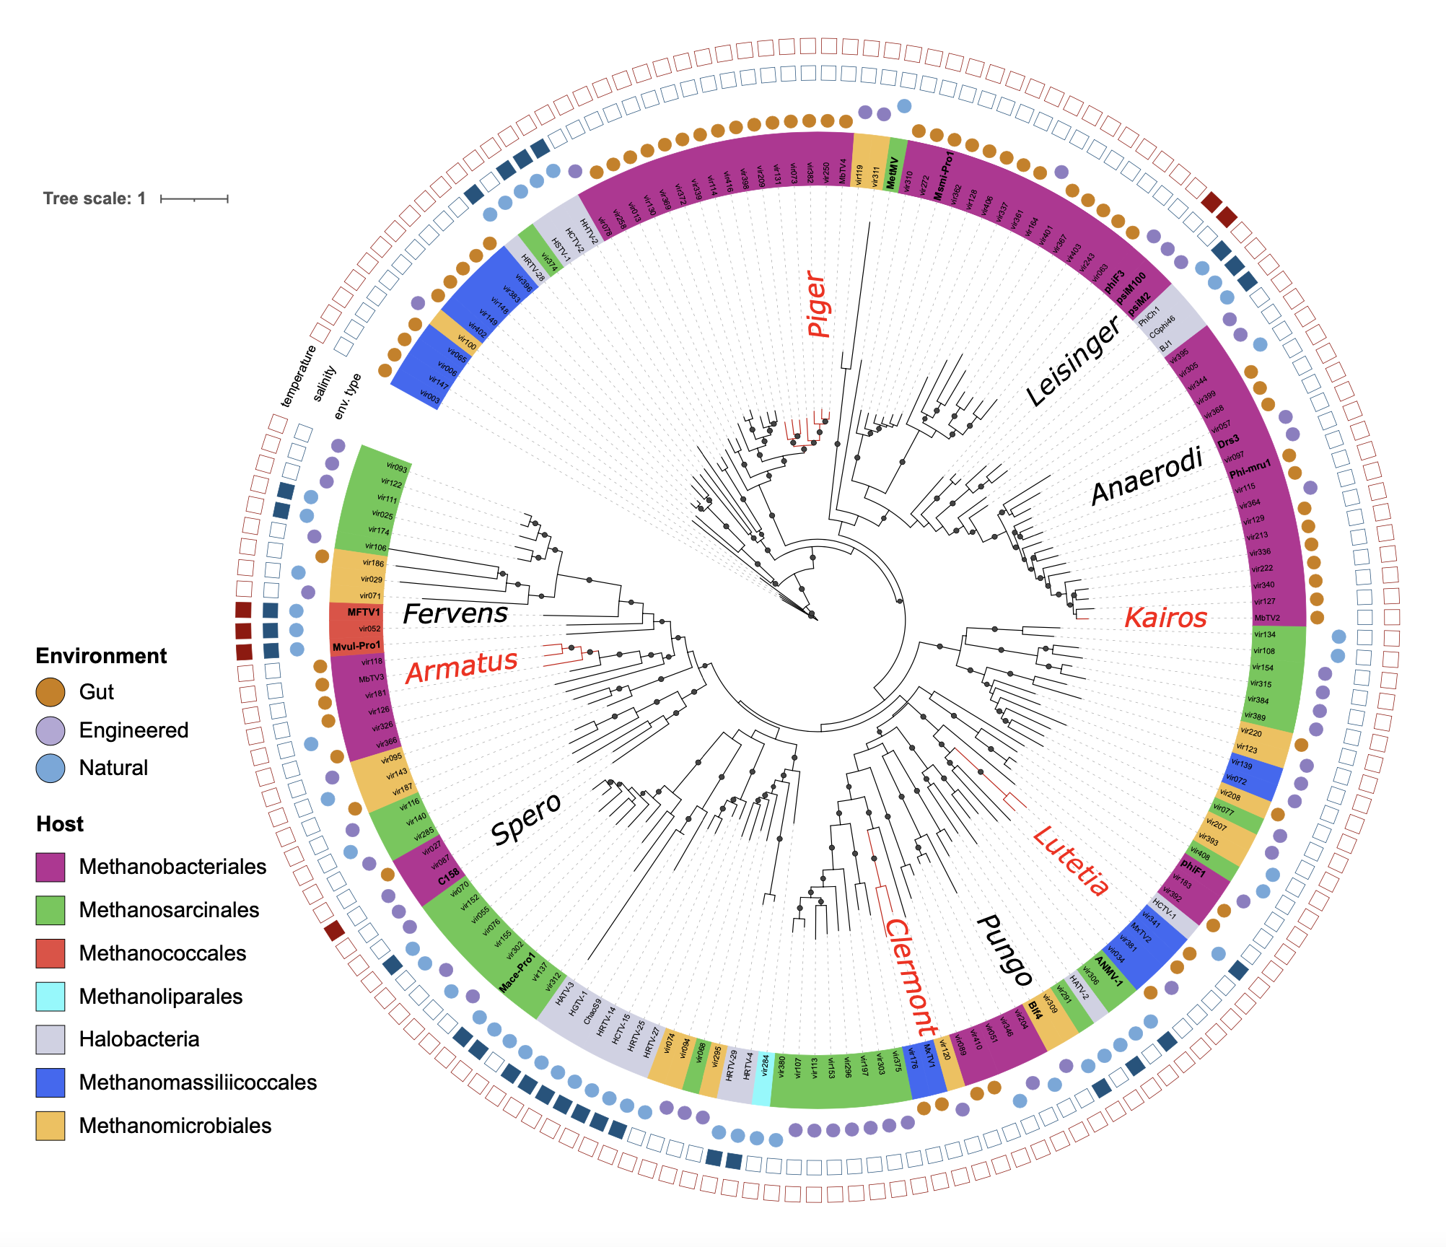

Figure 1B. Phylogenetic tree of archaeal tailed viruses based on the portal sequence. Branches with bootstrap support >0.9 are marked with dots. Colours of the leaves represent the host (at the level of order). Viral families are shown inside the annotation ring, proposed families are shown with red font. Protein sequences of portal proteins of 167 archaeal tailed viruses (identified in [1] and previously known viruses) were identified using Pfam hmm profiles search. Protein sequences were aligned with Promals3D and trimmed with trimal using the -gappyout option, leading to 351 amino acid positions. The phylogenetic tree was constructed by IQTree with –auto and fast bootstrap options (VT+F+R5 model was selected). The tree was visualized in itol.

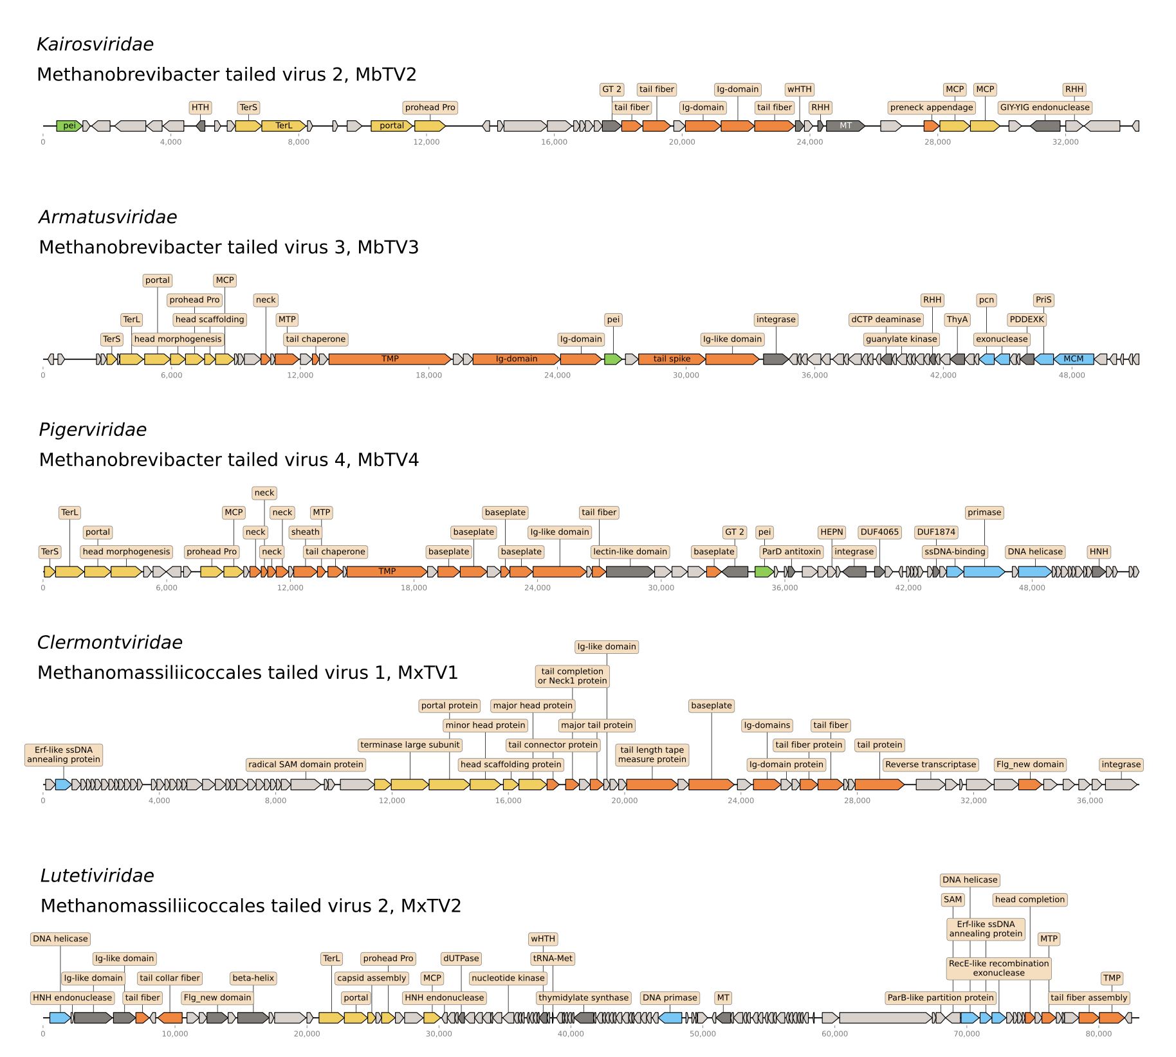

Figure 2. Genome maps of representative viruses. Head structural and assembly-related proteins are shown in yellow, tail proteins – in orange, replication protein – in blue, endolysin in green. TerS – terminase small subunit, TerL – terminase large subunit, MCP – major capsid protein, MTP – major tail protein, TMP – tail tape measure protein, pei – endolysin, GT 2 – glycosyltransferase family 2, Ig-domain – immunoglobulin-like domain.

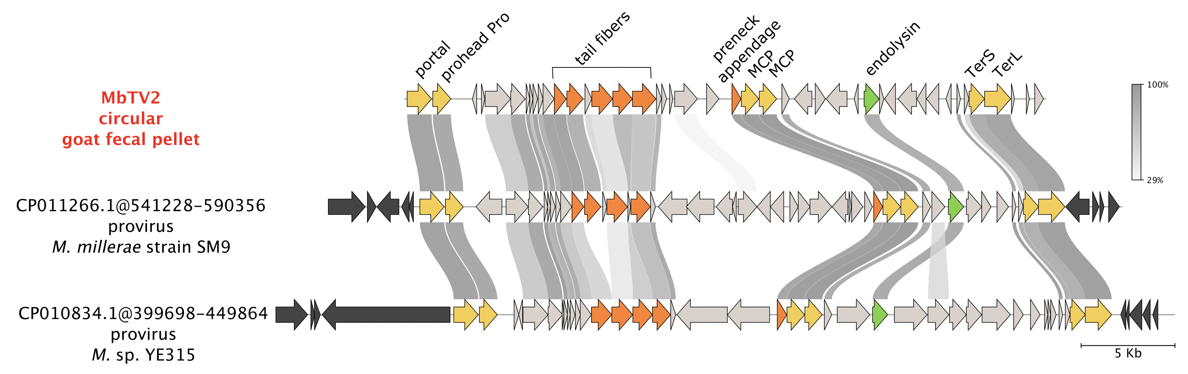
Figure 3. Kairosviridae: MbTV2 and two related proviruses. Head structural and assembly-related proteins are shown in yellow, tail proteins – in orange, endolysin in green. Host genes surrounding proviruses are in black.

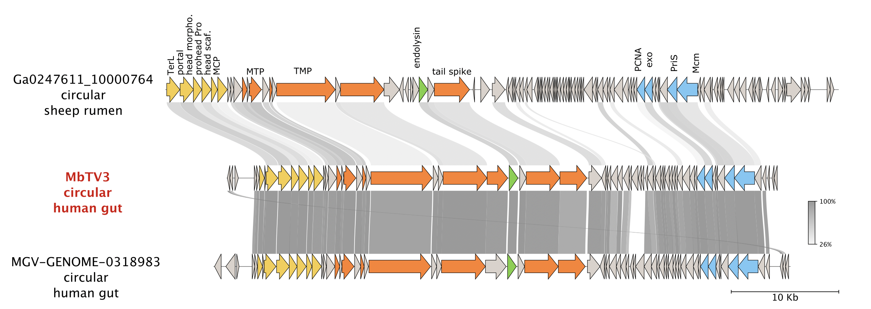
Figure 4. Armatusviridae: MbTV3 and two related viruses. Head structural and assembly-related proteins are shown in yellow, tail proteins – in orange, replication proteins – in blue, endolysin in green.

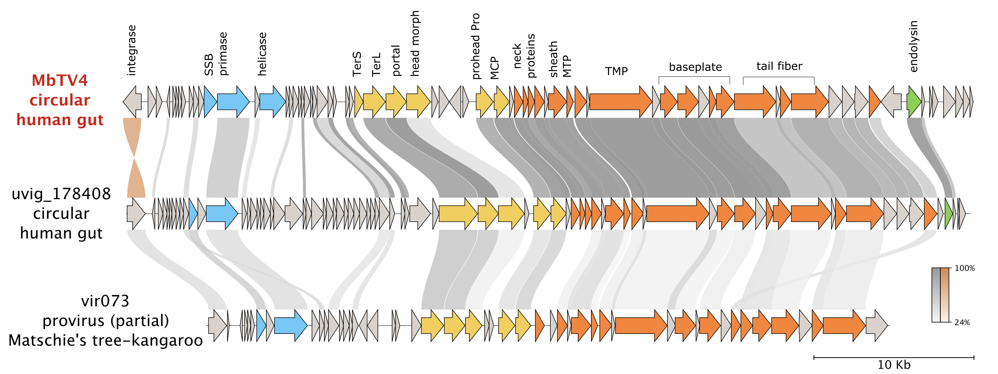
Figure 5. Pigerviridae: MbTV4 and related viruses and proviruses. Head structural and assembly-related proteins are shown in yellow, tail proteins – in orange, replication proteins – in blue, endolysin in green. Protein identity for the proteins from different strands is shown in brown.
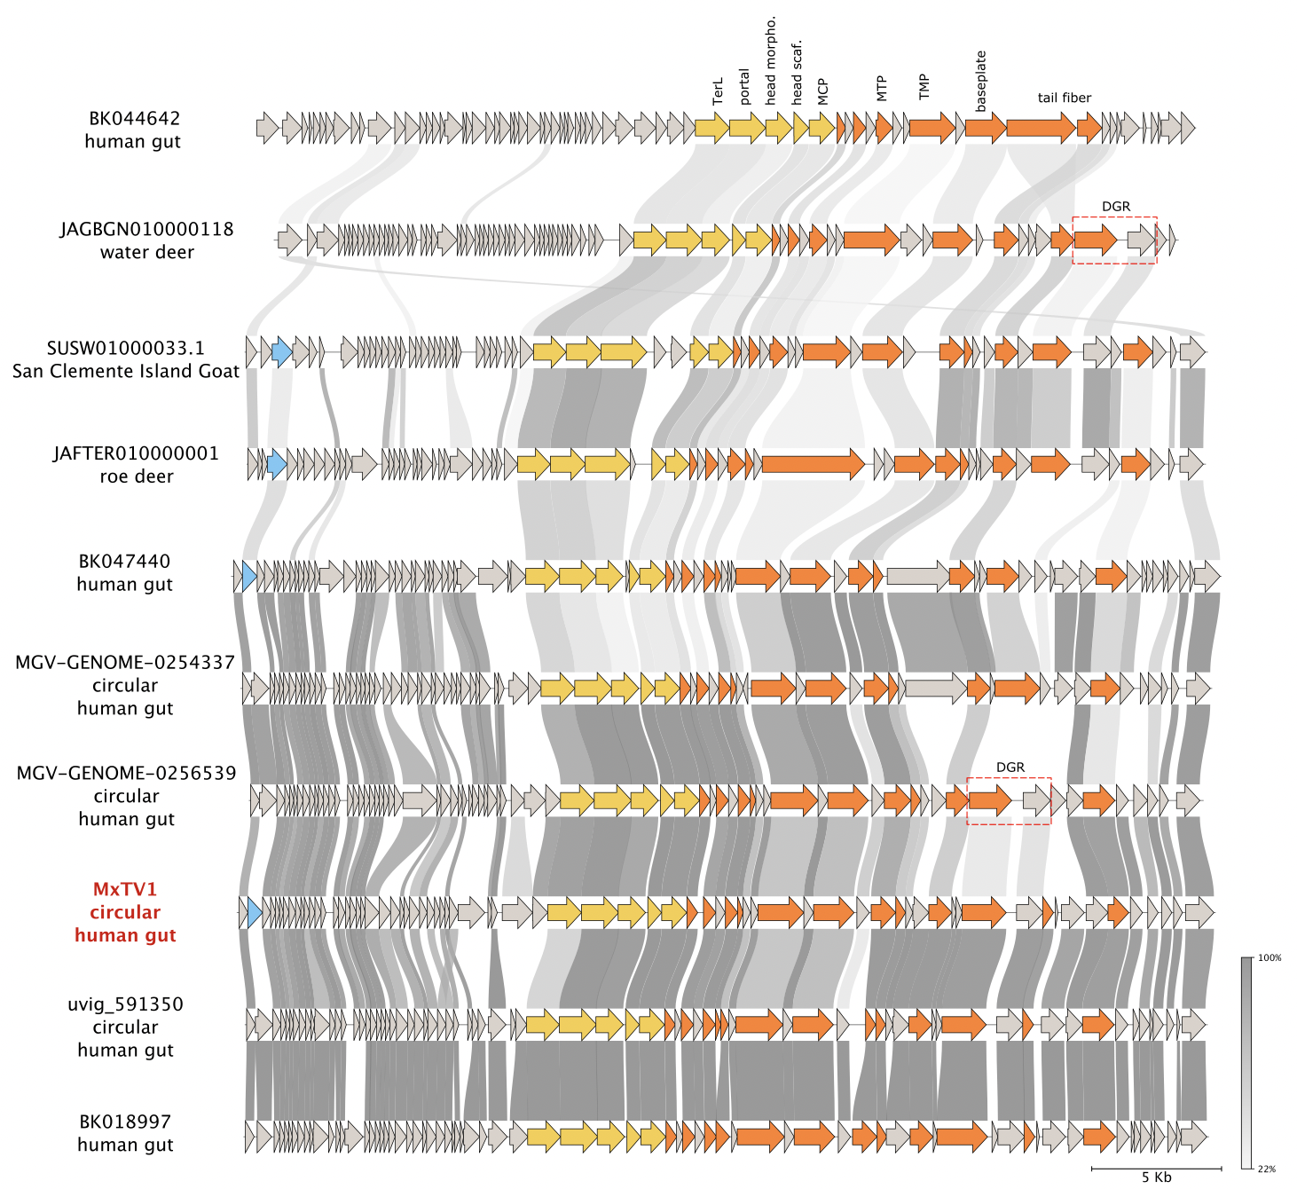
Figure 6. Clermontviridae: MxTV1 and related complete and almost complete viral sequences from human and animal gut. Head structural and assembly-related proteins are shown in yellow, tail proteins – in orange, replication protein – in blue.

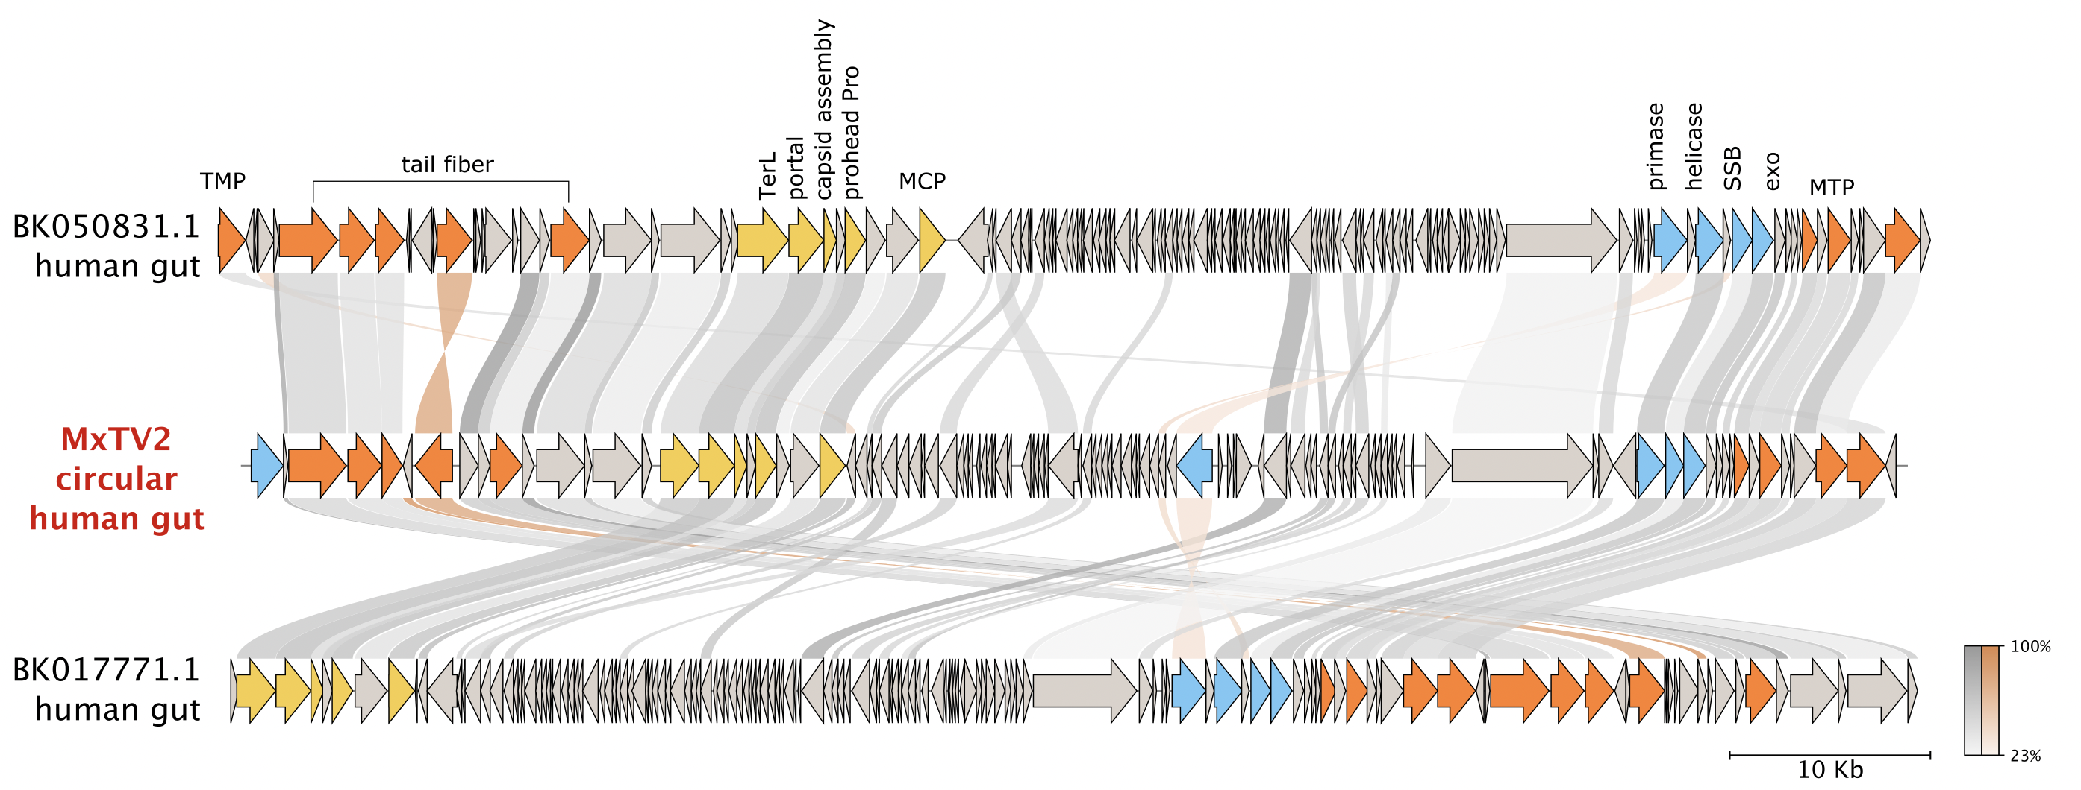
Figure 7. Lutetiaviridae: MxTV2 and two almost complete viral sequences from the human gut. Head structural and assembly-related proteins are shown in yellow, tail proteins – in orange, replication protein – in blue. Protein identity for the proteins from different strands is shown in brown.
References

[1] S. Medvedeva, G. Borrel, M. Krupovic, and S. Gribaldo. A global virome of methanogenic archaea highlights novel diversity and adaptations to the gut environment. Preprint. 10.21203/rs.3.rs-2539466/v1
[2] Camarillo-Guerrero LF, Almeida A, Rangel-Pineros G, Finn RD, Lawley TD. Massive expansion of human gut bacteriophage diversity. Cell. 2021;184: 1098–1109.e9.
[3] Nayfach S, Páez-Espino D, Call L, Low SJ, Sberro H, Ivanova NN, et al. Metagenomic compendium of 189,680 DNA viruses from the human gut microbiome. Nat Microbiol. 2021;6: 960–970.
[4] Stewart RD, Auffret MD, Warr A, Walker AW, Roehe R, Watson M. Compendium of 4,941 rumen metagenome-assembled genomes for rumen microbiome biology and enzyme discovery. Nat Biotechnol. 2019;37: 953–961.
[5] Tisza MJ, Buck CB. A catalog of tens of thousands of viruses from human metagenomes reveals hidden associations with chronic diseases. Proc Natl Acad Sci U S A. 2021;118. 10.1073/pnas.202320211

