Part 1: TITLE, AUTHORS, APPROVALS, etc

Code assigned: | 2023.004M
Short title: Create two new genera (Alphagymnorhavirus and Betagymnorhavirus) in the subfamily Betarhabdovirinae to include nine new species, and move one existing species from the genus Varicosavirus to the new genus Alphagymnorhavirus (Mononegavirales: Rhabdoviridae)
Author(s) and email address(es)
Bejerman N, Debat H, Dietzgen RG, Kondo H, Ramos-González P, Whitfield AE, Walker PJ, Freitas-Astúa J | bejerman.nicolas@inta.gob.ar;  debat.humberto@inta.gob.ar;  r.dietzgen@uq.edu.au; hkondo@rib.okayama-u.ac.jp;  plrg1970@gmail.com;  awhitfi@ncsu.edu;  peter.walker@uq.edu.au;  juliana.astua@embrapa.br
Author(s) institutional address(es) (optional)
Corresponding author
Bejerman N

List the ICTV Study Group(s) that have seen this proposal

ICTV Rhabdoviridae Study Group
ICTV Study Group comments and response of proposer
Good discussion regarding the creation of the genera.
ICTV Study Group votes on proposal
Study Group | Number of members
 | Votes support | Votes against | No vote
ICTV Rhabdoviridae Study Group | 11 | 0 | 3
Authority to use the name of a living person

Is any taxon name used here derived from that of a living person (Y/N) | N

Taxon name | Person from whom the name is derived | Permission attached (Y/N)

Submission dates
Date first submitted to SC Chair | June 23, 2023
Date of this revision (if different to above)
ICTV-EC comments and response of the proposer

Part 2: NON-TAXONOMIC PROPOSAL

Part 3: TAXONOMIC PROPOSAL
Name of accompanying Excel module
2023.004M.N.v1.Betarhabdovirinae_2ngen_9nsp_move1sp.xlxs
Abstract
Viruses classified in the family Rhabdoviridae infect vertebrates, invertebrates, and plants. Nine new plant-infecting rhabdoviruses were discovered recently and their coding-complete genomes were determined. This proposal aims to taxonomically classify these viruses into ten new species in two novel genera named Alphagymnorhavirus and Betagymnorhavirus in the subfamily Betarhabdovirinae. Also, a virus previously classified as a member of the genus Varicosavirus is proposed to be moved to the newly created genus Alphagymnorhavirus.
Text of proposal
Genera Alphagymnorhavirus and Betagymnorhavirus
Bejerman et al. [1] tentatively reported the first unsegmented varicosavirus, Pinus flexilis virus 1 (PiFleV1) which was associated with the gymnosperm Pinus flexilis. In a subsequent study, Bejerman et al. [2] complemented that result by the discovery of nine additional unsegmented varicosa-like viruses, which were exclusively associated with gymnosperms (Table 1), some of them linked to the same genus Pinus and presenting a significant co-evolution of viruses and hosts. The consensus gene junction sequences of the known bisegmented varicosaviruses were determined to be 3′ AU(N)₅UUUUUGCUCU 5′ while the gene junction sequences of all, but one, of the unsegmented gymnosperm-associated varicosa-like viruses differed slightly in the 3´end being GU(N)₅ instead of AU(N)₅. Strikingly, the consensus gene junction of the unsegmented Torreya virus 1 (TorV1) was similar to that of bisegmented varicosaviruses. The potential implication of this difference in the gene junctions needs to be explored since it could be linked to the basal evolutionary grouping of TorV1 [2]. These results robustly support two clades of all gymnosperm-associated varicosa-like viruses with a distinct genome architecture, requiring the rewriting of a previously proposed key feature and fundamental marker of varicosaviruses; their genomic bisegmented nature. The distinct phylogenetic branching and clustering of the unsegmented varicosa-like viruses suggest that they share a unique evolutionary history. Moreover, this may suggest that bisegmented varicosaviruses are evolutionarily younger than unsegmented varicosa-like viruses. It may also mean that a genome split in varicosa-like viruses occurred after the radiation of gymnosperms and angiosperms [2]. The clear association between gymnosperm-associated viruses and their hosts likely indicates a close coevolution, which suggests an early adaptation of this group of viruses to infect gymnosperms. This hypothesis is also supported by the distinct genomic architecture and divergent evolutionary history among varicosa-like viruses as shown in the phylogenetic tree, characterized by long branches and distinctive clustering [2]. Taken together, the gymnosperm-associated varicosa-like viruses could be taxonomically classified into two novel genera within the family Rhabdoviridae, subfamily Betarhabdovirinae for which we suggest the names “Alphagymnorhavirus” and “Betagymnorhavirus”.
The genus Alphagymnorhavirus is proposed to classify eight novel species as well as to include an unsegmented current varicosavirus member which is proposed to be moved to this newly created genus; while the genus Betagymnorhavirus is proposed to classify one new species.

Genus Alphagymnorhavirus

Species to be moved from the genus Varicosavirus and renamed

1) Pinus flexilis virus 1 (PiFleV1) was classified as a varicosavirus in the species Varicosavirus pini. We propose to move this virus to the Alphagymnorhavirus genus and rename the species as Alphagymnorhavirus piniflexilis.

Novel species

1) Abies virus 1 (AbiV1) was identified from an in silico analysis of transcriptome data of trojan fir (Abies nordmanniana) from Connecticut, USA. The coding-complete genome (CCG) sequence of AbiV1 has 11,287 nucleotides (BK061731) [2], and contains five ORFs (Figure 1). The nucleotide sequence of AbiV1 L gene has the highest sequence identity with that of Pinus flexilis virus 1 (PiFleV1, 52.91%) (Table 1) [2]. Based on ML trees generated from complete L protein sequences, AbiV1 is placed within a subclade of alphagymorhaviruses with Pinus banksiana virus 1, PiFleV1 and Pinus yunannensis virus 1 (Figure 2).

2) Amentotaxus virus 1 (AmeV1) was identified from an in silico analysis of transcriptome data of catkin yew (Amentotaxus argotaenia) from Chengdu, China. The coding-complete genome (CCG) sequence of AmeV1 has 10,965 nucleotides (BK061736) [2], and contains five ORFs (Figure 1). The nucleotide sequence of AmeV1 L gene has the highest sequence identity with that of Taxus virus 1 (TaxV1, 51.73%) (Table 1) [2]. Based on ML trees generated from complete L protein sequences, AmeV1 forms a well-supported clade with the alphagymnorhavirus TaxV1 (Figure 2).

3) Cupressus virus 1 (CupV1) was identified from an in silico analysis of transcriptome data of Cheng cypress (Cupressus chengiana) from Sichuan, China. The coding-complete genome (CCG) sequence of CupV1 has 12,143 nucleotides (BK061763) [2], and contains six ORFs (Figure 1). The nucleotide sequence of CupV1 L gene has the highest sequence identity with that of Pinus yunannensis virus 1 (Table 1) (PiYunV1, 50.02%) [2]. Based on ML trees generated from complete L protein sequences, CupV1 forms a well-supported clade with other alphagymnorhaviruses (Figure 2).

4) Picea virus 1 (PicV1) was identified from an in silico analysis of transcriptome data of Qinghai spruce (Picea crassifolia) from Qinghai, China. The coding-complete genome (CCG) sequence of PicV1 has 11,193 nucleotides (BK061792) [2], and contains five ORFs (Figure 1). The nucleotide sequence of PicV1 L gene has the highest sequence identity with that of Pinus yunannensis virus 1 (PiYunV1, 50.29%) (Table 1) [2]. Based on ML trees generated from complete L protein sequences, PicV1 forms a well-supported clade with other alphagymnorhaviruses (Figure 2).

5) Pinus banksiana virus 1 (PiBanV1) was identified from an in silico analysis of transcriptome data of jack pine (Pinus banksiana) from Alberta, Canada. The coding-complete genome (CCG) sequence of PiBanV1 has 11,276 nucleotides (BK061793) [2], and contains five ORFs (Figure 1). The nucleotide sequence of PiBanV1 L gene has the highest sequence identity with that of Pinus yunannensis virus 1 (Table 1) (PiYunV1, 66.89%) [2]. Based on ML trees generated from complete L protein sequences, PiBanV1 is placed within a subclade of alphagymnorhaviruses with Abies virus 1, Pinus flexilis virus 1 and PiYunV1 (Figure 2).

6) Pinus yunannensis virus 1 (PiYunV1) was identified from an in silico analysis of transcriptome data of Yunnan pine (Pinus yunannensis) from Yunnan, China. The coding-complete genome (CCG) sequence of PiYunV1 has 12,057 nucleotides (BK061794) [2], and contains five ORFs (Figure 1). The nucleotide sequence of PiYunV1 L gene has the highest sequence identity with that of Pinus flexilis virus 1 (PiFleV1, 70.31%) (Table 1) [2]. Based on ML trees generated from complete L protein sequences, PiYunV1 is placed within a subclade of alphagymnorhaviruses with Abies virus 1, Pinus banksiana virus 1 and PiFleV1 (Figure 2).

7) Sciadopitys virus 1 (SciV1) was identified from an in silico analysis of transcriptome data of Japanese umbrella pine (Sciadopitys verticillata). Two strains of this virus, named as SciV1_Chi and SciV1-Can were identified, one from transcriptome data from Kunming, China and the other one from British Columbia, Canada, respectively. The coding-complete genome (CCG) sequence of SciV1_Chi and SciV1-Can have 11,224 nucleotides (BK061803) and 11,132 nucleotides (BK061804), respectively [2], and contain five ORFs (Figure 1). The nucleotide sequences of the L gene of both SciV1 strains share an identity of 94.56% while both strains have the highest sequence identity with that of Pinus yunannensis virus 1 (PiYunV1, 46.77 and 46.81%, respectively%) (Table 1) [2]. Based on ML trees generated from complete L protein sequences, SciV1 forms a well-supported clade with other alphagymnorhaviruses (Figure 2).

8) Taxus virus 1 (TaxV1) was identified from an in silico analysis of transcriptome data of hybrid yew (Taxus media) from Hangzhou, China. The coding-complete genome (CCG) sequence of TaxV1 has 11,174 nucleotides (BK061817) [2], and contains five ORFs (Figure 1). The nucleotide sequence of TaxV1 L gene has the highest sequence identity with that of Amentotaxus virus 1 (AmeV1, 51.73%) (Table 1) [2]. Based on ML trees generated from complete L protein sequences, TaxV1 forms a well-supported clade with the alphagymnorhavirus AmeV1 (Figure 2).

We propose to classify AbiV1, AmeV1, CupV1, PicV1, PiBanV1, PiYunV1, SciV1 and TaxV1 in the new species Alphagymnorhavirus abietis, We propose to classify AbiV1, AmeV1, CupV1, PicV1, PiBanV1, PiYunV1, SciV1, TaxV1, and TorV1 in the new species Alphagymnorhavirus abietis, Alphagymnorhavirus amentotaxi, Alphagymnorhavirus cupressi, Alphagymnorhavirus piceae, Alphagymnorhavirus pinibanksiae, Alphagymnorhavirus piniyunannensis, Alphagymnorhavirus sciadopitysis and Alphaggymnorhavirus taxi, respectively, in the genus Alphagymnorhavirus, subfamily Betarhabdovirinae, family Rhabdoviridae.

We propose that viruses assigned to different species within the genera Alphagymnorhavirus have several of the following characteristics:
- nucleotide sequence identity lower than 75% for the L ORF; and
- occupy different ecological niches as evidenced by differences in hosts

- AbiV1, AmeV1, CupV1, PicV1, PiBanV1, PiYunV1, SciV1 and TaxV1 meet criteria A and B.

Genus Betagymnorhavirus

1) Torreya virus 1 (TorV1) was identified from an in silico analysis of transcriptome data of Chinese nutmeg yew (Torreya grandis) from Chengdu, China. The coding-complete genome (CCG) sequence of TorV1 has 10,253 nucleotides (BK061818) [2], and contains five ORFs (Figure 1). The nucleotide sequence of TorV1 L gene has the highest sequence identity with that of the alphagymnorhavirus Abies virus 1 (AbiV1, 37.53%) (Table 1) (Table 2) [2]. Based on ML trees generated from complete L protein sequences, TorV1 is placed in a clade that is basal to all alphagymnorhaviruses and varicosaviruses (Figure 2).

We propose to classify TorV1 in the new species Betagymnorhavirus torreyae, respectively, in the genus Betagymnorhavirus, subfamily Betarhabdovirinae, family Rhabdoviridae.

As soon as new species belonging to the newly created genus Betagymnorhavirus are discovered, a demarcation criterion will be proposed.

Supporting evidence

Table 1. L ORF alphagymnorhaviruses and the betagymnorhavirus and Percent Identity Matrix created by SDT v1.2.

Virus | AbiV1 | AmeV1 | CupV1 | PicV1 | PiBanV1 | PiFleV1 | PiYunV1 | SciV1_Chi | SciV1_Can | TaxV1 | TorV1
AbiV1 | 100 | 45.93 | 49.87 | 47.73 | 52.46 | 52.91 | 52.35 | 45.55 | 45.80 | 46.48 | 37.53
AmeV1 | 45.93 | 100 | 44.92 | 45.34 | 45.65 | 46.56 | 46.88 | 44.54 | 44.56 | 51.73 | 32.67
CupV1 | 49.87 | 44.92 | 100 | 47.68 | 48.60 | 49.36 | 50.02 | 46.35 | 46.30 | 45.78 | 33.16
PicV1 | 47.73 | 45.34 | 47.68 | 100 | 49.04 | 49.46 | 50.29 | 45.58 | 46.02 | 46.46 | 32.06
PiBanV1 | 52.46 | 45.65 | 48.60 | 49.04 | 100 | 65.41 | 66.89 | 46.58 | 46.63 | 46.69 | 31.76
PiFleV1 | 52.91 | 46.56 | 49.36 | 49.46 | 65.41 | 100 | 70.31 | 46.49 | 46.81 | 47.28 | 31.89
PiYunV1 | 52.35 | 46.88 | 50.02 | 50.29 | 66.89 | 70.31 | 100 | 46.77 | 46.50 | 47.36 | 32.54
SciV1_Chi | 45.55 | 44.54 | 46.35 | 45.58 | 46.58 | 46.49 | 46.77 | 100 | 94.59 | 44.41 | 33.43
SciV1_Can | 45.80 | 44.56 | 46.30 | 46.02 | 46.63 | 46.81 | 46.50 | 94.59 | 100 | 44.66 | 33.17
TaxV1 | 46.48 | 51.73 | 45.78 | 46.46 | 46.69 | 47.28 | 47.36 | 44.41 | 44.66 | 100 | 31.03
TorV1 | 37.53 | 32.67 | 33.16 | 32.06 | 31.76 | 31.89 | 32.54 | 33.43 | 33.17 | 31.03 | 100
Virus name abbreviations: Abies virus 1 (AbiV1), Amentotaxus virus 1 (AmeV1), Cupressus virus 1 (CupV1), Picea virus 1 (PicV1), Pinus banksiana virus 1 (PiBanV1), Pinus flexilis virus 1 (PiFleV1), Pinus yunannensis virus 1 (PiYunV1), Scidopitys virus 1 (SciV1), Taxus virus 1 (TaxV1) and Torreya virus 1 (TorV1).

Table 2. L ORF betagymnorhavirus and selected varicosaviruses and Percent Identity Matrix created by SDT v1.2.

Virus | AcoV1 | BrRV1 | CenV1 | EryV1 | FruV1 | GuiV1 | HolV1 | LufV1 | RapV1 | RibV1 | StrV1 | TorV1
TorV1 | 30.75 | 29.83 | 28.76 | 31.25 | 33.41 | 29.87 | 32.12 | 29.95 | 31.76 | 32.65 | 35.73 | 100
Virus name abbreviations: Aconitum virus 1 (AcoV1), Brassica virus 1 (BrV1), Centaurea virus 1 (CenV1), Erysimum virus 1 (EryV1), Frullania virus (FruV1), Guizotia virus 1 (GuiV1), Holcus virus 1 (HolV1), Luffa virus 1 (LufV1), Raphanus virus 1 (RapV1), Ribes virus 1 (RibV1), Streptoglossa virus 1 (StrV1) and Torreya virus 1 (TorV1).

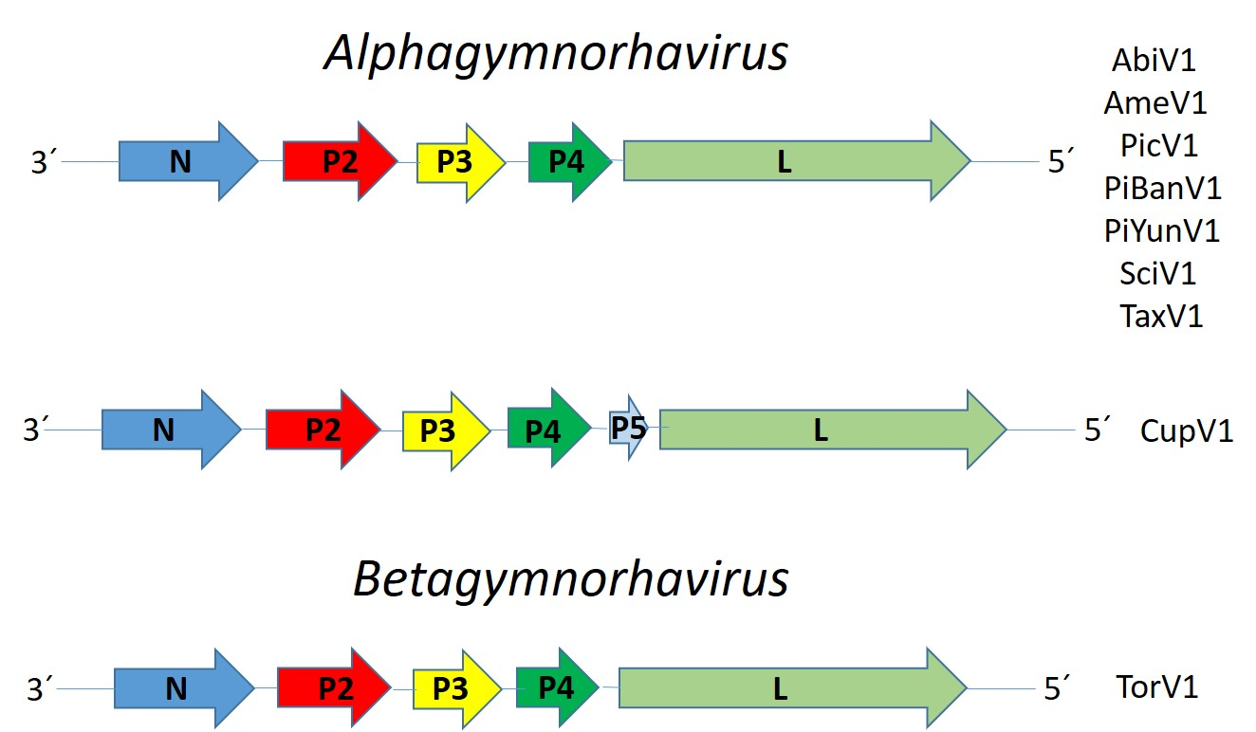

Figure 1. Genome graphs depicting architecture and gene products of viruses proposed to be included in species within genera Alphagymnorhavirus and Betagymnorhavirus. Abbreviations: N: nucleoprotein; P2: protein 2; P3: protein 3; P4: protein 4; P5: protein 5; L: RNA-dependent RNA polymerase. Virus name abbreviations: Abies virus 1 (AbiV1), Amentotaxus virus 1 (AmeV1), Cupressus virus 1 (CupV1), Picea virus 1 (PicV1), Pinus banksiana virus 1 (PiBanV1), Pinus yunannensis virus 1 (PiYunV1), Scidopitys virus 1 (SciV1), Taxus virus 1 (TaxV1) and Torreya virus 1 (TorV1).
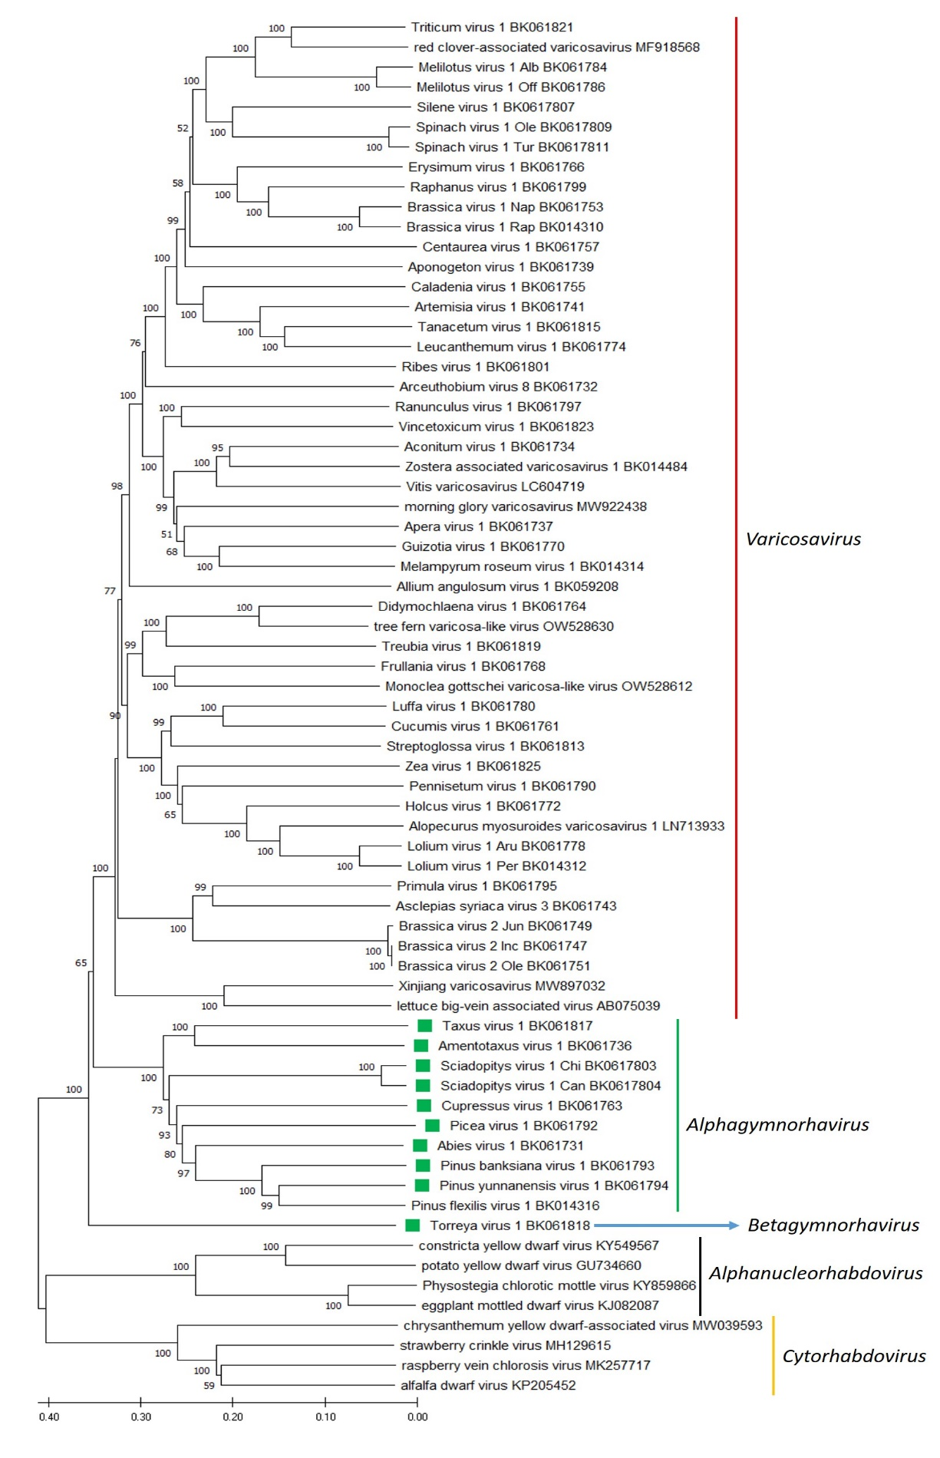
Figure 2. A Maximum Likelihood (ML) phylogenetic tree of plant-infecting rhabdovirus L polymerase protein sequences. Amino acid sequences were aligned using MUSCLE. The resulting alignment was used to generate a phylogenetic tree using MegaX with the best-fit model LG + G + I +F. Nine viruses potentially belonging to new species, as well as one previously classified as a varicosavirus, are indicated with green squares. Numbers at the nodes indicate bootstrap support (1000 replicates).

References
[1] Bejerman N, Dietzgen RG, Debat H (2021). Illuminating the plant rhabdovirus landscape through metatranscriptomics data. Viruses 13:1303. PMID:34372509, doi:10.3390/v13071304.
[2] Bejerman N, Dietzgen RG, Debat H (2022). Unlocking the hidden genetic diversity of varicosaviruses, the neglected plant rhabdoviruses. Pathogens 11:1127. PMID:36297184, doi: 10.3390/pathogens11101127

