Part 1: TITLE, AUTHORS, APPROVALS, etc

Code assigned: | 2023.014M
Short title: Create two new species in genus Mammarenavirus (Bunyavirales: Arenaviridae)
Author(s) and email address(es)
Cuypers LN, Gryseels S, Goüy de Bellocq J | lauracuypers@outlook.be; sophie.gryseels@uantwerpen.be; joellegouy@gmail.com
Author(s) institutional address(es) (optional)
University of Antwerp, Antwerp, Belgium [LNC, SG]; Royal Belgian Institute of Natural Sciences [LNC, SG]; Institute of Vertebrate Biology of the Czech Academy of Sciences, Brno, Czech Republic [JGB]
Corresponding author
Cuypers LN
List the ICTV Study Group(s) that have seen this proposal
ICTV Arenaviridae Study Group
ICTV Study Group comments and response of proposer
ICTV Study Group votes on proposal
Study Group | Number of members
 | Votes support | Votes against | No vote
ICTV Arenaviridae Study Group | 13 | 0 | 0
Authority to use the name of a living person
Is any taxon name used here derived from that of a living person (Y/N) | N

Taxon name | Person from whom the name is derived | Permission attached (Y/N)
N/A | N/A | N/A

Submission dates
Date first submitted to SC Chair | June 23, 2023
Date of this revision (if different to above)
ICTV-EC comments and response of the proposer

Part 2: NON-TAXONOMIC PROPOSAL
N/A

Part 3: TAXONOMIC PROPOSAL
Name of accompanying Excel module
2023.014M.N.v1.Mammarenavirus_2nsp
Abstract
We propose the establishment of two new species in arenavirid genus Mammarenavirus to accommodate Berega and Songea viruses discovered in woodland grammomys in Tanzania.
Text of proposal
Two distinct mammarenaviruses were detected in woodland grammomys (murid Grammomys surdaster (Thomas and Wroughton, 1908; sensu Musser & Carleton 2005 and Bryja et al. 2017) in Tanzania: one in a kidney sample from (TZ31109) trapped at Lilondo (Songea Rural District) and another in a salivary gland sample (TZ33709) trapped at Berega (Kilosa District). Metagenomic sequencing was performed on a TZ31109 dried blood sample, yielding a complete mammarenavirus genome sequence, and on the TZ33709 salivary gland sample, yielding a coding-complete mammarenavirus genome sequence that misses a few non-coding nucleotides at all ends except the 3’ end of the S segment (Cuypers et al. 2023). Both viruses meet the ICTV Arenaviridae Study Group’s criteria to each be considered members of new mammarenavirus species. We therefore propose the establishment of the species Mammarenavirus songeaense (for the first virus, named Songea virus [SOGV]) and Mammarenavirus beregaense (for the second virus, named Berega virus [BEGV]) after the district and the locality where they were discovered, respectively.

The best PASC hit for both SOGV genome segments is Solwezi virus (S segment: 70%, L segment: 63%; Figure 1), which is also Songea virus’s sister in the L and NP trees (Figure 2). A Geneious alignment of the two NP amino acids sequences reveals a pairwise identity of 83%.

The best PASC hit for BEGV is Mariental virus (S segment) (70% identity) and BEGV clusters with Mariental virus in the NP, GPC, and L phylogenetic tree below (Figure 2).

Supporting evidence
Figure 1. PAirwise Sequence Comparison analyses performed through the online webtool available at https://www.ncbi.nlm.nih.gov/sutils/pasc/viridty.cgi.
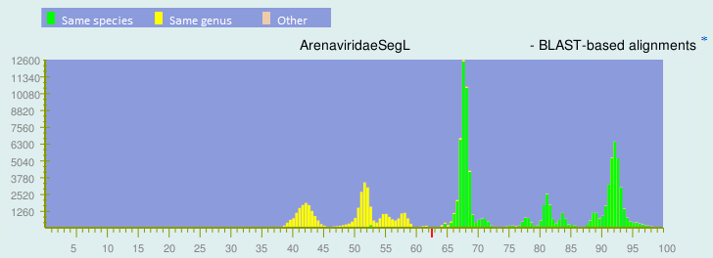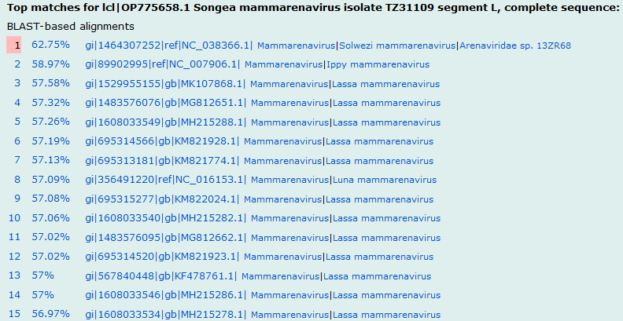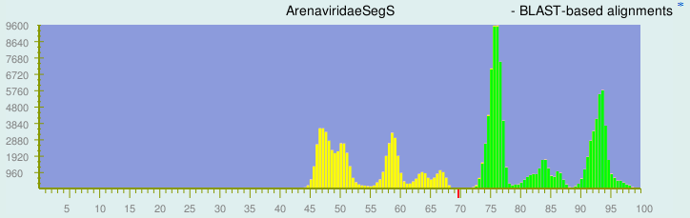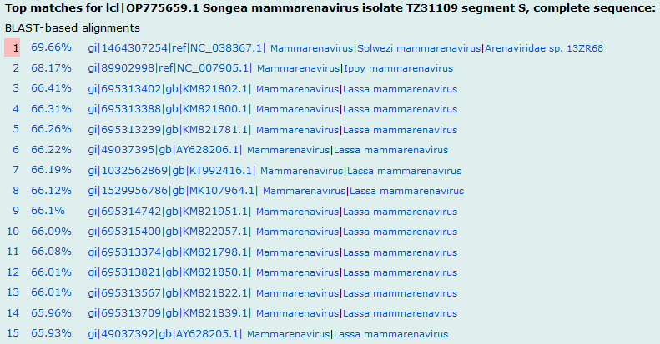
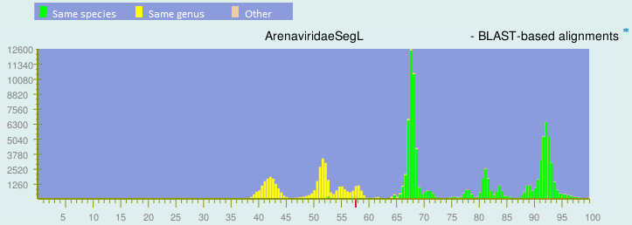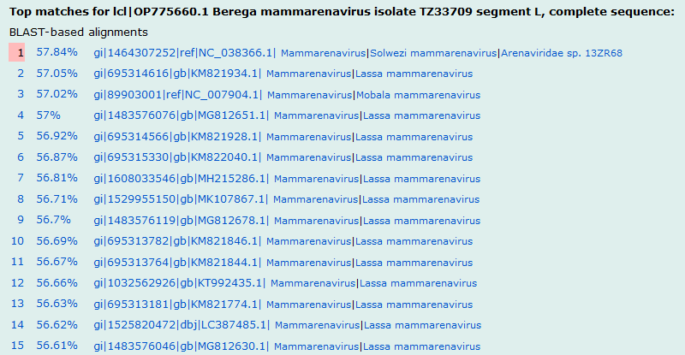
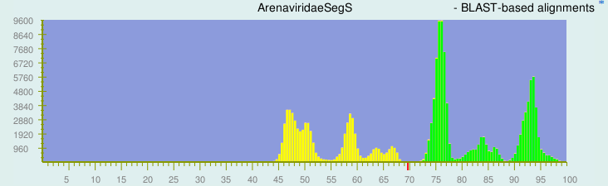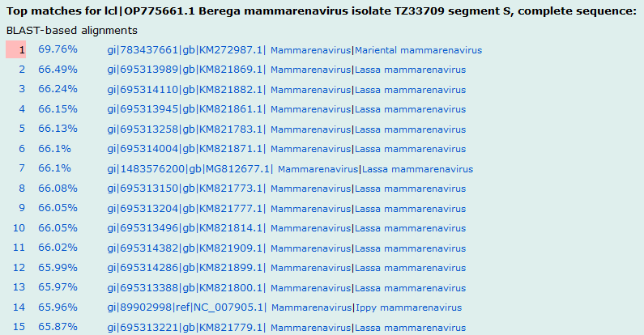

Figure 2. L, NP and GPC gene phylogenetic trees rooted with Alxa virus. The trees were inferred with MrBayes v3.2.7a with codon partitioning and a GTR+G nucleotide substitution model. In two independent runs four chains ran for 2,000,000 generations with a burn-in of 25%. Average standard deviations of split frequencies were examined for convergence, as were parameter effective sample sizes and trace patterns in Tracer (https://beast.community/tracer). Trees were visualized in FigTree (http://tree.bio.ed.ac.uk/software/figtree/). Posterior probabilities are indicated at the nodes and the scale bars indicate the number of nucleotide substitutions per site. Asterisks indicate that sequences were slightly modified from the corresponding GenBank sequences to improve translation alignment: a suspected chimaeric region of KP867641 was masked (Těšíková et al., 2021), one N was added at position 7,074 in AB693151 to restore the reading frame and enable a longer sequence (Cuypers et al. 2022), and the first four nucleotides of KY432893 were cut so the Alxa virus NP sequence starts with a start codon (Cuypers et al. 2022).

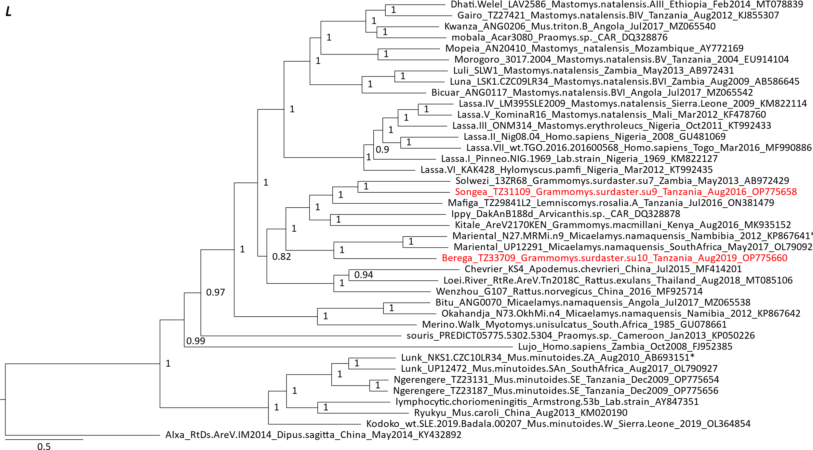
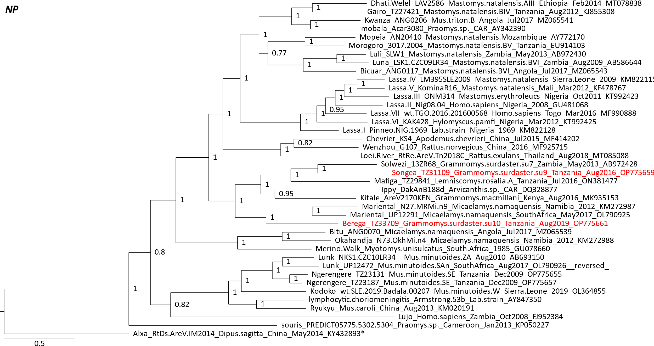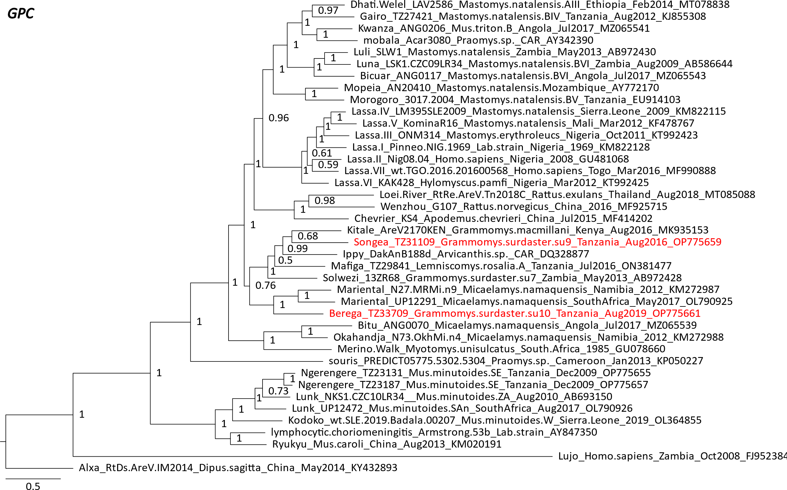

References
Bryja J, Šumbera R, Kerbis Peterhans JC, Aghová T, Bryjová A, Mikula O, Nicolas V, Denys C, Verheyen E (2017) Evolutionary history of the thicket rats (genus Grammomys) mirrors the evolution of African forests since late Miocene. J Biogeogr 44:182–194. https://doi.org/10.1111/jbi.12890

Cuypers LN, Čížková D, Goüy de Bellocq J (2022) Co-infection of mammarenaviruses in a wild mouse, Tanzania. Virus Evol 8:veac065. https://doi.org/10.1093/ve/veac065

Cuypers LN, Gryseels S, Van Houtte N, Baird SJE, Sabuni CA, Katakweba AS, van den Burg SRM, Bryja J, Leirs H, Goüy de Bellocq J (2023) Subspecific rodent taxa as the relevant host taxonomic level for mammarenavirus host specificity. Virology 581:116-127 https://doi.org/10.1016/j.virol.2023.02.014

Musser GG, Carleton MD (2005) Superfamily Muroidea. In: Wilson DE, Reeder DM (eds) Mammal species of the world: a taxonomic and geographic reference, Johns Hopkins University Press, Baltimore, pp 894–1531

Radoshitzky SR, Buchmeier MJ, Charrel RN, Clegg JCS, Gonzalez JJ, Günther S, Hepojoki J, Kuhn JH, Lukashevich IS, Romanowski V, Salvato MS, Sironi M, Stenglein MD, de la Torre JC, ICTV Report Consortium (2019) ICTV Virus Taxonomy Profile: Arenaviridae. J Gen Virol 100:1200-1201. https://doi.org/10.1099/jgv.0.001280

Těšíková J, Krásová J, Goüy de Bellocq J (2021) Multiple Mammarenaviruses Circulating in Angolan Rodents. Viruses 13:982. https://doi.org/10.3390/v13060982

