Part 1: TITLE, AUTHORS, APPROVALS, etc

Code assigned: | 2023.013M
Short title: Create one new species in genus Mammarenavirus (Bunyavirales: Arenaviridae)
Author(s) and email address(es)
Cuypers LN, Goüy de Bellocq J | lauracuypers@outlook.be; joellegouy@gmail.com
Author(s) institutional address(es) (optional)
University of Antwerp, Antwerp, Belgium [LNC]; Institute of Vertebrate Biology of the Czech Academy of Sciences, Brno, Czech Republic [JGB]
Corresponding author
Cuypers LN
List the ICTV Study Group(s) that have seen this proposal
ICTV Arenaviridae Study Group
ICTV Study Group comments and response of proposer
ICTV Study Group votes on proposal
Study Group | Number of members
 | Votes support | Votes against | No vote
ICTV Arenaviridae Study Group | 13 | 0 | 0
Authority to use the name of a living person
Is any taxon name used here derived from that of a living person (Y/N) | N

Taxon name | Person from whom the name is derived | Permission attached (Y/N)
N/A | N/A | N/A

Submission dates
Date first submitted to SC Chair | June 23, 2023
Date of this revision (if different to above)
ICTV-EC comments and response of the proposer
Part 2: NON-TAXONOMIC PROPOSAL
N/A

Part 3: TAXONOMIC PROPOSAL
Name of accompanying Excel module
2023.013M.N.v1.Mammarenavirus_1nsp
Abstract
We propose the establishment of one new species in arenavirid genus Mammarenavirus to accommodate Mafiga virus discovered in single-striped lemniscomys in Tanzania.
Text of proposal
A distinct mammarenavirus was detected in single-striped lemniscomys (murid Lemniscomys rosalia (Thomas, 1904) first in Mafiga, Morogoro and then in Komtema, Tanga, in Tanzania (Goüy de Bellocq et al. (2010); Cuypers et al. (2022)). Metagenomic sequencing revealed a complete, single S segment, but two complete, distinct L segments. The TZ29841 L segments are 87% identical to each other and 82-83% identical to the ‘Lemniscomys/F4-8/TZA/2008’ fragment, indicating they all belong to the same mammarenavirus species. This virus, named Mafiga virus (MAFV), is hosted by single-striped lemniscomys, not known to host any other mammarenavirus (demarcation criterion: association of the virus with a distinct main host or group of sympatric hosts). PAirwise Sequence Comparison (PASC) analysis (https://www.ncbi.nlm.nih.gov/sutils/pasc/viridty.cgi) reveals that the TZ29841 segments share 70% nucleotide sequence identity for S (demarcation criterion: < 80%) and 61% for both L segments (demarcation criterion: <76%) with Solwezi virus. NP amino acid sequence identity shared with Solwezi virus is 79% (demarcation criterion: < 88%). MAFV therefore meets the ICTV requirements to be assigned to a new mammarenavirus species.

Supporting evidence
Figure 1 (adapted from Figure 2 from Cuypers et al., 2022): L, NP, and GPC gene phylogenetic trees. The trees were inferred with MrBayes v3.2.7a with codon partitioning and a GTR+G nucleotide substitution model. In two independent runs four chains ran for 10,000,000 generations with a burn-in of 25%. Average standard deviations of split frequencies were examined for convergence, as were parameter effective sample sizes and trace patterns in Tracer (https://beast.community/tracer). Trees were visualized in FigTree (http://tree.bio.ed.ac.uk/software/figtree/). The scale bars indicate 0.5 nt substitutions per site. Numbers at the nodes represent posterior probability.
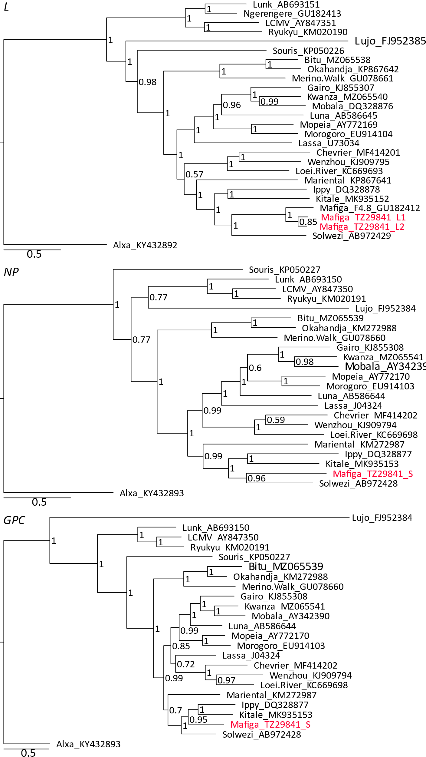
Figure 2 (adapted from S2 from Cuypers et al., 2022): PASC figures. PASC (PAirwise Sequence Alignment) webtool histogram of pre-computed pairwise identities of known arenavirus sequences. The best hit for the three Mafiga virus segments was Solwezi virus (S: NC_038367/AB972428; L: NC_038366/AB972429), those pairwise identities are marked by a red stripe on the x-axis.

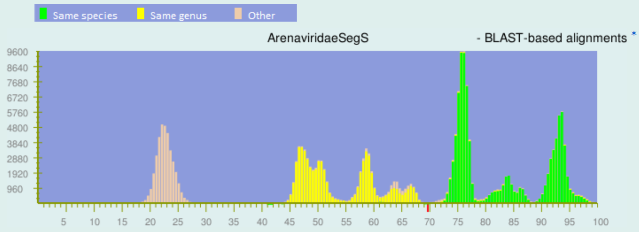
S
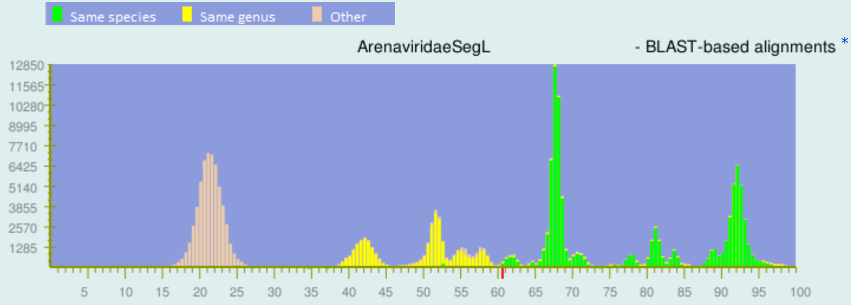
L1
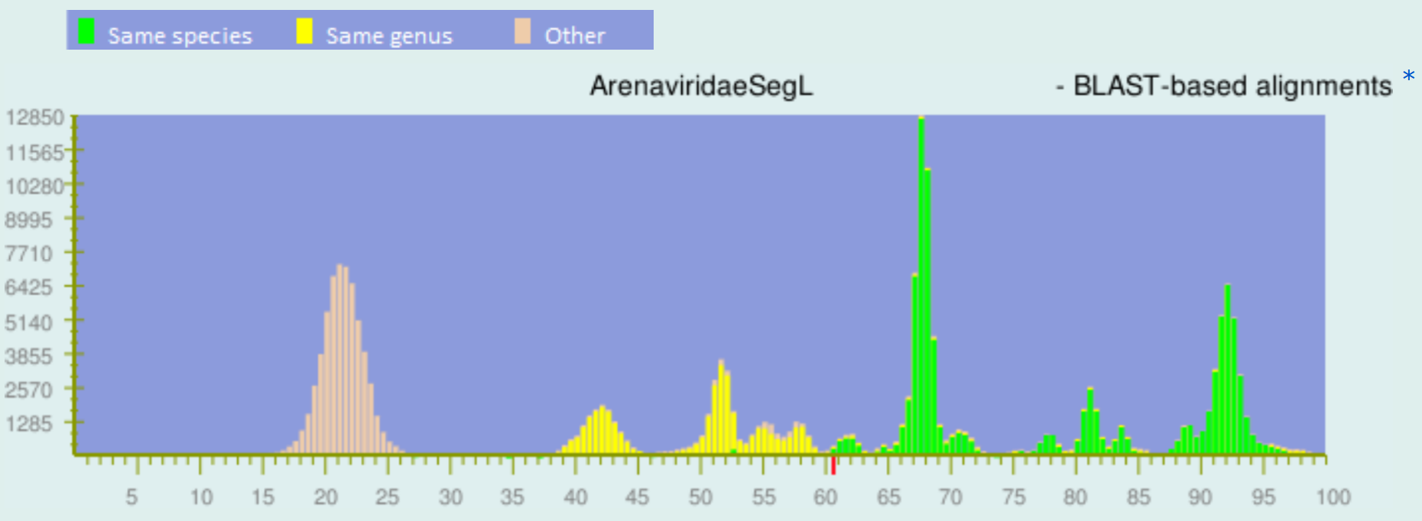
L2

References
Cuypers LN, Čížková D, Goüy de Bellocq J (2022) Co-infection of mammarenaviruses in a wild mouse, Tanzania. Virus Evol. 8, veac065. doi: 10.1093/ve/veac065

Goüy de Bellocq J, Borremans B, Katakweba A, Makundi R, Baird SJE, Becker-Ziaja B, Günther S, Leirs H (2010) Sympatric Occurrence of 3 Arenaviruses, Tanzania. Emerg. Infect. Dis. 16, 692-695. doi: 10.3201/eid1604.091721 PMID: 20350390

Radoshitzky SR, Buchmeier MJ, Charrel RN, Clegg JCS, Gonzalez JJ, Günther S, Hepojoki J, Kuhn JH, Lukashevich IS, Romanowski V, Salvato MS, Sironi M, Stenglein MD, de la Torre JC & ICTV Report Consortium (2019) ICTV Virus Taxonomy Profile: Arenaviridae. J Gen Virol 100, 1200-1201. doi: 10.1099/jgv.0.001280 PMID: 31192784

