Part 1: TITLE, AUTHORS, APPROVALS, etc

Code assigned: | 2023.019M
Short title: Create a new species in a new genus in the family Phenuiviridae and move a species into the new genus
Author(s) and email address(es)
Ayllon MA, Navarro B, Ruiz-Padilla A, Nicoloso VM, Di Serio F | vittorio.nicoloso@ipsp.cnr.it; ana.ruizp@upm.es; francesco.diserio@ipsp.cnr.it; beatriz.navarro@ipsp.cnr.it; mariaangeles.ayllon@upm.es
Author(s) institutional address(es) (optional)
Istituto per la Protezione Sostenibile delle Piante, CNR, Italy [BN; VMN; FDS]
Centro de Biotecnología y Genómica de Plantas, Universidad Politécnica de Madrid (UPM)-Instituto Nacional de Investigación y Tecnología Agraria y Alimentaria (INIA/CSIC), Spain [MAA; AR-P]
Departamento de Biotecnología-Biología Vegetal, Escuela Técnica Superior de Ingeniería Agronómica, Alimentaria y de Biosistemas, Universidad Politécnica de Madrid (UPM), Spain [MAA]
Corresponding author
Francesco Di Serio
List the ICTV Study Group(s) that have seen this proposal
ICTV Phenuiviridae Study Group
ICTV Study Group comments and response of proposer
ICTV Study Group votes on proposal
Study Group | Number of members
 | Votes support | Votes against | No vote
ICTV Phenuiviridae Study Group | 9 | 0 | 0
Authority to use the name of a living person
Is any taxon name used here derived from that of a living person (Y/N) | N

Taxon name | Person from whom the name is derived | Permission attached (Y/N)
N/A | N/A | N/A

Submission dates
Date first submitted to SC Chair | June 23, 2023
Date of this revision (if different to above)
ICTV-EC comments and response of the proposer

Part 2: NON-TAXONOMIC PROPOSAL
Text of proposal
N/A

Part 3: TAXONOMIC PROPOSAL
Name of accompanying Excel module
2023.019M.N.v1.Phenuiviridae_1ng_1nsp_1spmr.xlsx
Abstract
Botrytis cinerea bocivirus 1 (BcBV1) is a new virus identified during a metatranscriptomics study of the virome of a necrotrophic fungus (sclerotiniaceaen Botrytis cinerea Pers. (1794)). Here we propose to create a new genus, Bocivirus, including a new species in the family Phenuiviridae to classify this virus. Moreover, we propose to move and rename a current coguvirus species into this genus.
Text of proposal
Botrytis cinerea bocivirus 1 (BcBV1) is a new virus during a metatranscriptomics study of the virome of a necrotrophic fungus (sclerotiniaceaen Botrytis cinerea Pers. (1794)) (Ruiz-Padilla et al. 2021). BvBV1 is a negative-sense RNA virus with a trisegmented genome.
The trisegmented nature of BcBV1 genome was confirmed by the identification of 5’ and 3’ termini of each segment that, as expected, have almost identical sequences. The 5’ and 3’ termini of each RNA segment are complementary, thus forming a panhandle structure (Fig. 1) likely involved in replication, as reported for other members of the order Bunyavirales.
BcBV1 RNA1 (6,743 nt, GenBank #MN617081) encodes a putative protein of 2,211 amino acids (aa) that, based on Blastp analysis, shares the highest sequence identity values with viruses in bunyaviral family Phenuiviridae, including grapevine associated cogu-like virus 1 (GaCLV1) (99% query cover, 44.05% aa sequence identity). The RNA-directed RNA polymerase (RdRp) of BcBV1 contains the typical six motifs (premotif A, motifs A–E) that are highly conserved in the RdRps of members of the order Bunyavirales. RNA 2 (1,653 nt, MN617080) encodes a putative protein of 470 aa with 56.43% sequence identity (92% query cover) with a protein encoded by grapevine associated cogu-like virus 2 (GaCLV2). RNA3 (1,293 nt, MN617079) encodes a putative capsid protein of 356 aa sharing the highest sequence identity (41.69% aa sequence identity, 96% query cover) with the N protein encoded by grapevine associated cogu-like virus 1.
Both grapevine associated GaCLV1 and 2 have a tripartite genome (Chiapello et al. 2020). They are currently classified in phenuivirid genera Coguvirus and Laulavirus, respectively (species Coguvirus viticulum and Lulavirus alphaviticulum).

The demarcation criteria for coguvirus and laulavirus species have been established as less than 95% identity in the aa sequence of the RdRp. Since BcBV1 RdRp has an aa sequence identity below this limit with all members of these genera (Fig. 2), we propose to classify this virus as a member of a novel virus species.

A maximum likelihood phylogenetic tree was generated using amino acid (aa) sequences of the putative RdRp encoded by BcBV1, GaCLV1, and representative members of the genera of the Phenuiviridae family. In this tree, BcBV1 clusters in a clade together with GaCLV1 and separately from all the other known coguviruses (Fig. 3). The high bootstrap values in the phylogenetic tree strongly support the conclusion that BcBV1 and GaCLV1 are more closely related to each other than to the other members of the genus Coguvirus. Interestingly, while all known coguviruses have bisegmented genomes, composed of one negative-sense RNA segment and one ambisense RNA segment, both BcBV1 and GaCLV1 have trisegmented genomes.

Based on the data reported above we propose to create, in the family Phenuiviridae, a new genus, Bocivirus, including two species: the new species Bocivirus botrytidis, here proposed to be created to classify the novel virus BcBV1 and the species Bocivirus viticulum here proposed to classify GaCLV1 (species moved and renamed from genus Coguvirus).

Origin of the name of the species: the genus name Bocivirus derives from the name of the fungus (Botrytis cinerea Pers. (1794)) in which BcBV1 has been identified. The species name botrytidis derives from the fungal genus name.

Supporting evidence

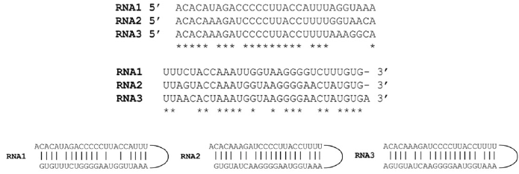

Figure 1. (A) Alignment of 5′ (left) and 3′ (right) termini of the genomic RNAs of Botrytis cinerea bocavirus 1 (BcBV1). Nucleotides conserved in all RNAs are denoted by an asterisk on the bottom.
(B) Panhandle structure formed by complementary termini of each BcBV1 genomic segment (Figure modified with permission from Ana Ruiz-Padilla et al., 2023).

Torzella virus 1 100.00
Brassica campestris chinensis-coguvirus 1 (UFE16634.1) 88.50 100.00
Watermelon crinkle leaf-associated virus 2 (ASY01343) 52.68 52.36 100.00
Yunnan Paris negative-stranded virus (QVU28732.1) 54.29 54.11 69.74 100.00
Edgeworthia chrysantha mosaic associated virus (ON602044) 54.57 53.93 70.41 74.88 100.00
Watermelon crinkle leaf-associated virus 1 (ASY01340.1) 55.43 55.02 59.51 60.71 60.06 100.00
Citrus concave gum-associated virus (YP 009422199.1) 55.52 55.20 58.30 59.82 59.41 62.64 100.00
Citrus virus A (AYN78568.1) 55.94 56.21 57.79 59.82 58.67 63.06 76.65 100.00
Grapevine associated cogu-like virus 1 (QIJ25704.1) 37.47 38.06 38.85 37.94 37.27 38.57 37.61 38.99 100.00
Botrytis cinerea bocivirus 1 (QJT73693.1) 38.99 39.17 38.71 38.97 38.22 38.86 38.73 38.50 44.18 100.00

Figure 2. Amino acid identity matrix (values in % of identity) of RdRp (panel A) and NP (panel B) proteins of ECMaV and all the current and proposed members of the genus Coguvirus

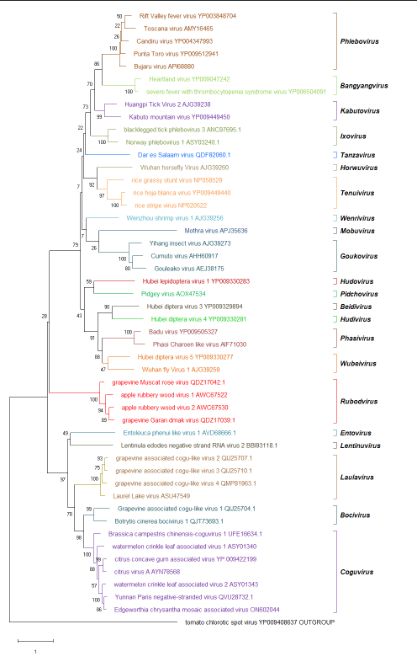

Figure 3 Phylogenetic tree of the RNA-directed RNA polymerase (RdRp) of Botrytis cinerea bocivirus 1, grapevine associated cogu-like virus 1, representative members of all phenuivirid genera, and tomato chlorotic spot virus (bunyaviral Tospoviridae) as the outgroup. Maximum likelihood method adopting the LG + G amino acid substitution model was used to infer the phylogenetic tree. Bootstrap probability values (1,000 replicates) are shown at branch nodes. Tree branches are proportional to the genetic distances, with the scale bar indicating substitutions per amino acid site.
References
Ruiz-Padilla A, Rodríguez-Romero J, Gómez-Cid I, Pacifico D, Ayllón MA. 2021. Novel mycoviruses discovered in the mycovirome of a necrotrophic fungus. mBio 12:e03705-20. https://doi.org/10.1128/mBio.03705-20

Chiapello M, Rodríguez-Romero J, Nerva L, Forgia M, Chitarra W, Ayllón MA, Turina M. 2020. Putative new plant viruses associated with Plasmopara viticola-infected grapevine samples. Ann Appl Biol 176:180–191.

