Part 1: TITLE, AUTHORS, APPROVALS, etc

Code assigned: | 2023.007M
Short title: Crate a new species in the genus Coguvirus (Bunyavirales : Phenuiviridae)
Author(s) and email address(es)
Navarro B, Nicoloso VM, Di Serio F | beatriz.navarro@ipsp.cnr.it; vittorio.nicoloso@ipsp.cnr.it; francesco.diserio@ipsp.cnr.it
Author(s) institutional address(es) (optional)
Istituto per la Protezione Sostenibile delle Piante, CNR, Italy [BN, VMN, FDS]
Corresponding author
Francesco Di Serio
List the ICTV Study Group(s) that have seen this proposal
ICTV Phenuiviridae Study Group
ICTV Study Group comments and response of proposer
ICTV Study Group votes on proposal
Study Group | Number of members
 | Votes support | Votes against | No vote
ICTV Phenuiviridae Study Group | 9 | 0 | 0
Authority to use the name of a living person
Is any taxon name used here derived from that of a living person (Y/N) | N

Taxon name | Person from whom the name is derived | Permission attached (Y/N)
N/A | N/A | N/A

Submission dates
Date first submitted to SC Chair | June 23, 023
Date of this revision (if different to above)
ICTV-EC comments and response of the proposer

Part 2: NON-TAXONOMIC PROPOSAL
Text of proposal

Part 3: TAXONOMIC PROPOSAL
Name of accompanying Excel module
2023.007M.N.v1.Coguvirus_1nsp.xlsx
Abstract
Edgeworthia chrysantha mosaic-associated virus (ECMaV) fulfils the criteria established by the International Committee on Taxonomy of Viruses Phenuiviridae Study Group to be classified as representative member of a new species in the phenuivirid genus Coguvirus. The name Coguvirus chrysanthae is proposed for such a species.
Text of proposal
Edgeworthia chrysantha mosaic-associated virus (ECMaV) has been recently identified in China as a novel virus infecting thymelaeaceaen Edgeworthia chrysantha Lindl (Wang et al., 2022). It is a negative-sense RNA virus with a bisegmented genome: the negative-sense RNA1 encodes the putative RNA-directed RNA polymerase (RdRp), whereas the ambisense RNA2 encodes for putative movement (MP) and nucleocapsid (NP) proteins. This genomic organization is similar to that reported previously for members of phenuivirid genus Coguvirus. The 5’ and 3’ terminal sequences (approximately 20 nucleotides) of each genomic RNA of ECMaV are complementary (Fig. 1), thus allowing the formation of panhandle structures (Fig. 2) typical of all members of order Bunyavirales and likely required for viral replication (Navarro et al., 2018a; Wang et al., 2022). In addition, the 5’ and 3’ termini of the ECMaV genomic RNA1 and RNA2 consist of the nucleotide sequences ACACA and UGUGU at the 5’ and 3’ termini, respectively (Fig. 1), which are conserved in all members of bunyaviral family Phenuiviridae (Tang et al., 2021). The RdRP of ECMaV contains the typical six motifs (premotif A, motifs A–E) that are highly conserved in the RdRps of members of the order Bunyavirales (Xin et al., 2017; Chen et al. 2021) (Fig. 3). This protein has amino acid (aa) identity ranging from 37.58 % to 74.88 % with the RdRps of classified coguviruses, with the highest identity value obtained with the RdRp encoded by Yúnnán Paris negative-stranded virus (Fig. 4A).

The amino acid (aa) sequence identities of the putative N protein with those of classified coguviruses ranges from 25.37% to 65.80 %, with the highest identity value obtained with the N protein encoded by Yúnnán Paris negative-stranded virus (Fig. 4B).

A maximum likelihood phylogenetic tree was generated using amino acid sequences of the putative RdRp encoded by ECMaV and representative members of all the genera of the Phenuiviridae family. In such a tree, ECMaV clusters with coguviruses (Fig. 5). The high bootstrap values in the phylogenetic tree strongly support the classification of ECMaV in the genus Coguvirus.

The demarcation criterion for the species of the genus Coguvirus has been established as less than 95% identity in the aa sequence of the RdRp (ratified taxonomic proposal 2019.026M.A.v1). Since ECMaV RdRp has an aa sequence identity ranging from 37.58% to 74.88 %, with the other members of the genus Coguvirus, we propose to classify ECMaV as a member of a novel species, named Coguvirus chrysantae.

Origin of the name of the species: chrysantae derives from the name of the plant species (Edgeworthia chrysanta) in which the virus has been identified for the first time.

Supporting evidence

5’ 3’
ECMaV-RNA1 ACACAAAGACUCUCAAACAUU....UGUGUUUGAGAUCUUUGUGU
ECMaV-RNA2 ACACAAAGAUCUCUCAACACU....ACGUUGAGAGAUCUGUGUGU
BCCoV1-RNA1 ACACAAAGACUCCCCAACUUU....AAGUUUGGGGAUCUUUGUGU
BCCoV1-RNA2 ACACAAAGA-UCCCCCUGUUU....AAGCAAGGGGGUCUUUGUGU
CCGaV-RNA1 ACACAAAGACUCCCAAACUUU....AUAGUUUGGGAUCUGUGUGU
CCGaV-RNA2 ACACAAAGA-UCCCAUAACUU....AAGUUAUGGGUUCUAUGUGU
CiVA-RNA1 ACACAAAGACUCCCAAACUUU....AAAGUUUGGGAUCUGUGUGU
CiVA-RNA2 ACACAUAGA-UCCCAUAAUUU....AAGUUAUGGGUUCUAUGUGU
WCLaV-1-RNA1 ACACAAAGACUCCCGUACUUC....UUAAUACGGGAUCUAUGUGU
WCLaV-1-RNA2 ACACAUAGA-ACCCAUAAACU....AGUUAAUGGGAUCUUUGUGU
WCLaV-2-RNA1 ACACAAAGACUCUCAAACACU....UGUGUUUGAGAUCUUUGUGU
WCLaV-2-RNA2 ACACAAAGAUCUCUCAACACA....AGUUGAAGAGAUCUGUGUGU
YPNSV-RNA1 CUCAAACACU--....UUUU-UUCAGUAAAC-GUGGU
YPNSV-RNA2 CUCAA-CACUUU....AAUAGUUGAGAGAUCUGUG-

Figure 1. Multiple alignment of 5′ (left) and 3′ (right) termini of the genomic RNAs of ECMaV and those of members of the genus Coguvirus. The conserved nucleotides in all members of the family Phenuiviridae are shown in bold. The terminal sequences of YPNSV reported in NCBI are likely incomplete.

ECMaV-RNA1 5’
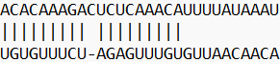
3’

ECMaV-RNA2 5’
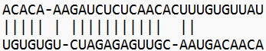
3’

Figure 2. Panhandle structures formed by the 5′ and 3′ termini of ECMaV RNA1 and RNA2.

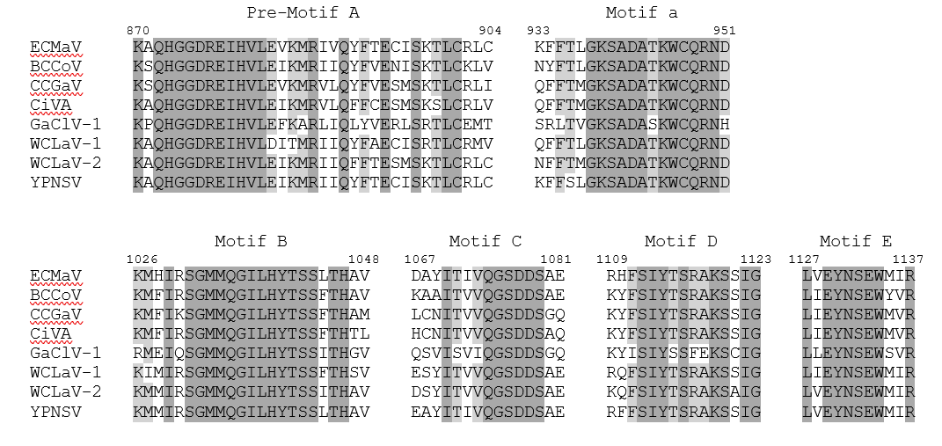
Figure 3. Conserved motifs in the RdRps typical of members of the order Bunyavirales

A
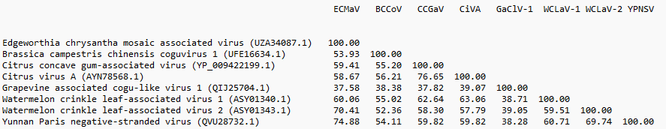
B
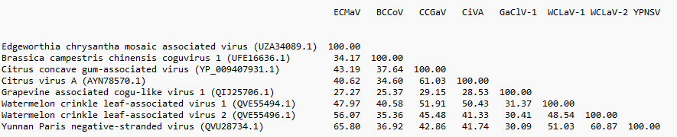

Figure 4. Amino acid identity (%) matrix of RdRp (panel A) and NP (panel B) proteins of ECMaV and all the current and proposed members of the genus Coguvirus.

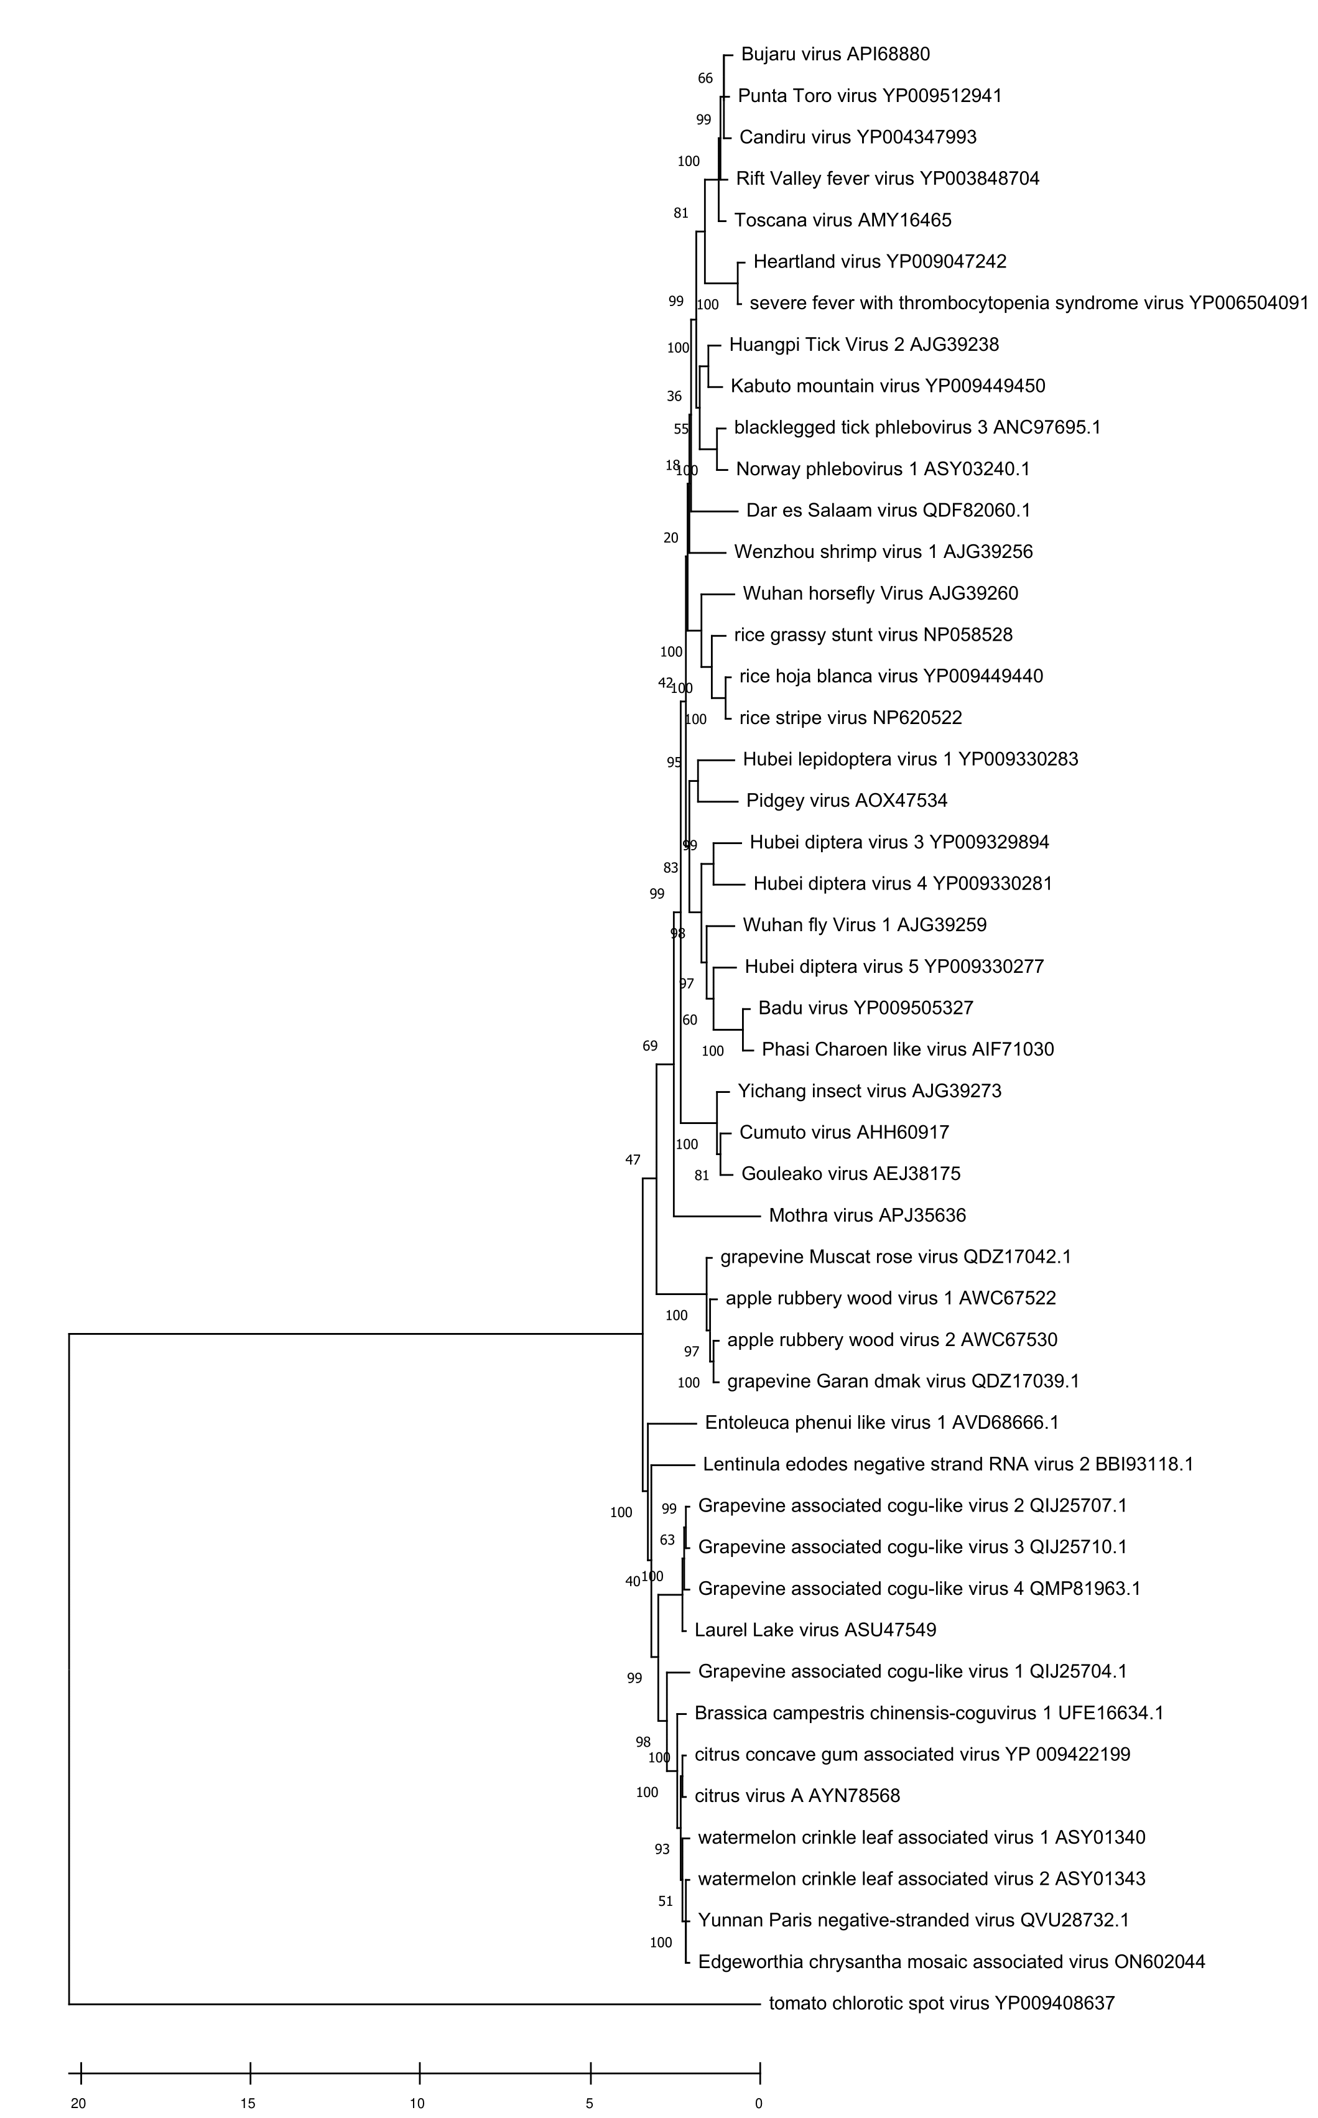

Figure 5. Phylogenetic tree of the RNA-directed RNA polymerase (RdRp) of ECMaV, representative members of all the genera of the family Phenuiviridae, and tomato chlorotic spot virus (bunyaviral Tospoviridae) as the outgroup. Maximum likelihood method adopting the LG + G + F amino acid substitution model was used to infer the phylogenetic tree. Bootstrap probability values (1,000 replicates) are shown at branch nodes. Tree branches are proportional to the genetic distances, with the scale bar indicating substitutions per amino acid site.

References
Chen Z, Anane RF., Wang Z, Gao L, Chen L, Li S, Wen G, Zhao M. (2021) Complete genome sequence analysis of a novel coguvirus isolated from Paris polyphylla var. yunnanensis. Arch Virol 166:2045–2050. https://doi.org/10.1007/s00705-021-05087-x

Tang L, Song L, Ye Z, Lin C, Wang B, Lin J, Gao C, Wang A. (2021) A novel negative-stranded RNA virus of the order Bunyavirales identified in Brassica campestris L. ssp. chinensis. Arch Virol 166:1525–1528. https://doi.org/10.1007/s00705-021-05031-z

Navarro B, Minutolo M, De Stradis A, Palmisano F, Alioto D, Di Serio F. (2018a) The first phlebo‐like virus infecting plants: a case study on the adaptation of negative‐stranded RNA viruses to new hosts. Mol Plant Pathol 19:1075–1089. doi: 10.1111/mpp.12587

Navarro B, Zicca S, Minutolo M, Saponari M, Alioto D, Di Serio F. (2018b) A negative-stranded RNA virus infecting citrus trees: the second member of a new genus within the order Bunyavirales. Front Microbiol 9:2340. doi: 10.3389/fmicb.2018.02340.

Wang X, Liao R, Yang X, Liu Q, Zhang S, Cao M. (2022) Complete genome sequence of Edgeworthia chrysantha mosaic-associated virus, a tentative new member of the genus Coguvirus (family Phenuiviridae). Arch Virol. 167:2827-2831. doi: 10.1007/s00705-022-05608-2.

Xin M, Cao M, Liu W, Ren Y, Zhou X, Wang X. (2017) Two negative-strand RNA viruses identified in watermelon represent a novel clade in the order Bunyavirales. Front Microbiol 8:1514. doi: 10.3389/fmicb.2017.01514.

Zhang S, Tian X, Navarro B, Di Serio F, Cao M. (2021) Watermelon crinkle leaf-associated virus 1 and watermelon crinkle leaf-associated virus 2 have a bipartite genome with molecular signatures typical of the members of the genus Coguvirus (family Phenuiviridae). Arch Virol. 166:2829-2834. doi: 10.1007/s00705-021-05181-0.

