Part 1: TITLE, AUTHORS, APPROVALS, etc

Code assigned: | 2023.012M
Short title: Create one new species for Kotalahti bat lyssavirus in the genus Lyssavirus (Mononegavirales: Rhabdoviridae)
Author(s) and email address(es)
Calvelage S, Müller T, Freuling CM, Höper D, Tammiranta N, Nokireki T, Gadd T | sten.calvelage@fli.de; Thomas.mueller@fli.de; conrad.freuling@fli.de; dirk.hoeper@fli.de; niina.tammiranta@ruokavirasto.fi; tiina.nokireki@ruokavirasto.fi; tuija.gadd@ruokavirasto.fi
Author(s) institutional address(es) (optional)
Friedrich-Loeffler-Institut; Institute of Diagnostic Virology, Germany (SC, DH)
Friedrich-Loeffler-Institut; Institute of Molecular Virology and Cell Biology, Germany (TM, CMF)
Finnish Food Authority, Research Department, Virology Unit, Finland (NT, TN, TG)
Corresponding author
Calvelage S
List the ICTV Study Group(s) that have seen this proposal
ICTV Rhabdoviridae Study Group
ICTV Study Group comments and response of proposer
Minor corrections; completed.
ICTV Study Group votes on proposal
Study Group | Number of members
 | Votes support | Votes against | No vote
ICTV Rhabdoviridae Study Group
Authority to use the name of a living person
Is any taxon name used here derived from that of a living person (Y/N) | N

Taxon name | Person from whom the name is derived | Permission attached (Y/N)
N/A | N/A | N/A

Submission dates
Date first submitted to SC Chair | June 23, 2023
Date of this revision (if different to above)
ICTV-EC comments and response of the proposer

Part 2: NON-TAXONOMIC PROPOSAL
N/A

Part 3: TAXONOMIC PROPOSAL
Name of accompanying Excel module
2023.012M.N.v1.Lyssavirus_1nsp.xlsx
Abstract
In 2017, a putative new lyssavirus named Kotalahti bat lyssavirus (KBLV) was detected in a Brandt´s bat (Myotis brandtii) that was found near the village Kotalahti, Finland [1]. Attempts to isolate the virus failed; however, next-generation sequencing yielded a nearly complete virus genome of 11,878 nt encompassing all five coding regions (GenBank accession LR994545) [2]. Alignments of the concatenated coding sequences of N+P+M+G+L show a clear segregation of KBLV from other lyssavirus species with the highest sequence identity of 79.96 % found between KBLV and KHUV. Furthermore, KBLV represents the first and, so far, sole lyssavirus reported to infect Myotis brandtii and therefore occupies its own niche by its host. Based on these results, the authors propose the classification of KBLV to a separate lyssavirus species as it fulfills the species demarcation criteria for the genus Lyssavirus. Following the new nomenclature, the authors suggest Lyssavirus kotalahti as species name and Kotalahti bat lyssavirus as virus name.
Text of proposal
To date, the genus Lyssavirus comprises 17 species that were classified by the International Committee on Taxonomy of Viruses (ICTV). In 2017, a tentative new member of the genus was reported by Nokireki et al.[1], who described a case of a deceased Brandt´s bat (Myotis brandtii) near the village Kotalahti, Finland. Initial diagnostic testing of sample material suggested a lyssavirus infection that was subsequently confirmed by successful Sanger sequencing of the N gene. As a result, a 1370 nt long sequence (MF960865) could be obtained that formed the basis for the initial assessment of the virus as related but yet unclassified lyssavirus by the ICTV. Phylogenetic analysis revealed the grouping of the new virus, named Kotalathi bat lyssavirus, with other lyssaviruses of the phylogroup I. Attempts to isolate the virus from the highly decomposed carcass failed and the remaining sample material was transferred to the FLI where next-generation sequencing in combination with a targeted virus sequence enrichment enabled us to obtain a nearly complete genome sequence with a length of 11,878 nt (LR994545) [2] with a presumed missing 6 nucleotide sequence at the 5’ untranslated region. With the use of reverse genetics, KBLV-G pseudotyped RABV was neutralized by sera with antibodies against RABV supporting the genetic classification as phylogroup I lyssavirus. A more detailed antigenic characterization of KBLV confirmed its close relationship to Phylogroup I lyssaviruses by utilizing a recombinant virus that assembled the KBLV G gene with a SAD B19 backbone. [3] Nonetheless, the assessment of the antigenic relationships via antigenic cartography also demonstrated that the recombinant virus was antigenically distinct from the other Phylogroup I lyssaviruses.
Based on this sequence and antigenic data, the classification of KBLV within the genus Lyssavirus enables the assessment of species demarcation criteria as stated by the ICTV:

Genetic distance
An alignment of the concatenated coding regions of all five KBLV genes with the concatenated coding regions of the reference sequences of the 17 classified lyssavirus species revealed the highest nucleotide sequence identity between KBLV and KHUV with 79.96%, followed by EBLV-2 (79.92%) and BBLV (79.20%, Table 1). A detailed comparison of available concatenated coding sequences of these lyssaviruses with KBLV identifies four out of 31 EBLV-2 sequences with a sequence identity above the demarcation threshold of 80% with 80.091% (KY688132), 80.081% (KY688133), 80.044% (KY688134) and 80.017 (KY688135), whereas identities of all other sequences are below this value. Considering the genetic diversity of viruses within the Lyssavirus helsinki species, a mean sequence identity of 79.73% can be observed while including all sequence identities of EBLV-2 sequences published at the time of submission, emphasizing that the genetic core of EBLV-2 does not interfere with the demarcation criteria for genetic distance. Consequently, the authors are convinced that KBLV meets the criteria of 80% nt identity between viruses assigned to designated lyssavirus species, while exceeding the demarcation criteria in comparison to a very small number of EBLV-2 sequences in the hundredths is truly negligible.

Phylogenetic relationship
Phylogenetic analyses of KBLV together with the 17 reference genomes of viruses assigned to the classified lyssavirus species were conducted and published before [2] (Figure 1 A) and showed the grouping of KBLV together with other lyssaviruses of phylogroup I. Moreover, KBLV clustered together with the three lyssaviruses that shared the highest sequence identity with it, i.e. KHUV, EBLV-2 and BBLV. A more detailed phylogenetic tree was constructed with focus on these closely related lyssaviruses by utilizing again the concatenated coding regions of all available complete genomes of EBLV-2, BBLV and KHUV (Figure 2). The resulting tree shows clear segregation of KBLV from sequences of other lyssaviruses and therefore does not represent a sister branch of a member of an already classified lyssavirus species, which is considered another characteristic feature of distinct lyssavirus species.

Ecological niche
Despite a comprehensive bat surveillance and epidemiological prevalence studies of lyssaviruses in Finnish bats [4], only one other lyssavirus, the European bat lyssavirus 2, was confirmed in cases of two Daubenton`s bats (Myotis daubentonii) [5, 6] and one fatal human rabies case [7]. More importantly, and to our best knowledge, no rabies cases in the Brandt´s bat (Myotis brandtii) caused by lyssaviruses other than KBLV were reported until today. This distinct host specificity of bat-related lyssaviruses is a well-documented phenomenon and KBLV adds another example of a putative lyssavirus species occupying ecological niches by infecting previously unscathed host species. However, as this is so far a single detection, the authors are aware that a cross-species transmission (CTS) event cannot be completely ruled out and hence, further investigations are necessary to confirm Myotis brandtii as reservoir host of KBLV. Nonetheless, the close genetic relation of KBLV to other lyssaviruses associated with distinct Myotis species (KHUV – Myotis mystacinus; EBLV-2 – Myotis daubentonii; BBLV- Myotis nattereri - see Figure 1 B) supports the hypothesis that KBLV occupies a unique ecological niche within the genus Myotis. Furthermore, the fact that CTS events of bat lyssaviruses from Eurasia are extremely rare in bats, except for EBLV-1 [8], and the probability of a novel lyssavirus being detected as a CTS event is extremely low makes it very likely that Myotis brandtii is indeed the reservoir host of KBLV.

Supporting evidence
Table 1) List of sequences used for the determination of sequence identities in relation to KBLV. For lyssavirus species with the highest sequence identity to KBLV (i.e. EBLV-2, BBLV and KHUV), all available complete genome sequences published in nucleotide databases by May 2023 were included in the analysis to increase the resolution of the comparison.
Lyssavirus species | Virus name | Abbreviation | Accession number reference sequence | Sequence length [nt] | Sequence identity to KBLV [%]*
Lyssavirus aravan | Aravan virus | ARAV | NC_020808.1 | 11918 | 77.44
Lyssavirus australis | Australian bat lyssavirus | ALBV | NC_003243.1 | 11822 | 74.67
Lyssavirus gannoruwa | Gannoruwa bat lyssavirus | GBLV | NC_031988.1 | 11919 | 76.58
Lyssavirus bokeloh | Bokeloh bat lyssavirus | BBLV | NC_025251.1  KC169985  KF245925  LT839617  LT839642  LT839643  LT839644  MF043188  MF197740  OU524416 | 11900  11830  11846  11900  11900  11901  11900  11900  11887  11896 | 79.20  79.00  79.30  79.14  79.20  79.14  79.17  78.93  79.12  79.21
Lyssavirus khujand | Khujand virus | KHUV | NC_025385.1 | 11903 | 79.96
Lyssavirus hamburg | European bat lyssavirus 1 | EBLV-1 | NC_009527.1 | 11966 | 75.02
Lyssavirus helsinki | European bat lyssavirus 2 | EBLV-2 | NC_009528.2  EU293114  JX129232  JX129233  KF155004  KY688132  KY688133  KY688134  KY688135  KY688136  KY688137  KY688138  KY688139  KY688140  KY688141  KY688142  KY688143  KY688144  KY688145  KY688146  KY688147  KY688148  KY688149  KY688150  KY688151  KY688152  KY688153  KY688154 | 11930  11924  11885  11886  11930  11932  11940  11930  11930  11930  11931  11929  11929  11929  11930  11930  11930  11929  11924  11924  11929  11929  11929  11932  11928  11924  11929  11928 | 79.92  79.79  79.94  79.93  79.86  80.09  80.08  80.04  80.01  79.85  79.89  79.98  79.89  79.97  79.83  79.80  79.78  79.86  79.82  79.84  79.86  79.89  79.93  79.84  79.93  79.86  79.93  79.97
Lyssavirus species | Virus name | Abbreviation | Accession number reference sequence | Sequence length [nt] | Sequence identity to KBLV [%]*
Lyssavirus helsinki | European bat lyssavirus 2 | EBLV-2 | MG760848  KY688155  KY688156 | 11929  11931  11930 | 79.88  79.92  79.91
Lyssavirus duvenhage | Duvenhage virus | DUUV | NC_020810.1 | 11976 | 73.60
Lyssavirus formosa | Taiwan bat lyssavirus | TWBLV | MF472710.1 | 11988 | 72.83
Lyssavirus irkut | Irkut virus | IRKV | NC_020809.1 | 11980 | 74.39
Lyssavirus shimoni | Shimoni bat lyssavirus | SHIBV | NC_025365.1 | 12045 | 68.20
Lyssavirus mokola | Mokola virus | MOKV | NC_006429.1 | 11940 | 68.00
Lyssavirus lleida | Lleida bat lyssavirus | LLEBV | NC_031955.1 | 11931 | 62.53
Lyssavirus caucasicus | West Caucasian bat virus | WCBV | NC_025377.1 | 12278 | 65.29
Lyssavirus lagos | Lagos bat lyssavirus | LBV | NC_020807.1 | 12016 | 68.05
Lyssavirus ikoma | Ikoma lyssavirus | IKOV | NC_018629.1 | 11902 | 63.15
Lyssavirus rabies | Rabies virus | RABV | NC_001542.1 | 11932 | 73.84
*based on concatenated coding regions of N+P+M+G+L

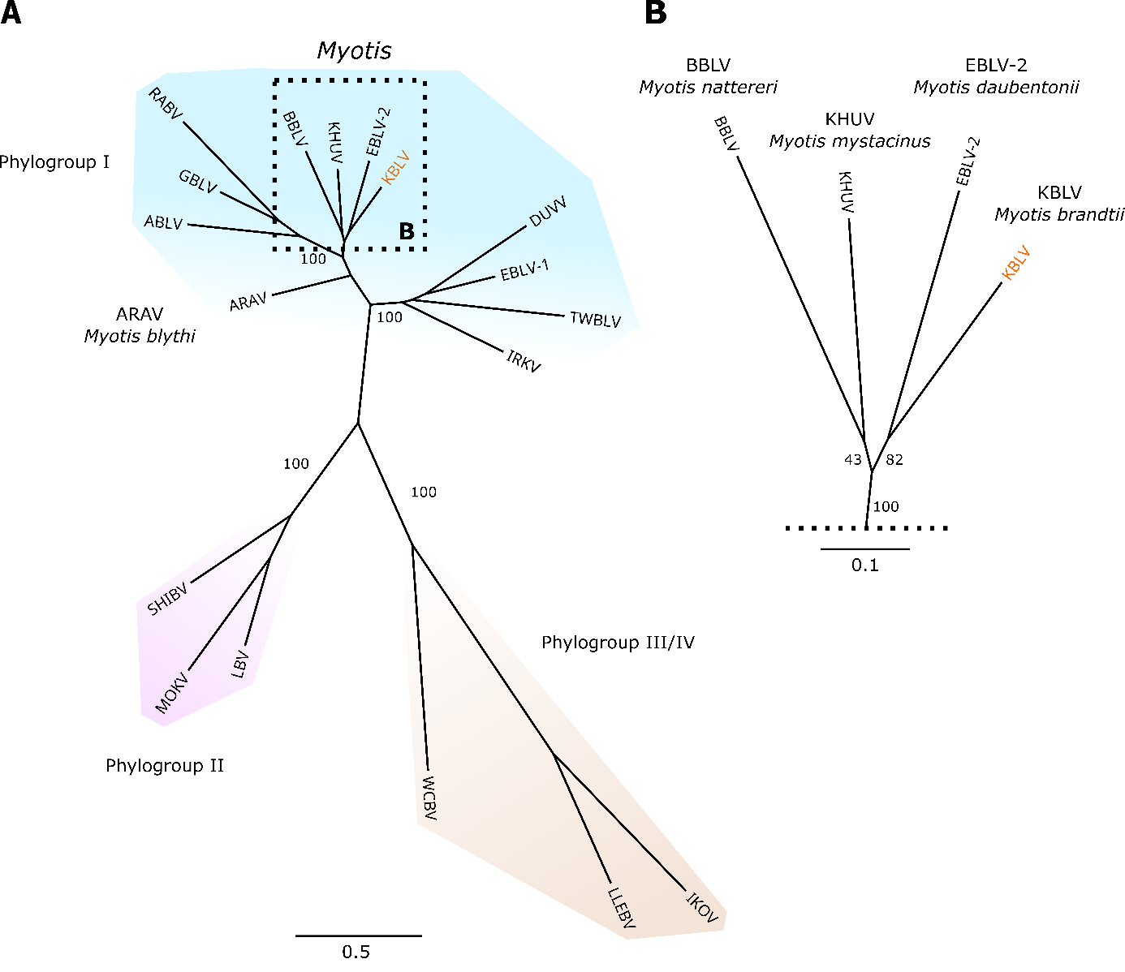
Figure 1) A Phylogenetic tree based on reference sequences of the 17 viruses classified to lyssavirus species and the obtained KBLV sequence. Members of the postulated 3 phylogroups are highlighted by color. B Phylogroup I cluster of lyssaviruses detected in Myotis species. Figure adapted from [2].
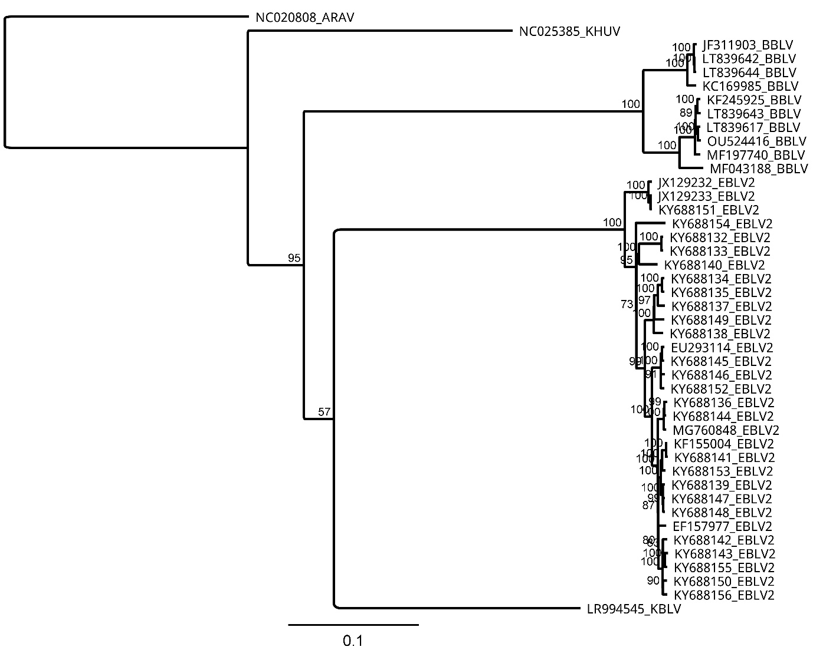
Figure 2) A maximum-likelihood phylogenetic tree of concatenated N+P+M+G+L including available EBLV-2, BBLV, KHUV and KBLV sequences was constructed under usage of the IQ-TREE software version 2.2.2.3 under usage of the ModelFinder feature (identified best-fit model: GTR+F+I+G4) and 100.000 ultrafast-bootstraps. The ARAV reference sequence (NC_020808.1) was used as outgroup.

References

1. Nokireki T, Tammiranta N, Kokkonen U-M et al. (2018) Tentative novel lyssavirus in a bat in Finland. Transbound Emerg Dis 65:593–596. https://doi.org/10.1111/tbed.12833
2. Calvelage S, Tammiranta N, Nokireki T et al. (2021) Genetic and Antigenetic Characterization of the Novel Kotalahti Bat Lyssavirus (KBLV). Viruses 13:69. https://doi.org/10.3390/v13010069
3. Shipley R, Wright E, Lean FZX et al. (2021) Assessing Rabies Vaccine Protection against a Novel Lyssavirus, Kotalahti Bat Lyssavirus. Viruses 13. https://doi.org/10.3390/v13050947.
4. Nokireki T, Huovilainen A, Lilley T et al. (2013) Bat rabies surveillance in Finland. BMC Vet Res 9:174. https://doi.org/10.1186/1746-6148-9-174
5. Jakava-Viljanen M, Lilley T, Kyheröinen E-M et al. (2010) First encounter of European bat lyssavirus type 2 (EBLV-2) in a bat in Finland. Epidemiol Infect 138:1581–1585. https://doi.org/10.1017/S0950268810000373
6. Nokireki T, Sironen T, Smura T et al. (2017) Second case of European bat lyssavirus type 2 detected in a Daubenton's bat in Finland. Acta Vet Scand 59:62. https://doi.org/10.1186/s13028-017-0331-y
7. Lumio J, Hillbom M, Roine R et al. (1986) HUMAN RABIES OF BAT ORIGIN IN EUROPE. The Lancet 327:378. https://doi.org/10.1016/S0140-6736(86)92336-6
8. Marston DA, Banyard AC, McElhinney LM et al. (2018) The lyssavirus host-specificity conundrum-rabies virus-the exception not the rule. Curr Opin Virol 28:68–73. https://doi.org/10.1016/j.coviro.2017.11.007

