

**Part 1:** **TITLE, AUTHORS, APPROVALS, etc**

|  |  |  |
| --- | --- | --- |
| **Code assigned:** | ***2023.006M*** |  |
| **Short title:** Create a new family *Konkoviridae* including one new genus *Olpivirus* (*Bunyavirales*) | | |
|  | | |

**Author(s) and email address(es)**

|  |  |
| --- | --- |
| Neriya Y, Morikawa T, Natsuaki T, Tomitaka Y, Di Serio F, Jonson GB, Rubino L, Sasaya T | [neriya@a.utsunomiya-u.ac.jp](mailto:neriya@a.utsunomiya-u.ac.jp); [toshiyuki.morikawa@pref.toyama.lg.jp](mailto:toshiyuki.morikawa@pref.toyama.lg.jp); [natsuaki@cc.utsunomiya-u.ac.jp](mailto:natsuaki@cc.utsunomiya-u.ac.jp); [yasut@affrc.go.jp](mailto:yasut@affrc.go.jp);  [francesco.diserio@ipsp.cnr.it](mailto:francesco.diserio@ipsp.cnr.it); [g.jonson@irri.org](mailto:g.jonson@irri.org);  [luisa.rubino@ipsp.cnr.it](mailto:luisa.rubino@ipsp.cnr.it);  [tsasaya@affrc.go.jp](mailto:tsasaya@affrc.go.jp); |

**Author(s) institutional address(es) (optional)**

|  |
| --- |
| Utsunomiya University, Japan [YN, TN]; Toyama Prefectural Agricultural, Forestry ＆ Fisheries Research Center, Japan [TM]; Institute for Plant Protection, NARO, Japan [YT, TS]; Istituto per la Protezione Sostenibile delle Piante, CNR, Italy [FDS, LR]; International Rice Research Institute, Philippines [GBJ] |

**Corresponding author**

|  |
| --- |
| Sasaya T |

**List the ICTV Study Group(s) that have seen this proposal**

|  |
| --- |
| ICTV *Phenuiviridae* Study Group |

**ICTV Study Group comments and response of proposer**

|  |
| --- |
|  |

**ICTV Study Group votes on proposal**

|  |  |  |  |
| --- | --- | --- | --- |
| **Study Group** | **Number of members** | | |
| **Votes support** | **Votes against** | **No vote** |
| ICTV *Phenuiviridae* Study Group | 9 | 0 | 0 |

**Authority to use the name of a living person**

|  |  |
| --- | --- |
| **Is any taxon name used here derived from that of a living person (Y/N)** | N |

|  |  |  |
| --- | --- | --- |
| **Taxon name** | **Person from whom the name is derived** | **Permission attached (Y/N)** |
|  |  |  |

**Submission dates**

|  |  |
| --- | --- |
| Date first submitted to SC Chair | June 23, 2023 |
| Date of this revision (if different to above) |  |

**ICTV-EC comments and response of the proposer**

|  |
| --- |
|  |

**Part 2:** **NON-TAXONOMIC PROPOSAL**

**Text of proposal**

|  |
| --- |
|  |

**Part 3:** **TAXONOMIC PROPOSAL**

**Name of accompanying Excel module**

|  |
| --- |
| 2023.006M.N.v1.Bunyavirales_1nfam_1ngen_1nsp.xlxs |

**Abstract**

|  |
| --- |
| On the base of biological properties and genomic data, such as RdRp-encoding sequences, we propose establishment of one new bunyaviral family, genus, and species to classify tulip streak virus (TuSV). |

**Text of proposal**

|  |  |
| --- | --- |
| |  | | --- | | **NEW FAMILY: *Konkoviridae***  A genomic sequence of a bi-segmented negative-sense bunyaviral-like RNA virus named tulip streak virus (TuSV) was obtained from tulips (liliaceaen *Tulipa gesneriana* L.) showing streaking symptoms. Two genome segments encode an RNA-directed RNA polymerase (RdRp) (RNA1), a nucleocapsid protein (NP; RNA2), and two proteins (p20 and p11; RNA2) of unknown function. Genome organization and phylogenetic analysis of the viral RdRp indicated that, albeit affinities to bunyavirals *sensu lato*, this virus cannot be assigned to established taxa in the order. For this reason, we propose to place TuSV in a new genus (*Olpivirus*) in a new family (*Konkoviridae*).  **Biology**  The streak disease of tulips was first observed in Toyama, Japan. The streaking symptoms appear as white-to-yellow elongated stripes along the leaf veins, with necrotic streaking or colour banding on petals (Fig.1 a and b). Virions have a thin filamentous shape 7–11 nm in diameter with lengths proportional to the lengths (300–1,600 nm) of the segmented genomic RNAs. The filamentous particles may appear to be spiral-shaped, branched or panhandle and no envelope has been observed (Fig. 1 c). TuSV is transmitted by soil-inhabitant fungi, olpidiaceaean *Olpidium virulentus (*synonym *O. brassicae)* (Fig. 1 d). Mechanical transmission using diseased-tulip sap extracts to benth (solanaceaen *Nicotiana benthamiana* Domin) and quinoa (amaranthaceaen *Chenopodium quinoa* Willd.) is possible [1, 2].  **Genome:**  The genomes of TuSV comprise two segments of negative-sense or ambisense RNA (Fig. 2). RNA1 (6,379 nt) is negative-sense and encodes a protein with a predicted molecular mass of 240 kDa that shares the bunyaviral RdRp domain. The amino acid identity value obtained with the RdRp of classified viruses in the order *Bunyavirales* is below 20%. RNA2 (1,110 nt) is ambisense and encodes a protein of 29.6 kDa on the viral complementary RNA (vcRNA) that shares the tenuivirus/phlebovirus N domain and two proteins of 20.3 kDa (p20) and 11.1 kDa (p11) on the viral RNA (vRNA) that do not possess any viral motifs or domains and is not identified any homologous proteins by the BLASTP analysis. The p20 and p11 proteins are encoded in overlapping reading frames and are presumably translated from the same virus-sense mRNA as the result of alternate AUG initiation codon usage. 3' and 5' RACE experiments were performed revealing that the two termini of the two genomic segments share a conserved motif (5'-ACACAAAGAAGAC-3') that enables panhandle pairing of the 5' and 3' ends of each genomic segment (Fig. 3 a, b). The eight nucleotides at both RNA ends were almost identical to the corresponding sequences of viruses in the families *Leishbuviridae*, *Discoviridae*, and *Phenuiviridae* (Fig. 3 c) [3].  **Phylogenetic relationships**:  The phylogenetic analysis and identity matrix based on an RdRp alignment with representatives of current bunyaviral families (Fig. 4), show that this virus belongs to a distinct lineage in the order and should be classified in a new species to be placed in a newly created genus (*Olpivirus*). The tree is currently ambiguous on whether this genus ought to be a member of *Leishbuviridae* or represent a new family. Because leishubuvirids have been exclusively found in protists, whereas TuSV is undoubtedly a plant virus, we propose to include *Olpivirus* in a new family, *Konkoviridae*.  We propose to classify TuSV as a member of a novel species, named *Olpivirus tulipae*.  Etymologies of newly proposed taxa: See Excel module. | |

**Supporting evidence**

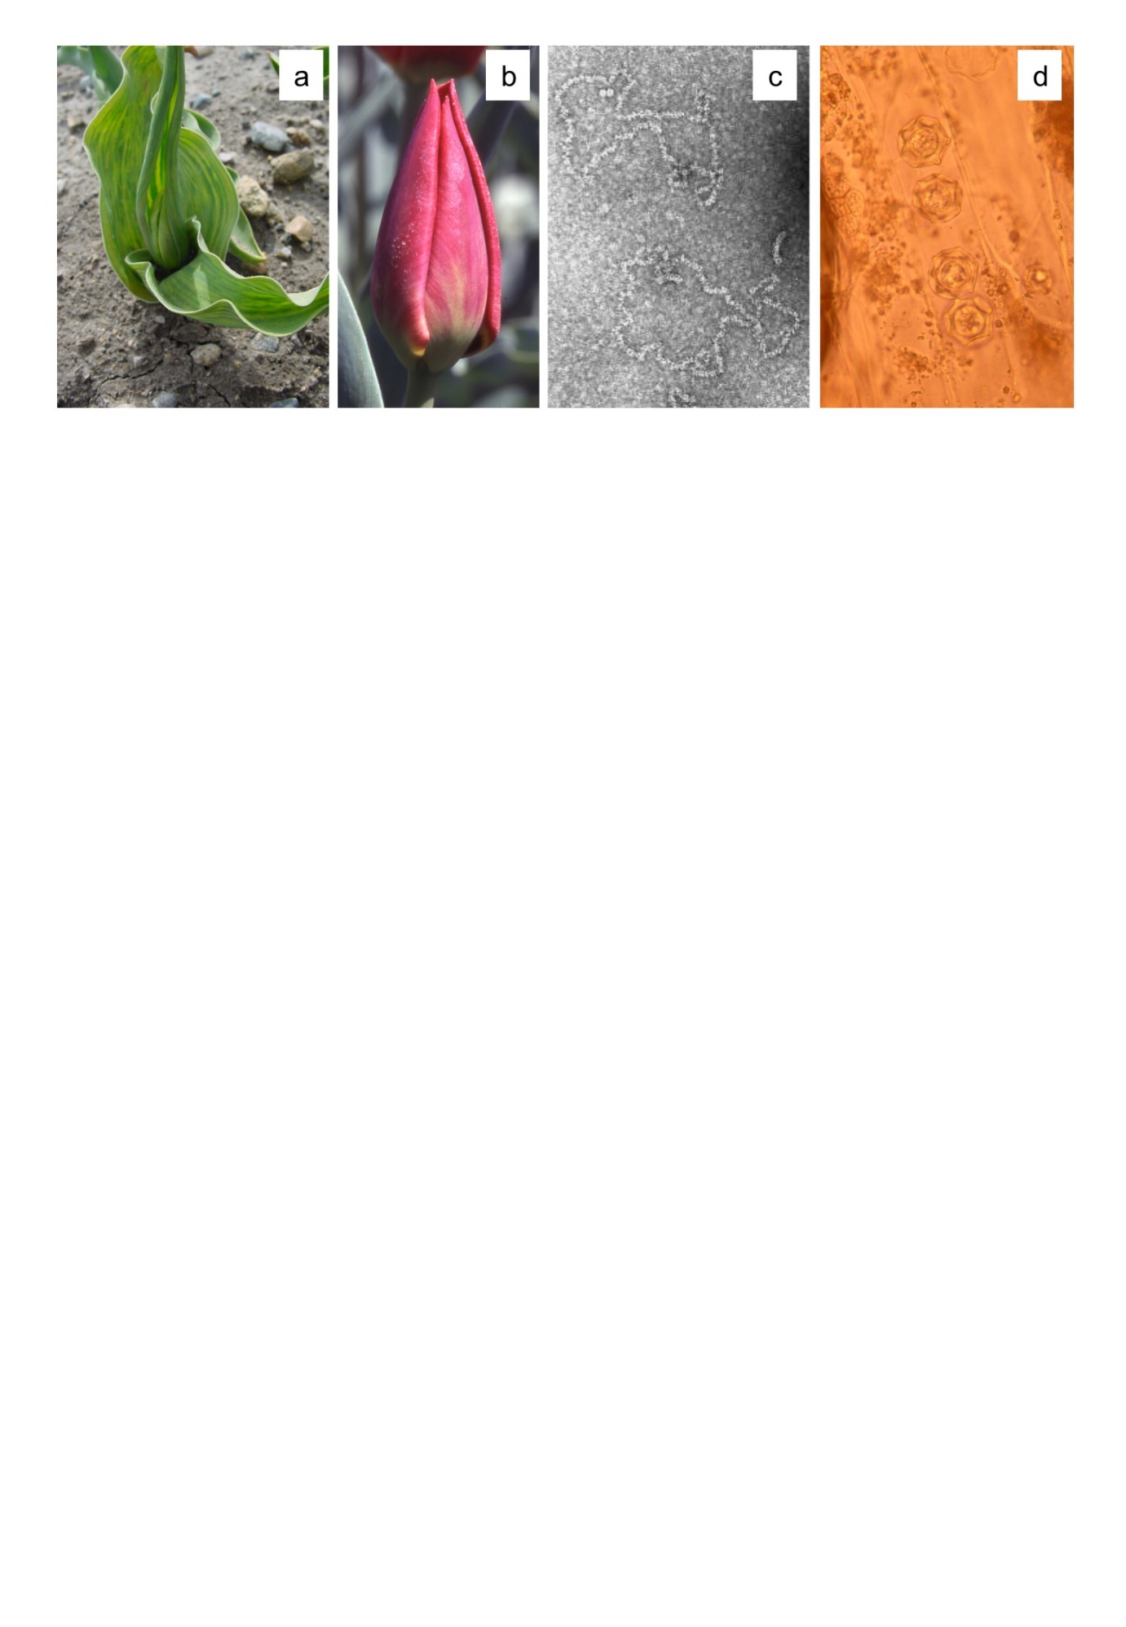

**Figure 1.** Tulip streak virus (TuSV)-infected tulip (a, b), virus particles (c), and virus fungal vectors (d).

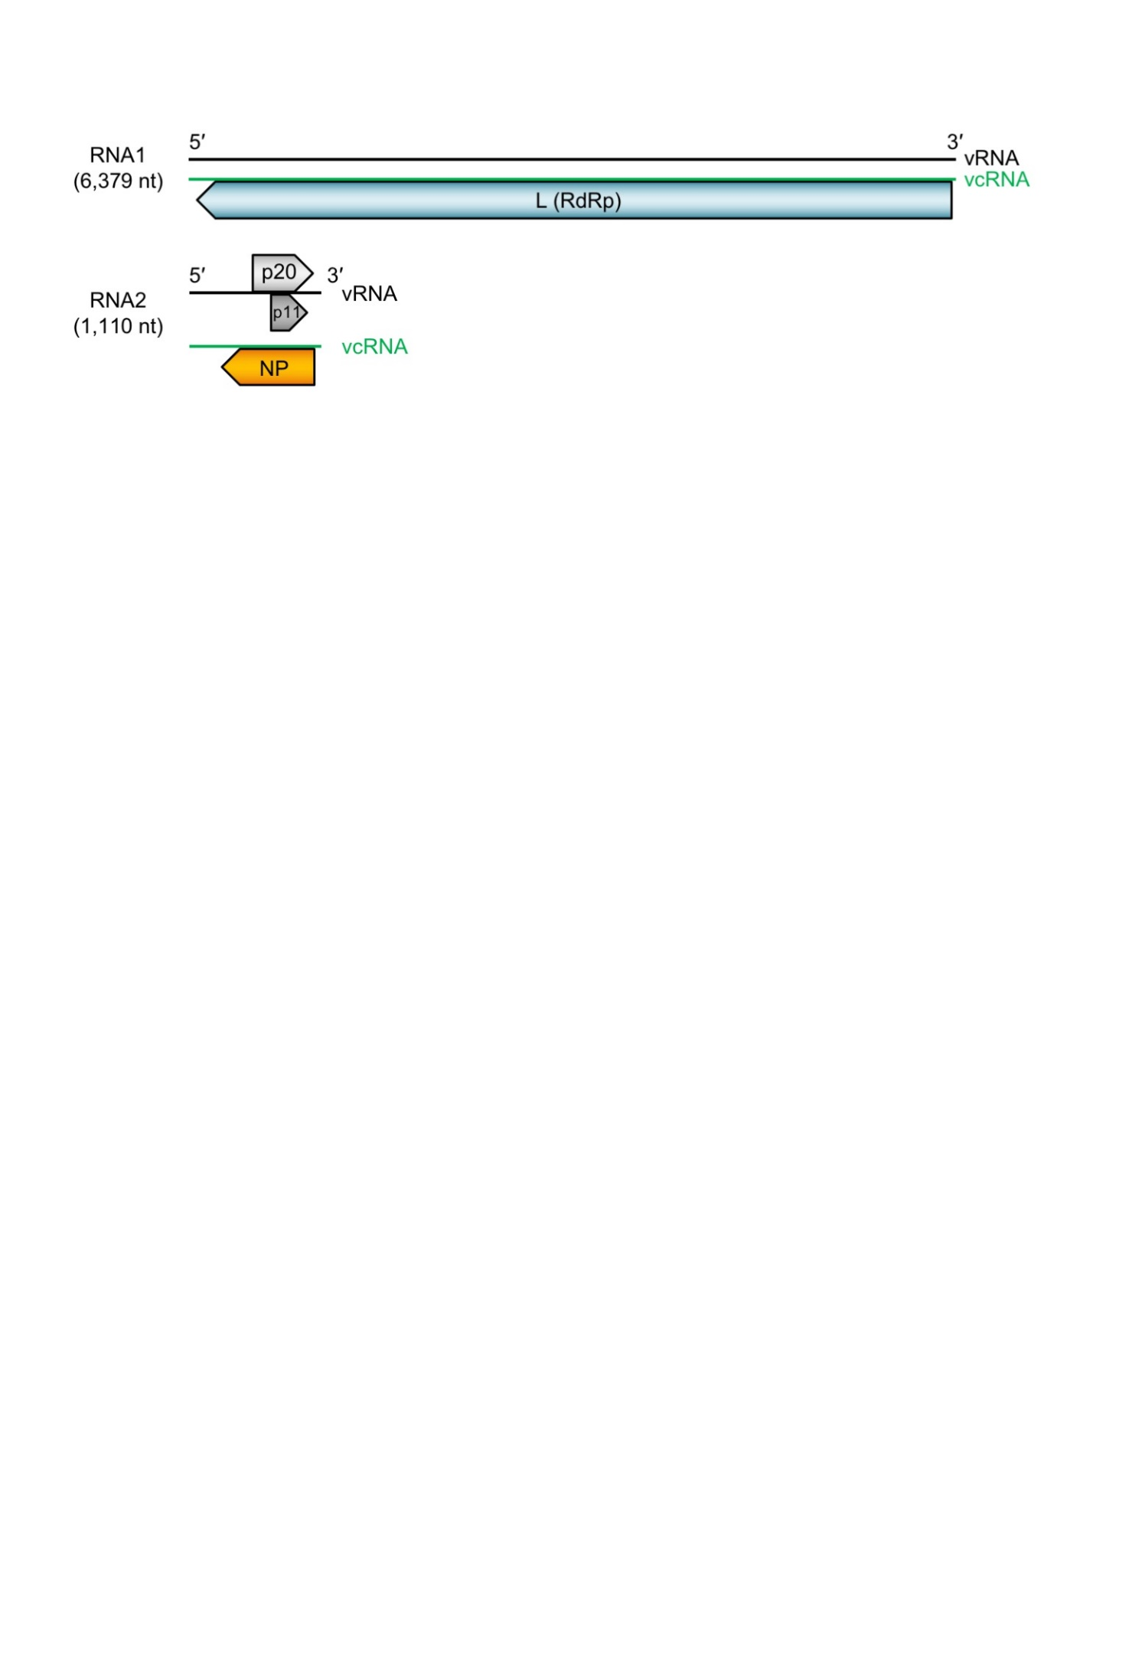

**Figure 2.** Structure of the TuSV genome structure. The vcRNAs are depicted in 3′→5′ direction and mRNAs are depicted in a 5′→3′ direction. Arrows on the mRNAs depict ORFs that encode structural proteins; NP, nucleocapsid protein; L (RdRp), putative large protein (RNA-directed RNA polymerase); p20, non-structural protein of 20.3 kDa; and p11, non-structural protein of 11.1 kDa.

**a**

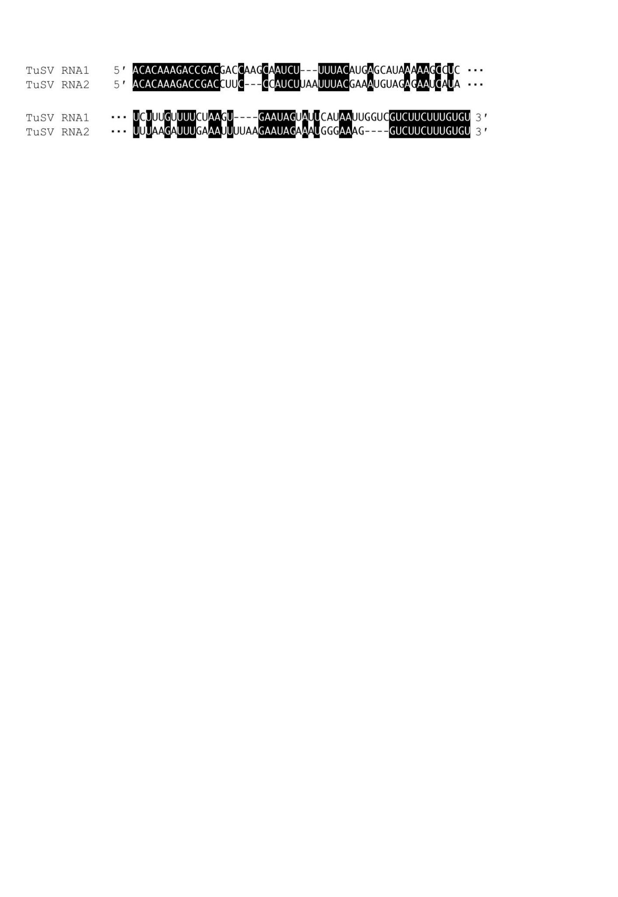

**b**



**C　 5’** 　　　 **3’**

TuSV RNA1 **ACACAAAGAAGAC**......**UCGGUCUUUGUGU**

TuSV RNA2 **ACACAAAGAAGAC**......**UCGGUCUUUGUGU**

LEPMV L **ACACAAAGA**CA**A**A......UUAU**UCUUUGUGU**

PDV L **ACACAAAG**C**A**CC**C**......GG**G**UG**CUUUGUGU**

RVFV L **ACACAAAG**GC**G**C**C**......G**CGGUCUUUGUGU**

WhMV2 L U**C**U**C**U**AAGA**UAUA......CAUU**UCUU**A**G**A**G**A

HbMV5 Seg1 GCG**C**G**A**GG**A**UAGA......G**C**A**G**C**C**C**U**C**G**CGC

LASV L CGCACCG**G**GGAU**C**......GAUCCUCGGUGCG

FRKV L **A**GUAGU**A**A**A**CACA......**U**GU**GU**U**U**ACUAC**U**

HTNV L UAGU**A**GUAG**A**CUA......CAUACUAC**U**ACUA

TSWV L **A**G**A**GC**AA**UC**AG**GU......A**C**CUGA**UU**GC**U**C**U**

EMARaV RNA1 **A**GUAGUGA**A**CU**A**A......GGA**G**AACACUAC**U**

WlCV9 Seg1 **A**GUAGU**A**U**A**CAGG......C**C**U**GUCU**ACUAC**U**

BUNV L **A**GUAGUGU**A**CUC**C**......GGA**G**CACACUAC**U**

DUGV L U**C**U**CAAAGA**CAUC......GAUUU**CUUUG**A**G**A

**Figure 3.** (a) Alignment of 5′ (upper) and 3′ (lower) termini of the genomic RNAs of tulip streak virus (TuSV) The conserved nucleotides are shown in black background. (b) Panhandle structures formed by the 5′ and 3′ termini of TuSV. (c) Alignment of 5′ and 3′ terminal sequences of TuSV and viruses in the order *Bunyavirales*. Red characters indicate the conserved octa-nucleotides.



**Figure 4.** The neighbor-joining phylogenetic tree of replicase amino acids of *Bunyavirales*. GENETYX and MEGA7 was used to align the sequences and to generate phylogenetic tree. Numbers on branches are bootstrap values (%) obtained from 1,000 replicates. TuSV is written in red.

**References**

1. Morikawa T, Nomura Y, Yamamoto T, Natsuaki T. (1995) Partial characterization of virus-like particles associated with tulip mild mottle mosaic. Annals of the Phytopathological Society of Japan 61:578–581. DOI: [10.3186/jjphytopath.61.578](https://doi.org/10.3186/jjphytopath.61.578)

2. Morikawa T, Ohoura K, Yamamoto T, Nomura Y, Matsumoto M, Nahata K. (1995)Occurrence of virus-like diseases of tulip, mild mottle mosaic and streaking, in Toyama prefecture. Bulletin of the Toyama Agricultural Research Center 16:55–66 (in Japanese with English summary).

3. Neriya Y., Morikawa T., Hamamoto K., Noguchi K., Kobayashi T., Suzuki T., Nishigawa H., Natsuaki T. (2020) Characterization of tulip streak virus, a novel virus associated with the family *Phenuiviridae*. Journal of General Virology 102:001525.

<https://doi.org/10.1099/jgv.0.001525>