Part 1: TITLE, AUTHORS, APPROVALS, etc

Code assigned: | 2023.027M
Short title: Create six new species in genus Mammarenavirus (Bunyavirales: Arenaviridae)
Author(s) and email address(es)
Sironi M, Kuhn JH, Reuter G, de la Torre C | manu.sir@gmail.com; kuhnjens@mail.nih.gov; reuter.gabor@gmail.com; juanct@scripps.edu
Author(s) institutional address(es) (optional)
Corresponding author
Sironi M
List the ICTV Study Group(s) that have seen this proposal
ICTV Arenaviridae Study Group
ICTV Study Group comments and response of proposer
ICTV Study Group votes on proposal
Study Group | Number of members
 | Votes support | Votes against | No vote
ICTV Arenaviridae Study Group | 13 | 0 | 0
Authority to use the name of a living person
Is any taxon name used here derived from that of a living person (Y/N) | N

Taxon name | Person from whom the name is derived | Permission attached (Y/N)
N/A | N/A | N/A

Submission dates
Date first submitted to SC Chair | June 23, 2023
Date of this revision (if different to above)
ICTV-EC comments and response of the proposer

Part 2: NON-TAXONOMIC PROPOSAL
N/A

Part 3: TAXONOMIC PROPOSAL
Name of accompanying Excel module
2023.027M.N.v1.Mammarenavirus_6nsp.xlsx
Abstract
We propose the establishment of six new species in arenavirid genus Mammarenavirus to accommodate three distinct pika viruses, a hedgehog virus, a bat virus, and one rodent virus.
Text of proposal
Here we propose the establishment of six new mammarenavirus species for six recently discovered/described viruses:

Bātáng virus (BTTV; formerly plateau pika virus [PPV])
Plateau pika virus (PPV) was discovered by high-throughput sequencing in lagomorph plateau pikas (ochotonid Ochotona curzoniae (Hodgson, 1858)) sampled in Yùshù (玉树市), Qīnghǎi Province (青海省), China [5]. In addition, PPV was isolated in mammalian cell culture and in vivo in immunocompromised laboratory mice. The PPV genome (coding-complete; S segment: GenBank #MN444013; L segment: GenBank #MN443993) shares the typical bisegmented, ambisense organization of all other classified mammarenaviruses, but represents the first identified mammarenavirus of lagomorphs [5]. The ICTV Arenaviridae Study Group has recommended the use of the Pairwise Sequence Comparison (PASC) tool (https://www.ncbi.nlm.nih.gov/sutils/pasc/viridty.cgi?textpage=overview) for the taxonomic assessment of potentially novel arenavirids [6]. Cut-off values for classifying arenavirids belonging to the same species using this tool are >80% and >76% nucleotide sequence identity in the S and L segment, respectively. Cut-off values for classifying arenaviruses belonging to the same genus using this tool are >29–40% and >30–35% nucleotide sequence identity in the S and L segment, respectively. Therefore, we performed PASC analyses to compare the PPV genome to other arenavirids. The closest PASC hits for the S and L segments of PPV are Ippy virus (IPPYV; arenavirid species Mammarenavirus ippyense) and Alxa virus (ALXV; species Mammarenavirus alashanense), with pairwise identities of 45.23% and 37.71%, respectively. To further confirm the taxonomic position of PPV, maximum likelihood phylogenetic analyses inferred from alignments of the complete L and NP amino-acid sequences were estimated using IQ-TREE employing a best-fit model of amino acid substitution with 1,000 bootstrap replicates. The trees were visualized using FigTree v1.4.4 graphical viewer (Figure 1). This analysis confirmed the unique position of PPV among other mammarenaviruses. Due to the discovery of additional, distinct pika mammarenaviruses (see below), we recommend to refer to PPV as Bātáng virus (BTTV) – a reference to the place of isolation of the virus in Yùshù (Bātáng Township [巴塘乡]) and the name of the virus given by the discoverers in the associated GenBank record [5]. We propose the name Mammarenavirus batangense for the species (after the place of discovery) to accommodate BTTV.

Mecsek Mountains virus (MEMV)
Mecsek Mountains virus (MEMV) was discovered by RT-PCR in northern white-breasted hedgehogs (erinaceid Erinaceus roumanicus Barrett-Hamilton, 1900) sampled in Baranya county, Hungary [7]. The MEMV genome (coding-complete; S segment: GenBank #OP191656; L segment: GenBank #OP191655 ) shares the typical bi-segmented, ambisense organization of all other classified mammarenaviruses, but represents the first identified mammarenavirus of eulipotyphla [7]. The closest PASC hit for the S and L segments of MEMV is ALXV, with pairwise identities of 65.31% and 65.18%, respectively. Maximum likelihood phylogenetic analyses (Figure 1) confirmed the unique position of MEMV among other mammarenaviruses. We propose the name Mammarenavirus mecsekense for the species (after the place of discovery) to accommodate MEMV.

Ngerengere virus (NGEV)
Ngerengere virus (NGEV) was discovered by RT-PCR screening in southern African pygmy mice (murid Mus (Nannomys) minutoides (A Smith, 1834)) sampled in Morogoro, Tanzania [4]. The NGEV genome (complete; S segment: GenBank #OP775655; L segment: GenBank #OP775654) shares the typical bi-segmented, ambisense organization of all other classified mammarenaviruses [3]. The closest PASC hit for the S and L segments of NGEV is Lunk virus (LNKV; species Mammarenavirus lunkense; Arenaviridae: Mammarenavirus), with pairwise identities of 77.36% and 69.53%, respectively. Maximum likelihood phylogenetic analyses (Figure 1) confirmed the unique position of NGEV among other mammarenaviruses. We propose the name Mammarenavirus ngerengerense for the species (after the river near its place of discovery in Morogoro) to accommodate NGEV.

Gānzī virus (GNZV) and Ābà-Miányáng virus (AMYV)
Gānzī virus (GNZV) and Ābà-Miányáng virus (AMYV) were discovered by high-throughput sequencing in plateau pikas (ochotonid Ochotona curzoniae (Hodgson, 1858)) sampled in Garzê Tibetan Autonomous Prefecture (甘孜藏族自治州; abbreviated as Ganzi Prefecture (甘孜藏族自治州) and Ngawa Tibetan and Qiang Autonomous Prefecture (阿坝藏族羌族自治州; abbreviated as Ābà [阿坝州])/Miányáng (绵阳市), China, respectively [2]. The GNZV genome (coding-complete; S segments: GenBank #OQ348152–3; L segments: GenBank #OQ348136–7) and AMYV genome (coding-complete; S segments: GenBank #OQ348154-67; L segments: GenBank #OQ348138-51) share the typical bi-segmented, ambisense organization of all other classified mammarenaviruses, but represent only the second to fourth discovery of mammarenaviruses in lagomorphs [2]. The closest PASC hits for the S and L segments of GNZV are Wēnzhōu virus (WENV; species Mammarenavirus wenzhouense) and souris virus (SOUV; species Mammarenavirus cameroonense), with pairwise identities of 46.04% and 38.27%, respectively. The closest PASC hits for the S and L segments of AMYV are ALXV and Bear Canyon virus (BCNV; species Mammarenavirus bearense), with pairwise identities of 45.16% and 36.70%, respectively Maximum likelihood phylogenetic analyses (Figure 1) confirmed the unique positions of GNZV and AMYV among other mammarenaviruses. We propose the names Mammarenavirus ganziense, and Mammarenavirus abaense for the species (after their places of discovery) to accommodate GNZV and AMYV, respectively.

Tietê virus (TIEV)
Tietê virus (recommended abbreviation: TIEV) was discovered by RT-PCR in Seba's short-tailed bats (phyllostomid Carollia perspicillata (Linnaeus, 1758)) sampled in southeastern Brazil [1]. The TIEV genome (coding-complete; S segment: GenBank #ON648824; L segment: GenBank #ON648820) shares the typical bi-segmented, ambisense organization of all other classified mammarenaviruses, but represents only the second mammarenavirus of bats [1]. The closest PASC hit for the S and L segments of TIEV is Tacaribe virus (TCRV; species Mammarenavirus tacaribeense), with pairwise identities of 77.07% and 76.88%, respectively. Maximum likelihood phylogenetic analyses (Figure 1) confirmed the unique position of TIEV among other mammarenaviruses. We propose the name Mammarenavirus tietense for the species (after the place of discovery) to accommodate TIEV.

Supporting evidence

Figure 1. Maximum likelihood phylogenetic trees based on complete NP (top) and L (bottom) amino-acid sequences. The trees were midpoint rooted and only bootstrap values ≥90% are marked with dots (black and red). Viruses representing new species are highlighted in red.
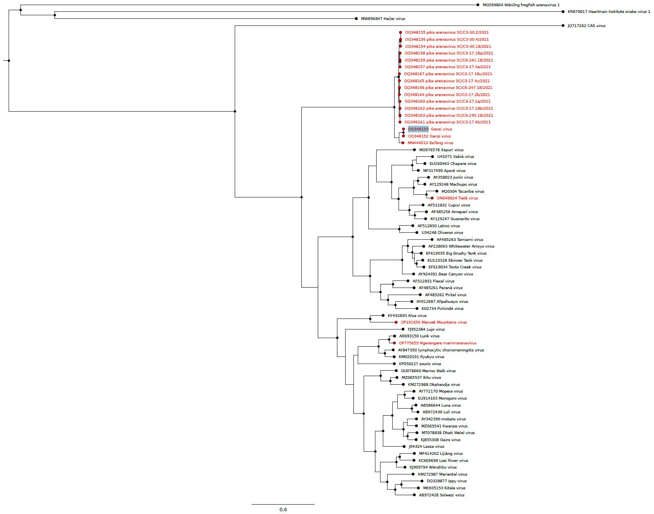

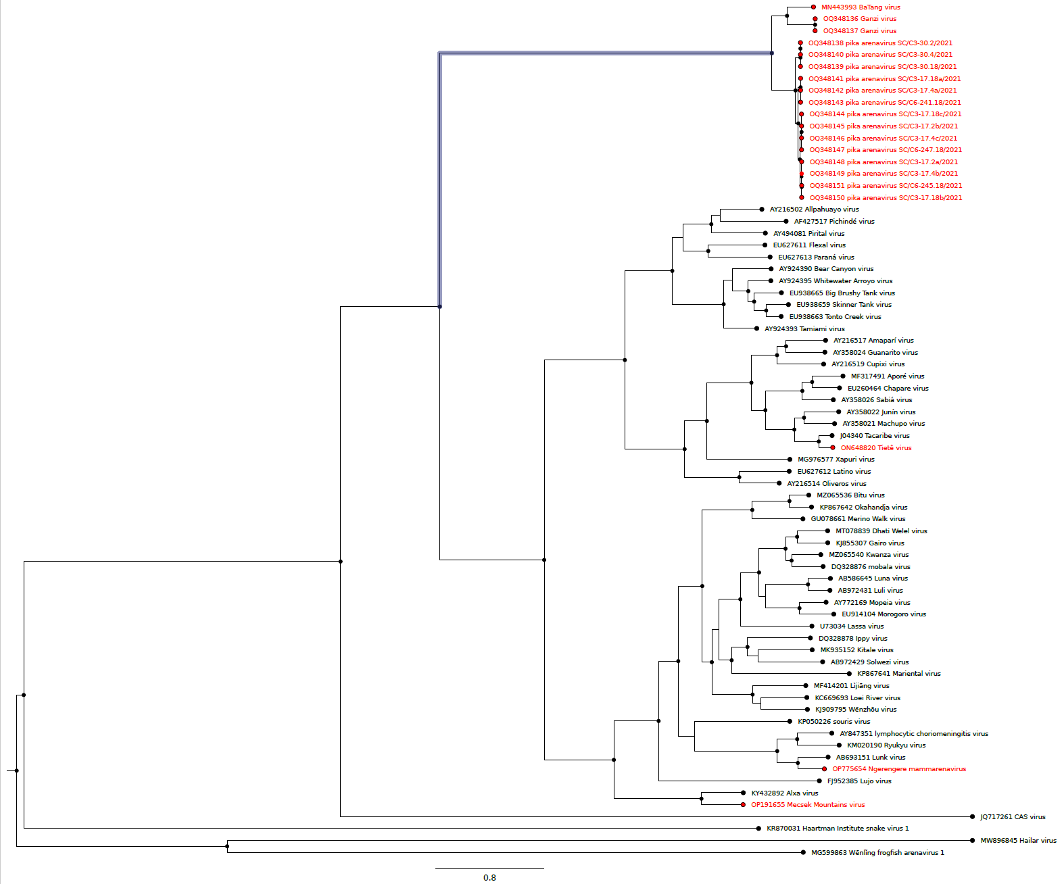

References
1. Bentim Góes LG, Fischer C, Almeida Campos AC, de Carvalho C, Moreira-Soto A, Ambar G, Ruckert da Rosa A, de Oliveira DC, Jo WK, Cruz-Neto AP, Pedro WA, Queiroz LH, Minoprio P, Durigon EL, Drexler JF (2022) Highly diverse arenaviruses in neotropical bats, Brazil. Emerg Infect Dis 28:2528-2533. PMID: 36417964. PMCID: PMC9707603. doi: 10.3201/eid2812.220980.
2. Cui X, Fan K, Liang X, Gong W, Chen W, He B, Chen X, Wang H, Wang X, Zhang P, Lu X, Chen R, Lin K, Liu J, Zhai J, Liu DX, Shan F, Li Y, Chen RA, Meng H, Li X, Mi S, Jiang J, Zhou N, Chen Z, Zou JJ, Ge D, Yang Q, He K, Chen T, Wu YJ, Lu H, Irwin DM, Shen X, Hu Y, Lu X, Ding C, Guan Y, Tu C, Shen Y (2023) Virus diversity, wildlife-domestic animal circulation and potential zoonotic viruses of small mammals, pangolins and zoo animals. Nat Commun 14:2488. PMID: 37120646. PMCID: PMC10148632. doi: 10.1038/s41467-023-38202-4.
3. Cuypers LN, Gryseels S, Van Houtte N, Baird SJE, Sabuni CA, Katakweba AS, van den Burg SRM, Bryja J, Leirs H, Goüy de Bellocq J (2023) Subspecific rodent taxa as the relevant host taxonomic level for mammarenavirus host specificity. Virology 581:116-127. PMID: 36958216. doi: 10.1016/j.virol.2023.02.014.
4. de Bellocq JG, Borremans B, Katakweba A, Makundi R, Baird SJ, Becker-Ziaja B, Günther S, Leirs H (2010) Sympatric occurrence of 3 arenaviruses, Tanzania. Emerg Infect Dis 16:692-5. PMID: 20350390. PMCID: PMC3321973. doi: 10.3201/eid1604.091721.
5. Luo X-L, Lu S, Qin C, Shi M, Lu X-B, Wang L, Ga S, Jin D, Ma X-L, Yang J, Dai Y, Bao L-L, Cheng Y-P, Ge Y-J, Bai Y-B, Zhu W-T, Pu J, Sun H, Huang Y-Y, Xu MC, Lei WJ, Dong K, Yang CX, Jiao Y-F, Lv Q, Li F-D, Xu J (2023) Emergence of an ancient and pathogenic mammarenavirus. Emerg Microbes Infect 12:e2192816. PMID: 36939609. PMCID: PMC10337645. doi: 10.1080/22221751.2023.2192816.
6. Radoshitzky SR, Bào Y, Buchmeier MJ, Charrel RN, Clawson AN, Clegg CS, DeRisi JL, Emonet S, Gonzalez JP, Kuhn JH, Lukashevich IS, Peters CJ, Romanowski V, Salvato MS, Stenglein MD, de la Torre JC (2015) Past, present, and future of arenavirus taxonomy. Arch Virol 160:1851-74. PMID: 25935216. doi: 10.1007/s00705-015-2418-y.
7. Reuter G, Boros Á, Takáts K, Mátics R, Pankovics P (2023) A novel mammarenavirus (family Arenaviridae) in hedgehogs (Erinaceus roumanicus) in Europe. Arch Virol 168:174. PMID: 37291370. PMCID: PMC10250479. doi: 10.1007/s00705-023-05804-8.

