Part 1: TITLE, AUTHORS, APPROVALS, etc

Code assigned: | 2023.009M
Short title: Create a new species in the genus Dichorhavirus, subfamily Betarhabdovirinae (Mononegavirales: Rhabdoviridae)
Author(s) and email address(es)
Ramos-González PL, Chabi-Jesus C, Bejerman N, Dietzgen RG, Kondo H, Whitfield AE, Walker PJ, Freitas-Astúa J | plrg1970@gmail.com; millachabi@yahoo.com.br; bejerman.nicolas@inta.gob.ar; r.dietzgen@uq.edu.au; hkondo@rib.okayama-u.ac.jp; awhitfi@ncsu.edu; peter.walker@uq.edu.au; juliana.astua@embrapa.br
Author(s) institutional address(es) (optional)
Corresponding author
Freitas-Astúa J
List the ICTV Study Group(s) that have seen this proposal
ICTV Rhabdoviridae Study Group
ICTV Study Group comments and response of proposer
Minor corrections regarding the creation of a new species.

ICTV Study Group votes on proposal
Study Group | Number of members
 | Votes support | Votes against | No vote
ICTV Rhabdoviridae Study Group | 10 | 0 | 4
Authority to use the name of a living person

Is any taxon name used here derived from that of a living person (Y/N) | N

Taxon name | Person from whom the name is derived | Permission attached (Y/N)
N/A | N/A | N/A

Submission dates
Date first submitted to SC Chair | June 23, 2023
Date of this revision (if different to above)
ICTV-EC comments and response of the proposer

Part 2: NON-TAXONOMIC PROPOSAL
N/A

Part 3: TAXONOMIC PROPOSAL
Name of accompanying Excel module
2023.009M.N.v1.Dichorhavirus_1nsp.xlxs
Abstract
This taxonomic proposal aims to classify citrus bright spot virus (CiBSV) into a new species of the genus Dichorhavirus, family Rhabdoviridae, subfamily Betarhabdovirinae (Mononegavirales). Genomes of three characterized isolates of CiBSV comprise ~13 kb. They are divided into two linear single-stranded negative-sense RNA molecules. In each isolate, the RNA1 segment, ~7 kb, contains five open reading frames (ORFs) in the sense 3’-5’ N, P, P3, M, and G. The RNA2 segment, ~6 kb, has the ORF L coding the RNA-dependent RNA polymerase (RdRp), also known as L protein. The complete sequence of the RNA1 and ORF L in the RNA2 of CiBSV share less than 80% of nt sequence identity in comparison with known dichorhaviruses. Phylogenetic analyses using the L proteins place the CiBSV isolates in a subclade together with viruses of the species Dichorhavirus leprosis.
Text of proposal
Genus Dichorhavirus, family Rhabdoviridae (negative-sense, single-stranded RNA genome) groups plant-infecting viruses transmitted by mites of the genus Brevipalpus [1]. The genome of dichorhaviruses is bi-segmented in which genes N, P, P3, M, and G are located in RNA1, whereas the gene L is in RNA2. In nature, dichorhaviruses cause non-systemic diseases mostly producing chlorotic and necrotic spots. Dichorhaviruses also replicate in their vectors [1, 2].

Citrus bright spot virus (CiBSV) was identified in leaves of sweet orange (Citrus sinensis L. Osbeck) trees affected by bright yellow spots, which resemble those characteristics of citrus leprosis disease [3]. Necrotic lesions were frequently found in the fruits but not in the affected leaves. CiBSV was first detected in trees of small orchards in the Southern region of Brazil, in the period 2019-2021. Experimentally, CiBSV was successfully transmitted to Arabidopsis thaliana plants using viruliferous mites of the species Brevipalpus azores. Attempts to transmit CiBSV using B. yothersi, B. papayensis, B. californicus s.l., and B. obovatus were ineffective. Virions from CiBSV are rod-like particles of ~40 × 100 nm and can be observed in the cytoplasm forming the so-called “spoke wheel” arrangement and also in the nucleoplasm of the parenchymal cells in the foliar lesions [3].

The full genomes of three isolates of CiBSV were obtained and the sequences were deposited in the GenBank (CiBSV_PFd01 RNA1: MZ773933 and RNA2: MZ773938, CiBSV_MSo01: MZ773934 and MZ773936, and CiBSV_Ser01: MZ773935 and MZ773937). Nucleotide sequence identity values in paired comparisons between the genomic segments of the three isolates are higher than 97%, whereas the values range from 98 to 100% in the analyses using the deduced amino acid (aa) sequences of the encoded proteins. Nucleotide sequence comparisons of CiBSV_PFd01 with other dichorhaviruses show identity values below 74% (Table 1), and the highest values corresponded to the alignments with citrus leprosis virus N (CiLV-N, Dichorhavirus leprosis) [4]. Amino acid sequence identity values of the deduced proteins from the isolate PFd01 with those of other dichorhaviruses range from 73 to 83% with proteins of CiLV-N, 33–63% with orchid fleck virus (Dichorhavirus orchidaceae), 40–64% with coffee ringspot virus (CoRSV, Dichorhavirus coffeae), 38–64% with clerodendrum chlorotic spot virus (ClCSV, Dichorhavirus clerodendri), and 39–64% with citrus chlorotic spot virus (CiCSV, Dichorhavirus citri) (Table 1). Values of the comparisons with proteins from the betanucleorhabdovirus sonchus yellow net virus (SYNV, Betanucleorhabdovirus retesonchi) range from 10% to 25%, at least ten units lower than those obtained in comparisons involving dichorhaviruses (Table 1B). Based on a maximum likelihood (ML) tree generated from L protein sequences, isolates of CiBSV share a branch with isolates of CiLV-N (Figure 1).

We propose to classify CiBSV in the new species Dichorhavirus australis, in the genus Dichorhavirus, subfamily Betarhabdovirinae (Mononegavirales: Rhabdoviridae). The species epithet for Dichorhavirus australis means "of the south", in this case, from the Southern region of Brazil, the geographic area where the virus has been detected so far.

The current demarcation criteria for species of the genus Dichorhavirus are:
- minimum nucleotide sequence divergence of 20% in L genes;
- minimum nucleotide sequence divergence of 20% in RNA1;
- distinctive serological reactions;
- different ecological niches as evidenced by differences in plant hosts and/or arthropod vectors.

Viruses assigned to different species within the genus must satisfy at least two of the mentioned characteristics. While the information on the serological tests of CiBSV is not available, the virus described in this proposal meets criteria A, B, and partially, criterium D.

Supporting evidence

Table 1: Percentage of nucleotide (A) and deduced amino acid (B) sequence identities among CiBSV isolates and other members of the genus Dichorhavirus and sonchus yellow net virus (SYNV), a member of the genus Betanucleorhabdovirus.

A
CiBSV_PFd01¹ | CiBSV_MSo01² | CiBSV_Ser01³ | CiLV-N⁴ | OFV⁵ | CoRSV⁶ | ClCSV⁷ | CiCSV⁸ | SYNV⁹
RNA1 | 98 | 97 | 68 | 47 | 51 | 51 | 51 | -
N | 98 | 98 | 74 | 54 | 60 | 60 | 59 | 49
P | 99 | 99 | 71 | 48 | 55 | 56 | 55 | 35
P3 | 98 | 98 | 78 | 63 | 64 | 64 | 64 | 45
M | 98 | 97 | 69 | 49 | 55 | 55 | 57 | 32
G | 98 | 98 | 70 | 43 | 48 | 48 | 48 | 44
RNA2 | 98 | 98 | 74 | 57 | 60 | 60 | 60 | -
L | 98 | 98 | 74 | 59 | 62 | 63 | 63 | 47

B
CiBSV_PFd01¹ | CiBSV_MSo01² | CiBSV_Ser01³ | CiLV-N⁴ | OFV⁵ | CoRSV⁶ | ClCSV⁷ | CiCSV⁸ | SYNV⁹
N | 99 | 99 | 81 | 50 | 58 | 58 | 58 | 20
P | 99 | 99 | 75 | 33 | 47 | 47 | 45 | 11
P3 | 100 | 100 | 85 | 63 | 63 | 64 | 62 | 13
M | 98 | 98 | 73 | 40 | 50 | 47 | 49 | 10
G | 98 | 98 | 74 | 33 | 40 | 38 | 39 | 15
L | 99 | 99 | 83 | 57 | 64 | 64 | 64 | 25

¹citrus bright spot virus isolate PFd01 (GenBank accession numbers MZ773933 and MZ773938), ²CiBSV_MSo01 (MZ773934 and MZ773936), ³CiBSV_Ser01 (MZ773935 and MZ773937), ⁴citrus leprosis virus N (RefSeq accession numbers NC_052230 and NC_052231), ⁵orchid fleck virus (NC_009608 and NC_009609), ⁶coffee ringspot virus (NC_038756 and NC_038755), ⁷clerodendrum chlorotic spot virus (NC_043648 and NC_043649), ⁸citrus chlorotic spot virus (NC_055208 and NC_055208), and ⁹sonchus yellow net virus (NC_001615).

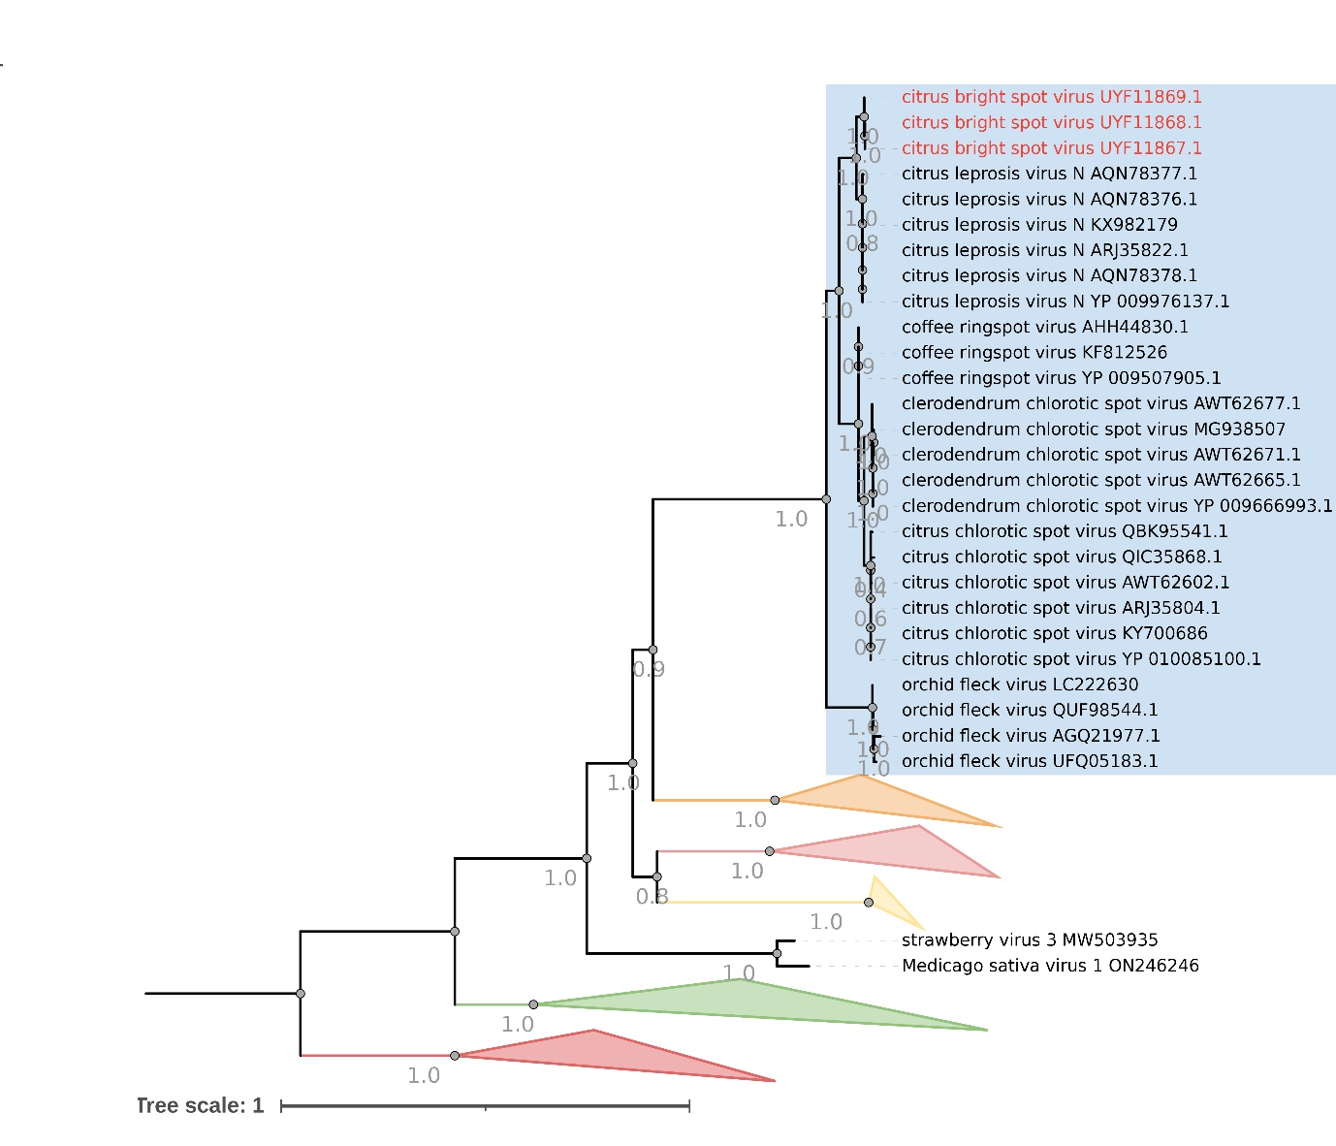
Alphanucleorhabdovirus
Cytorhabdovirus
Betanucleorhabdovirus
Varicosavirus
Figure 1. Phylogenetic reconstruction for viruses of the subfamily Betarhabdovirinae (family Rhabdoviridae). Isolates of citrus bright spot virus are highlighted in purple. The branch grouping members of the genus Dichorhavirus is framed by a blue box. Branches comprising definitive and tentative members of other demarcated genera of the subfamily Betarhabdovirinae were collapsed. The maximum-likelihood phylogenetic tree is based on the deduced amino acid sequences of L proteins. The tree was rooted using viruses of the genus Varicosavirus as an external group. Phylogenetic informative regions of the multiple sequence alignment included 531 residues that were selected using BMGE software [5] and its evolutionary history was inferred based on the model LG+F+R10 [6]. The bootstrap support values (1,000 replications) of branches greater than 50% are indicated next to the corresponding nodes. The scale bar specifies the average number of amino acid substitutions per site. Strawberry virus 3 and Medicago sativa virus 1 are tentative members of the subfamily Betarhabdovirinae.

References
1. Dietzgen RG, Freitas-Astúa J, Chabi-Jesus C, et al (2018) Dichorhaviruses in their Host Plants and Mite Vectors. In: Adv. Virus Res. Academic Press Inc., pp 119–148
2. de Lillo E, Freitas-Astúa J, Kitajima EW, et al (2021) Phytophagous mites transmitting plant viruses: update and perspectives. Entomol Gen 41:439–462. doi: 10.1127/ENTOMOLOGIA/2021/1283
3. Chabi-Jesus C, Ramos-González PL, Tassi AD, et al (2023) Citrus Bright Spot Virus: A New Dichorhavirus, Transmitted by Brevipalpus azores, Causing Citrus Leprosis Disease in Brazil. Plants 12:1371. doi: 10.3390/PLANTS12061371
4. Ramos-González PL, Chabi-Jesus C, Guerra-Peraza O, et al (2017) Citrus leprosis virus N: a new dichorhavirus causing Citrus Leprosis disease. Phytopathology 107:963–976. doi: 10.1094/PHYTO-02-17-0042-R
5. Criscuolo A, Gribaldo S (2010) BMGE (Block Mapping and Gathering with Entropy): a new software for selection of phylogenetic informative regions from multiple sequence alignments. BMC Evol Biol 10:210. doi: 10.1186/1471-2148-10-210
6. Le SQ, Gascuel O (2008) An improved general amino acid replacement matrix. Mol Biol Evol 25:1307–1320. doi: 10.1093/molbev/msn067

