

**Part 1:** **TITLE, AUTHORS, APPROVALS, etc**

|  |  |  |
| --- | --- | --- |
| **Code assigned:** | ***2023.026M*** |  |
| **Short title:** Create three new genera and six new species in family *Kolmioviridae* (*Ribozyviria*) | | |
|  | | |

**Author(s) and email address(es)**

|  |  |
| --- | --- |
| Smura TP, Kuhn JH, Hepojoki JM | [teemu.smura@helsinki.fi](mailto:teemu.smura@helsinki.fi); [kuhnjens@mail.nih.gov](mailto:kuhnjens@mail.nih.gov); [jussi.hepojoki@helsinki.fi](mailto:jussi.hepojoki@helsinki.fi) |

**Author(s) institutional address(es) (optional)**

|  |
| --- |
|  |

**Corresponding author**

|  |
| --- |
| Hepojoki J |

**List the ICTV Study Group(s) that have seen this proposal**

|  |
| --- |
| ICTV *Ribozyviria* Study Group |

**ICTV Study Group comments and response of proposer**

|  |
| --- |
|  |

**ICTV Study Group votes on proposal**

|  |  |  |  |
| --- | --- | --- | --- |
| **Study Group** | **Number of members** | | |
| **Votes support** | **Votes against** | **No vote** |
| ICTV *Ribozyviria* Study Group | 12 | 0 | 0 |

**Authority to use the name of a living person**

|  |  |
| --- | --- |
| **Is any taxon name used here derived from that of a living person (Y/N)** | N |

|  |  |  |
| --- | --- | --- |
| **Taxon name** | **Person from whom the name is derived** | **Permission attached (Y/N)** |
| N/A | N/A | N/A |

**Submission dates**

|  |  |
| --- | --- |
| Date first submitted to SC Chair | June 23, 2023 |
| Date of this revision (if different to above) | October 27, 2023 |

**ICTV-EC comments and response of the proposer**

|  |
| --- |
|  |

**Part 2:** **NON-TAXONOMIC PROPOSAL**

|  |
| --- |
| N/A |

**Part 3:** **TAXONOMIC PROPOSAL**

**Name of accompanying Excel module**

|  |
| --- |
| 2023.026M.N.v1.Kolmioviridae_3ng_6nsp.xlsx |

**Abstract**

|  |
| --- |
| We propose the establishment of three new genera and six new species in ribozyvirian family *Kolmioviridae* to accommodate new hepatitis D-like viruses from artiodactyls, bats, birds, rodents, and termites. |

**Text of the proposal**

|  |  |
| --- | --- |
| |  | | --- | | Family *Kolmioviridae* is currently the only family in realm *Ribozyviria*. Kolmiovirids are hepatitis D virus (HDV)-like entities, i.e., each of these viruses has a hepatitis D ribozyme-containing circular, negative-sense, single-stranded, circular RNA genome reminiscent of those of viroids but encoding a protein (referred to as the delta antigen [DAg]) that binds the genomic RNA to form a ribonucleoprotein complex [2, 3, 7, 8].  In 2020, kolmiovirid demarcation was established to be based on DAg similarity as analyzed primarily at the amino acid level for more distantly related viruses, and at the nucleotide level for comparison of more closely related viruses, with whole genome comparisons being encouraged (TaxoProp 2020.012D.R.Ribozyviria) [5]. Since then, the Study Group refined the demarcation criteria to  Members of the same species should have a minimum of 80 % nt genome and 70 % Dag aa identity AND form a monophyletic cluster. Members of different species should have a maximum of 90 % genome nt and 90 % Dag aa identity to the closest sister species and both species should be monophyletic.  Surveys of the literature and GenBank revealed several kolmiovirids that are classifiable, i.e., fulfill the above definitions of kolmiovirids and association with coding-complete/complete genomes:   1. **Bat deltavirus (DesRot/Peru/AYA14_DrDV-A), Marmota monax deltavirus, and Odocoileus virginianus deltavirus**   Bat deltavirus (DesRot/Peru/AYA14_DrDV-A), Marmota monax deltavirus, and Odocoileus virginianus deltavirus were discovered in common vampire bats (phyllostomid Desmodus rotundus (Geoffroy, 1810)) sampled in Peru, groundhogs (sciurid *Marmota monax* (Linnaeus, 1758), and white tailed deer (cervid *Odocoileus virginianus* (Zimmermann, 1780)), respectively [1, 4]. In pairwise genome comparisons and DAg phylogeny (Table 1, Figure 2), the three viruses represent three new species in one new genus sister to *Deltavirus* (*Perideltavirus* *desmodi*, *Perideltavirus* marmotae, and *Perideltavirus* *odocoilei*).   1. **Bat deltavirus (DesRot/Peru/AYA11_DrDV-B)**   Bat deltavirus (DesRot/Peru/AYA11_DrDV-B), bat deltavirus (DesRot/Peru/CAJ1/DrDV-B), and bat deltavirus (DesRot/Peru/LMA6/DrDV-B) were discovered in common vampire bats (phyllostomid *Desmodus rotundus* (Geoffroy, 1810)) sampled in Peru [1]. In pairwise genome comparisons and DAg phylogeny (Table 1, Figure 2), the three viruses represent a single new species sister to *Thurisazvirus myis* (Tome’s spiny-rat virus 1). We propose bat deltavirus (DesRot/Peru/AYA11_DrDV-B) to be the exemplar virus of this new species, *Thurisazvirus desmodi*, with bat deltavirus (DesRot/Peru/CAJ1/DrDV-B) and bat deltavirus (DesRot/Peru/LMA6/DrDV-B) now being considered isolates of bat deltavirus (DesRot/Peru/AYA11_DrDV-B).   1. **Taeniopygia guttata deltavirus**   Lonchura striata deltavirus, Pardaliparus venustulus deltavirus, and Taeniopygia guttata deltavirus were discovered in white-rumped munias (estrildid *Lonchura striata* (Linnaeus, 1766)), yellow-bellied tits (parid *Pardaliparus venustulus*  (R. Swinhoe, 1870)), and Australian zebra finches (estrildid *Taeniopygia castanotis* (Gould, 1837)), respectively [4]. In pairwise genome comparisons and DAg phylogeny (Table 1, Figure 2), the three viruses represent a single new species in a new genus sister to *Thurisazvirus*. We propose Taeniopygia guttata deltavirus to be the exemplar virus of this new genus/species, *Perithurisazvirus passeriformes*, with Lonchura striata deltavirus and Pardaliparus venustulus deltavirus now being considered isolates of Taeniopygia guttata deltavirus.   1. **Cát Tiên Odontotermes delta-like virus**   Cát Tiên Odontotermes delta-like virus was discovered in fungus growing termites (termitid *Odontotermes wallonensis* Wasmann, 1902) in Cát Tiên National Park, Vietnam [6]. In pairwise genome comparisons and DAg phylogeny (Table 1, Figure 2), this virus represents a single new species in a new genus sister to *Dagazvirus*. We propose this genus/species to be named *Donvirus odontotermitis*. | |

**Supporting evidence**

**Table 1.** Percentage amino acid identity among HDAgs.



**Figure 1.** Maximum-likelihood phylogeny based on small delta antigen aa sequence.

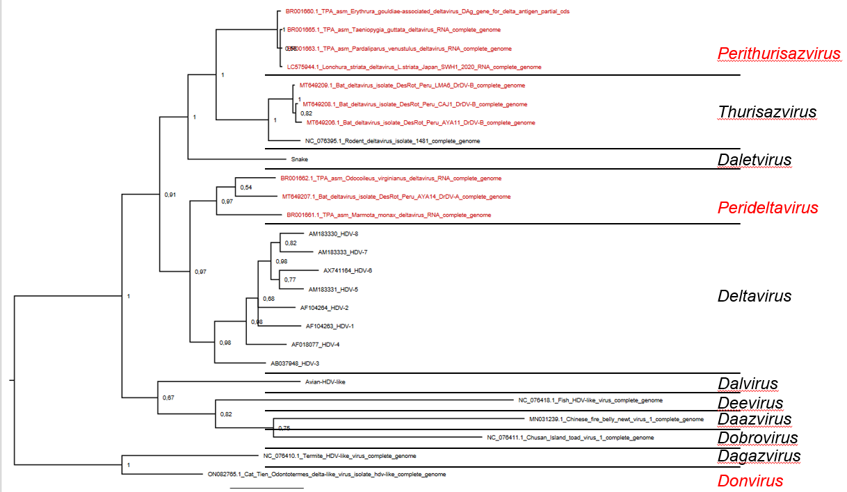

**References**

1. Bergner LM, Orton RJ, Broos A, Tello C, Becker DJ, Carrera JE, Patel AH, Biek R, Streicker DG (2021) Diversification of mammalian deltaviruses by host shifting. Proc Natl Acad Sci U S A 118. PMID: 33397804. PMCID: PMC7826387. doi: 10.1073/pnas.2019907118.

2. Chang W-S, Pettersson JH-O, Le Lay C, Shi M, Lo N, Wille M, Eden J-S, Holmes EC (2019) Novel hepatitis D-like agents in vertebrates and invertebrates. Virus Evol 5:vez021. PMID: 31321078. PMCID: PMC6628682. doi: 10.1093/ve/vez021.

3. Hetzel U, Szirovicza L, Smura T, Prähauser B, Vapalahti O, Kipar A, Hepojoki J (2019) Identification of a novel deltavirus in boa constrictors. mBio 10:e00014-19. PMID: 30940697. PMCID: PMC6445931. doi: 10.1128/mBio.00014-19.

4. Iwamoto M, Shibata Y, Kawasaki J, Kojima S, Li YT, Iwami S, Muramatsu M, Wu HL, Wada K, Tomonaga K, Watashi K, Horie M (2021) Identification of novel avian and mammalian deltaviruses provides new insights into deltavirus evolution. Virus Evol 7:veab003. PMID: 33614159. PMCID: PMC7882216. doi: 10.1093/ve/veab003.

5. Le Gal F, Gault E, Ripault M-P, Serpaggi J, Trinchet J-C, Gordien E, Dény P (2006) Eighth major clade for hepatitis delta virus. Emerg Infect Dis 12:1447-50. PMID: 17073101. PMCID: PMC3294742. doi: 10.3201/eid1209.060112.

6. Litov AG, Zueva AI, Tiunov AV, Van Thinh N, Belyaeva NV, Karganova GG (2022) Virome of three termite species from southern Vietnam. Viruses 14:860. PMID: 35632601. PMCID: PMC9143207. doi: 10.3390/v14050860.

7. Paraskevopoulou S, Pirzer F, Goldmann N, Schmid J, Corman VM, Gottula LT, Schroeder S, Rasche A, Muth D, Drexler JF, Heni AC, Eibner GJ, Page RA, Jones TC, Muller MA, Sommer S, Glebe D, Drosten C (2020) Mammalian deltavirus without hepadnavirus coinfection in the neotropical rodent Proechimys semispinosus. Proc Natl Acad Sci U S A. PMID: 32651267. doi: 10.1073/pnas.2006750117.

8. Wille M, Netter HJ, Littlejohn M, Yuen L, Shi M, Eden J-S, Klaassen M, Holmes EC, Hurt AC (2018) A divergent hepatitis D-like agent in birds. Viruses 10:720. PMID: 30562970. PMCID: PMC6315422. doi: 10.3390/v10120720.