Part 1: TITLE, AUTHORS, APPROVALS, etc

Code assigned: | 2023.017M
Short title: Create one new genus, Deltanucleorhabdovirus, with two new species, and an additional seven new species in the subfamily Betarhabdovirinae (Mononegavirales: Rhabdoviridae)
Author(s) and email address(es)
Bejerman N, Debat H, Dietzgen RG, Kondo H, Ramos-González P, Whitfield AE, Walker PJ, Freitas-Astúa J | bejerman.nicolas@inta.gob.ar;  debat.hmberto@inta.gob.ar;  r.dietzgen@uq.edu.au; hkondo@rib.okayama-u.ac.jp;  plrg1970@gmail.com;  awhitfi@ncsu.edu;  peter.walker@uq.edu.au;  juliana.astua@embrapa.br
Author(s) institutional address(es) (optional)
Corresponding author
Bejerman N
List the ICTV Study Group(s) that have seen this proposal
ICTV Rhabdoviridae Study Group
ICTV Study Group comments and response of proposer
Minor corrections regarding the creation of the genus and the species.

ICTV Study Group votes on proposal
Study Group | Number of members
 | Votes support | Votes against | No vote
ICTV Rhabdoviridae Study Group | 11 | 0 | 3
Authority to use the name of a living person

Is any taxon name used here derived from that of a living person (Y/N) | N

Taxon name | Person from whom the name is derived | Permission attached (Y/N)
N/A | N/A | N/A

Submission dates
Date first submitted to SC Chair | June 23, 2023
Date of this revision (if different to above)
ICTV-EC comments and response of the proposer

Part 2: NON-TAXONOMIC PROPOSAL
N/A

Part 3: TAXONOMIC PROPOSAL
Name of accompanying Excel module
2023.017M.N.v1.Betarhabdovirinae_1ng_7nsp.xlsx
Abstract
Viruses classified in the family Rhabdoviridae infect vertebrates, invertebrates, and plants. Nine new plant-infecting rhabdoviruses were discovered recently and their complete or coding-complete genomes were determined. This proposal aims to classify taxonomically these nine viruses into nine new species in the existing genera Alphanucleorhabdovirus, Betanucleorhabdovirus, Gammanucleorhabdovirus and in the newly proposed genus Deltarhabdovirus.
Text of proposal
Two new species in the genus Alphanucleorhabdovirus

1) Tomato alphanucleorhabdovirus 1 (TARV1) was identified from tomato samples collected in Strunjan, Slovenia. The coding-complete genome (CCG) sequence (partial 3’ leader and 5’ trailer) of TARV1 has 13,405 nucleotides (OL472126) and contains seven ORFs in the order 3’-N-X-P-P3-M-G-L-5’ [1] representing the five canonical rhabdovirus structural protein genes and the putative cell-to-cell movement protein gene P3 in the conserved location between P and M genes, as well as the accessory ORF encoding the X protein between the N and P genes (Figure 1). The CCG nucleotide sequence of TARV1 has the highest sequence identity with that of eggplant mottle dwarf virus (EMDV; 74%) (Figure 2) [1]. Based on ML trees generated from complete L protein sequences, TARV1 forms a well-supported clade within alphanucleorhabdoviruses with EMDV and Physostegia chlorotic mottle virus (Figure 3).

2) Xinjiang alphanucleorhabdovirus (XARV) was identified from soil samples collected in Xinjiang, China. The coding-complete genome (CCG) sequence (partial 3’ leader and 5’ trailer) of XARV has 13,358 nucleotides (MW897039) and contains eight ORFs in the order 3’-N-X-P-P3-M-P5-G-L-5’ [2] representing the five canonical rhabdovirus structural protein genes and the putative cell-to-cell movement protein gene P3 in the conserved location between P and M genes, as well as two accessories ORF encoding the X protein between the N and P genes and the P5 between the M and G genes (Figure 1). The CCG nucleotide sequence of XARV has the highest sequence identity with that of eggplant mottle dwarf virus (EMDV; 40.35%) (Figure 2). Based on ML trees generated from complete L protein sequences, XARV forms a well-supported clade with other alphanucleorhabdoviruses (Figure 3).

We propose to classify TARV1 and XARV in the new species Alphanucleorhabdovirus lycopersici and Alphanucleorhabdovirus xinjianensis in the genus Alphanucleorhabdovirus, subfamily Betarhabdovirinae, family Rhabdoviridae.

Viruses assigned to different species within the genus Alphanucleorhabdovirus have several of the following characteristics:
- nucleotide sequence identity lower than 75% in the complete genome sequence;
- occupy different ecological niches as evidenced by differences in hosts and/or arthropod vectors; and
- can be clearly distinguished in serological tests or by nucleic acid hybridization.

- TARV1 and XARV meet criteria A and B.

Four new species in the genus Betanucleorhabdovirus

1) Picris betanucleorhabdovirus 1 (PBRV1) was identified from Picris echoides (bristly oxtongue, Asteraceae) samples collected in Slovenia. The coding-complete genome (CCG) sequence (partial 3’ leader and 5’ trailer) of PBRV1 has 15,193 nucleotides (isolate SKO20SW, OL472117) and contains six ORFs in the order 3’-N-P-P3-M-G-L-5’ [1] representing the five canonical rhabdovirus structural protein genes and the putative cell-to-cell movement protein gene P3 in the conserved location between P and M genes (Figure 1). The CCG nucleotide sequence of PBRV1 has the highest sequence identity with that of Rhododendron delavayi virus 1 (RhoDeV1; 61%) (Figure 2). Based on ML trees generated from complete L protein sequences, PBRV1 is placed within a subclade of betanucleorhabdoviruses with RhoDeV1 (Figure 3).

2) Taraxacum betanucleorhabdovirus 1 (TarBRV1) was identified from Taraxacum officinale (dandelion, Asteraceae) samples collected in Slovenia. The coding-complete genome (CCG) sequence (partial 3’ leader and 5’ trailer) of TarBRV1 has 13,736 nucleotides (isolate PLE20SW, OL472118) and contains six ORFs in the order 3’-N-P-P3-M-G-L-5’ [1] representing the five canonical rhabdovirus structural protein genes and the putative cell-to-cell movement protein gene P3 in the conserved location between P and M genes (Figure 1). The CCG nucleotide sequence of TarBRV1 has the highest sequence identity with that of sonchus yellow net virus (SYNV; 62%) (Figure 2) [1]. Based on ML trees generated from complete L protein sequences, TarBRV1 is placed within a subclade of betanucleorhabdoviruses with SYNV (Figure 3).

3) Tomato betanucleorhabdovirus 1 (TBRV1) was identified from tomato samples collected in Bericevo, Slovenia. The coding-complete genome (CCG) sequence (partial 3’ leader and 5’ trailer) of TBRV1 has 13,426 nucleotides (OL472119) and contains six ORFs in the order 3’-N-P-P3-M-G-L-5’ [1] representing the five canonical rhabdovirus structural protein genes and the putative cell-to-cell movement protein gene P3 in the conserved location between P and M genes (Figure 1). The CCG nucleotide sequence of TBRV1 has the highest sequence identity with that of tomato betanucleorhabdovirus 2 (TBRV2; 68%) (Figure 2) [1]. Based on ML trees generated from complete L protein sequences, TBRV1 is placed within a subclade of betanucleorhabdoviruses with TBRV2, Bacopa monnieri virus 2, datura yellow vein virus, and Plectranthus aromaticus virus 1 (Figure 3).

4) Tomato betanucleorhabdovirus 2 (TBRV2) was identified from tomato samples collected in Slovenia. The coding-complete genome (CCG) sequence (partial 3’ leader and 5’ trailer) of TBRV2 has 13,423 nucleotides (isolate SKO20ST1, OL472114) and contains six ORFs in the order 3’-N-P-P3-M-G-L-5’ [1] representing the five canonical rhabdovirus structural protein genes and the putative cell-to-cell movement protein gene P3 in the conserved location between P and M genes (Figure 1). The CCG nucleotide sequence of TBRV2 has the highest sequence identity with that of tomato betanucleorhabdovirus 1 (TBRV1; 68%) (Figure 2) [1]. Based on ML trees generated from complete L protein sequences, TBRV2 is placed within a subclade of betanucleorhabdoviruses with TBRV1, Bacopa monnieri virus 2, datura yellow vein virus, and Plectranthus aromaticus virus 1 (Figure 3).

We propose to classify PBRV1, TarBRV1, TBRV1 and TBRV2 in the new species Betanucleorhabdovirus picridis, Betanucleorhabdovirus taraxaci, Betanucleorhabdovirus alphalycopersici and Betanucleorhabdovirus betalycopersici, respectively, in the genus Betanucleorhabdovirus, subfamily Betarhabdovirinae, family Rhabdoviridae.

Viruses assigned to different species within the genus Betanucleorhabdovirus have several of the following characteristics:
- nucleotide sequence identity lower than 75% in the complete genome sequence;
- occupy different ecological niches as evidenced by differences in hosts and/or arthropod vectors; and
- can be clearly distinguished in serological tests or by nucleic acid hybridization.

- PBRV1, TarBRV1, TBRV1 and TBRV2 meet criteria A and B.

One new species in the genus Gammanucleorhabdovirus

1) Cereal chlorotic mottle virus (CCMoV) was identified from Avena sativa (oat, Poaceae) samples collected in Morocco. The complete genome (CG) sequence of CCMoV has 13,800 nucleotides (isolate M, MW731536) and contains seven ORFs in the order 3’-N-P-P3-P4-M-G-L-5’ [3] (Figure 1), representing the five canonical rhabdovirus structural protein genes and two accessory ORFs encoding the P3 and P4 proteins between the P and M genes. The CG nucleotide sequence of CCMoV has the highest sequence identity with that of maize fine streak virus (MFSV; 57.6%) (Figure 2) which has a similar genomic organization. Based on ML trees generated from complete L protein sequences, CCMoV is clustered together with the gammanucleorhabdovirus MFSV (Figure 3).

We propose to classify CCMoV in the new species Gammanucleorhabdovirus cerealis, in the genus Gammanucleorhabdovirus, subfamily Betarhabdovirinae, family Rhabdoviridae.

No species demarcation criteria have been developed so far for gammanucleorhabdoviruses. Thus, we propose the similar criteria that are used for alpha- and betanucleorhabdoviruses. Therefore, viruses assigned to different species within the genus Gammanucleorhabdovirus have several of the following characteristics:
- nucleotide sequence identity lower than 75% in the complete genome sequence;
- occupy different ecological niches as evidenced by differences in hosts and/or arthropod vectors; and
- can be clearly distinguished in serological tests or by nucleic acid hybridization.

- CCMoV meets criteria A and B.

Genus Deltanucleorhabdovirus

The genus Deltanucleorhabdovirus is proposed to classify two novel species which are phylogenetically distinct from members of the genera Alphanucleorhabdovirus, Betanucleorhabdovirus, Gammanucleorhabdovirus and Dichorhavirus. Additionally, the nucleotide and deduced amino acid sequence comparisons between the two novel species and the alphanucleo- betanucleo- and gammanucleorhabdoviruses, as well as dichorhaviruses show sequence identities ranging from 22.8 to 26.7% [4, 5].

1) Medicago sativa virus 1 (MSV1) was identified from Medicago sativa (alfalfa) samples collected in China. The coding-complete genome (CCG) sequence of MSV1 has 14,041 nucleotides (isolate ZM1-NX2, ON246246) and contains six ORFs in the order 3’-N-P-P3-M-G-L-5’ [4], representing the five canonical rhabdovirus structural protein genes and the putative cell-to-cell movement protein gene P3 in the conserved location between P and M genes (Figure 1). The CCG nucleotide sequence of MSV1 has the highest sequence identity with that of strawberry virus 3 (StrV3; 57.6%) (Figure 2). Based on ML trees generated from complete L protein sequences, MSV1 is clustered together with StrV3 in a distinct clade (Figure 3).

2) Strawberry virus 3 (StrV3) was identified from strawberry samples collected in the USA. The complete genome (CG) sequence of StrV3 has 14,433 nucleotides (isolate Fragaria 7, MW503935) and contains six ORFs in the order 3’-N-P-P3-M-G-L-5’ [5], representing the five canonical rhabdovirus structural protein genes and the putative cell-to-cell movement protein gene P3 in the conserved location between P and M genes (Figure 1). The CG nucleotide sequence of StrV3 has the highest sequence identity with that of Medicago sativa virus 1 (MSV1; 57.6%) (Figure 2). Based on ML trees generated from complete L protein sequences, StrV3 is clustered together with the MSV1 in a distinct clade (Figure 3).

We propose to classify MSV1 and StrV3 in the new species Deltanucleorhabdovirus medicagonis and Deltanucleorhabdovirus fragariae, respectively, in the genus Deltanucleorhabdovirus, subfamily Betarhabdovirinae, family Rhabdoviridae.

We propose the similar criteria that are used to demarcate species for alpha- and betanucleorhabdoviruses. Therefore, viruses assigned to different species within the genus Deltanucleorhabdovirus have several of the following characteristics:
- nucleotide sequence identity lower than 75% in the complete genome sequence;
- occupy different ecological niches as evidenced by differences in hosts and/or arthropod vectors; and
- can be clearly distinguished in serological tests or by nucleic acid hybridization.

MSV1 and StrV3 meet criteria A and B.

Supporting evidence

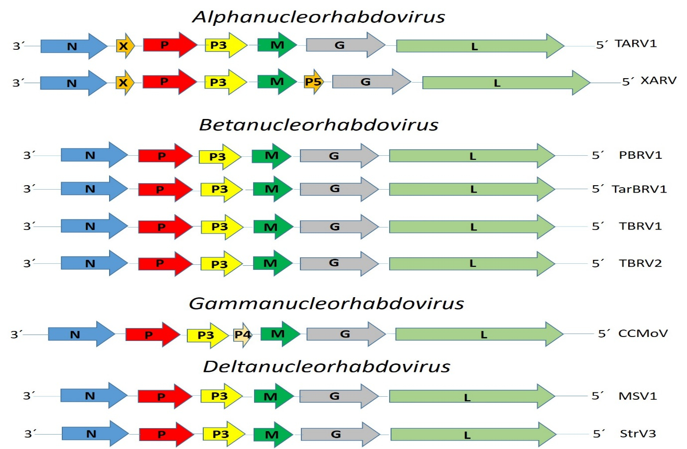

Figure 1. Genome graphs depicting architecture and gene products of proposed viruses to be included in species within genera Alphanucleorhabdovirus, Betanucleorhabdovirus. Gammanucleorhabdovirus and Deltanucleorhabdovirus Abbreviations: N: nucleoprotein; X; X protein; P: phosphoprotein; P3: putative cell-to-cell movement protein; P4; protein 4 M: matrix protein; G: glycoprotein; L: RNA-dependent RNA polymerase. Virus name abbreviations: cereal chlorotic mottle virus (CCMoV), Medicago sativa virus 1 (MSV1), Picris betanucleorhabdovirus 1 (PBRV1), strawberry virus 3 (StrV3), Taraxacum betanucleorhabdovirus 1 (TarBRV1), tomato alphanucleorhabdovirus 1 (TARV1), tomato betanucleorhabdovirus 1 (TBRV1), tomato betanucleorhabdovirus 2 (TBRV2) and Xinjiang alphanucleorhabdovirus (XARV).

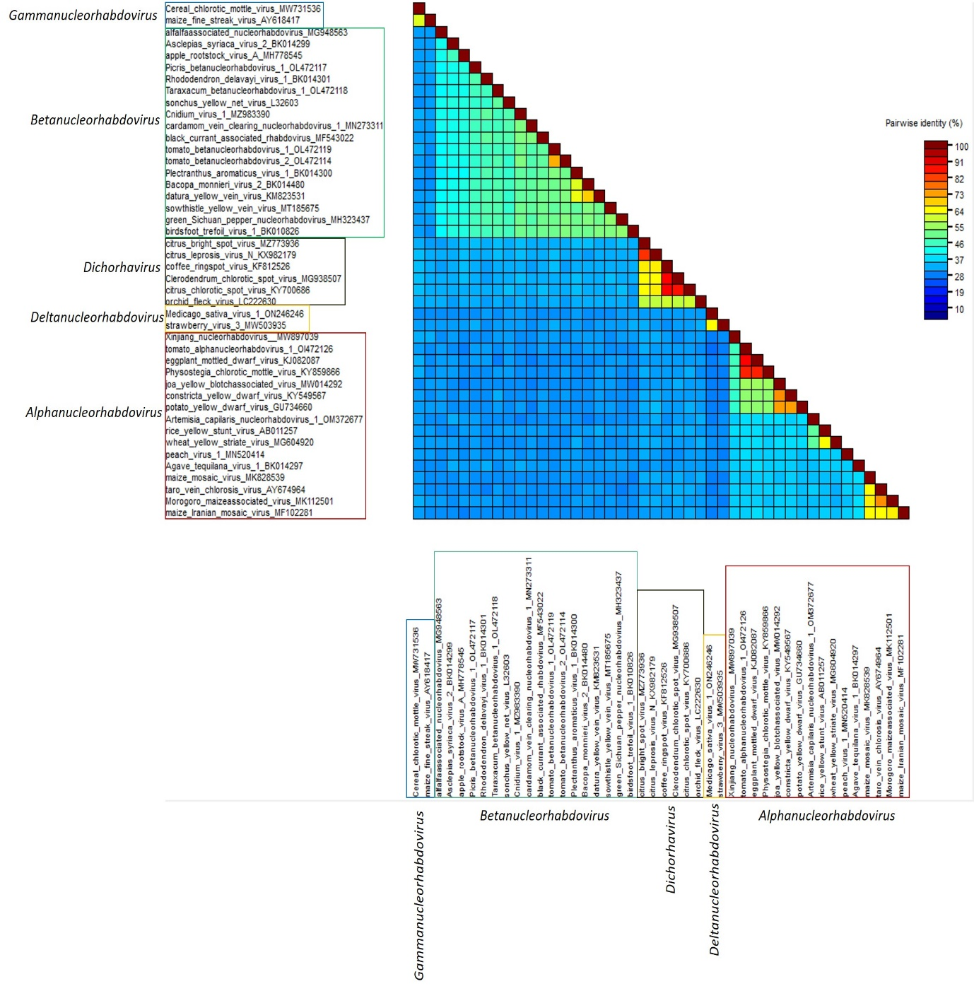

Figure 2. Pairwise identity matrix based on the coding complete nucleotide sequences of all alphanucleorhabdoviruses, betanucleorhabdoviruses, deltanucleorhabdoviruses, dichorhaviruses and gammanucleorhabdoviruses members. The matrix was generated using the SDT v1.2 software.
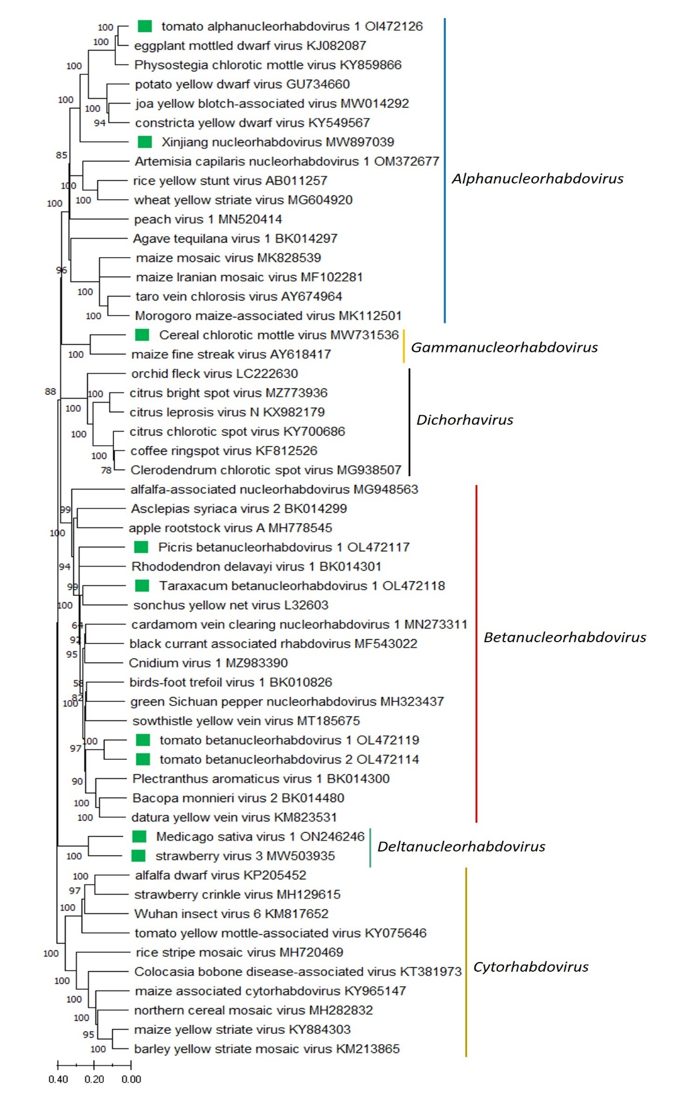
Figure 3. A Maximum Likelihood (ML) phylogenetic tree of plant-infecting rhabdovirus L polymerase protein sequences. Amino acid sequences were aligned using MUSCLE. The resulting alignment was used to generate a phylogenetic tree using MegaX with the best-fit model LG + G + I +F. Nine viruses potentially belonging to the new species are indicated with green squares. Numbers at the nodes indicate bootstrap support (1000 replicates).

References

[1] Rivarez M, Pecma A, Bacnik K, et al (2022). In-depth study of tomato and weed viromes reveals undiscovered plant virus diversity in an agroecosystem. Microbiome 11:60, PMID:36973750, doi: 10.1186/s40168-023-01500-6.
[2] Chen Y, Sadiq S, Tian J, et al (2022). RNA viromes from terrestrial sites across China expand environmental viral diversity. Nat Microbiol 7:1312-1323. PMID:35902778, doi:10.1038/s41564-022-01180-2.
[3] Alvarez-Quinto R, Lockhart B, Serrano J, Grinstead S, Mollov D (2022). Complete genome sequence of Cereal Chlorotic mottle virus from Morocco. Arch Virol 167:2347-2350. PMID:35834001, doi:10.1007/s00705-022-05527-2
[4] Li J, Shang Q, Liu Y, et al. (2022). Occurrence, Distribution, and Transmission of Alfalfa Viruses in China. Viruses 14:1519. PMID35891498, doi:10.3390/v14071519
[5] Medberry A, Srivastava A, Diaz-Lara A, et al (2022). A novel, divergent member of the Rhabdoviridae infects strawberry. Plant Dis. PMID:35857372, doi:10.1094/PDIS-05-22-1078-SC

