Part 1: TITLE, AUTHORS, APPROVALS, etc

Code assigned: | 2023.016M
Short title: Establishment of eleven new species in genera Penicillimonavirus, Plasmopamonavirus, Phyllomonavirus, and Sclerotimonavirus in family Mymonaviridae (Mononegavirales)
Author(s) and email address(es)
Jiāng D, Ayllón MA, Marzano S-YL, Kondō H, Turina M | daohongjiang@mail.hzau.edu.cn; mariaangeles.ayllon@upm.es; shinyi.marzano@usda.gov; hkondo@okayama-u.ac.jp; massimo.turina@ipsp.cnr.it
Author(s) institutional address(es) (optional)
Huazhong Agricultural University [DJ]
Universidad Politécnica de Madrid (UPM) [MAA]
United States Department of Agriculture, Agricultural Research Service [SYLM]
Okayama University [HK]
Institute for Sustainable Plant Protection, CNR [MT]
Corresponding author
Jiāng D
List the ICTV Study Group(s) that have seen this proposal
ICTV Mymonaviridae Study Group
ICTV Study Group comments and response of proposer
ICTV Study Group votes on proposal
Study Group | Number of members
 | Votes support | Votes against | No vote
ICTV Mymonaviridae Study Group | 5 | 0 | 0
Authority to use the name of a living person
Is any taxon name used here derived from that of a living person (Y/N)

Taxon name | Person from whom the name is derived | Permission attached (Y/N)

Submission dates
Date first submitted to SC Chair | June 23, 2023
Date of this revision (if different to above)
ICTV-EC comments and response of the proposer

Part 2: NON-TAXONOMIC PROPOSAL

Part 3: TAXONOMIC PROPOSAL
Name of accompanying Excel module
2023.016M.N.v1.Mymonaviridae_11nsp.xlsx
Abstract
We propose to create one new species in genus Penicillimonavirus, one in genus Phyllomonavirus, two in genus Plasmopamonavirus, and seven in genus Sclerotimonavirus of the mononegaviral family Mymonaviridae.
Text of proposal
The monjiviricete family Mymonaviridae currently includes nine genera. Genera Penicillimonavirus, Phyllomonavirus, Plasmopamonavirus and Sclerotimonavirus include fourteen, two, two and seventeen species, respectively. We searched the NCBI database for novel mymonavirids and found that, based upon available coding-complete (or near-complete) genome sequences, several novel viruses should be classified into a total of eleven novel species in genera Penicillimonavirus, Phyllomonavirus, Plasmopamonavirus, and Sclerotimonavirus (Table 1). The phylogenetic analysis and matrix diagram of amino acid identities of selected viruses are shown in Figures 1 and 2.
The proposed species are named Penicillimonavirus cercosporae, Phyllomonavirus culicis, Plasmopamonavirus alphatrichodermae, Plasmopamonavirus betatrichodermae, Sclerotimonavirus alpharhipicephali, Sclerotimonavirus betarhipicephali, Sclerotimonavirus ceratocystidis, Sclerotimonavirus alphaalternariae, Sclerotimonavirus prolifusarii, Sclerotimonavirus betaalternariae, Sclerotimonavirus trichodermae.

32% L protein amino acid sequence identity is proposed as a genus rank demarcation threshold.
The demarcation criteria for species (80%) and genus demarcation (32%) in the family Mymonaviridae are supported by the result of phylogenetic analysis.

Supporting evidence

Table 1 Newly proposed species of the family Mymonaviridae

Genus name | New species name | Newly identified virus | Accession number | Host | Reference
Penicilliumonavirus | Penicilliumonavirus cercosporae | Cercospora beticola negative-stranded virus 3 | MZ599588 | Dothideomycete fungi (mycosphaerellaceaen Cercospora beticola Sacc., (1876)) | (1)
Phyllomonavirus | Phyllomonavirus culicis | XiangYun mono-chu-like virus | OL700132 | Mosquitoes (culicid Culex pipiens Linnaeus, 1758) | NCBI:txid2952074
Plasmopamonavirus | Plasmopamonavirus alphatrichodermae | Trichoderma harzianum mononegavirus 1 | OQ463847 | Sordariomycete fungi (hypocreaceaen Trichoderma harzianum Rifai, (1969)) | (2)
 | Plasmopamonavirus betatrichodermae | Trichoderma harzianum mononegavirus 2 | OQ463848 | Sordariomycete fungi (hypocreaceaen Trichoderma harzianum Rifai, (1969)) | (2)
Sclerotimonavirus | Sclerotimonavirus prolifusarii | Fusarium proliferatum mymonavirus 1 | OK524200 | Sordariomycete fungi (nectriaceaen Fusarium proliferatum (Matsush.) Nirenberg ex Gerlach & Nirenberg (1976)) | NCBI:txid2974662
 | Sclerotimonavirus ceratocystidis | Sclerotimonavirus cacaofunestae | BK062943 | Sordariomycete fungi (ceratocystidaceaen Ceratocystis cacaofunesta Engelbr. & T.C.Harr. (2005)) | (3)
 | Sclerotimonavirus alpharhipicephali | Zhangzhou Mymon tick virus 3 | ON746412 | Brown dog ticks (ixodid Rhipicephalus sanguineus (Latreille, 1806)) | (4)
 | Sclerotimonavirus betarhipicephali | Sanya Mymon tick virus 1 | ON746413 | Brown dog ticks (ixodid Rhipicephalus sanguineus (Latreille, 1806)) | (4)
 | Sclerotimonavirus alphaalternariae | Alternaria dianthicola negative-stranded RNA virus 1 | ON843764 | Dothideomycete fungi (pleosporaceaen Alternaria dianthicola Neerg. (1945)) | (5)
 | Sclerotimonavirus betaalternariae | Alternaria tenuissima negative-stranded RNA virus 2 | OP566533 | Dothideomycete fungi (pleosporaceaen Alternaria tenuissima Samuel Paul Wiltshire (1933)) | (6)
 | Sclerotimonavirus trichodermae | Trichoderma harzianum negative-stranded virus 2 | OQ463851 | Sordariomycete fungi (hypocreaceaen Trichoderma harzianum Rifai, (1969)) | (2)

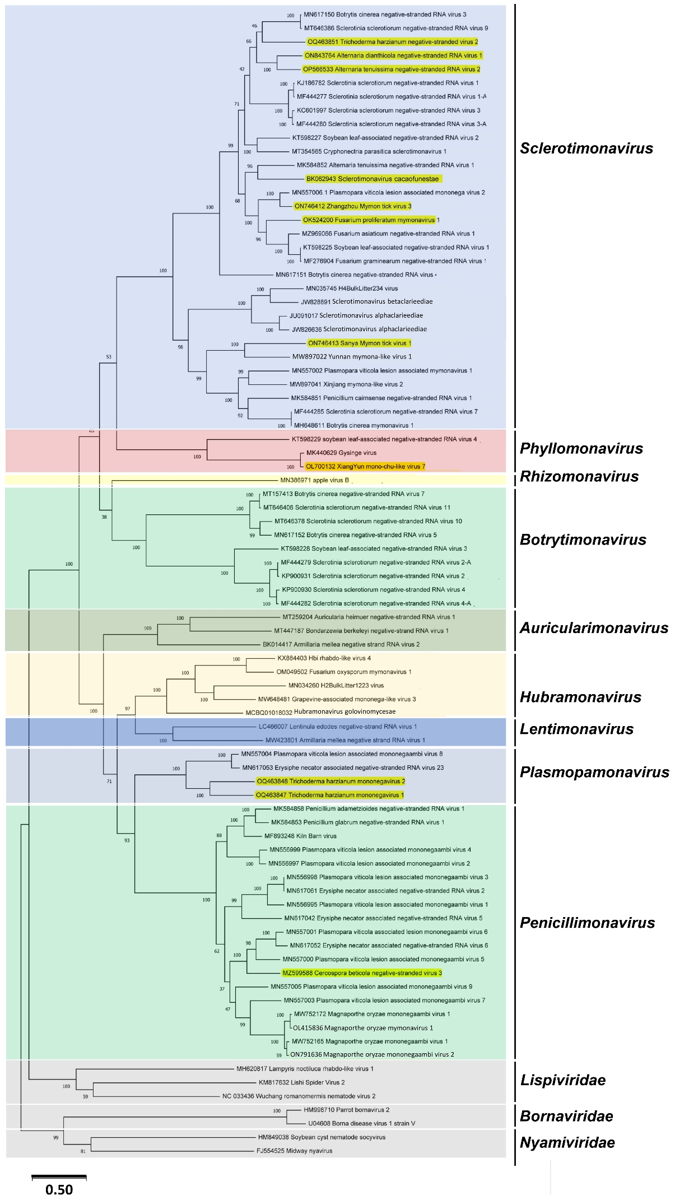

Figure 1 The phylogenetic tree of the expanded and reorganized family Mymonaviridae by using the Maximum Likelihood method and Le_Gascuel_2008 model [7]. The tree with the highest log likelihood (-244848.36) is shown. The percentage of trees in which the associated taxa clustered together is shown next to the branches. Initial tree(s) for the heuristic search were obtained automatically by applying Neighbor-Join and BioNJ algorithms to a matrix of pairwise distances estimated using the JTT model, and then selecting the topology with superior log likelihood value. The tree is drawn to scale, with branch lengths measured in the number of substitutions per site. This analysis involved 84 amino acid sequences. There were a total of 2410 positions in the final dataset. Evolutionary analyses were conducted in MEGA11 [8]. Viruses classified in families Lispiviridae, Nyamiviridae, and Bornaviridae were used as outgroups. Newly identified viruses are highlighted in yellow.

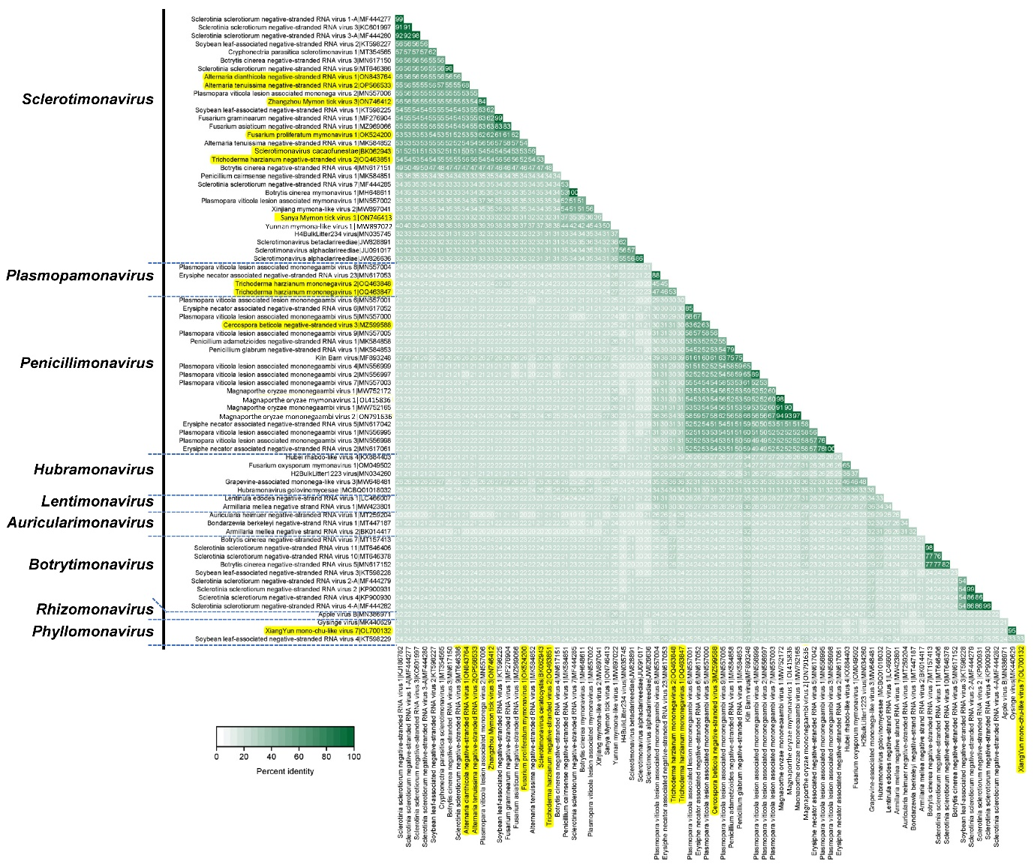

Figure 2 Matrix diagram of amino acid identities of L proteins among members of the expanded and reorganized family Mymonaviridae. The percent identity matrix was created via multiple sequence alignment using Clustal Omega. Percent identity matrices were converted to heat map plots using a custom R script. Newly identified viruses are highlighted in yellow.
References

- Li Y, Zhou M, Yang Y, Liu Q, Zhang Z, Han C, Wang Y(2021)Characterization of the mycovirome from the plant-pathogenic fungus Cercospora beticola. Viruses 13 (10):1915. PMID: 34696345.DOI: 10.3390/v13101915
- Pagnoni S, Oufensou S, Balmas V, Bulgari D, Gobbi E, Forgia M, Migheli Q, Turina M (2023) A collection of Trichoderma isolates from natural environments in Sardinia, a biodiversity hotspot, reveals a complex virome that includes negative-stranded mycoviruses with unprecedented genome organizations. bioRxiv (2023) DOI: 10.1101/2023.03.31.535183
- Espinal RBA, de Santana SF, Santos VC, Lizardo GNR, Silva RJS, Correa RX, Loguercio LL, Goes-Neto A, Pirovani CP, Fonseca PLC, Aguiar ERGR (2023) Uncovering a complex virome associated with the cacao pathogens Ceratocystis cacaofunesta and Ceratocystis fimbriata. Pathogens 12 (2): 287. PMID: 36839559.doi: 10.3390/pathogens12020287.
- Ni XB, Cui XM, Liu JY, Ye RZ et al (2023) Metavirome of 31 tick species provides a compendium of 1,801 RNA virus genomes. Nature Microbiology 8:162–173. PMID: 36604510. doi.org/10.1038/s41564-022-01275-w
- Zhong J, Li P, Gao BD, Zhong SY, Li XG, Hu Z, Zhu JZ (2022) Novel and diverse mycoviruses co-infecting a single strain of the phytopathogenic fungus Alternaria dianthicola. Front Cell Infect Microbiol 12:980970. PMID: 36237429. doi.org/10.3389/fcimb.2022.980970.
- Wang W, Wang X, Tu C, Yang M, Xiang J, Wang L, Hong N, Zai L, Wang G (2022) Novel mycoviruses discovered from a metatranscriptomics survey of the phytopathogenic alternaria fungus. Viruses 14 (11): 2552. PMID: 36423161. DOI: 10.3390/v14112552
- Le SQ, Gascuel O (2008). An improved general amino acid replacement matrix. Mol Biol Evol 25(7):1307-1320. PMID: 18367465. DOI: 10.1093/molbev/msn067.
- Tamura K, Stecher G, Kumar S (2021) MEGA 11: Molecular evolutionary genetics analysis version 11. Molecular Biology and Evolution 38(7): 3022-3027. PMID: 33892491. doi.org/10.1093/molbev/msab120.

