Part 1: TITLE, AUTHORS, APPROVALS, etc

Code assigned: | 2023.023M
Short title: Create ten new genera and eleven new species in the family Xinmoviridae, order Mononegavirales
Author(s) and email address(es)
Paraskevopoulou S, Sharpe SR, Feng G | paraskevopoulous@rki.de;  Stephen.Sharpe@westernsydney.edu.au;  fengguozhong@caas.cn
Author(s) institutional address(es) (optional)
Corresponding author
Paraskevopoulou S
List the ICTV Study Group(s) that have seen this proposal
ICTV Xinmoviridae Study Group
ICTV Study Group comments and response of proposer
ICTV Study Group votes on proposal
Study Group | Number of members
 | Votes support | Votes against | No vote
ICTV Xinmoviridae Study Group | 3 | 0 | 0
Authority to use the name of a living person
Is any taxon name used here derived from that of a living person (Y/N) | N

Taxon name | Person from whom the name is derived | Permission attached (Y/N)
N/A | N/A | N/A

Submission dates
Date first submitted to SC Chair | June 23, 2023
Date of this revision (if different to above)
ICTV-EC comments and response of the proposer

Part 2: NON-TAXONOMIC PROPOSAL
N/A

Part 3: TAXONOMIC PROPOSAL
Name of accompanying Excel module
2023.023M.N.v1.Xinmoviridae_10ng_11nsp.xlsx
Abstract
We propose the creation of 10 new genera and 11 new species to be included in mononegaviral family Xinmoviridae. Genus (and species) demarcation is proposed to be based on coding-complete genome sequence analyses, phylogenetic analyses, and pairwise sequence comparisons similar to established genus/species demarcation criteria for other mononegaviral families.
Text of proposal
Here, we propose the classification of 10 genera and 11 new species in the Xinmoviridae family of the haploviricotine order Mononegavirales. Species and genera are proposed for classification according to the established classification criteria:
- a coding/near-complete genome
- at least 20% amino acid identity of the RNA-directed RNA polymerase (RdRp) sequence
The above criteria are similar to those used for other mononegaviral families.

Accordingly, the xinmovirid genus demarcation criterion requires a coding-complete RdRp with amino acid identity between 20-59%, and the xinmovirid species demarcation criterion requires a coding-complete RdRp with amino acid identity 60% or higher. Thus, based on the present phylogenetic analysis shown in Figure 1, we propose the demarcation of 10 new genera and 11 new species.

Etymologies:

- Trocevirus haikouense for Bactrocera dorsalis xinmovirus 2. The virus was discovered by HTS in tephritid fruit flies (oriental fruit fly species: Bactrocera dorsalis, family: Tephritidae) in Haikou, Hainan Province, China. The genus is named after a syllable excerpt from the word Bactrocera. The species is named using its discovered geography location Haikou in an epithet form “haikouense”.

- Gudgevirus namadgii for Gudgenby calliphora mononega-like virus. The virus was discovered by HTS in bluebodied blowflies (Calliphora augur, family: Calliphoridae) at the Gudgenby Valley, in Namadgi National Park (Gudg), Australia. The genus is named after a syllable excerpt from the word Gudgenby. The species is named using its discovered geography location Namadgi in an epithet form “namadgii”.

- Culivirus belgradiense for Serbia mononega-like virus 1. The virus was discovered by HTS in common house mosquitoes (Culex pipiens, family: Culicidae) sampled in Belgrade, Serbia. The genus is named after a syllable excerpt from the word Culicidae. The species is named using its discovered geography location Belgrade in an epithet form “belgradiense”.

- Culivirus dunyae for Aedes albopictus anphevirus. The virus was discovered by HTS in common Asian tiger mosquitoes (Aedes albopictus, family: Culicidae) found in both wild-caught and lab colony mosquitoes, collected from several countries: USA, Japan, Italy, China, Thailand, Switzerland. The genus is named after a syllable excerpt from the translation of the word “worldwide” in Turkish: dunya in the latin genitive: “dunyae”.

- Gordisvirus californiense for Gordis virus. The virus was discovered by HTS in mosquitoes (Culiseta particeps, family: Culicidae) sampled in San Diego County, California, USA. The genus is named after the word Gordis. The species is named using its discovered geography location California in an epithet form “californiense”.

- Puclevirus hangzhouense for Hangzhou cletus punctiger xinmovirus 1. The virus was discovered by HTS in rice stinkbugs (Cletus punctiger, family: Coreidae) sampled in the Fuyang district of the city Hangzhou in the Zhejiang province, China. The genus is named after a syllable combination from the words Cletus and punctiger. The species is named using its discovered geography location Hangzhou in an epithet form “hangzhouense”.

- Corulvirus hangzhouense for Hangzhou zicrona caerulea xinmovirus 1. The virus was discovered by HTS in blue shieldbugs (Zircona caerulea, family: Pentatomidae) sampled in the Fuyang district of the city Hangzhou in the Zhejiang province, China. The genus is named after a syllable combination from the words Zircona and caerulea. The species is named using its discovered geography location Hangzhou in an epithet form “hangzhouense”.

- Nurnegvirus hainanense for Sanya ischnura senegalensis xinmovirus 1. The virus was discovered by HTS in common bluetail damselflies (Ischnura senegalensis, family: Coenagrionidae) sampled in the city Sanya of the Hainan island province, China. The genus is named after a syllable combination from the words Ischnura and senegalensis. The species is named using its discovered geography location Hainan in an epithet form “hainanense”.

- Molauvirus liaoningense for Fushun monolepta lauta xinmovirus 1. The virus was discovered by HTS in leaf beetles (Monolepta lauta, family: Chrysomelidae) sampled in the Fuyang district of the city Fushun in the Liaoning province, China. The genus is named after a syllable combination from the words Monolepta and lauta. The species is named using its discovered geography location Liaoning in an epithet form “liaoningense”.

- Laumovirus liaoningense for Fushun monolepta lauta xinmovirus 2. The virus was discovered by HTS in leaf beetles (Monolepta lauta, family: Chrysomelidae) sampled in the Fuyang district of the city Fushun in the Liaoning province, China. The genus is named after a syllable combination from the words Monolepta and lauta. The species is named using its discovered geography location Liaoning in an epithet form “liaoningense”.

- Tecephavirus sydneyense for Bat faecal associated anphe-like virus 1. The virus was discovered by HTS in the gut metagenome of grey-headed flying foxes (Pteropus poliocephalus, family: Pteropodidae) sampled in the Centennial Park of Sydney, Australia. The genus is named after a syllable combination from the words Pteropus and poliocephalus. The species is named using its discovered geography location Sydney in an epithet form “sydneyense”.

Supporting evidence

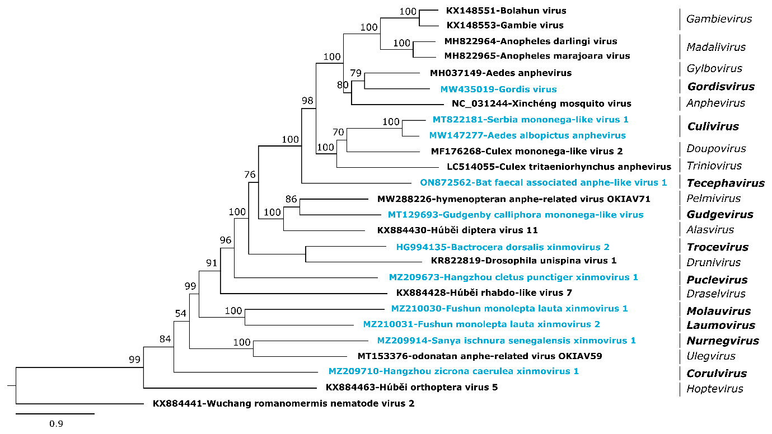

Figure 1: Phylogenetic relationships of xinmovirids. The phylogenetic tree is based on a MAFFT-alignment of the RdRp amino acid sequences using the E-INS-i algorithm and was inferred using IQtree and the LG substitution model. Numbers on branch nodes represent transfer bootstrap expectation values (1,000 replicates). Proposed new xinmovirid genera are shown in bold at the right; viruses proposed to be classified into new species are shown in blue. The tree is rooted to Wuchang arlivirus from the genus Arlivirus of the Lispiviridae family.

References

Sharpe SR, et al. (2021). Tephritid fruit flies have a large diversity of co-occurring RNA viruses. Journal of Invertebrate Pathology, 186 (2021): 107569. PMID: 33727045

Manni M, Zdobnov EM. A (2020). Novel Anphevirus in Aedes albopictus Mosquitoes Is Distributed Worldwide and Interacts with the Host RNA Interference Pathway. Viruses. 2(11):1264. doi: 10.3390/v12111264. PMID: 33172032.

Stanojević M, et al. (2020). Depicting the RNA Virome of Hematophagous Arthropods from Belgrade, Serbia. Viruses. 12(9):975. doi: 10.3390/v12090975. PMID: 32887342.

Mahar JE, et al. (2020). Comparative Analysis of RNA Virome Composition in Rabbits and Associated Ectoparasites. J Virol. 94(11):e02119-19. doi: 10.1128/JVI.02119-19. PMID: 32188733.

Batson J, et al. (2021). Single mosquito metatranscriptomics identifies vectors, emerging pathogens and reservoirs in one assay. Elife. 10:e68353. doi: 10.7554/eLife.68353. PMID: 33904402.

Xavier CAD, et al. (2021). Ever-increasing viral diversity associated with the red imported fire ant Solenopsis invicta (Formicidae: Hymenoptera). Virol J. 18(1):5. doi: 10.1186/s12985-020-01469-w. PMID: 33407622.

