Part 1: TITLE, AUTHORS, APPROVALS, etc

Code assigned: | 2023.011M
Short title: Create one new genus (Birfecvirus) and four new species in the genera Ganiavirus, Copasivirus, Anicalvirus, and Birfecvirus (Mononegavirales: Lispiviridae)
Author(s) and email address(es)
Paraskevopoulou S, Li J-M, Ye G, Wang F | paraskevopoulous@rki.de; lijunmin@nbu.edu.cn; chu@zju.edu.cn; wangfei@wh.iov.cn
Author(s) institutional address(es) (optional)
Corresponding author
Paraskevopoulou S
List the ICTV Study Group(s) that have seen this proposal
ICTV Lispiviridae Study Group
ICTV Study Group comments and response of proposer
ICTV Study Group votes on proposal
Study Group | Number of members
 | Votes support | Votes against | No vote
ICTV Lispiviridae Study Group | 4 | 0 | 0
Authority to use the name of a living person
Is any taxon name used here derived from that of a living person (Y/N) | N

Taxon name | Person from whom the name is derived | Permission attached (Y/N)
N/A | N/A | N/A

Submission dates
Date first submitted to SC Chair | June 23, 2023
Date of this revision (if different to above)
ICTV-EC comments and response of the proposer

Part 2: NON-TAXONOMIC PROPOSAL

Part 3: TAXONOMIC PROPOSAL
Name of accompanying Excel module
2023.011M.N.v1.Lispiviridae_1ngen_4nsp.xlsx
Abstract
We propose the creation of one new genus and four new species to be included in mononegaviral family Lispiviridae. Genus (and species) demarcation is proposed to be based on coding-complete genome sequence analyses, phylogenetic analyses, and pairwise sequence comparisons similar to established genus/species demarcation criteria for other mononegaviral families.
Text of proposal
Here, we propose the classification of a new genera and four new species in the Lispiviridae family of the haploviricotine order Mononegavirales. Species and genera are proposed for classification according to the established classification criteria:

- a coding-complete RNA-directed RNA polymerase (RdRp)
- at least 20% amino acid identity of the RdRp sequence

The above criteria are similar to those used for other mononegaviral families.

Accordingly, the lispivirid genus demarcation criterion requires a coding-complete RdRp with amino acid identity between 20-49%, and the lispivirid species demarcation criterion a coding-complete RdRp with amino acid identity 50% or higher. Thus, based on the present phylogenetic analysis shown in Figure 1, we propose the demarcation of 1 new genus and 4 new species.

Etymologies:

- Copasivirus cattienense for Cát Tiên Hospitalitermes lispi-like virus. The virus was discovered by HTS in termites (nasutitermitinine Hospitalitermes bicolor Holmgren, 1912) in Cát Tiên National Park, Vietnam. The RdRp of this virus has 66% amino acid identity with that of the RdRp of Jimsystermes virus (Copasivirus manlyvaleense). The species is named using its discovered geography location Cát Tiên in an epithet form “cattienense”.

- Birfecvirus tibetense for Arlivirus sp. XZN142933. The virus was discovered by HTS in fecal samples of birds collected in Tibet, China. The RdRp of this virus has 35% amino acid identity with that of the RdRp of Hángzhōu scotinophara lurida lispivirus 1 (Arlivirus hangzhouense). The genus is named after bird and fecal, and the species is named using its discovered geography location Tibet in an epithet form “tibetense”.

- Anicalvirus hesdarense for hymenopteran arli-related virus OKIAV100. The virus was discovered by HTS in parasitic wasps (orussid Orussus unicolor Latreille, 1812) in Darmstadt, Hesse, Germany. The RdRp of this virus has 51% amino acid identity with that of Anisopteromalus calandrae negative-strand RNA virus 2 (Anicalvirus hangzhouense). The species is named using its discovered geography location Hesse-Darmstadt in an epithet form “hesdarense”.

- Ganiavirus fuyunense for Fùyùn tick virus 1. The virus was discovered by HTS in parasitic ticks collected from domestic animals (camels and sheep) in Fùyùn County (富蕴县) of Xīnjiāng Uygur Autonomous Region, China. The RdRp of this virus has 53% amino acid identity with that of Tǎchéng tick virus 6 (Ganiavirus tachengense). The species is named using its discovered geography location Fùyùn in an epithet form “fuyunense”.

Supporting evidence

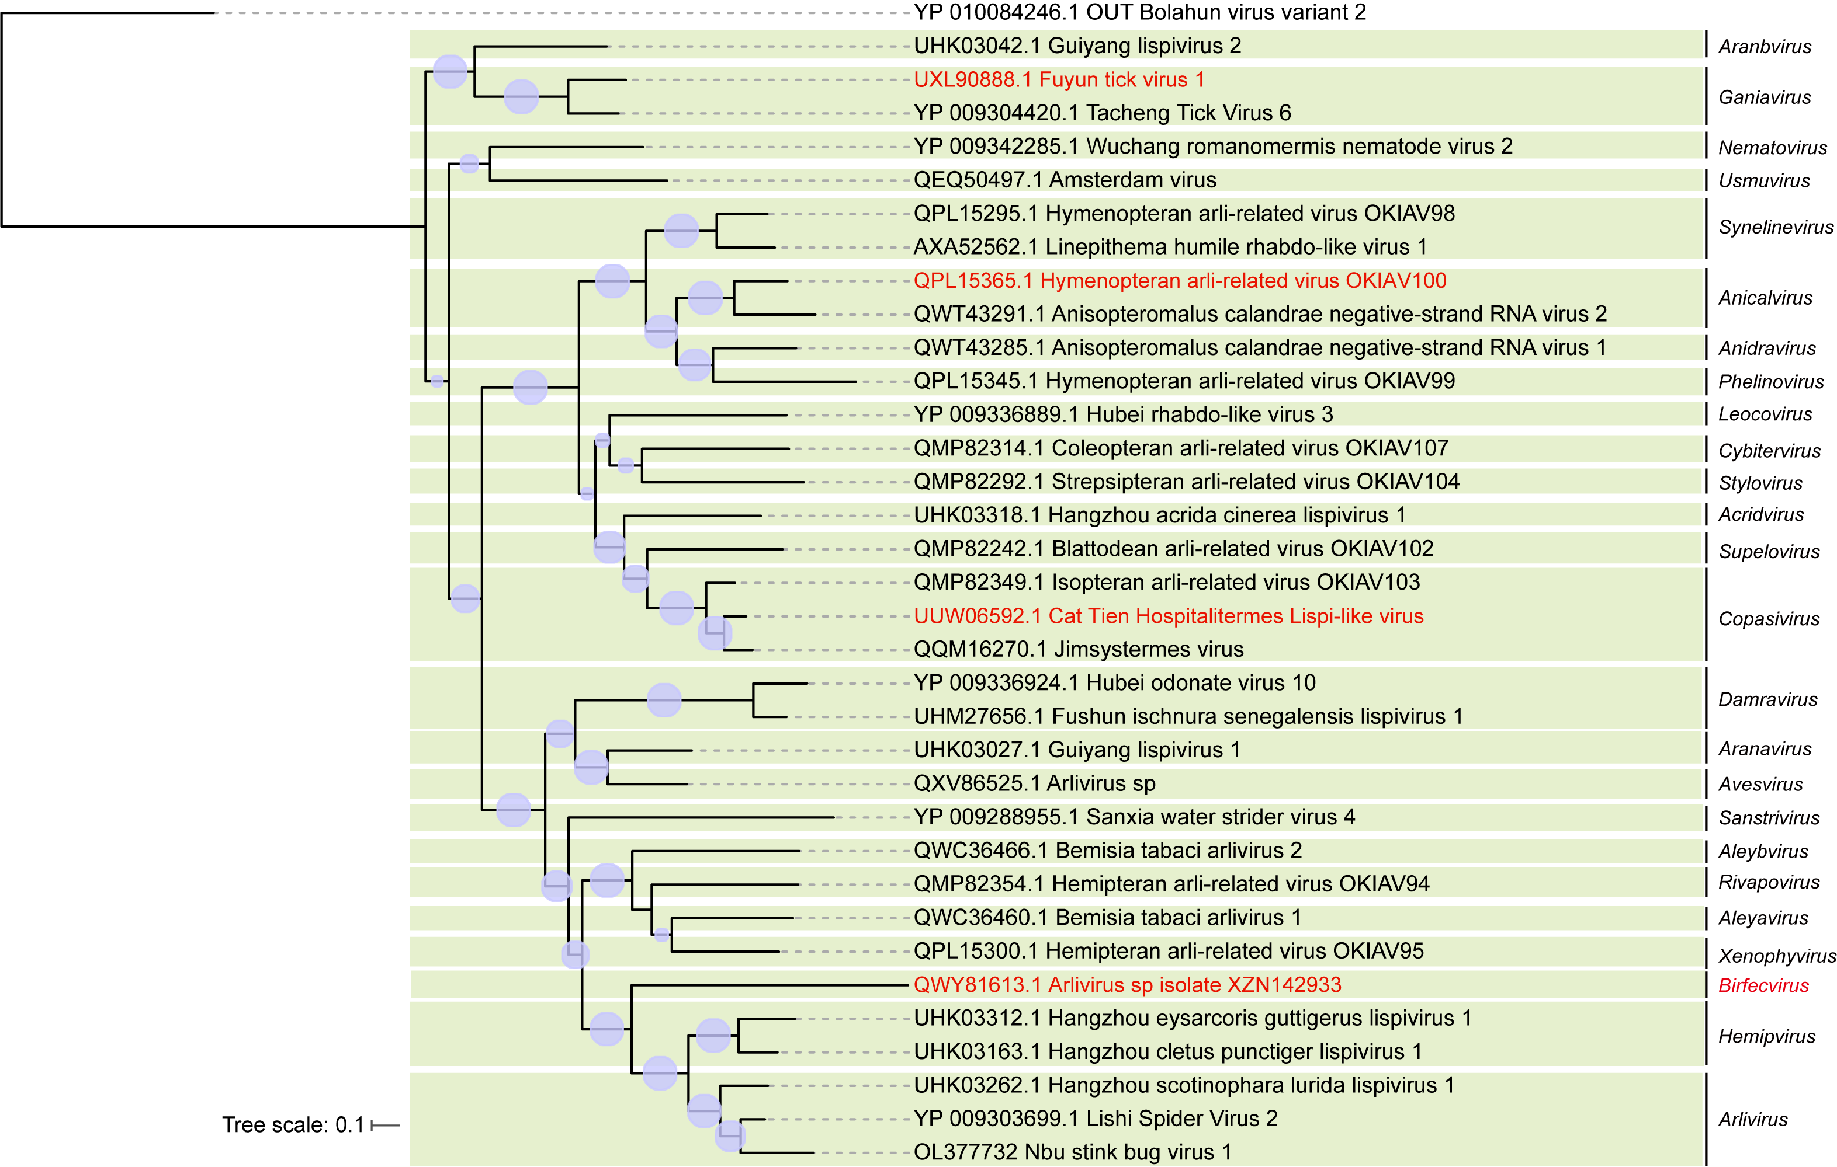

Figure 1: Phylogenetic relationships of lispivirids. The phylogenetic tree is based on a MAFFT-alignment of the RdRp amino acid sequences using the L-INS-i algorithm and was inferred using ModelTest-NG and the LG substitution model. Numbers on branch nodes represent transfer bootstrap expectation values (1,000 replicates). Proposed new lispivirid genera or species are shown in red font. The tree is rooted to Bolahun virus of the Anphevirus genus of the Xinmoviridae family.

References
Litov, A.G., et al. (2022). Virome of Three Termite Species from Southern Vietnam. Viruses 14(5): 860, PMID: 35632601
Zhu, W., et al. (2022). RNA Virus Diversity in Birds and Small Mammals From Qinghai-Tibet Plateau of China. Front Microbiol 13:780651, PMID: 35250920
Käfer, S., et al. (2019). Re-assessing the diversity of negative strand RNA viruses in insects. PLoS Pathog 15:e1008224, PMID: 31830128
Kong, Y., et al. (2022). Metatranscriptomics Reveals the Diversity of the Tick Virome in Northwest China. Microbiol Spectr 10:e0111522, PMID: 36214702

