Part 1: TITLE, AUTHORS, APPROVALS, etc

Code assigned: | 2023.008M
Short title: Create twelve new species in the genus Cytorhabdovirus, subfamily Betarhabdovirinae (Mononegavirales: Rhabdoviridae)
Author(s) and email address(es)
Bejerman N, Debat H, Dietzgen RG, Kondo H, Ramos-González P, Whitfield AE, Walker PJ, Freitas-Astúa J | bejerman.nicolas@inta.gob.ar;  debat.humberto@inta.gob.ar;  r.dietzgen@uq.edu.au; hkondo@rib.okayama-u.ac.jp;  plrg1970@gmail.com;  awhitfi@ncsu.edu;  peter.walker@uq.edu.au;  juliana.astua@embrapa.br
Author(s) institutional address(es) (optional)
Corresponding author
Bejerman N
List the ICTV Study Group(s) that have seen this proposal
ICTV Rhabdoviridae Study Group
ICTV Study Group comments and response of proposer
Minor corrections regarding the creation of new species.
ICTV Study Group votes on proposal
Study Group | Number of members
 | Votes support | Votes against | No vote
ICTV Rhabdoviridae Study Group | 10 | 0 | 4
Authority to use the name of a living person

Is any taxon name used here derived from that of a living person (Y/N) | N

Taxon name | Person from whom the name is derived | Permission attached (Y/N)
N/A | N/A | N/A

Submission dates
Date first submitted to SC Chair | June 23, 2023
Date of this revision (if different to above)
ICTV-EC comments and response of the proposer

Part 2: NON-TAXONOMIC PROPOSAL
N/A

Part 3: TAXONOMIC PROPOSAL
Name of accompanying Excel module
2023.008M.N.v1.Cytorhabdovirus_12nsp.xlxs
Abstract
Viruses classified in the family Rhabdoviridae infect vertebrates, invertebrates, and plants. Twelve new plant-infecting rhabdoviruses were discovered recently and their complete or coding-complete genomes were determined. This proposal aims to classify taxonomically these twelve viruses into twelve new species in the genus Cytorhabdovirus.
Text of proposal
We propose the taxonomic classification of twelve novel plant-infecting rhabdoviruses in twelve new species in the established genus Cytorhabdovirus in the subfamily Betarhabdovirinae, family Rhabdoviridae:

1) Blackcurrant rhabdovirus 2 (BCRV2) was identified in blackcurrant (Ribes nigrum) plants collected in the Czech Republic. The complete genome (CG) sequence of BCRV2 has 12,863 nucleotides (isolate KB1, OP352885) and contains seven ORFs in the order 3’-N-P´-P-P3-M-G-L-5’ [1] representing the five canonical rhabdovirus structural protein genes as well as the putative cell-to-cell movement protein gene P3 in the conserved location between P and M genes, and an overlapping ORF within the P-encoding ORF, which is named P´ (Figure 1). The CG nucleotide sequence of BCRV2 has the highest sequence identity with that of strawberry virus 2 (StrV2, 67%) [1], while the BCRV2 L protein amino acid sequence has the highest sequence identity with that of StrV2 (75%) [1]. Based on ML trees generated from complete L protein sequences BCRV2 forms a well-supported clade with the cytorhabdovirus StrV2 (Figure 2).

2) Daphne virus 1 (DV1) was identified in Daphne odora plants collected in South Korea. The complete genome (CG) sequence of DV1 has 13,206 nucleotides (isolate SK, OP180101) and contains seven ORFs in the order 3’-N- P´-P-P3-M-G-L-5’ [2] representing the five canonical rhabdovirus structural protein genes as well as the putative cell-to-cell movement protein gene P3 in the conserved location between P and M genes, and an overlapping ORF within the P-encoding ORF, which is named P´ (Figure 1). The CG nucleotide sequence of DV1 has the highest sequence identity with that of Asclepias syriaca virus 1 (AscSyV1, 57.4%) [2], while the DV1 L protein amino acid sequence has the highest sequence identity with that of AscSyV1 (57%) [2]. Based on ML trees generated from complete L protein sequences DV1 forms a well-supported clade with forms a well-supported clade with the cytorhabdovirus AscSyV1 (Figure 2).

3) Hyptis latent virus (HpLV) was identified in Hyptis pectinata plants collected in Ecuador. The complete genome (CG) sequence of HpLV has 13,765 nucleotides (isolate Prosperina, ON073823) and contains eight ORFs in the order 3’-N- P´-P-P3-M-G-P6-L-5’ [3] representing the five canonical rhabdovirus structural protein genes as well as the putative cell-to-cell movement protein gene P3 in the conserved location between P and M genes, an overlapping ORF within the P-encoding ORF, which is named P´, and the accessory protein P6 between the G and L genes (Figure 1). The CG nucleotide sequence of HpLV has the highest sequence identity with that of alfalfa dwarf virus (ADV, 53.4%), while the HpLV L protein amino acid sequence has the highest sequence identity with that of ADV (56.3%) [3]. Based on ML trees generated from complete L protein sequences HpLV is placed within a subclade of the cytorhabdoviruses, with ADV, raspberry vein chlorosis virus and strawberry crinkle virus (Figure 2).

4) Pastinaca cytorhabdovirus 1 (PaCRV1) was identified in Pastinaca sativa plants collected in Slovenia. The coding-complete genome (CCG) sequence of PaCRV1 has 13,072 nucleotides (isolate POR19SW, OL472112) and contains eight ORFs in the order 3’-N- P´-P-P3-M-G-P6-L-5’ [4] representing the five canonical rhabdovirus structural protein genes as well as the putative cell-to-cell movement protein gene P3 in the conserved location between P and M genes, an overlapping ORF within the P-encoding ORF, which is named P´, and the accessory protein P6 between the G and L genes (Figure 1). The CCG nucleotide sequence of PaCRV1 has the highest sequence identity with that of chrysanthemum yellow dwarf-associated virus (CYDaV, 61%) [4], while the PaCRV1 L protein amino acid sequence has the highest sequence identity with that of CYDaV (55.6%). Based on ML trees generated from complete L protein sequences PaCRV1 forms a well-supported clade with forms a well-supported clade with the cytorhabdovirus CYDaV (Figure 2).

5) Patchouly chlorosis-associated cytorhabdovirus (PCaCV) was identified in patchouly (Pogostemon cablin) plants collected in Pará, Brazil. The complete genome (CG) sequence of PCaCV has 12,913 nucleotides (isolate PA, ON409991) and contains six ORFs in the order 3’-N- P´-P-P3-M-L-5’ [5] representing four canonical rhabdovirus structural protein genes (N, P, M and L, the G gene was found to be defective), as well as the putative cell-to-cell movement protein gene P3 in the conserved location between P and M genes and the overlapping ORF within the P-encoding ORF, which is named P (Figure 1). The CG nucleotide sequence of PCaCV has the highest sequence identity with that of tomato yellow mottle-associated virus (TYMaV, 61.1%) [5], while the PCaCV L protein amino acid sequence has the highest sequence identity with that of TYMaV (73.9%) [5]. Based on ML trees generated from complete L protein sequences PCaCV forms a well-supported clade with forms a well-supported clade with the cytorhabdovirus TYMaV (Figure 2).

6) Rose-associated cytorhabdovirus (RaCV) was identified from the analysis of rose (Rosa rubiginosa) plants collected in Chongqing, China. The complete genome (CG) sequence of RaCV has 16,067 nucleotides (isolate SWU-X, ON762421), and contains eight ORFs in the order 3’-N-P-P3-P4-M-G-P7-L-5’ [6] (Figure 1). The CG nucleotide sequence of RaCV has the highest sequence identity with that of raspberry vein chlorosis virus (39.35%) [6], while the RaCV L protein amino acid sequence has the highest sequence identity with that of Yerba mate virus A (YmVA, 33.55%) [6]. Based on ML trees generated from complete L protein sequences, RaCV forms a well-supported clade with the cytorhabdovirus YmVA (Figure 2).

7) Rudbeckia virus (RudV1) was identified from the analysis of Rudbeckia sp. seeds from China. The complete genome (CG) sequence of RudV1 has 12,502 nucleotides (isolate PQ, ON185810), and contains five ORFs in the order 3’-N-P-P3-M-L-5’ [7] (Figure 1). The CG nucleotide sequence of RudV1 has the highest sequence identity with that of Tagetes erecta virus 1 (TaEV1; 51.7%) [7], while the RudV1 L protein amino acid sequence has the highest sequence identity with that of TaEV1 (56.8%) [7]. Based on ML trees generated from complete L protein sequences, RudV1 forms a well-supported clade with the cytorhabdovirus TaEV1 (Figure 2).

8) Sambucus virus 1 (SaV1) was identified in elderberry (Sambucus nigra) plants collected in the Czech Republic. The complete genome (CG) sequence of SaV1 has 12,622 nucleotides (isolate B15, OM523356) and contains seven ORFs in the order 3’-N- P´-P-P3-M-G-L-5’ [8] representing the five canonical rhabdovirus structural protein genes as well as the putative cell-to-cell movement protein gene P3 in the conserved location between P and M genes and an overlapping ORF within the P-encoding ORF, which is named P´(Figure 1). The CG nucleotide sequence of SaV1 has the highest sequence identity with that of Trichosanthes-associated rhabdovirus 1 (TrARV1, 63.5%) [8], while the SaV1 L protein amino acid sequence has the highest sequence identity with that of TrARV1 (69.5%) [8]. Based on ML trees generated from complete L protein sequences SaV1 is placed within a subclade of the cytorhabdoviruses, with TrARV1, Wuhan insect virus 5 and Persimmon virus A (Figure 2).

9) Soybean blotchy mosaic virus (SbBMV) was identified in soybean (Glycine max) plants collected in South Africa. The complete genome (CG) sequence of SbBMV has 13,425 nucleotides (isolate 21-0287, OM681518) and contains six ORFs in the order 3’-N- P-P3-M-G-L-5’ [9] representing the five canonical rhabdovirus structural protein genes as well as the putative cell-to-cell movement protein gene P3 in the conserved location between P and M genes (Figure 1). The CG nucleotide sequence of SbBMV has the highest sequence identity with that of Bemisia tabaci-associated virus 1(BeTaV1, 67%), while the SbBMV L protein amino acid sequence has the highest sequence identity with that of BeTaV1 (68.9%). Based on ML trees generated from complete L protein sequences SbBMV is placed within a subclade of the cytorhabdoviruses, with BeTaV1 and cucurbit cytorhabdovirus 1(Figure 2).

10) Strawberry virus 2 (StrV2) was identified in strawberry plants collected in USA. The complete genome (CG) sequence of StrV2 has 12,956 nucleotides (isolate CFRA9094, MW480851) and contains seven ORFs in the order 3’-N- P´-P-P3-M-G-L-5’ [10] representing the five canonical rhabdovirus structural protein genes as well as the putative cell-to-cell movement protein gene P3 in the conserved location between P and M genes and an overlapping ORF within the P-encoding ORF, which is named P´ (Figure 1). The CG nucleotide sequence of StrV2 has the highest sequence identity with that of blackcurrant cytorhabdovirus 2 (BCRV2, 67%), while the StrV2 L protein amino acid sequence has the highest sequence identity with that of BCRV2 (75%). Based on ML trees generated from complete L protein sequences StrV2 forms a well-supported clade with the cytorhabdovirus BCRV2 (Figure 2).

11) Taraxacum cytorhabdovirus 1 (TCRV1) was identified in Taraxacum officinale plants collected in Slovenia. The coding-complete genome (CCG) sequence of TCRV1 has 13,718 nucleotides (isolate PLE20SW, OL472125) and contains seven ORFs in the order 3’-N- P´-P-P3-M-G-L-5’ [4] representing the five canonical rhabdovirus structural protein genes as well as the putative cell-to-cell movement protein gene P3 in the conserved location between P and M genes and an overlapping ORF within the P-encoding ORF, which is named P´ (Figure 1). The CCG nucleotide sequence of TCRV1 has the highest sequence identity with that of Actinidia virus D (AcVD, 60%) [4], while the TCRV1 L protein amino acid sequence has the highest sequence identity with that of AcVD (54.4%). Based on ML trees generated from complete L protein sequences TCRV1 forms a well-supported clade with the cytorhabdovirus AcVD (Figure 2).

12) Tilia cytorhabdovirus 1 (TiCRV1) was identified in Tilia cordata plants collected in Germany. The coding-complete genome (CCG) sequence of TiCRV1 has 14,152 nucleotides (isolate E54634, OX411436) and contains eight ORFs in the order 3’-N-P-P3-M-G-P6-P6´-L-5’ [11] representing the five canonical rhabdovirus structural protein genes as well as the putative cell-to-cell movement protein gene P3 in the conserved location between P and M genes, and the accessory proteins P6 and P6´ between the G and L genes (Figure 1). The CCG nucleotide sequence of TiCRV1 has the highest sequence identity with that of Colocasia bobone disease-associated virus (CBDaV, 45.1%), while the TiCRV1 L protein amino acid sequence has the highest sequence identity with that of CBDaV (36.1%). Based on ML trees generated from complete L protein sequences TiCRV1 forms a well-supported clade with other cytorhabdoviruses (Figure 2).

We propose to classify BCRV2, DV1, HpLV, PaCRV1, PCaCV, RaCV, RudV1, SaV1, SbBMV, StrV2, TCRV1, and TiCRV1 in the new species Cytorhabdovirus ribes, Cytorhabdovirus daphnis, Cytorhabdovirus hyptisis, Cytorhabdovirus pastinacae, Cytorhabdovirus pogostemi, Cytorhabdovirus betarosae, Cytorhabdovirus rudbeckiae, Cytorhabdovirus sambuci, Cytorhabdovirus glycinis, Cytorhabdovirus betafragariae, Cytorhabdovirus taraxaci and Cytorhabdovirus tiliae, respectively, in the genus Cytorhabdovirus, subfamily Betarhabdovirinae, family Rhabdoviridae.

Viruses assigned to different species within the genus Cytorhabdovirus have several of the following characteristics:
- nucleotide sequence identity less than 75% for the complete genome sequence;
- amino acid sequence identity less than 80% in proteins encoded by all the cognate open reading frames;
- occupy different ecological niches as evidenced by differences in hosts and/or arthropod vectors.

BCRV2, DV1, HpLV, PaCRV1, PCaCV, RaCV, RudV1, SaV1, SbBMV, StrV2, TCRV1, and TiCRV1 meet criteria A, B and C.

Supporting evidence

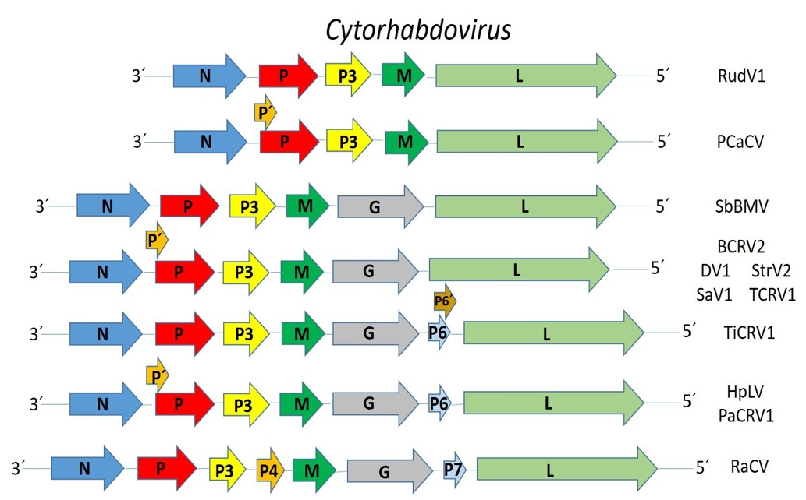

Figure 1. Genome graphs depicting architecture and gene products of viruses to be included in proposed species within genus Cytorhabdovirus. Abbreviations: N: nucleoprotein; P: phosphoprotein; P´; protein P´ P3: putative cell-to-cell movement protein; P4: protein 4; M: matrix protein; G: glycoprotein; P6: Protein 6; P6¨: Protein 6´; P7: Protein 7 L: RNA-dependent RNA polymerase. Virus name abbreviations: blackcurrant rhabdovirus 2 (BCRV2), Daphne virus 1 (DV1), Hyptis latent virus (HpLV), Pastinaca cytorhabdovirus 1 (PaCRV1), Patchouly chlorosis-associated cytorhabdovirus (PCaCV), rose-associated cytorhabdovirus (RaCV), Rudbeckia virus 1 (RudV1), Sambucus virus 1 (SaV1), soybean blotchy mosaic virus (SbBMV), strawberry virus 2 (StrV2), Taraxacum cytorhabdovirus 1 (TCRV1), and Tilia cytorhabdovirus 1 (TiCRV1).

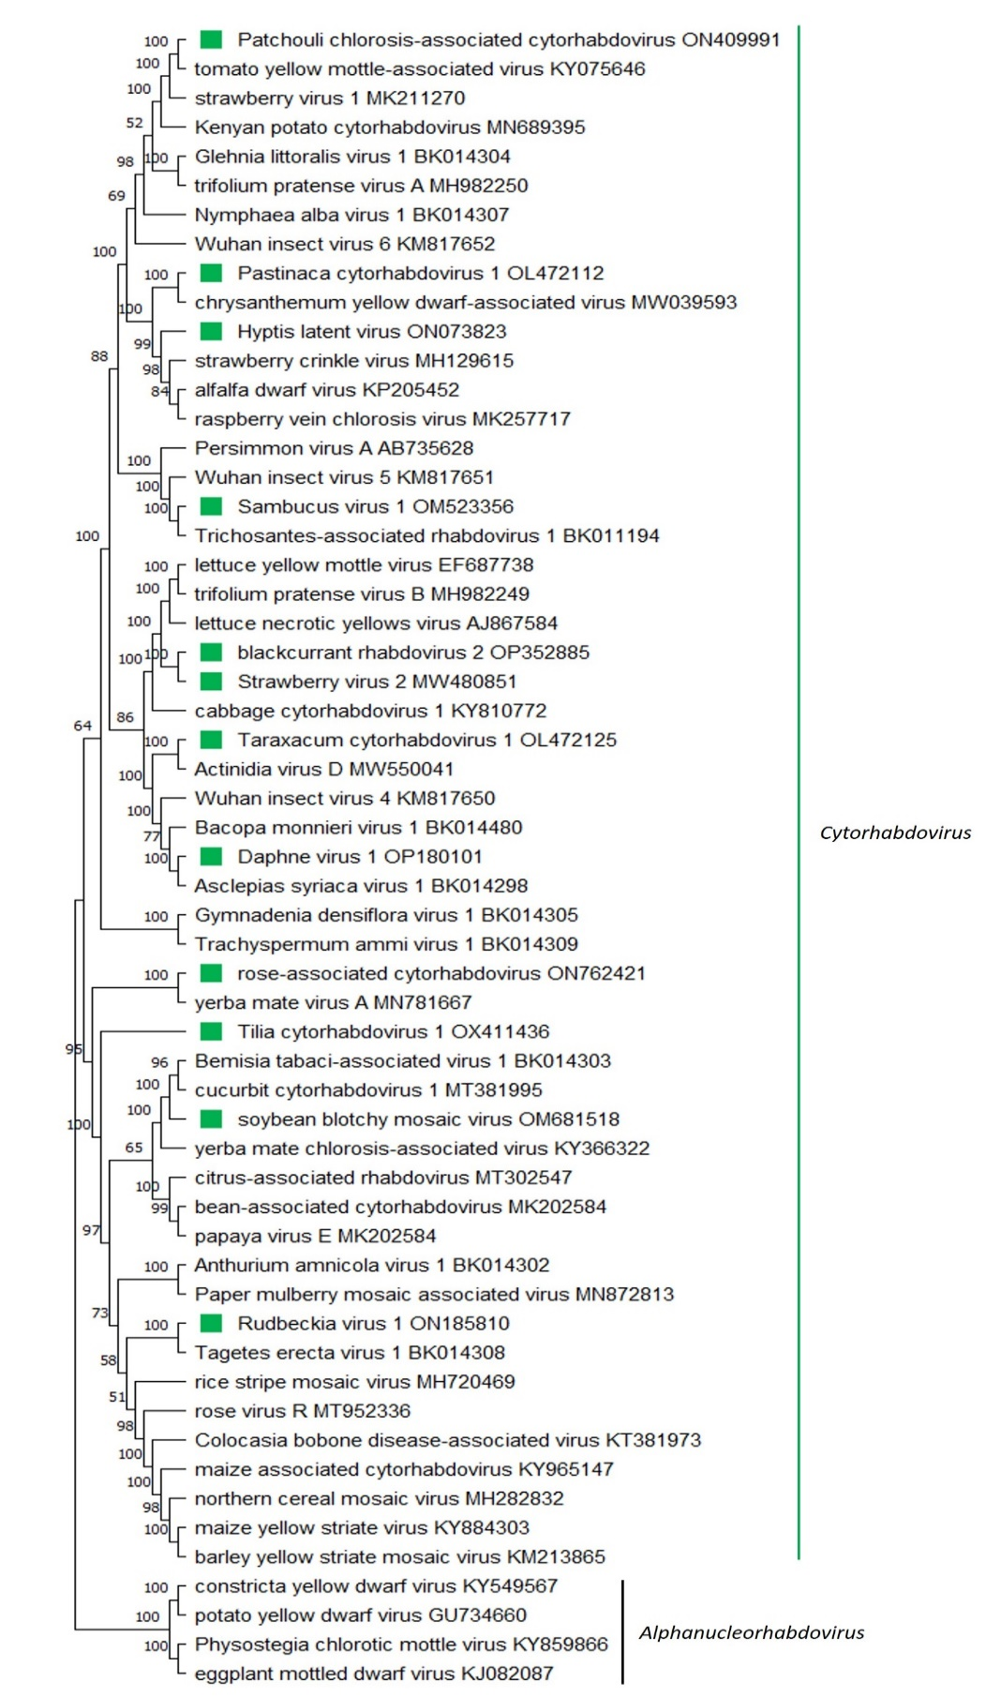

Figure 2. A Maximum Likelihood (ML) phylogenetic tree of plant-infecting rhabdovirus L polymerase protein sequences. Amino acid sequences were aligned using MUSCLE. The resulting alignment was used to generate a phylogenetic tree using MegaX with the best-fit model LG + G + I +F. Ten viruses potentially belonging to the new species are indicated with green squares. Numbers at the nodes indicate bootstrap support (1000 replicates).

References

[1] Petrzik K, Pribylova J, Spak J, et al. (2022). Mixed Infection of Blackcurrant with a Novel Cytorhabdovirus and Black Currant-Associated Nucleorhabdovirus. Viruses 14:2456. PMID:36366554, doi:10.3390/v14112456.
[2] Belete M, Kim S, Igori D, ahn J, Seo H, Park Y, Moon J(2023). Complete genome sequence of Daphne virus 1, a novel cytorhabdovirus infecting Daphne odora. Archives of Virology. PMID: 37062005, doi: 10.1007/s00705-023-05734-5.
[3] Reyes-Proaño E, Alvarez-Quinto R, Delgado-Jimenez J, et al (2022). Genome Characterization and Pathogenicity of Two New Hyptis pectinata Viruses Transmitted by Distinct Insect Vectors. Phytopathology 112:2440-2448. PMID:35694887, doi:10.1094/PHYTO-04-22-0130-R
[4] Rivarez M, Pecma A, Bacnik K, et al (2022). In-depth study of tomato and weed viromes reveals undiscovered plant virus diversity in an agroecosystem. Microbiome 11:60, PMID:36973750, doi: 10.1186/s40168-023-01500-6.
[5] Kauffmann C, de Jesus Boari A, Silva J, Blawid R, Nagata T (2022). Complete genome sequence of patchouli chlorosis-associated cytorhabdovirus, a new cytorhabdovirus infecting patchouli plants in Brazi. Archives of Virology 167:2817-2820. PMID:36125555, doi:10.1007/s00705-022-05594-5.
[6] Wu Y, Yang M, Yang H, Qiu Y, Xuan Z, Xing F, Cao M (2023). Identification and molecular characterization of a novel cytorhabdvirus from rose plants (Rosa chinensis Jacq.). Archives of Virology 168:118. PMID:36952055, doi:10.1007/s00705-023-05742-5.
[7] Lee D, Kim J, Jun M, Shin S, Lee S, Lim S (2022). Complete genome sequence of a putative novel cytorhabdovirus isolated from Rudbeckia sp. Archives of Virology 167:2381-2385. PMID:35920980, doi:10.1007/s00705-022-05556-x.
[8] Šafářová D, Candresse T, Navrátil M (2022). Complete genome sequence of a novel cytorhabdovirus infecting elderberry (Sambucus nigra L.) in the Czech Republic. Archives of Virology 167:1589-1592. PMID:35538166, doi:10.1007/s00705-022-05444-4.
[9] Read D, Strydom E, Slippers B, Steenkamp E, Pietersen G (2022). Genomic characterization of soybean blotchy mosaic virus, a cytorhabdovirus from South Africa. Archives of Virology 167:2359-2363. PMID:35857145, doi:10.1007/s00705-022-05526-3.
[10] Medberry A, Tzanetakis I (2022). Identification, Characterization, and Detection of a Novel Strawberry Cytorhabdovirus. Plant Disease 106:2784-2787. PMID:36176214, doi:10.1094/PDIS-11-21-2449-SC.
[11] Köpke K, Rumbou A, von Bargen S, Büttner C (2023). Identification of the Coding-Complete Genome Sequence of a Novel Cytorhabdovirus in Tilia cordata Showing Extensive Leaf Chloroses. Microbiology resource announcements e0005223. PMID:36927006, doi:10.1128/mra.00052-23

