Part 1: TITLE, AUTHORS, APPROVALS, etc

Code assigned: | 2023.035M
Short title: Reevaluate and reorganize family Hantaviridae (order Bunyavirales)
Author(s) and email address(es)
Kuhn JH, Bradfute SB, Calisher CH, Klempa B, Klingström J, Laenen L, Palacios G, Schmaljohn CS, Tischler N, Maes P | kuhnjens@mail.nih.gov; sbradfute@salud.unm.edu; calisher6920@gmail.com; boris.klempa@savba.sk; jonas.klingstrom@ki.se; lies.laenen@uzleuven.be; Gustavo.palacios@mssm.edu; connie.schmaljohn@nih.gov; ntischler@cienciavida.org; piet.maes@kuleuven.be
Author(s) institutional address(es) (optional)
Corresponding author
Maes P
List the ICTV Study Group(s) that have seen this proposal
ICTV Hantaviridae Study Group
ICTV Study Group comments and response of proposer
ICTV Study Group votes on proposal
Study Group | Number of members
 | Votes support | Votes against | No vote
ICTV Hantaviridae Study Group | 7 | 0 | 0
Authority to use the name of a living person
Is any taxon name used here derived from that of a living person (Y/N) | N

Taxon name | Person from whom the name is derived | Permission attached (Y/N)
N/A | N/A | N/A

Submission dates
Date first submitted to SC Chair | June 23, 2023
Date of this revision (if different to above)
ICTV-EC comments and response of the proposer
Part 2: NON-TAXONOMIC PROPOSAL
N/A

Part 3: TAXONOMIC PROPOSAL
Name of accompanying Excel module
2023.035M.N.v1.Hantaviridae_reorg.xlxs
Abstract
We propose to abolish five established hantavirid species not represented by fully-sequenced viruses; to rename two species after fully sequenced viruses representing them; to establish three new orthohantavirus species for previously unclassified fully sequenced viruses; to move one species from genus Orthohantavirus to genus Mobatvirus; to establish one new genus with one new species for a novel fish hantavirid and to move one species from genus Actinovirus into this new genus; and to remove several “viruses” (isolates of classified viruses) from the ICTV Virus Metadata Resource (VMR) as previously outlined in [7].
Text of proposal
In 2017, the International Committee on Taxonomy of Viruses (ICTV) permitted official virus classification based only on genomic sequence information as long as that information is coding-complete (i.e., covers all open reading frames) or near-complete (i.e., lacks only very few terminal or internal nucleotide that are difficult to resolve) [11]. Soon after, the ICTV made it a requirement to provide coding-/near-complete genome sequence information via GenBank deposition for exemplar viruses of novel species [10, 12]. However, this decision was prospective, i.e., it applied only to classification of newly discovered or previously unclassified viruses into new taxa. Viruses classified by the ICTV prior to the 2017 decision remained classified even with, in some cases, the complete absence of genomic sequence information. This situation contradicts the ICTV’s goal to “…categorize the multitude of known viruses into a single classification scheme that reflects their evolutionary relationships, i.e., their individual phylogenies” [5, 12].

We recently evaluated the taxonomy of bunyaviral family Hantaviridae considering coding-/near-complete genome sequence information [7]. Based on this evaluation, we propose:

- To abolish the following five orthohantavirus species due to the absence of coding-complete sequence information for their exemplar viruses:
- Orthohantavirus fusongense;
- Orthohantavirus necocliense;
- Orthohantavirus oxbowense;
- Orthohantavirus seewisense; and
- Orthohantavirus yakeshiense.

- To remove (“declassify”) the following nine non-exemplar viruses from established species (and the ICTV VMR) due to the absence of coding-complete sequence information for their exemplar viruses (and to consider these “virus” names potential isolates of the remaining exemplar viruses):
- Adler virus (ADLV) from Orthohantavirus tulaense;
- Castelo dos Sonhos virus (CASV), Lechiguanas virus (LECV = LECHV), and Orán virus (ORNV) from Orthohantavirus andesense;
- El Moro Canyon virus (ELMCV) from Orthohantavirus moroense;
- gōu virus (GOUV) from Orthohantavirus seoulense;
- Laguna Negra virus (LANV) from Orthohantavirus negraense;
- Liánghé virus (LHEV) from Orthohantavirus caobangense;
- Serang virus (SERV) from Orthohantavirus thailandense;

- To rename the following two species which currently have confusing names due to the removal of previously name-giving viruses:
- Orthohantavirus moroense → Orthohantavirus carrizalense (after Carrizal virus [CARV]); and
- Orthohantavirus negraense → Orthohantavirus mamorense (after Rio Mamoré virus [RIOMV]).

Coding-/near-complete genome sequence information is available for several currently unclassified hantavirids [7]:

- A potential new mobatvirus:
- Đakrông virus [2].

- Potential new orthohantaviruses:
- Artybash virus [1];
- Jīngmén Rattus norvegicus orthohantavirus 1 [Unpublished];
- Juquitiba virus [Unpublished];
- Lanka virus [9];
- Limestone Canyon virus [Unpublished];
- Monongahela virus [13];
- Rusne virus [3];
- Traemmersee virus [6];
- Ussuri virus [Unpublished];
- Wēnzhōu Niviventer niviventer orthohantavirus 1 [Unpublished];
- Wùfēng Chodsigoa smithii orthohantavirus 1 [Unpublished];
- Xìnyì virus [4];

- A potential new thottimvirus:
- Wēnzhōu Suncus murinus thottimvirus 1 [Unpublished].

- A potential new actinovirus:
- Luposicya lupus actinovirus [Unpublished].

To determine the taxonomic placement of these viruses, we re-performed family-wide DivErsity pArtitioning by hieRarchical Clustering (DEmARC) analysis as originally established for this family by the ICTV Hantaviridae Study Group [8].
Briefly, all publicly available coding-complete hantavirus genomes (last update June 23, 2023) were downloaded from NCBI GenBank. For each of the sequences the three hantavirus protein (N, M and L) amino acid sequences were deduced and used to construct a concatenated multiple alignment. For this, the sequences of each of the proteins were separately aligned with MAFFT v7.453 (Katoh and Standley, 2013) and trimmed with TrimAl v1.4.rev15 (Capella-Gutièrrez et al, 2009), after which the 3 multiple sequence alignments were concatenated. Bayesian phylogenetic analyses were inferred in BEAST v.1.10.4 (Suchard et al, 2018) using the LG+R10 substitution model and using MCMC with a chain length of 100,000,000 generations using the concatenated (S-M-L) alignment. The Markov chain Monte Carlo analysis was run until an effective samples size higher than 200 was obtained (allowing a burn-in period of 10%). A consensus tree was built with TreeAnnotator v1.10.4 using the maximum clade credibility method. This consensus tree was used as input for DEmARC to calculate a pairwise patristic distance matrix. This matrix was then used to calculate subfamily, genera, and species demarcation.

This analysis (Figures 1 and 2) yielded the following results:
- Đakrông virus represents a new mobatvirus species
- Artybash virus, Lanka virus, and Wùfēng Chodsigoa smithii orthohantavirus 1 represent novel orthohantavirus species
- Robina virus, currently classified in species Orthohantavirus robinaense is a mobatvirus and hence needs to be reclassified as Mobatvirus robinaense
- “Jīngmén Rattus norvegicus orthohantavirus 1” is an isolate of Seoul virus (and hence the name “Jīngmén Rattus norvegicus orthohantavirus 1” should not be used anymore)
- “Juquitiba virus” is an isolate of Andes virus (and hence the name “Juquitiba virus” should not be used anymore). Furthermore, we here discourage the use of the names “Ape Aimé–Itapúa virus”, “Araraquara virus”, “Araucaria virus”, “Bermejo virus”, “Buenos Aires virus”, “Cajuru virus”, “Central Plata virus”, “Hu39694 virus”, “Itapúa virus”, “Jaborá virus”, “Lechiguanas virus”, “Maciel virus”, “Ñeembucu virus”, “Orán virus”, “Paranoá virus”, “Pergamino virus”, and “Tunari virus”, all of which are, based on the available limited sequence information, isolates of Andes virus
- "Limestone Canyon virus” is an isolate of Montaño virus (and hence the name “Limestone Canyon virus” should not be used anymore)
- Luposicya lupus actinovirus forms a new genus/species (proposed name Percilovirus gobii) within subfamily Actantavirinae together with Goosefish agnatovirus
- Goosefish agnatovirus will moved to the genus Percilovirus by moving/renaming Actinovirus lophii as Percilovirus lophii
- “Monongahela virus” is an isolate of Sin Nombre virus (and hence the name “Monongahela virus” should not be used anymore)
- “Rusne virus” is an isolate of Tatenale virus (and hence the name “Rusne virus” should not be used anymore)
- “Traemmersee virus” is an isolate of Tatenale virus (and hence the name “Traemmersee virus” should not be used anymore)
- “Ussuri virus” is an isolate of Puumala virus (and hence the name “Ussuri virus” should not be used anymore)
- “Wēnzhōu Niviventer niviventer orthohantavirus 1” is an isolate of Dabieshan virus (and hence the name “Wēnzhōu Niviventer niviventer orthohantavirus 1” should not be used anymore)
- “Wēnzhōu Suncus murinus thottimvirus 1” is an isolate of Thottapalayam virus (and hence the name “Wēnzhōu Suncus murinus thottimvirus 1” should not be used anymore)
- “Xìnyì virus” is an isolate of Cao Bằng virus (and hence the name “Xìnyì virus” should not be used anymore)

Supporting evidence
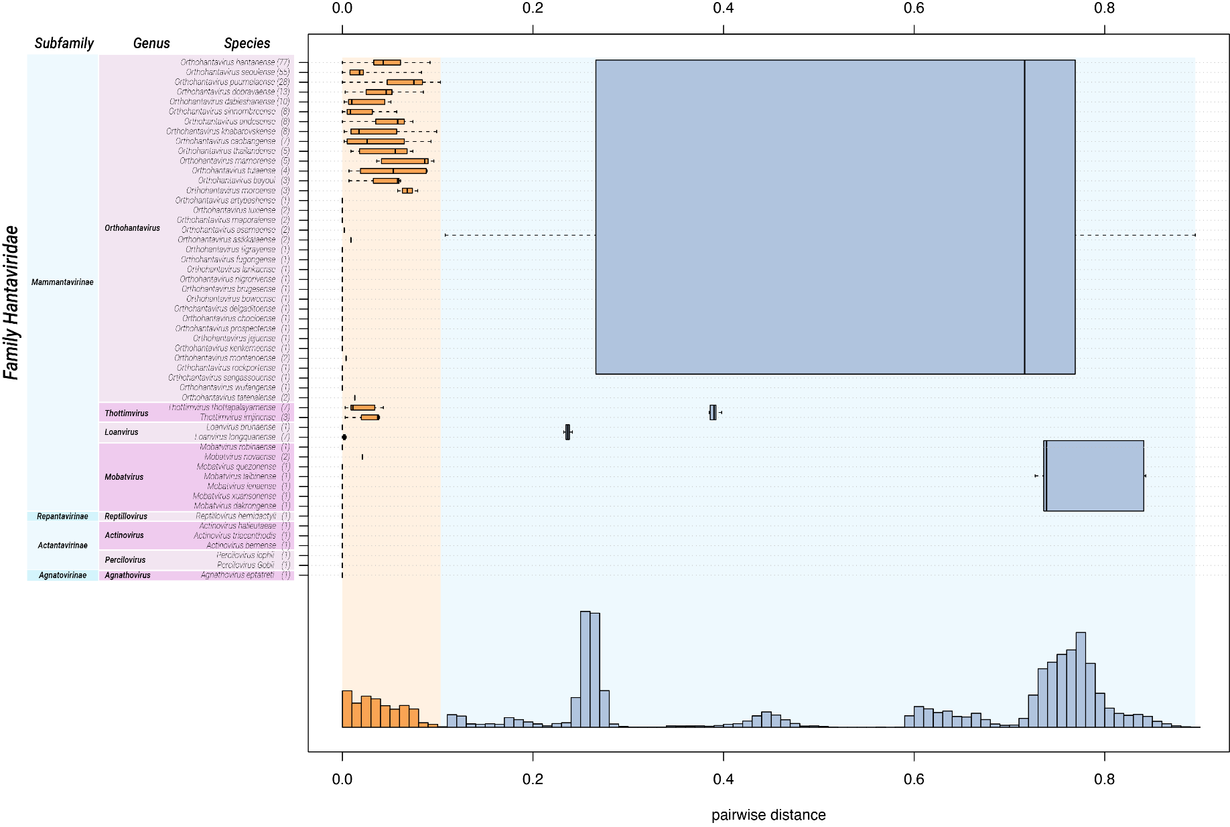
Figure 1 (see Supplementary File 1 for original size): Intra-family genetic divergence in three-level hierarchical clustering of hantaviruses by DEmARC (version 1.4). Ranks are defined by the three strongest PED thresholds. The number of viruses in the identified clusters are shown in brackets. All identified clusters correspond to monophyletic groups. Box-and-whisker graphs were used to plot distributions of distances between viruses from the same species (orange), and between viruses from different species but the same genus, and between viruses from different genera but the same family (blue). The boxes span from the first to the third quartile and include the median (bold line), and the whiskers (dashed lines) extend to the extreme values. The corresponding part of the PED distribution is shown below.

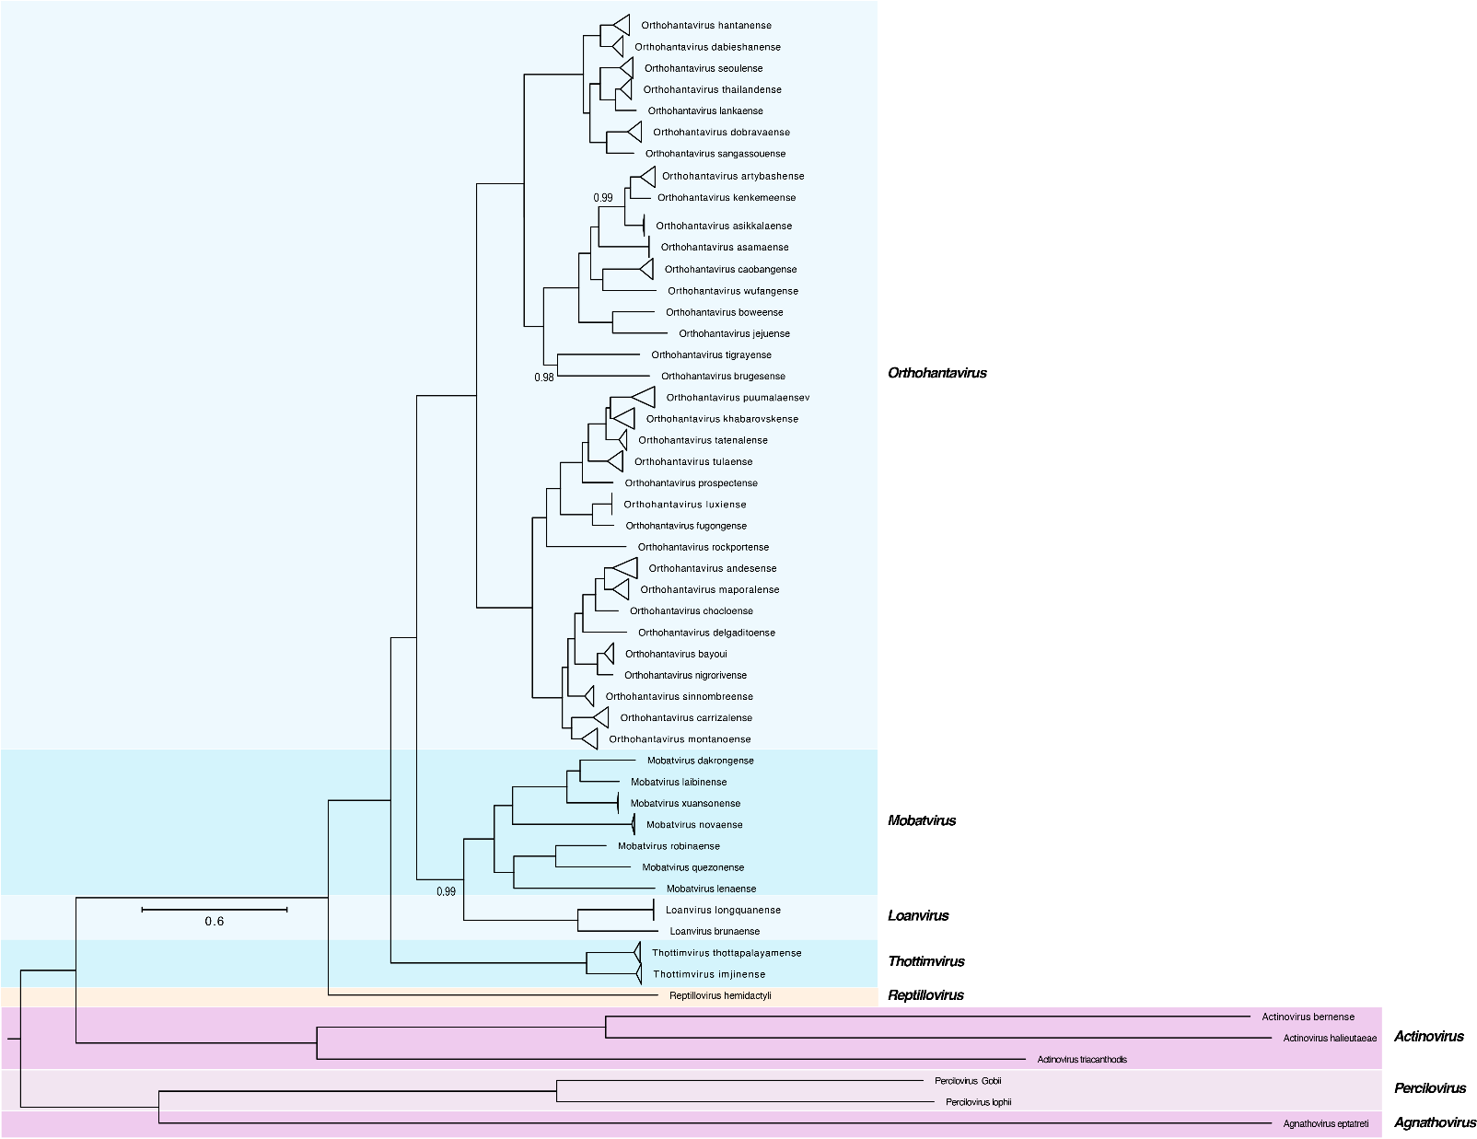
Figure 2 (see Supplementary File 2 for original size): Overview of the revised Hantaviridae taxonomy matched with a Bayesian maximum clade credibility summary tree. Numbers next to selected nodes indicate the posterior support, which can be interpreted as the probability of the clade being true given the data, the model, and the parameter priors. Only posterior values lower than 1 are shown. The tree is drawn to scale, with branch lengths expressed in the number of substitutions per site.

References

1. Arai S, Kang HJ, Gu SH, Ohdachi SD, Cook JA, Yashina LN, Tanaka-Taya K, Abramov SA, Morikawa S, Okabe N, Oishi K, Yanagihara R (2016) Genetic diversity of Artybash virus in the Laxmann's shrew (Sorex caecutiens). Vector Borne Zoonotic Dis 16:468-75. PMID: 27172519. PMCID: PMC4931335. doi: 10.1089/vbz.2015.1903.
2. Arai S, Aoki K, Sơn NT, Tú VT, Kikuchi F, Kinoshita G, Fukui D, Thành HT, Gu SH, Yoshikawa Y, Tanaka-Taya K, Morikawa S, Yanagihara R, Oishi K (2019) Đakrông virus, a novel mobatvirus (Hantaviridae) harbored by the Stoliczka's Asian trident bat (Aselliscus stoliczkanus) in Vietnam. Sci Rep 9:10239. PMID: 31308502. PMCID: PMC6629698. doi: 10.1038/s41598-019-46697-5.
3. Drewes S, Jeske K, Straková P, Balčiauskas L, Ryll R, Balčiauskienė L, Kohlhause D, Schnidrig GA, Hiltbrunner M, Špakova A, Insodaitė R, Petraitytė-Burneikienė R, Heckel G, Ulrich RG (2021) Identification of a novel hantavirus strain in the root vole (Microtus oeconomus) in Lithuania, Eastern Europe. Infect Genet Evol 90:104520. PMID: 32890767. doi: 10.1016/j.meegid.2020.104520.
4. Gu SH, Arai S, Yu H-T, Lim BK, Kang HJ, Yanagihara R (2016) Genetic variants of Cao Bang hantavirus in the Chinese mole shrew (Anourosorex squamipes) and Taiwanese mole shrew (Anourosorex yamashinai). Infect Genet Evol 40:113-118. PMID: 26921799. PMCID: PMC4844841. doi: 10.1016/j.meegid.2016.01.031.
5. International Committee on Taxonomy of Viruses (2023) Charge to the ICTV. The basis for taxonomic classification by the ICTV. https://ictv.global/about/charge.
6. Jeske K, Hiltbrunner M, Drewes S, Ryll R, Wenk M, Špakova A, Petraitytė-Burneikienė R, Heckel G, Ulrich RG (2019) Field vole-associated Traemmersee hantavirus from Germany represents a novel hantavirus species. Virus Genes 55:848-853. PMID: 31573059. doi: 10.1007/s11262-019-01706-7.
7. Kuhn JH, Bradfute SB, Calisher CH, Klempa B, Klingström J, Laenen L, Palacios G, Schmaljohn CS, Tischler ND, Maes P (2023) Pending Reorganization of Hantaviridae to Include Only Completely Sequenced Viruses: A Call to Action. Viruses 15:660. PMID: 36992369. PMCID: PMC10059669. doi: 10.3390/v15030660.
8. Laenen L, Vergote V, Calisher CH, Klempa B, Klingström J, Kuhn JH, Maes P (2019) Hantaviridae: current classification and future perspectives. Viruses 11:788. PMID: 31461937. doi: 10.3390/v11090788.
9. Muthusinghe DS, Shimizu K, Lokupathirage SMW, Wei Z, Sarathkumara YD, Fonseka GRA, Senarathne P, Koizumi N, Kawakami T, Koizumi A, Wickramasinghe C, Ebihara H, Matsuno K, Tsuda Y, Arikawa J, Gamage CD, Yoshimatsu K (2021) Identification of novel rodent-borne orthohantaviruses in an endemic area of chronic kidney disease of unknown etiology (CKDu) in Sri Lanka. Viruses 13:1984. PMID: 34696414. PMCID: PMC8539126. doi: 10.3390/v13101984.
10. Siddell SG, Smith DB, Adriaenssens E, Alfenas-Zerbini P, Dutilh BE, Garcia ML, Junglen S, Krupovic M, Kuhn JH, Lambert AJ, Lefkowitz EJ, Łobocka M, Mushegian AR, Oksanen HM, Robertson DL, Rubino L, Sabanadzovic S, Simmonds P, Suzuki N, Van Doorslaer K, Vandamme A-M, Varsani A, Zerbini FM (2023) Virus taxonomy and the role of the International Committee on Taxonomy of Viruses (ICTV). J Gen Virol 104:001840. PMID: 37141106. PMCID: PMC10227694. doi: 10.1099/jgv.0.001840.
11. Simmonds P, Adams MJ, Benkő M, Breitbart M, Brister JR, Carstens EB, Davison AJ, Delwart E, Gorbalenya AE, Harrach Bz, Hull R, King AMQ, Koonin EV, Krupovic M, Kuhn JH, Lefkowitz EJ, Nibert ML, Orton R, Roossinck MJ, Sabanadzovic S, Sullivan MB, Suttle CA, Tesh RB, van der Vlugt RA, Varsani A, Zerbini FM (2017) Consensus statement: Virus taxonomy in the age of metagenomics. Nat Rev Microbiol 15:161–168. PMID: 28134265. doi: 10.1038/nrmicro.2016.177.
12. Simmonds P, Adriaenssens EM, Zerbini FM, Abrescia NGA, Aiewsakun P, Alfenas-Zerbini P, Bao Y, Barylski J, Drosten C, Duffy S, Duprex WP, Dutilh BE, Elena SF, García ML, Junglen S, Katzourakis A, Koonin EV, Krupovic M, Kuhn JH, Lambert AJ, Lefkowitz EJ, Łobocka M, Lood C, Mahony J, Meier-Kolthoff JP, Mushegian AR, Oksanen HM, Poranen MM, Reyes-Muñoz A, Robertson DL, Roux S, Rubino L, Sabanadzovic S, Siddell S, Skern T, Smith DB, Sullivan MB, Suzuki N, Turner D, Van Doorslaer K, Vandamme AM, Varsani A, Vasilakis N (2023) Four principles to establish a universal virus taxonomy. PLoS Biol 21:e3001922. PMID: 36780432. doi: 10.1371/journal.pbio.3001922.
13. Song JW, Baek LJ, Nagle JW, Schlitter D, Yanagihara R (1996) Genetic and phylogenetic analyses of hantaviral sequences amplified from archival tissues of deer mice (Peromyscus maniculatus nubiterrae) captured in the eastern United States. Arch Virol 141:959-67. PMID: 8678841. doi: 10.1007/bf01718170.

