Part 1: TITLE, AUTHORS, APPROVALS, etc

Code assigned: | 2023.028M
Short title: Create one new genus and nine new species in family Nairoviridae (family Bunyavirales)
Author(s) and email address(es)
Alkhovsky SV, Avšič-Županc T, Bergeron É, Burt F, Ergünay K, Garrison AR, Kuhn JH, Marklewitz M, Mirazimi A, Papa A, Pawęska JT, Postler TS. Spengler JR, Palacios G | salkh@yandex.ru; Tatjana.Avsic@mf.uni-lj.si; exj8@cdc.gov; burtfj@ufs.ac.za; ekoray@hacettepe.edu.tr; aura.r.garrison.civ@health.mil; kuhnjens@mail.nih.gov; marco.marklewitz@finddx.org; Ali.Mirazimi@ki.se; annap.med@gmail.com; januszp@nicd.ac.za; TPostler@iavi.org; JSpengler@cdc.gov; gustavo.palacios@mssm.edu
Author(s) institutional address(es) (optional)
Corresponding author
Palacios G
List the ICTV Study Group(s) that have seen this proposal
ICTV Nairoviridae Study Group
ICTV Study Group comments and response of proposer
ICTV Study Group votes on proposal
Study Group | Number of members
 | Votes support | Votes against | No vote
ICTV Nairoviridae Study Group | 13 | 0 | 0
Authority to use the name of a living person
Is any taxon name used here derived from that of a living person (Y/N) | N

Taxon name | Person from whom the name is derived | Permission attached (Y/N)
N/A | N/A | N/A

Submission dates
Date first submitted to SC Chair | June 23, 2023
Date of this revision (if different to above)
ICTV-EC comments and response of the proposer
Part 2: NON-TAXONOMIC PROPOSAL
N/A

Part 3: TAXONOMIC PROPOSAL
Name of accompanying Excel module
2023.028M.N.v1.Nairoviridae_1ng_9nsp.xlsx
Abstract
We propose the classification of nine novel nairovirids into eight novel orthonairovirus species and one new genus including a new species.
Text of proposal
The bunyaviral family Nairoviridae currently includes seven genera (Norwavirus, Ocetevirus, Orthonairovirus, Sabavirus, Shaspivirus, Striwavirus, and Xinspivirus). In 2021, the ICTV Nairoviridae Study Group established a species demarcation criterion of <93% identity in the amino acid sequence of the nairovirid RNA-directed RNA polymerase (RdRp) (TaxoProp 2020.027M). A reanalysis of the dataset used of last year’s TaxoProp 2022.015M, complemented with newly described nairovirid sequences, indicated nine viruses should be classified into nine novel species, with one of them included in a new genus (Supplementary Data, Figure 1):

Novel genus Sitinavirus:
Sìchuān tick nairovirus (proposed abbreviation ScTNV rather than the published STNV, which is already in use for other viruses) was first discovered by high-throughput sequencing (HTS) in unspecified ixodid ticks feeding on giant pandas in Sìchuān Province (四川省), China [4]. We propose to establish genus/species Sitinavirus sichuanense to classify this virus.

Novel orthonairovirus species:
- Āntú virus (proposed abbreviation: ANTV) was first discovered by HTS in ticks (ixodid Dermacentor silvarum Olenev, 1931) collected in Āntú County (安图县), Yánbiān Korean Autonomous Prefecture (延边朝鲜族自治州), Jílín Province (吉林省), China [2]. We propose to establish species Orthonairovirus antuense to classify this virus.
- cencurut virus (CENV) was first discovered by HTS in Singapore in Asian house shrews (soricid Suncus murinus (Linnaeus, 1766)) and in a nymphal tick (ixodid Amblyomma helvolum Koch, 1844) collected from an infected shrew [3]. We propose to establish species Orthonairovirus sunci to classify this virus.
- Gubbo nairovirus (GUBV) was first discovered by HTS in ticks (argasid Carios vespertilionis Latreille, 1796) in Snesslinge, Uppland, Sweden [6]. We propose to establish species Orthonairovirus gubboense to classify this virus.
- Lamusara virus (LMSV) was first discovered by RT-PCR in goliath shrews (soricid Crocidura goliath Thomas, 1906) sampled around Lambaréné in Gabon [7]. We propose to establish species Orthonairovirus lambarenense to classify this virus.
- Méihuā Mountain virus (MHMV) was first discovered by HTS in ixodid ticks (Haemaphysalis hystricis Supino, 1897, Haemaphysalis formosensis Neumann, 1913, Dermacentor taiwanensis Sugimoto, 1935, and Rhipicephalus microplus (Canestrini, 1888)) sampled in the Méihuā Mountains (梅花山), Fújiàn Province (福建省), China [8]. We propose to establish species Orthonairovirus meihuashanense to classify this virus.
- orthonairovirus sp. strain YS was first discovered by HTS in an unspecified shrew sampled in China [unpublished]. We propose to establish species Orthonairovirus sinense to classify this virus.
- pangolin orthonairovirus (PONV) was first discovered by HTS in unspecified pangolins sampled in China [unpublished]. We propose to establish species Orthonairovirus manidae to classify this virus.
- Wufeng Crocidura attenuata orthonairovirus 1 (proposed abbreviation: WfCAV1) was first discovered by HTS in Asian grey shrews (soricid Crocidura attenuata Milne-Edwards, 1872) sampled in China [unpublished]. We propose to establish species Orthonairovirus crocidurae to classify this virus.

Supporting evidence

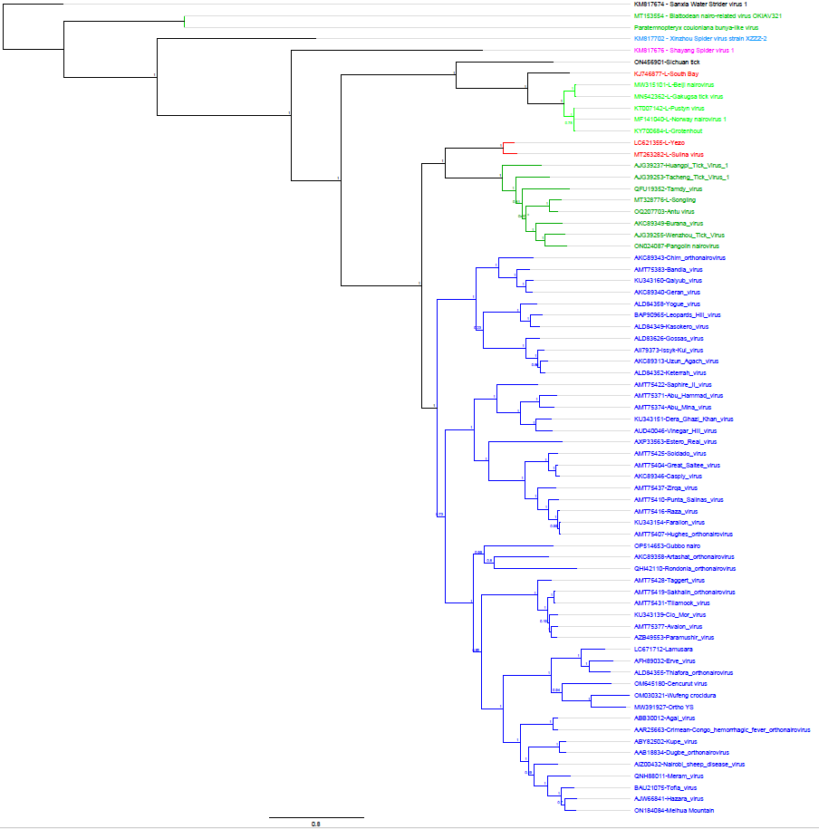
Figure 1. The maximum-likelihood phylogenetic tree was inferred using IQtree [5]; the numbers on the nodes represent bootstrap values derived from the ultrafast bootstrap algorithm [1]. Trees were inferred under the LG+G+I substitution model. Tree branches are proportional to genetic distances between sequences, and the scale bars at the top indicate substitutions per amino acid. For all taxa shown here, the complete genome or complete coding sequence is available on the GenBank nucleotide sequence database. Accession numbers are shown next to the respective virus taxon.

References
1. Hoang DT, Chernomor O, von Haeseler A, Minh BQ, Vinh LS (2018) UFBoot2: improving the ultrafast bootstrap approximation. Mol Biol Evol 35:518-522. PMID: 29077904. PMCID: PMC5850222. doi: 10.1093/molbev/msx281.
2. Li F, Li J, Song J, Yin Q, Nie K, Xu S, He Y, Fu S, Liang G, Wei Q, Wang H (2023) Novel orthonairovirus isolated from ticks near China-North Korea border. Emerg Infect Dis 29:1254-1257. PMID: 37209692. PMCID: PMC10202851. doi: 10.3201/eid2906.230056.
3. Low DHW, Ch'ng L, Su YCF, Linster M, Zhang R, Zhuang Y, Kwak ML, Borthwick SA, Hitch AT, Smith GJD, Mendenhall IH (2023) Cencurut virus: a novel orthonairovirus from Asian house shrews (Suncus murinus) in Singapore. One Health 16:100529. PMID: 37363265. PMCID: PMC10288052. doi: 10.1016/j.onehlt.2023.100529.
4. Ma R, Zhao M, Wang H, Hou R, Qin K, Qian Y, Zhang H, Zhou Y, Wu W, Gu J, Wang X, Shen Q, Liu S, Liu J, Bi W, Yu X, Yang S, Feng F, Li Z, Zhang L, Lan G, Chen C, Xue F, Wang Y, Chong H, Hong Y, Ji L, Liu Y, Qi D, Shan T, Zhang W (2022) Virome of giant panda-infesting ticks reveals novel bunyaviruses and other viruses that are genetically close to those from giant pandas. Microbiol Spectr 10:e0203422. PMID: 35916407. PMCID: PMC9430136. doi: 10.1128/spectrum.02034-22.
5. Nguyen LT, Schmidt HA, von Haeseler A, Minh BQ (2015) IQ-TREE: a fast and effective stochastic algorithm for estimating maximum-likelihood phylogenies. Mol Biol Evol 32:268-74. PMID: 25371430. PMCID: PMC4271533. doi: 10.1093/molbev/msu300.
6. Ortiz-Baez AS, Jaenson TGT, Holmes EC, Pettersson JH-O, Wilhelmsson P (2023) Substantial viral and bacterial diversity at the bat-tick interface. Microb Genom 9:mgen000942. PMID: 36862584. PMCID: PMC10132063. doi: 10.1099/mgen.0.000942.
7. Ozeki T, Abe H, Ushijima Y, Nze-Nkogue C, Akomo-Okoue EF, Ella GWE, Koumba LBM, Nso B, Mintsa-Nguema R, Makouloutou-Nzassi P, Makanga BK, Nguelet FLM, Ondo GN, Mbadinga M, Igasaki Y, Okada S, Hirano M, Yoshii K, Lell B, Bonney LC, Hewson R, Kurosaki Y, Yasuda J (2022) Identification of novel orthonairoviruses from rodents and shrews in Gabon, Central Africa. J Gen Virol 103. PMID: 36215163. doi: 10.1099/jgv.0.001796.
8. Zhang X, Li H-Y, Shao J-W, Pei M-C, Cao C, Huang F-Q, Sun M-F (2022) Genomic characterization and phylogenetic analysis of a novel Nairobi sheep disease genogroup Orthonairovirus from ticks, Southeastern China. Front Microbiol 13:977405. PMID: 36090082. PMCID: PMC9453679. doi: 10.3389/fmicb.2022.977405.

