

**Part 1:** **TITLE, AUTHORS, APPROVALS, etc**

|  |  |  |
| --- | --- | --- |
| **Code assigned:** | ***2023.014S*** |  |
| **Short title:** Create one new species in the genus *Senecavirus* (*Picornavirales*: *Picornaviridae*) | | |
|  | | |

**Author(s) and email address(es)**

|  |  |
| --- | --- |
|  |  |
| Sullivan DS, Vernygora O, Nielsen O, Burek-Huntington K, Rouse N, Popov VL, Lung O | [Daniel.Sullivan@inspection.gc.ca](mailto:Daniel.Sullivan@inspection.gc.ca);  [Oksana.Vernygora@inspection.gc.ca](mailto:Oksana.Vernygora@inspection.gc.ca);  [Ole.Nielsen@dfo-mpo.gc.ca](mailto:Ole.Nielsen@dfo-mpo.gc.ca);  [avps.kbh@gmail.com](mailto:avps.kbh@gmail.com);  [avps.natalierouse@gmail.com](mailto:avps.natalierouse@gmail.com);  [vpopov@UTMB.EDU](mailto:vpopov@UTMB.EDU);  [Oliver.Lung@inspection.gc.ca](mailto:Oliver.Lung@inspection.gc.ca); |

**Author(s) institutional address(es) (optional)**

|  |
| --- |
| National Centre for Foreign Animal Disease, Canadian Food Inspection Agency, Winnipeg, MB, Canada [SDS, VO, LO]  Fisheries and Oceans Canada, Winnipeg, MB, Canada [NO]  Center for Biodefense and Emerging Infectious Diseases, University of Texas Medical Branch, Galveston, TX, United States [NO, PVL]  Alaska Veterinary Pathology Services, Eagle River, AK, United States. [BHK, RN]  Department of Biological Sciences, University of Alaska Anchorage, Anchorage, AK, United States. [BHK, RN]  Department of Biological Sciences, University of Manitoba, Winnipeg, MB, Canada [SDS, LO] |

**Corresponding author**

|  |
| --- |
| Lung O |

**List the ICTV Study Group(s) that have seen this proposal**

|  |
| --- |
| Picornavirus Study Group |

**ICTV Study Group comments and response of proposer**

|  |
| --- |
| Suggestions from the Study group indicated below were all incorporated :   1. The suggested species designation 2. The common name of the cetacean picornavirus and Seneca Valley virus 3. The inclusion of the recently described Seneca-like viruses from pangolins and other genera in the phylogenetic analysis 4. Missing extreme 5’ and 3’ end of the genome 5. Adding a cartoon diagram of the genome layout of the new sequence |

**ICTV Study Group votes on proposal**

|  |  |  |  |
| --- | --- | --- | --- |
| **Study Group** | **Number of members** | | |
| **Votes support** | **Votes against** | **No vote** |
| *Picornaviridae* SG | 6 | 0 | 6 |
|  |  |  |  |

**Authority to use the name of a living person**

|  |  |
| --- | --- |
| **Is any taxon name used here derived from that of a living person (Y/N)** | N |

|  |  |  |
| --- | --- | --- |
| **Taxon name** | **Person from whom the name is derived** | **Permission attached (Y/N)** |
|  |  |  |
|  |  |  |
|  |  |  |

**Submission dates**

|  |  |
| --- | --- |
| Date first submitted to SC Chair | 22 February 2023 |
| Date of this revision (if different to above) | 16 August 2023 |

**ICTV-EC comments and response of the proposer**

|  |
| --- |
|  |

**Part 2:** **NON-TAXONOMIC PROPOSAL**

**Text of proposal**

**Part 3:** **TAXONOMIC PROPOSAL**

**Name of accompanying Excel module**

|  |
| --- |
| 2023.014S.N.v2.Senecavirus_1nsp.xlsx |

**Abstract**

|  |
| --- |
| We propose the creation of a new species in the *Senecavirus* genus, which would include the recently isolated and sequenced cetacean picornavirus 1 (CPv1). We suggest the species name *Senecavirus cetus* in line with the new binomial species nomenclature. The complete genome (7455nt) and coding genome (6645nt / 2215aa) was sequenced from post-mortem brain tissue of a stranded Beluga Whale (*Delphinapterus leucas*). The resulting assembled contig was compared to publicly available sequences and it was found that the closest match was the only member of the *Senecavirus* genus, Seneca Valley virus (SVV; species *Senecavirus* A), accession KY618836.1) having an ORF1 pairwise nucleotide identity of 58.29% and ORF1 amino acid identity of 51.32%. Sequence divergence between the new species and SVV was 40.5% and 44.5% nucleotide identity for the 3Dpol and P1 regions, respectively. This would make CPv1 the first virus in the *Senecavirus* genus that is isolated from a cetacean. |

**Text of proposal**

|  |  |
| --- | --- |
| |  | | --- | | A new virus, tentatively named cetacean picornavirus 1 (CPv1) was isolated from the brain of a stranded dead beluga whale (*Delphinapterus leucas*) from Alaska, USA in 2019 and sequenced (**Table 1**). The 7455nt complete genome and 6645nt / 2215aa complete coding genome of the named CPv1 showed the greatest degree of similarity to Seneca Valley virus (species *Senecavirus A*, accession MN812958.1) which is currently the sole member of the *Senecavirus* genus. CPv1 showed an ORF1 pairwise nucleotide identity of 58.29% and ORF1 amino acid identity of 51.32% to its top BLAST match (**Table 2**). Additionally, sequence divergence between the new species and Senecavirus A was 40.5% and 44.5% nucleotide identity for the 3Dpol and P1 protein coding regions, respectively. When compared with the next closest match from an adjacent genus (species *Cardiovirus C*, accession JQ864242), CPv1 continued to show the greatest degree of similarity to members of the *Senecavirus* genus (**Figure 1**). When queried against the NCBI nr/nt database, no other matches with a higher percent identity were found. Based on the nucleotide and amino acid identity, as well as the results of the genome layout (**Figure 2**) and phylogenetic analysis (**Figure 3**), we propose that CPv1 should be classified as a new member within the *Senecavirus* genus and suggest the species name *Senecavirus cetus* in line with the new binomial species nomenclature. The name Cetus, is Latin for whale, and is referenced as a sea monster in Greek mythology  Comparative genomic analysis of the complete coding genome for CPv1 found that conserved motifs present within members of the *Picornaviridae* family were present including the Walker A motif (GxxGxGKS/T), 3C proteinase motif (GxCGx10-15GxH) and 3D polymerase motifs (KDE, DxxxxD, PSG, YGDD, FLKR).  A virus isolate very similar to our novel CPv1 was also isolated and sequenced from a stranded dead harbor porpoise (*Phocoena phocoena*). *Senecavirus cetus* (porpoise rectal) isolate showed an ORF1 pairwise nucleotide identity of 100% and ORF1 amino acid identity of 100% to CPv1 and *Senecavirus cetus* (porpoise brain) isolate showed an ORF1 pairwise nucleotide identity of 98.8% and ORF1 amino acid identity of 99.0% to CPv1. | |

**Supporting evidence**

**Table 1:** Summary of details regarding the proposed novel *Picornavirus* species

|  |  |  |  |  |  |
| --- | --- | --- | --- | --- | --- |
| **Species name** | **GenBank accession** | **Virus acronym** | **Isolate ID** | **Country of Isolate** | **Host/isolation source** |
| *Senecavirus cetus* | OR416239 | CPv1 | Alaska /  2019 | USA | *Delphinapterus leucas* (Beluga whale) / Brain |

**Table 2:** Comparison of novel *Picornavirus* species to closest BLAST matches

|  |  |  |  |
| --- | --- | --- | --- |
| **Species name** | **GenBank accession** | **Percent Identity** | |
| **Nucleotide** | **Amino Acid** |
| *Senecavirus cetus* | OR416239 | - | - |
| *Senecavirus A* | MN812958 | 58.3 | 51.8 |
| Pangolin senecavirus | OL519620 | 53.7 | 49.7 |

**A**

**B**



**Figure 1:** Percent identity matrix based on picornavirus polyprotein gene pairwise nucleotide (**A**) and amino acid sequences (**B**).

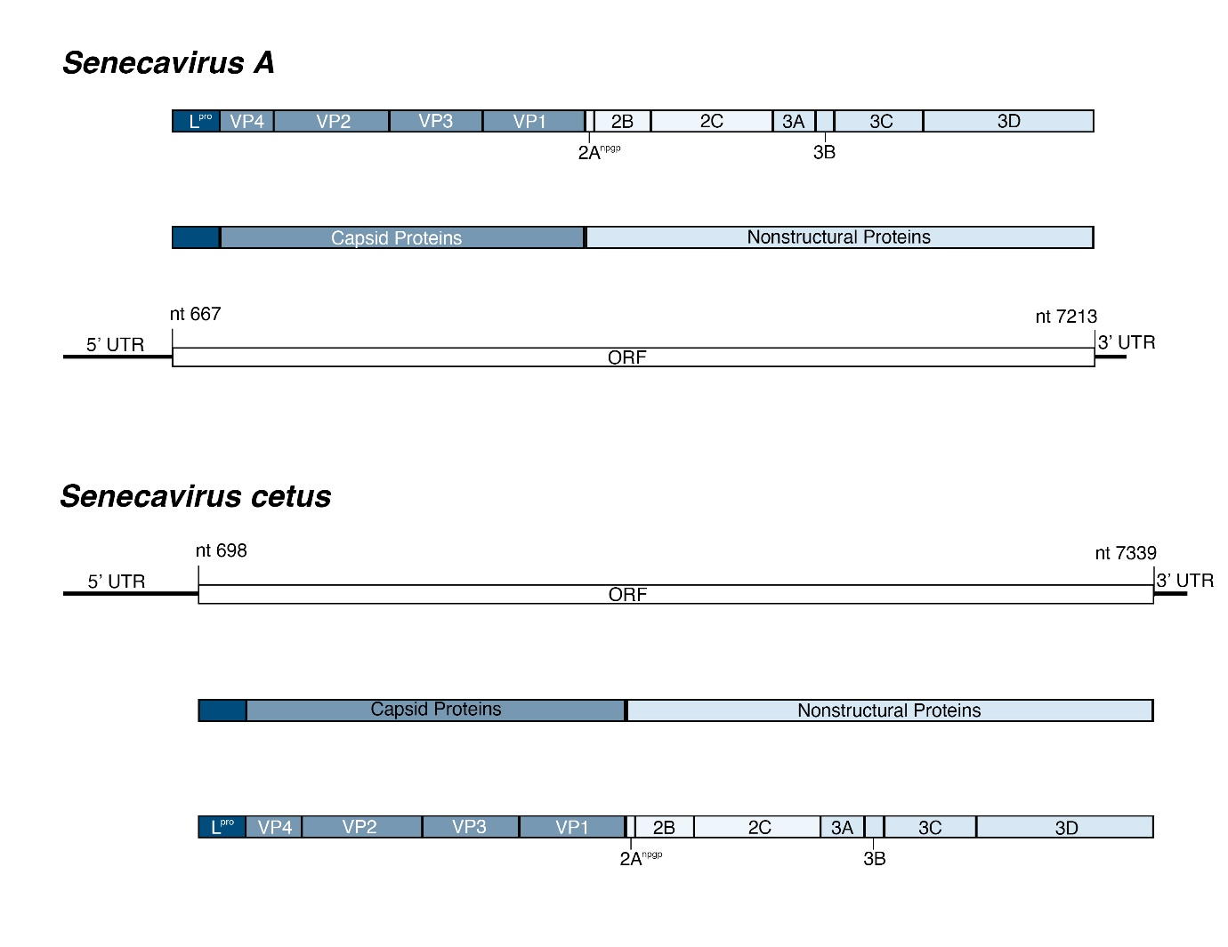

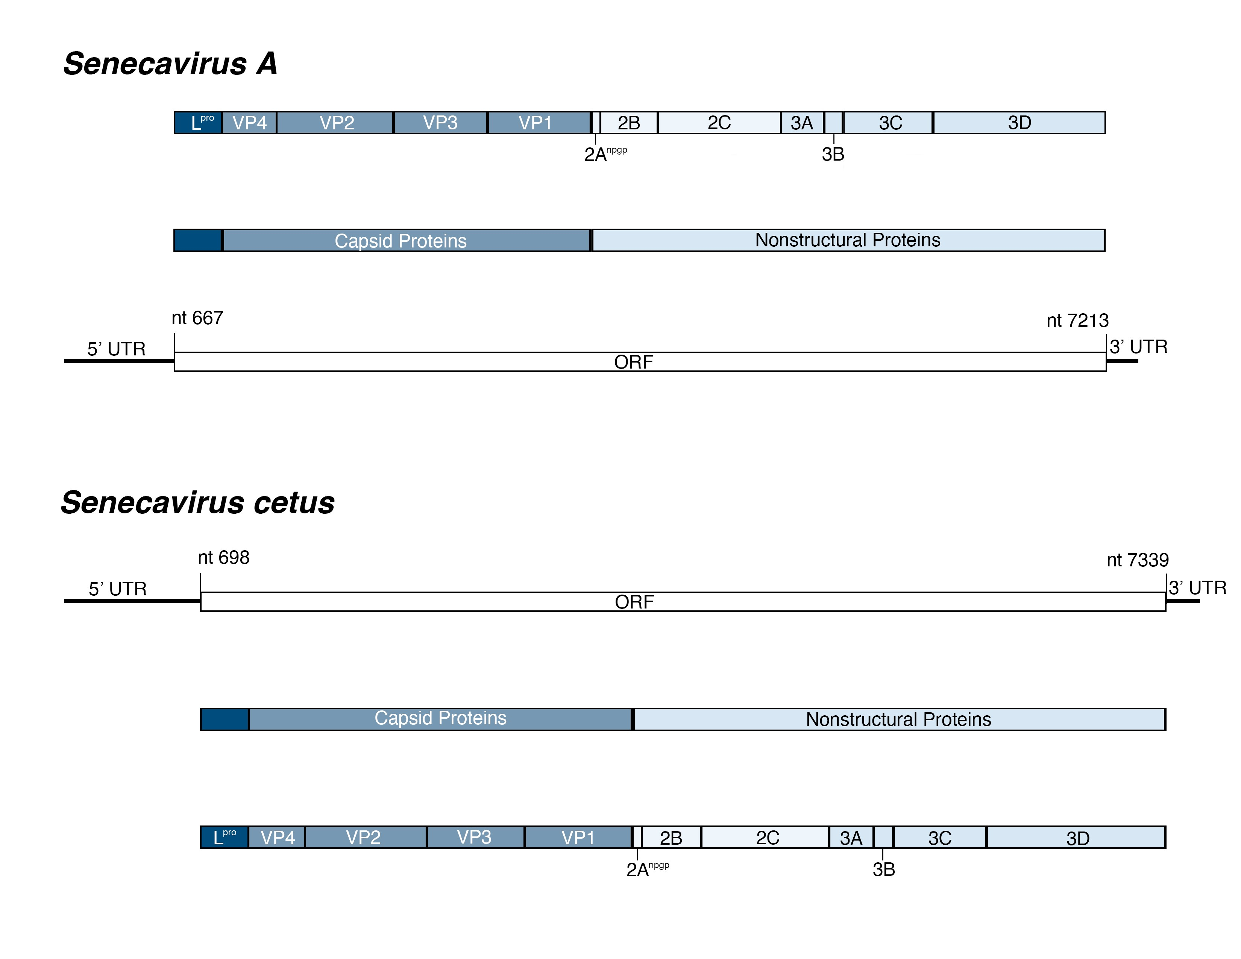

**Figure 2:** *Senecavirus cetus*genome layout and organization compared to *Senecavirus A*.

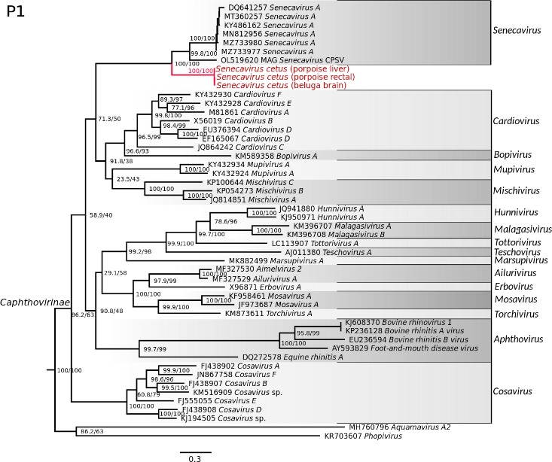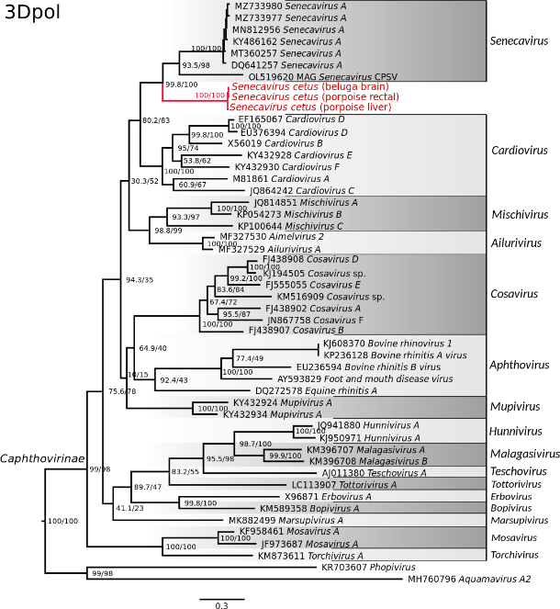

**Figure 3:** Maximum likelihood phylogenetic trees of picornaviruses in the subfamily *Caphthovirinae* reconstructed based on the nucleotide sequences of the P1 (left) and 3Dpol (right) genes. Sequences of the novel picornavirus is shown in red (GenBank accession numbers are OR416237-liver; OR416238-rectal; and OR416239-brain); the most closely related lineage, genus *Senecavirus*, includes a Senecavirus identified in pangolin, OL519620 MAG Senecavirus CPSV (Ning et al., 2022). Phylogenetic analysis was performed using IQ-Tree web server 1.6.12 (Nguyen et al., 2015; Trifinopoulos et al., 2016). The best-fit model of sequence evolution was selected based on the Bayesian information criterion (BIC) score (Schwarz, 1978) calculated by ModelFinder (Kalyaanamoorthy et al., 2017), GTR+F+I+G4 model was selected as the best-fitting for P1 and 3Dpol data sets. Node support was estimated by ultrafast bootstrap (Hoang et al., 2018) and the SH-aLRT test (Guindon et al., 2010) with 1,000 replicates each. Support values are shown at the nodes (SSH-LRT/Ultrafast bootstrap). The trees were rooted to the outgroups, Phopivirus and Aquamavirus A2, members of the subfamilies *Heptrevirinae* and *Paavivirinae*, respectively. Scale bars represent estimated average number of substitutions per site.

**References**

Guindon S, Dufayard JF, Lefort V, et al (2010) New algorithms and methods to estimate maximum-likelihood phylogenies: assessing the performance of PhyML 3.0. Systematic biology. 59:307-21. [doi.org/10.1093/sysbio/syq010](https://doi.org/10.1093/sysbio/syq010)

Hoang DT, Chernomor O, Von Haeseler A, et al (2018) UFBoot2: improving the ultrafast bootstrap approximation. Molecular biology and evolution. 35:518-22. doi.org/ 10.1093/molbev/msx281

Kalyaanamoorthy S, Minh BQ, Wong TK, et al (2017) ModelFinder: fast model selection for accurate phylogenetic estimates. Nature methods. 14:587-9. doi.org/10.1038/nmeth.4285

Nguyen LT, Schmidt HA, Von Haeseler A, et al (2015) IQ-TREE: a fast and effective stochastic algorithm for estimating maximum-likelihood phylogenies. Molecular biology and evolution. 32:268-74. [doi.org/10.1093/molbev/msu300](https://doi.org/10.1093/molbev/msu300)

Ning S, Dai Z, Zhao C, Feng Z, Jin K, Yang S, Shen Q, Wang X, Sun R, Zhang W. Novel putative pathogenic viruses identified in pangolins by mining metagenomic data. J Med Virol. 2022 Jun;94(6):2500-2509. Epub 2022 Jan 11. Doi: 10.1002/jmv.27564.

Schwarz G (1978) Estimating the dimension of a model. The annals of statistics 1:461-4. doi.org/ 10.1214/aos/1176344136

Trifinopoulos J, Nguyen LT, von Haeseler A, et al (2016) W-IQ-TREE: a fast online phylogenetic tool for maximum likelihood analysis. Nucleic acids research 44:232-235. [doi.org/10.1093/nar/gkw256](https://doi.org/10.1093/nar/gkw256)