Part 1: TITLE, AUTHORS, APPROVALS, etc

Code assigned: | 2023.004F
Short title: Create a new genus in the family Marseilleviridae (Pimascovirales) and rename species in the family
Author(s) and email address(es)
Sabanadzovic S, Abrahão J, Greub G, Colson P | ssabanadzovic@entomology.msstate.edu; jonatas.abrahao@gmail.com; gilbert.greub@chuv.ch;  philippe.colson@univ-amu.fr
Author(s) institutional address(es) (optional)
Corresponding author
Sead Sabanadzovic, ssabanadzovic@entomology.msstate.edu

List the ICTV Study Group(s) that have seen this proposal

ICTV Marseilleviridae Study Group

ICTV Study Group comments and response of proposer

ICTV Study Group votes on proposal

Study Group | Number of members
 | Votes support | Votes against | No vote
Marseilleviridae | 3 | 0 | 0

Authority to use the name of a living person
Is any taxon name used here derived from that of a living person (Y/N) | N

Taxon name | Person from whom the name is derived | Permission attached (Y/N)
 |  | NA

Submission dates
Date first submitted to SC Chair | 06-28-2023
Date of this revision (if different to above) | 10-25-2023
ICTV-EC comments and response of the proposer
Please change originally proposed name for the genus “Lausannevirus” as it is identical with previous species name and conflicts with the ICTV Rule 3.14.

Response:
We accept the suggestion and change the proposed name to “Losannavirus” which is sufficiently distinct from, but still reminiscent of the original nomenclature.

Part 2: NON-TAXONOMIC PROPOSAL

Text of proposal

Part 3: TAXONOMIC PROPOSAL
Name of accompanying Excel module
2023.004F.v2.Marseilleviridae_1newgen_spren.xlsx

Abstract
In order to comply with recently adopted binomial system for species nomenclature, here we propose to create a new genus named “Losannavirus” to classify two currently unassigned species in the family and to rename all four currently recognized species of marseillevirids.

Text of proposal
Following results of multiannual debate and consultations (1) the Ratification Vote held in March 2021, approved universal adoption of binomial format for species names across the ICTV framework of virus taxonomy (2).
According to the ratified original proposal “2018.001G.R.binomial_species”, starting from 2021 all species names must follow new guidelines. This process is envisioned for completion in 2023.

Briefly, new rules indicate:

"A species name shall consist of only two distinct word components separated by a space. The first word component shall begin with a capital letter and be identical in spelling to the name of the genus to which the species belongs. The second word component shall not contain any suffixes specific for taxa of higher ranks. The entire species name (both word components) shall be italicized."

Hence, the new standards require renaming most of already recognized species. In 2021 and 2022, the new nomenclature was already applied to approximately 80% of current species. Therefore, in this document we propose renaming four species belonging to the family Marseilleviridae to fit new standards by adopting binomial species names.

In order to accomplish that, we propose creation of a new genus to classify two currently unassigned (“floating”) species in the family for which we propose the name “Losannavirus” (Table 1). The grouping of these two species in a new genus has already been supported in a number of published papers (originally in reference #4), based upon close evolutionary relatedness of a set of taxonomically-relevant proteins encoded by genomes of the known family members (Figure 1).
The two current species in the genus Marseillevirus are renamed to fit Linnaean (genus-species) format (Table 1)

Supporting evidence

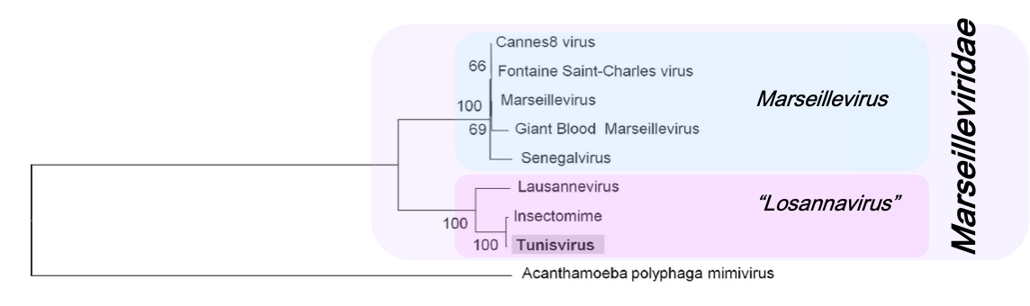

Figure 1. Maximum Likelihood phylogenetic tree constructed on the alignment of concatenated amino acid sequences of VV-A18 and D5 helicases and the very late transcription factor (VLTF), the three proteins universally encoded by members of the family Marseilleviridae. The final dataset consisted of 1,270 positions. Tree was generated and visualized by MEGA v5 software (5). The numbers on branching points indicate percentage (%) bootstrap support. The original tree was published by Aherfi et al, 2014 (4).

Table 1. Current and proposed classification and species nomenclature in the family Marseilleviridae. Changes in species nomenclature only are highlighted in blue font, while changes in classification and nomenclature are reported in red.

Current |  | Proposed
Family Marseilleviridae |  | Family Marseilleviridae
Genus Marseillevirus |  | Genus Marseillevirus
Species Marseillevirus marseillevirus |  | Species Marseillevirus massiliense
Species Senegalvirus marseillevirus |  | Species Marseillevirus senegalense
Unassigned |  | Genus “Losannavirus”
Species Lausannevirus |  | Species “Losannavirus lausannense”
Species Tunisvirus |  | Species “Losannavirus tunisense”

References
- Siddell SG, Walker PJ, Lefkowitz EJ, Mushegian AR, Dutilh BE, Harrach B, Harrison RL, Junglen S, Knowles NJ, Kropinski AM,Krupovic M, Kuhn JH, Nibert ML, Rubino L, Sabanadzovic S, Simmonds P, Varsani A, Zerbini FM, Davison AJ (2020) Binomial nomenclature for virus species: a consultation. Arch Virol 165:519–525. DOI: 10.1007/s00705-019-04477-6, PMID: 31797129
- Walker PJ, Siddell SG, Lefkowitz EJ, Mushegian AR, Adriaenssens EM, Alfenas-Zerbini P, Davison AJ, Dempsey DM, Dutilh BE, Garcia ML, Harrach B, Harrison RL, Hendrickson RC, Junglen S, Knowles NJ, Krupovic M, Kuhn JH, Lambert AJ, Lobocka M, Nibert ML, Oksanen HM, Orton RJ, Robertson DL, Rubino L, Sabanadzovic S, Simmonds P, Smith DB, Suzuki N, Van Dooerslaer K, Vandamme AM, Varsani A, Zerbini FM (2021) Changes to virus taxonomy and to the International Code of Virus Classification and Nomenclature ratified by the International Committee on Taxonomy of Viruses (2021). Arch Virol 166:2633–2648. DOI: 10.1007/s00705-021-05156-1, PMID: 34231026
- Zerbini FM, Siddell SG, Lefkowitz EJ, Mushegian AR, Adriaenssens EM, Alfenas-Zerbini P, Dempsey DM, Dutilh BE, García ML, Hendrickson RC, Junglen S, Krupovic M, Kuhn JH, Lambert AJ, Łobocka M, Oksanen HM, Robertson DL, Rubino L, Sabanadzovic S, Simmonds P, Smith DB, Suzuki N, Van Doorslaer K, Vandamme AM, Varsani A (2023) Changes to virus taxonomy and the ICTV Statutes ratified by the International Committee on Taxonomy of Viruses (2023). Arch Virol 168:175 DOI: 10.1007/s00705-023-05797-4 , PMID: 37296227
- Aherfi S, Boughalmi M, Pagnier I, Fournous G, La Scola B, Raoult D, Colson P (2014) Complete genome sequence of Tunisvirus, a new member of the proposed family Marseilleviridae. Arch Virol 159:2349-2358. DOI: 10.1007/s00705-014-2023-5, PMID: 24770845
- Tamura K, Peterson D, Peterson N, Stecher G, Nei M, Kumar S (2011) MEGA5: molecular evolutionary genetics analysis using maximum likelihood, evolutionary distance, and maximum par-simony methods. Mol Biol Evol 28:2731–2739. DOI: 10.1093/molbev/msr121, PMID: 21546353

