

**Part 1:** **TITLE, AUTHORS, APPROVALS, etc**

|  |  |  |
| --- | --- | --- |
| **Code assigned:** | ***2023.007F*** |  |
| **Short title:** Create one new phylum, *Ambiviricota*, including one new class, one new order, four new families, four new genera, and 20 new species, in kingdom *Orthornavirae* (realm *Riboviria*) | | |
|  | | |

**Author(s) and email address(es)**

|  |  |
| --- | --- |
| Turina M, Lee B, Sabanadzovic S, Vainio E, Navarro B, Simmonds P, Kuhn JH, De La Pena M, Botella L, Krupovic M | [massimo.turina@ipsp.cnr.it](mailto:massimo.turina@ipsp.cnr.it); [benjamin.lee@chch.ox.ac.uk](mailto:benjamin.lee@chch.ox.ac.uk); [SSabanadzovic@entomology.msstate.edu](mailto:SSabanadzovic@entomology.msstate.edu); [eeva.vainio@luke.fi](mailto:eeva.vainio@luke.fi); [beatriz.navarro@ipsp.cnr.it](mailto:beatriz.navarro@ipsp.cnr.it); [peter.simmonds@ndm.ox.ac.uk](mailto:peter.simmonds@ndm.ox.ac.uk); [kuhnjens@mail.nih.gov](mailto:kuhnjens@mail.nih.gov); [rivero@ibmcp.upv.es](mailto:rivero@ibmcp.upv.es); [qqbotell@mendelu.cz](mailto:qqbotell@mendelu.cz); [mart.krupovic@pasteur.fr](mailto:mart.krupovic@pasteur.fr) |

**Author(s) institutional address(es) (optional)**

|  |
| --- |
|  |

**Corresponding author**

|  |
| --- |
| Turina M |

**List the ICTV Study Group(s) that have seen this proposal**

|  |
| --- |
|  |

**ICTV Study Group comments and response of proposer**

|  |
| --- |
|  |

**ICTV Study Group votes on proposal**

|  |  |  |  |
| --- | --- | --- | --- |
| **Study Group** | **Number of members** | | |
| **Votes support** | **Votes against** | **No vote** |
|  |  |  |  |

**Authority to use the name of a living person**

|  |  |
| --- | --- |
| **Is any taxon name used here derived from that of a living person (Y/N)** | Y |

|  |  |  |
| --- | --- | --- |
| **Taxon name** | **Person from whom the name is derived** | **Permission attached (Y/N)** |
| *Suforviricetes* | Suvi Sutela and Marco Forgia | Y |

**Submission dates**

|  |  |
| --- | --- |
| Date first submitted to SC Chair | June 23, 2023 |
| Date of this revision (if different to above) | October 22, 2023 |

**ICTV-EC comments and response of the proposer**

|  |
| --- |
| Please double-check the nomenclature.  Response:  Names of all taxa were thoroughly checked and approved by the authors. |

**Part 2:** **NON-TAXONOMIC PROPOSAL**

**Text of proposal**

|  |
| --- |
|  |

**Part 3:** **TAXONOMIC PROPOSAL**

**Name of accompanying Excel module**

|  |
| --- |
| 2023.007F.v2.Ambiviricota_nphy.xlsx |

**Abstract**

|  |
| --- |
| “Ambiviruses” are mobile genetic elements that were recently discovered in fungi. Their RNA genomes are circular, circa 5 kb in length, and have at least two open reading frames (ORFs) in non-overlapping ambisense orientation. Both ORFs are conserved among all currently known “ambiviruses” and one of them encodes a viral RNA-directed RNA polymerase (RdRp) that firmly places “ambiviruses” into ribovirian kingdom *Orthornavirae*. However, the “ambivirus” RdRps are only distantly related to those encoded by orthornaviraens in currently established phyla. Furthermore, their genomes have the unique features of encoding RdRps but also having divergent ribozymes in various combinations in both sense and antisense orientation. Indeed, the detection of circular forms in both sense orientations suggest that “ambiviruses” use rolling circle replication for propagation. Here we propose to establish a framework for the classification of this very rapidly growing group of viruses that accommodates an initial set of 20 well-annotated “ambivirus” genome sequences in a new phylum, a new class, a new order, four families, four new genera, and 20 new species. |

**Text of proposal**

|  |  |
| --- | --- |
| |  | | --- | | “Ambiviruses” is the term first used by Sutela et al. and Forgia et al. for a group of unique mobile genetic elements with RNA genomes discovered in isolates of agaricomycete (Ceratobasidiaceae: *Ceratobasidium* sp. and Tulasnellaceae: *Tulasnella* sp.) [9] and sordariomycete fungi (Cryphonectriaceae: *Cryphonectria parasitica* (Murrill) M.E.Barr (1978)) [4]. Soon after, a number of other “ambiviruses” have been characterized from mostly agaricomycetes (e.g., physalacriaceaen *Armillaria* spp., bondarzewiaceaen *Heterobasidion* spp., ceratobasidiaceaen *Rhizoctonia* spp., and phanerochaetaceaen *Phlebiopsis* *gigantea* (Fr.) Jülich (1978)) [2, 7, 10]. All these “ambiviruses” were discovered as “orphan encoding sequences” (i.e., BLAST searches with non-redundant database at the time of discovery did not result in detectable homologs). Indeed, recent highly comprehensive similarity-based virus-discovery searches in large metatranscriptomic datasets missed “ambiviruses” as well [3, 8, 12].  “Ambiviruses” from axenically isolated fungi have RNA genome lengths of 4.3–5.2 kb and encode at least two conserved proteins from non-overlapping open reading frames (ORFs) in ambisense orientation (ORF-A and ORF-B) (Fig. 1). Some “ambivirus” genomes have a third ORF encoding a protein with a sequence not conserved among the clade members. ORF-A encodes a highly divergent RNA-directed RNA polymerase (RdRp) with typical A, B, and C motifs in the palm subdomain [5], indicating that “ambiviruses” are ribovirian orthornaviraens. Interestingly, other researchers discovered “ambiviruses” as circular ribozyme-possessing entities, with hammerhead (HHRz), hairpin (HpRz), and other ribozyme types located at the C-termini of both ORFs [5, 6] (Fig. 1) Ribozyme activity and rolling circle replication was confirmed *in vitro* and *in vivo* for two specific “ambiviruses”, Cryphonectria parasitica ambivirus 1 (CpAV1) and Tulasnella ambivirus 4 (TuAV4) [5]. This finding identified “ambiviruses” as “hybrids” of RdRp-encoding orthornaviraens and viroids.  Here, we propose an initial taxonomic framework for the classification of “ambiviruses”. Notably, “ambiviruses” monophyletic in the RdRP phylogeny carry unrelated types of ribozymes (Fig. 4), indicating that the two characters evolve independently of each other and are exchanged horizontally, with RdRP being the only feature unifying the entire virus group. Due to the conservation of the RdRP, the hallmark protein of orthornaviraens, we propose that “ambiviruses” be accommodated within kingdom *Orthornavirae*. Furthermore, given the unique combination of highly divergent RdRP-encoding ORFs, ribozyme activity, and circular genomes, we propose assigning this virus group to a new orthornaviraen phylum, *Ambiviricota*.  Focusing only on several well-annotated ambiviricot sequences at this time, we propose the phylum to include a single class with a single order for four families including four genera and 20 species, based upon a 90%-identity threshold in pairwise alignment of ORF-A as the species demarcation criterion (Figs. 2 and 3). Primary distinction among the genera is based on phylogenetic analyses. All viruses assigned to different genera and the four families proposed in this document form monophyletic clades in phylogenetic analyses performed using their RdRP proteins.  Our knowledge of ambiviricot diversity is rapidly increasing [1, 5]. A recent study of 46,500 fungal transcriptomes identified more than 2,500 ambivircot sequences with as little as 27% protein sequence identity to previously described genomes; these sequences likely represent at least 345 distinct ambiviricots [1] in addition to hundreds described before [5] (Figs. 4 and 5). The framework proposed here will likely suffice to classify these new ambiviricots in an expanded scheme requiring future creation of additional classes, orders, and families.  Etymology for proposed taxa: see Excel spreadsheet. | |

**Supporting evidence**

**Fig. 1. Genome organization or representative “ambiviruses”**

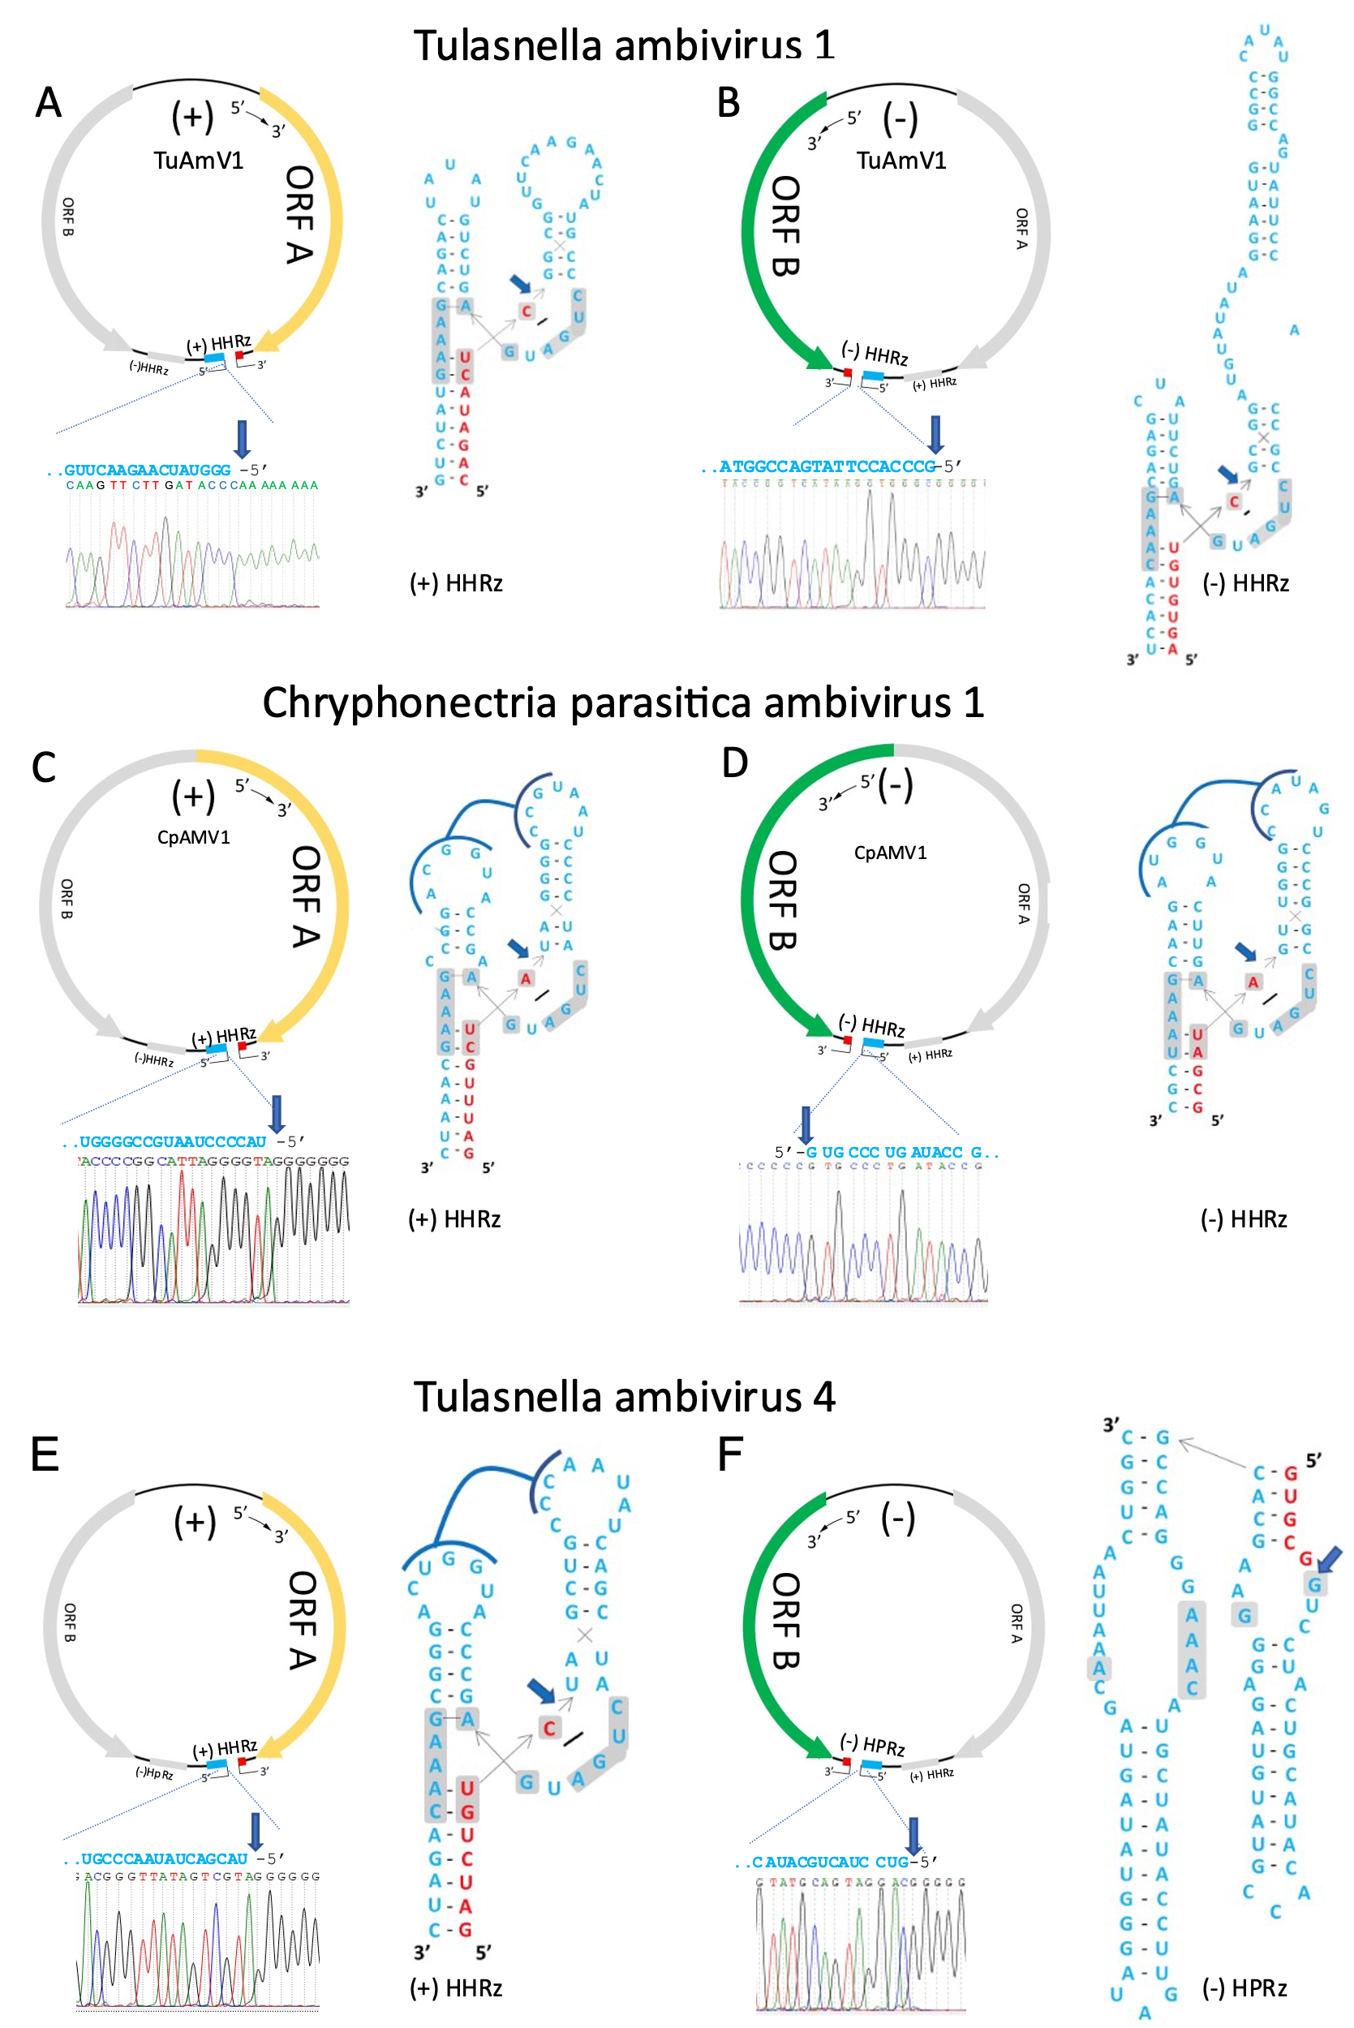

5′ RACE and Sanger sequencing of the (A, C, E) positive (+) and (B, D, F) negative (-) strands of three ambiviricot genomic RNAs, showing the *in vivo* self-cleavage sites (blue arrows) at the predicted cleavage-sites for their HHRz and HpRz motifs, respectively. Ribozyme secondary structures are drawn as inlays. Adapted from Figure 3 in [5].

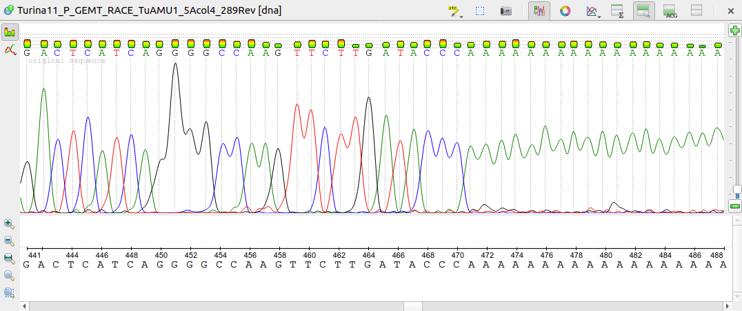

**..GUUCAAGAACUAUGGG**-5’

C A A G T T C T T G A T A C C C A A A A A A A A

**Fig. 2.** Phylogenetic tree based upon alignment of amino acid sequences of well annotated ambiviricot RdRPs (ORF-A encoded proteins) considered in this proposal. Alignment was performed with MAFFT, while tree topology was calculated with the maximum likelihood methodology implemented in IQ-Tree [11], using the ultrafast bootstrap methods.

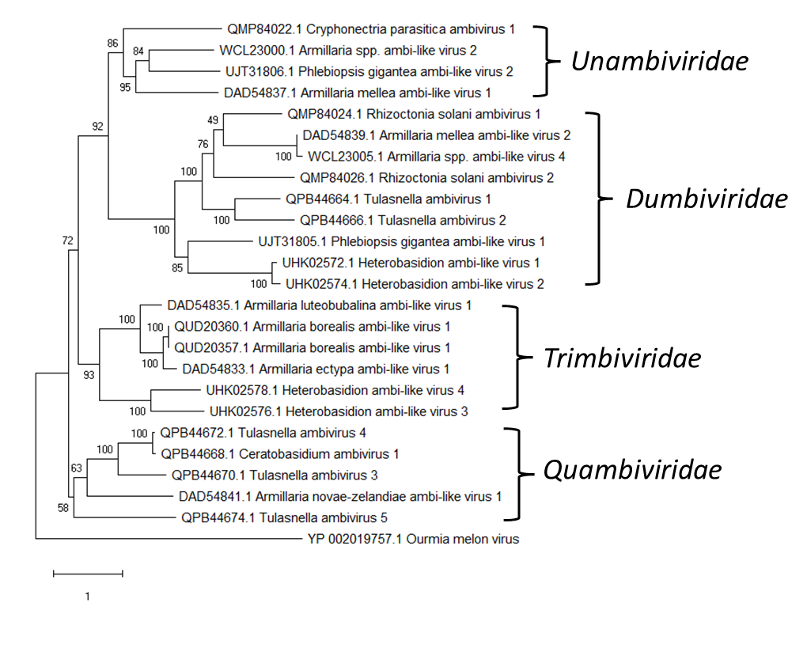

**Fig. 3.** Identity matrix of all ambiviricot ORF-A encoded protein sequences used for this proposal (Supplementary File). Pairwise alignment was performed using Clustal omega. Shades of color intensity from blue to red represent percentiles of identity.



**Fig. 4. Ambiviricot diversity**



Maximum-likelihood phylogenetic tree of ambiviricot RNA-directed RNA polymerase (RdRp) palmprints of 439 distinct species-like operational taxonomic units (sOTUs). DVRz, delta virus ribozyme; HHRz, hammerhead ribozyme; HpRz, hairpin ribozyme; TWRz, twister ribozyme. Sites of self-cleavage are indicated with arrows. Adapted from Figure 2 in [5].

**Fig. 5. Ambiviricot diversity**

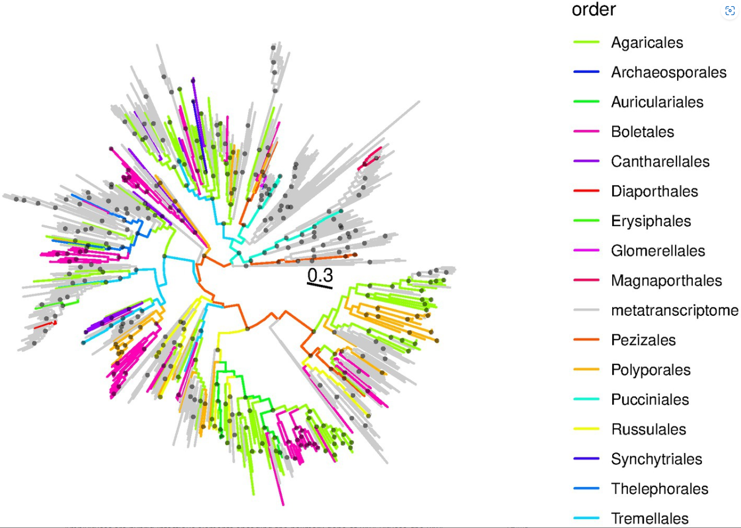

Maximum-likelihood phylogenetic tree of ambiviricot RNA-directed RNA polymerases (RdRps), mid-point pseudo-rooted. Branches are colored according to the fungal order of the SRA sequencing experiment from which the viral sequences were discovered; gray branches correspond to ambiviricots from metatranscriptome projects reported by [5] (see Figure 4) and used to create the HMM search profile used. Black dots at internal nodes indicate branching events with SH-like support of 0.9 or better. The scale bar is in average amino acid substitutions per site (taken from Figure 3 in [1]).

**References**

1. Chong LC, Lauber C (2023) Viroid-like RNA-dependent RNA polymerase-encoding ambiviruses are abundant in complex fungi. Front Microbiol 14:1144003. PMID: 37275138. PMCID: PMC10237039. doi: 10.3389/fmicb.2023.1144003.

2. Drenkhan T, Sutela S, Veevälii V, Vainio EJ (2022) *Phlebiopsis gigantea* strains from Estonia show potential as native biocontrol agents against *Heterobasidion* root rot and contain diverse dsRNA and ssRNA viruses. Biol Control 167:104837. doi: 10.1016/j.biocontrol.2022.104837.

3. Edgar RC, Taylor J, Lin V, Altman T, Barbera P, Meleshko D, Lohr D, Novakovsky G, Buchfink B, Al-Shayeb B, Banfield JF, de la Peña M, Korobeynikov A, Chikhi R, Babaian A (2022) Petabase-scale sequence alignment catalyses viral discovery. Nature 602:142-147. PMID: 35082445. doi: 10.1038/s41586-021-04332-2.

4. Forgia M, Isgandarli E, Aghayeva DN, Huseynova I, Turina M (2021) Virome characterization of *Cryphonectria parasitica* isolates from Azerbaijan unveiled a new mymonavirus and a putative new RNA virus unrelated to described viral sequences. Virology 553:51-61. PMID: 33221630. doi: 10.1016/j.virol.2020.10.008.

5. Forgia M, Navarro B, Daghino S, Cervera A, Gisel A, Perotto S, Aghayeva DN, Akinyuwa MF, Gobbi E, Zheludev IN, Edgar RC, Chikhi R, Turina M, Babaian A, Di Serio F, de la Peña M (2023) Hybrids of RNA viruses and viroid-like elements replicate in fungi. Nat Commun 14:2591. PMID: 37147358. PMCID: PMC10162972. doi: 10.1038/s41467-023-38301-2.

6. Lee BD, Neri U, Roux S, Wolf YI, Camargo AP, Krupovic M, RNA Virus Discovery Consortium, Simmonds P, Kyrpides N, Gophna U, Dolja VV, Koonin EV (2023) Mining metatranscriptomes reveals a vast world of viroid-like circular RNAs. Cell 186:646-661 e4. PMID: 36696902. PMCID: PMC9911046. doi: 10.1016/j.cell.2022.12.039.

7. Linnakoski R, Sutela S, Coetzee MPA, Duong TA, Pavlov IN, Litovka YA, Hantula J, Wingfield BD, Vainio EJ (2021) Armillaria root rot fungi host single-stranded RNA viruses. Sci Rep 11:7336. PMID: 33795735. PMCID: PMC8016926. doi: 10.1038/s41598-021-86343-7.

8. Neri U, Wolf YI, Roux S, Camargo AP, Lee B, Kazlauskas D, Chen IM, Ivanova N, Zeigler Allen L, Paez-Espino D, Bryant DA, Bhaya D, RNA Virus Discovery Consortium, Krupovic M, Dolja VV, Kyrpides NC, Koonin EV, Gophna U (2022) Expansion of the global RNA virome reveals diverse clades of bacteriophages. Cell 185:4023-4037 e18. PMID: 36174579. doi: 10.1016/j.cell.2022.08.023.

9. Sutela S, Forgia M, Vainio EJ, Chiapello M, Daghino S, Vallino M, Martino E, Girlanda M, Perotto S, Turina M (2020) The virome from a collection of endomycorrhizal fungi reveals new viral taxa with unprecedented genome organization. Virus Evol 6:veaa076. PMID: 33324490. PMCID: PMC7724248. doi: 10.1093/ve/veaa076.

10. Sutela S, Piri T, Vainio EJ (2021) Discovery and community dynamics of novel ssRNA mycoviruses in the conifer pathogen *Heterobasidion parviporum*. Front Microbiol 12:770787. PMID: 34899655. PMCID: PMC8652122. doi: 10.3389/fmicb.2021.770787.

11. Trifinopoulos J, Nguyen LT, von Haeseler A, Minh BQ (2016) W-IQ-TREE: a fast online phylogenetic tool for maximum likelihood analysis. Nucleic Acids Res 44:W232-5. PMID: 27084950. PMCID: PMC4987875. doi: 10.1093/nar/gkw256.

12. Zayed AA, Wainaina JM, Dominguez-Huerta G, Pelletier E, Guo J, Mohssen M, Tian F, Pratama AA, Bolduc B, Zablocki O, Cronin D, Solden L, Delage E, Alberti A, Aury J-M, Carradec Q, da Silva C, Labadie K, Poulain J, Ruscheweyh H-J, Salazar G, Shatoff E, Tara Oceans Coordinators, Bundschuh R, Fredrick K, Kubatko LS, Chaffron S, Culley AI, Sunagawa S, Kuhn JH, Wincker P, Sullivan MB (2022) Cryptic and abundant marine viruses at the evolutionary origins of Earth's RNA virome. Science 376:156-162. PMID: 35389782. doi: 10.1126/science.abm5847.